X-ray Data Analysis in Real Time (XDART)

Contents

Scanning Area Detector (ttheta_scan) 3

Getting Started: 3

File Browser 4

Metadata Panel 6

Data Viewer Panel 7

Integrator Panel 8

Wrangler Panel 9

Mask Widget 12

Appendix 13

pyFAI Geometry 13

# Scanning Area Detector (ttheta_scan)

## Getting Started:

When first opened, XDART will produce a screen as follows:

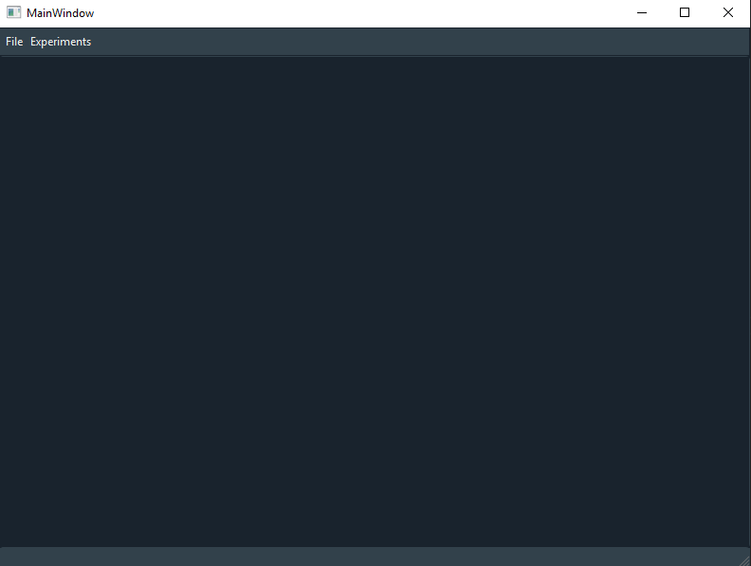

Under “Experiments” in the top toolbar, select “ttheta_scan” to launch the interface. This will create a new tab, shown below:

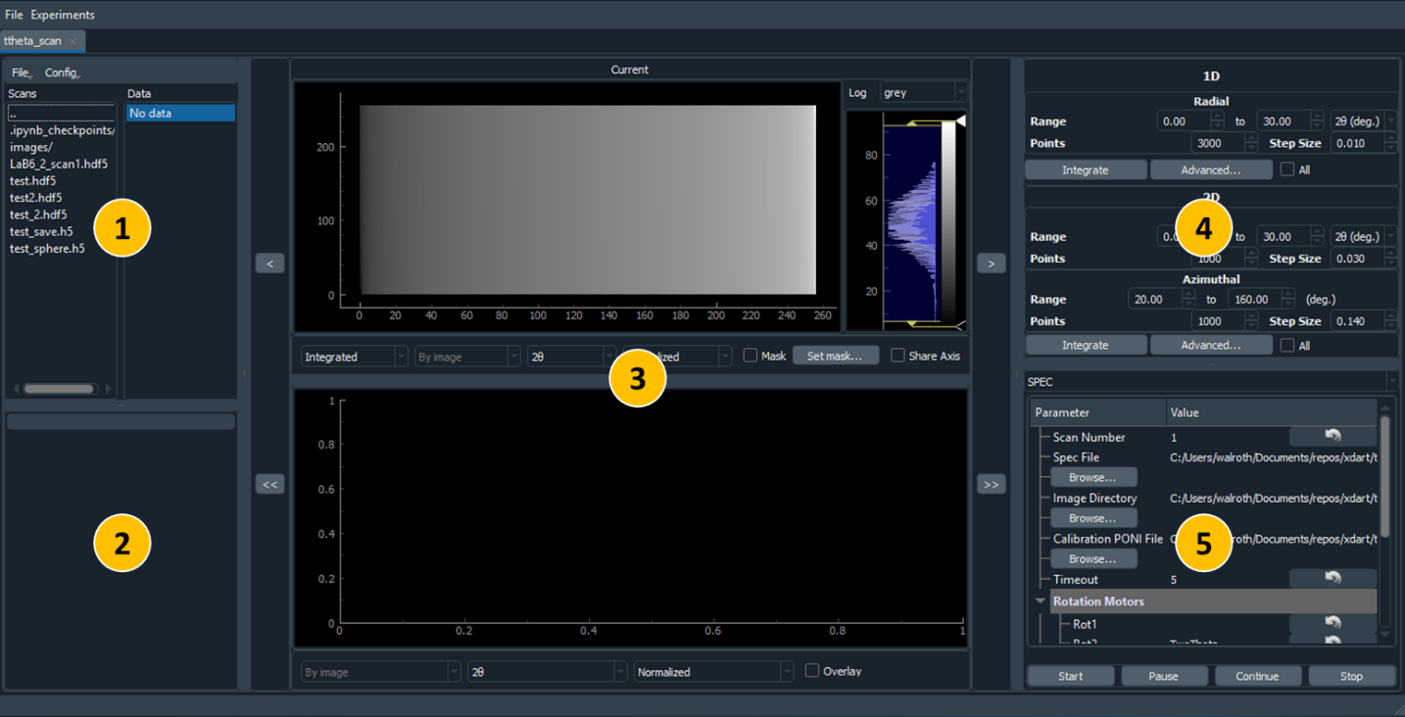

The tab is split into five sections: 1) File browser, 2) Metadata, 3) Data viewer, 4) Integrator, and 5) Wrangler. Each is explained in subsequent sections.

### File Browser

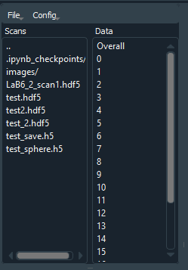

The file browser panel has two panels, one for listing files and the other for groups within the data file. The left panel will show any hdf5 files and directories in the present directory. The first entry is always “..”, double clicking on this will move one level up in the directory. Directories in the list have a “/” character at the end, double clicking on these will navigate into that directory. Finally, double clicking on an hdf5 file will load that file for processing.

In the right panel, there is an entry for overall data and then each individual image which contributes to the overall data. Single clicking on any item in the list will load that image or the overall data.

Above these panels is a toolbar with two menus, File and Config. File presents the following options:

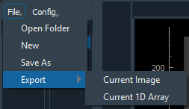

* Open folder: Navigate to new folder to display in file browser
* New: create a new, empty file
* Save as: Save copy of the current data to a new file, and then set that as the current file.
* Export:
  + Current image: The currently displayed image, including any scaling or color maps, is saved.
  + Current 1D array: Saves the currently displayed 1D array, either as CSV or XYE. This will also save the variance as calculated by pyFAI.

The Config menu has the following options:

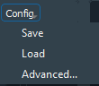

* Save: Save the current parameters to a JSON file
* Load: Load from JSON file
* Advanced: Pop up a window (see below) with all parameters displayed for editing. These parameters are for other panels in the program, and will be described later.

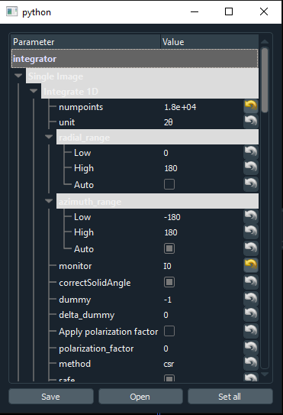

### Metadata Panel

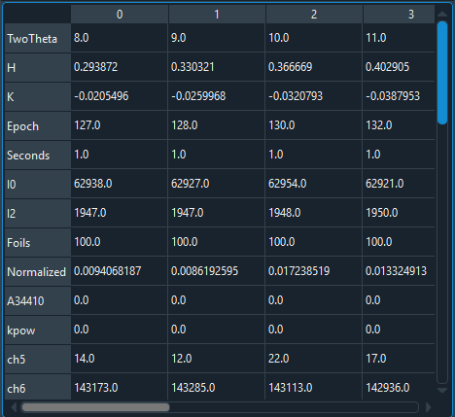

The metadata panel displays all metadata from the overall scan or individual images depending on selection in File Browser panel.

### Data Viewer Panel

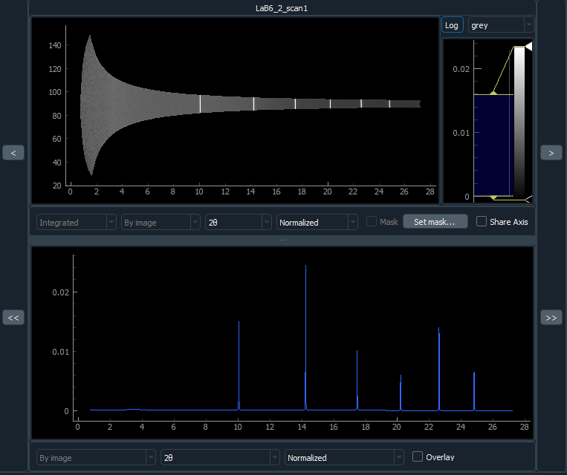

The data viewer panel displays image data (top) and integrated data (bottom). Arrows on the left and right cycle through images in the overall scan. These are disabled if “Overall” is selected. If the double right arrow button is pushed and a scan is actively being loaded, it will automatically move to the latest image during collection.

For both display areas, dragging the left mouse button will display a box, releasing the mouse button will zoom into that area. Right clicking will bring out the full view. If the ranges are not already set to automatically adjust to new data, a letter “A” in a box will appear in the lower left of the panel. Clicking this will enable automatic range adjustment.

The image pane also has a histogram of values, which allows for adjusting the min and max value. Also, the arrows on the color bar can be adjusted. Clicking the color bar will create a new arrow, and right clicking on the arrow lets the color be specified.

Image options:

* Integrated vs Raw: whether raw or integrated data is displayed. Only available with individual images.
* Unit: unit for X axis.
* Normalized, Raw, Pixel Count: What data is displayed for integrated data. Normalized refers to normalization to number of pixels, raw represents the total signal in any particular bin of angle or q. Pixel count displays how many pixels were in each bin.
* Mask: whether the mask is overlaid on top.
* Set mask: launch window for setting a user defined mask (see section on Mask Widget)
* Share Axis: whether to share the same X-axis range between 1D and 2D data.
* Log: displays data in log scale
* Color map: drop down list of available color maps.

Array options:

* Unit: unit for X axis.
* Normalized, Raw, Pixel Count: What data is displayed for integrated data, see Image options.
* Overlay: whether to overlay the overall data with individual image data. NOTE: when saving the 1D arrays, only individual image data will be saved, not the overlaid data.

### Integrator Panel

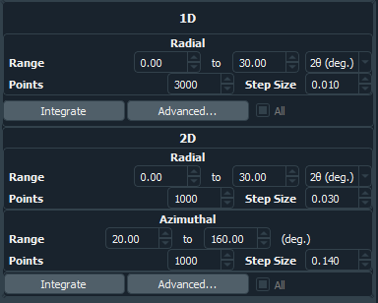

This panel controls the integration for data loaded from the file. Simple parameters are displayed including range, number of points, step size, and unit. More advanced options can be set in a pop up window with the “Advanced” button:

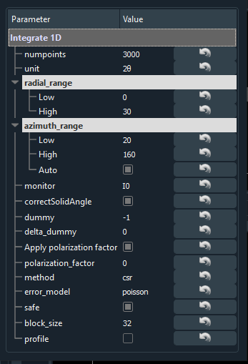

For an explanation of the above parameters, see integrate1d and integrate2d at <https://pyfai.readthedocs.io/en/latest/api/pyFAI.html#module-pyFAI.azimuthalIntegrator>. The curled arrows will return the value to the default, which is the value loaded from the JSON file.

The “Integrate” buttons will integrate either 1D or 2D. If “All” is checked, all images are integrated and the results saved to disk. Otherwise, only the current image is integrated and the result is not stored. This second option is useful for checking that a particular parameter change causes the desired result. Clicking on a separate image or overall data will erase the result.

### Wrangler Panel

XDART is designed to have flexible data intake. This is handled by the “Wrangler” panel. The default is a static SPEC wrangler. Currently SPEC and Live SPEC are the only available Wranglers. Wranglers will automatically determine the name of the hdf5 file that will be used to store image and array data. Users can load in other data files while the wrangler is working to check on old data.

#### Spec

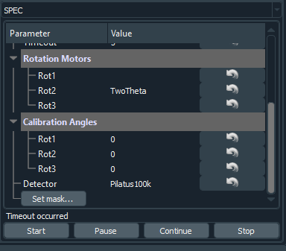

The SPEC wrangler is designed to work with data collected using SPEC. It requires the following input from the user:

* Scan Number: number used in the SPEC file, denoted in the file by #S
* Spec File: Path to the relevant Spec File. “Browse…” will bring up a file dialog to search for this path.
* Image Directory: Directory with image data
* Calibration PONI File: PONI file from calibration
* Timeout: How long to wait for new image data to be available. The Wrangler will continue to look for new data until this limit is reached. If images are being added to the image directory in real time, this allows for data integration to be performed live.
* Rotation Motors: The name of the rotation motors in the Spec file. These must be the names in the row denoted by #L. NOTE: For 2-1, the two-theta motor is entered in Rot2. pyFAI geometry is displayed in the appendix, more info at <https://pyfai.readthedocs.io/en/latest/usage/tutorial/Geometry/geometry.html>.
* Calibration Angles: Angles at which calibration was done. Will be 0 if direct beam approach was used.
* Detector: Which detector is being used
* Set mask: this is optional, but allows the user to pre-define a mask that will be used when loading in images

The four buttons have the following functions:

* Start: start looking for data. Can be launched with an active scan running.
* Pause: pauses data wrangling
* Continue: continues looking for data
* Stop: stops data wrangling

While data wrangling is in progress, all parameters will be frozen until data wrangling completes or the “Stop” button is pushed. “Pause” does not allow for adjustment of parameters. The data will be stored in the same location as the Spec file, and the data file name will be based on the spec file name.

#### Live SPEC

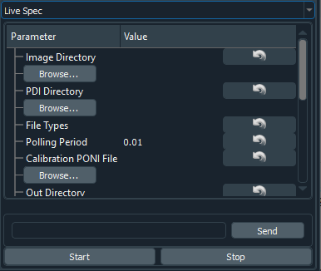

Live SPEC is designed to also work with Spec data, but to directly interface with Spec instead of relying on the Spec file. Inputs are:

* Image Directory: directory where images are stored. Should be the detector computer directory.
* PDI Directory: directory where pdi files will be stored.
* File Types: File types to look for, separated by spaces. Should be only raw for most cases.
* Polling Period: how often to check for new files.
* Calibration PONI File, Rotation Motors, Calibration Angles: see SPEC
* Detector: Which detector is being used
* Set mask: this is optional, but allows the user to pre-define a mask that will be used when loading in images

Beneath the parameters is a command line. Commands entered here are sent on to SPEC, operates much like the SPEC command line. Up and down arrows will cycle through old commands. The “Start” and “Stop” buttons trigger polling for new files and wrangling images. The command line is active regardless of whether or not polling is active.

### Mask Widget

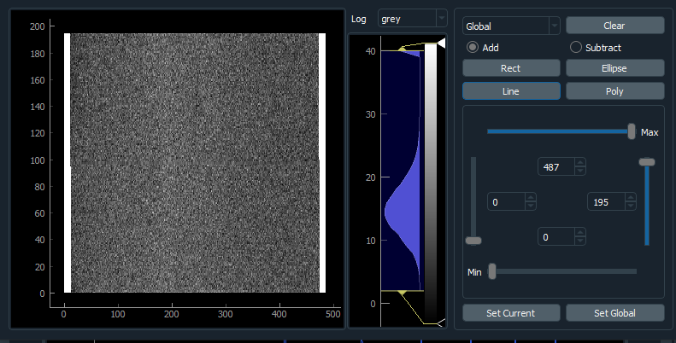

The mask widget is a pop up window for setting a user defined mask. The left panel will show data to be masked for that image, with the same tools for color maps and scale as the main widget. The top right section has a drop down of available images that can be set. Next to this is a “Clear” button which will completely erase the mask. Beneath these is a set of buttons to add mask shapes, either in addition or subtraction mode. These either add to or subtract from the mask, in the order they were created. Next is a set of sliders to set upper and lower bounds in both x and y. Finally, there is a button to set the mask for the current image or the global mask which will be applied to all images. Until these set buttons are used, the mask is not saved. Once saved, any specified ROI or limit information is lost and only the resulting mask is saved. These masks can be edited, either by adding more regions to the mask or subtracting out regions using ROIs. The resulting edited mask can then be saved the same way as a mask starting from scratch.

## Appendix

### pyFAI Geometry

