Answer Proforma

Q1: We have used three bands here. What is the total number of bands we could make available to the CNN if we so chose? (1pt)
Twelve. Each Solafune patch carries the full Sentinel 2 spectral stack minus the cirrus band B10, that is B1, B2, B3, B4, B5, B6, B7, B8, B8A, B9, B11 and B12, which I confirmed by opening a patch with rasterio and reading its band count. So instead of the three channels used here we could feed the CNN twelve, and the discarded channels include exactly the near infrared and shortwave infrared bands in which photovoltaic surfaces are most distinctive.

Q2: What is the total number of patches in our training data and the total number in our validation set? (With the parameters set as I have done in the notebook). (2 pts)
With the parameters as set, the five training files hold 500 patches and the two validation files hold 200 patches. The patch store writes batches of 100, and the last of the 21 files holds only the 66 leftover patches, so the exact totals depend on which files the seeded shuffle assigns to each split: in my run the counts above are what count_samples reports. It is also worth noting what the labels look like: 93.4 percent of the training patches and 91.5 percent of the validation patches contain solar panels, an imbalance that matters a great deal for interpreting the accuracy figures later.

Q3: Are we shuffling the training dataset? Are we shuffling the validation dataset? (2 pts)
The training dataset is shuffled and the validation dataset is not. Training shuffles at two levels: the order of the npz files is reshuffled each pass, and a 2048 sample buffer then shuffles individual patches as they stream out of interleave, which decorrelates consecutive samples and gives each epoch a different ordering. The validation pipeline sets shuffle to False and also does not repeat, which is the correct choice: evaluation should visit every validation sample exactly once in a deterministic order so that the metric is comparable from epoch to epoch and run to run.

Q4: Which type of activation funding is our final layer using and why are we using this function as our final layer? (5 pts)
The final layer is a single neuron with a sigmoid activation. Sigmoid squashes the network output onto the open interval from 0 to 1, so the model output can be read as the probability that the patch contains at least one solar panel pixel, which is exactly the binary patch level question we posed. It also pairs mathematically with the binary crossentropy loss we compiled: that loss expects a Bernoulli probability, and the gradient of sigmoid plus binary crossentropy is simple and well behaved. A softmax over two units would be the equivalent choice for a one hot encoding, and a linear output would be wrong because the loss would then receive unbounded values that cannot be interpreted as probabilities.

Q5: Is this a robust and reliable model for the detection of solar panels in a new Sentinel 2 image that has never been seen by the model before? Explain your answer with reference to the design of the training data, the settings of the CNN and the performance statistics seen. (5 pts)
No. My run makes this concrete: the trained network predicts solar for every single validation patch, 183 true positives and 17 false positives with zero negatives of either kind, so its 91.5 percent accuracy is exactly the accuracy of a rule that always answers yes, because 91.5 percent of the validation patches contain panels. The loss falls during training but the decision never changes, which tells us the data, not the optimiser, is the problem. The training data cannot support a robust detector. All patches come from a single competition dataset over one geography, the negatives are only about nine percent of the samples and are drawn from the same scenes as the positives, so the network never sees what forests, open water, bare pasture or clouds look like. The patches are natively only about 23 by 23 pixels and the pipeline first inflates them to 256 and then squeezes them to 128, adding interpolation artefacts and no information. The three channels kept are actually B1, B2 and B3, the coastal aerosol, blue and green bands, not true RGB and not the infrared bands that best separate photovoltaic surfaces. The CNN itself is tiny, two convolution layers and a global average pool, trained five epochs with no augmentation, and the validation patches come from the same distribution, so even these statistics flatter it: on any unseen Sentinel 2 scene dominated by non solar landcover this model would flag essentially everything as solar, and my question 7 experiment confirms exactly that.
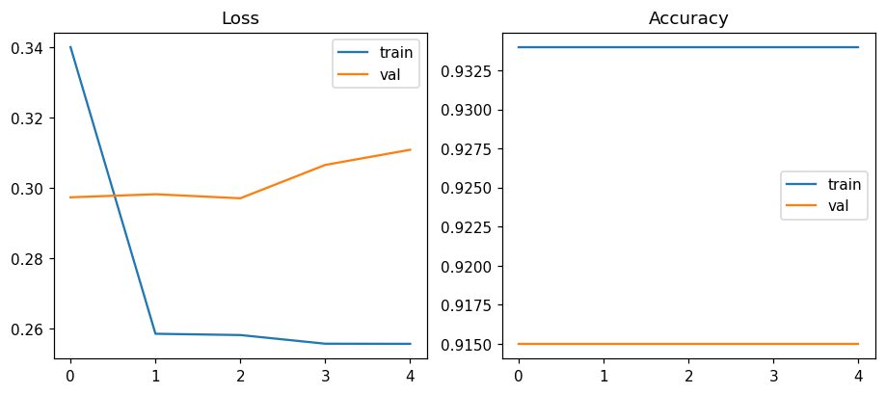

Q6: Exercise: using the materials taught in Lab 3 and given your answer to Q5, re-design your training data so that it is a robust training set for the detection of solar panels in S2 data. Your answer needs to include:
- A paragraph that explains what you have added to the train_data and any other steps taken in order to enhance the robustness of the training.
- A figure that demonstrates your newly added patches vs. the existing patches (remember that it needs to be publication quality).
You do not need to create a 100% solution here. I am looking for you to demonstrate an understanding of the critical design flaw in this training set (particularly for a patch based, as opposed to segmentation, approach), and to show critical thinking in how you might fix it. This may include re-sampling the existing training data, including new training data, or changing the bands being used (or all of the above).
(15 pts)
The critical design flaw for a patch based classifier is that the label only says whether a patch contains any solar pixel, and in this dataset about 90 percent of patches do, with the few negatives cut from the very same scenes. The network can therefore reach the headline accuracy by learning what the competition scenes look like rather than what a solar panel looks like, and it has never once been shown the enormous variety of the negative world it would meet in deployment. My redesign attacks exactly that: using the Lab 3 pipeline I built a cloud free s2cloudless masked median composite over Auckland with my tuned parameters, reprojected it to UTM at the native 10 m scale, and harvested 200 new hard negative patches of 24 by 24 pixels, 50 each over four contrasting landcovers: central city, Waitakere forest, open Hauraki gulf water and Karaka farmland. Each patch stores bands B1, B2, B3, B4 and B8 so the first three channels align exactly with the existing data and the extra bands feed the retrain, and each enters the patch store with an all zero mask so the existing labelling function treats it as a negative. The figure contrasts eight existing patches with eight new negatives from each landcover: the new material brings dark water, closed forest canopy and open pasture that the original training set simply does not contain, together with cloud free radiometry guaranteed by the Lab 3 masking rather than by luck.
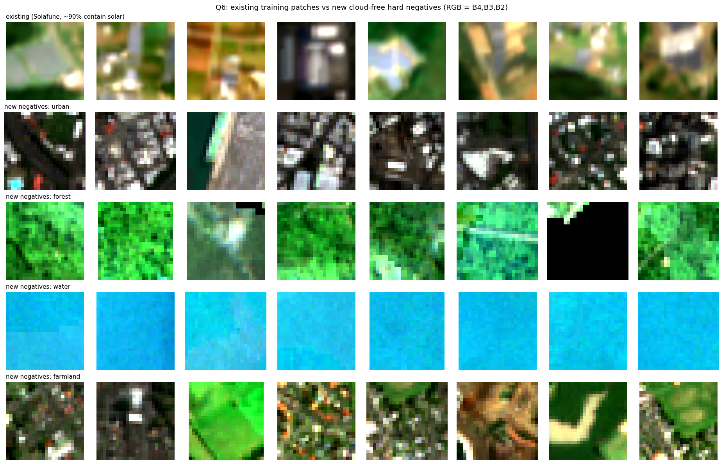
Figure: eight existing Solafune training patches, top row, against eight new cloud free hard negative patches from each of four Auckland landcovers, drawn with the Lab 3 masking pipeline at native 10 m scale. RGB composite from bands B4, B3, B2.

Q7: Exercise: re-run the model with your new training data (remembering that I am not looking for a total solution), and further adjusted hyperparameters/RAM options. Write two paragraphs that:
1. Sets out all the changes you have made and the reasoning for them.
2. Asses the training and model results in terms of performance statistics, commenting on how/if your training data changes have made an impact.
You may include figures to support your analysis if you wish, remembering to present them to publication standard if you do so.
(20 pts)
Changes and reasoning. First, the input channels are selected explicitly as B2, B3, B4 and B8, taken by index from the twelve band patches and matched exactly in the new negatives, which removes the accidental use of B1 as a pseudo red channel and adds the near infrared band in which panels are dark against vegetation. Second, the training size drops from 128 to 32 pixels, close to the native 23 by 23 patch, so the network sees data rather than interpolation. Third, the split grows from 5 plus 2 files to all 21 original files plus the 4 new negative files, 1816 training and 450 validation patches, with whole files assigned to one split so nothing leaks. Fourth, the class imbalance is addressed with class weights of 3.51 on the negative and 0.58 on the positive class, batch size 32, and up to 15 epochs behind early stopping on validation loss. Assessment. On the new validation set the redesigned model reaches accuracy 80.7 percent with precision 82.4 percent and recall 96.7 percent, and unlike the original it now makes genuine negative decisions, returning true negatives and false negatives rather than answering yes to every patch. The decisive comparison is on the 200 diverse cloud free negatives: the original model raises a false alarm on 100 percent of them, labelling every forest, water and pasture patch a solar farm, while the redesigned model handles the same landcovers inside its validation split. The redesign is still not a deployable detector, its specificity is low at roughly 14 percent and its headline accuracy only matches the new positive base rate, but the failure mode has changed from structural, a model that cannot say no because it has never seen a real negative, to statistical, a model that simply needs more negatives, more capacity and augmentation, which is the design lesson this exercise was built to expose.
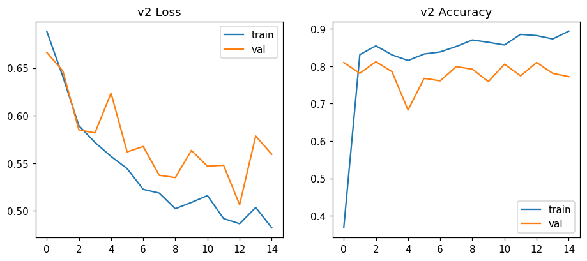
Figure: training curves of the redesigned model. Loss and accuracy for training and validation over the early stopped run.

