Answer Proforma
(1) Zoom in to a cloudy region and look at the S2 image, 'clouds' layer, 'dark pixels', and the 'shadows' layers. Write a short paragraph that discusses:
- The performance of each masking element. Are they perfect or getting confused? What is causing the confusion?
- How do the three elements work together to define pixels that are not clear? I am looking for you to show an understanding of both the algorithm you have just applied and the underlying spectral sensing principles.
(10 pts)
The clouds layer from s2cloudless captures the bright cumulus cores very reliably: every dense white cloud visible in the RGB mosaic, over the harbour and over the suburbs, is flagged. It becomes confused at cloud margins and over thin semi transparent cloud, where the pixel probability falls below the 50 percent threshold, so small wispy clouds and the outer halo of larger clouds are missed. The dark pixels layer is by far the noisiest element. It is a simple radiometric threshold, B8 reflectance below 0.15 excluding water, so it fires on everything that is dark at 842 nm: asphalt roads, shaded south facing streets, dense vegetation and the tidal fringe, none of which are cloud shadow. On its own it would be useless as a shadow detector. The shadows layer shows why the chain still works: a dark pixel is only accepted as shadow where it also falls inside the cloud projection, computed by dragging every detected cloud along the shadow azimuth of 90 degrees minus the mean solar azimuth for up to CLD PRJ DIST km. In my scene the surviving shadow patches sit consistently on the southern to south western side of their parent clouds, exactly where a summer sun positioned to the north must cast them, and nearly all of the urban false dark pixels are rejected because no cloud lies up sun of them. The three elements therefore act as independent physical tests that multiply together: a learned spectral brightness classifier proposes cloud, a NIR darkness test proposes candidate shadows, and solar geometry arbitrates which candidates are physically possible. Their union is then cleaned morphologically, focalMin removes isolated speckle and focalMax dilates by the buffer distance, giving a final cloudmask that covers each cloud together with its displaced shadow.
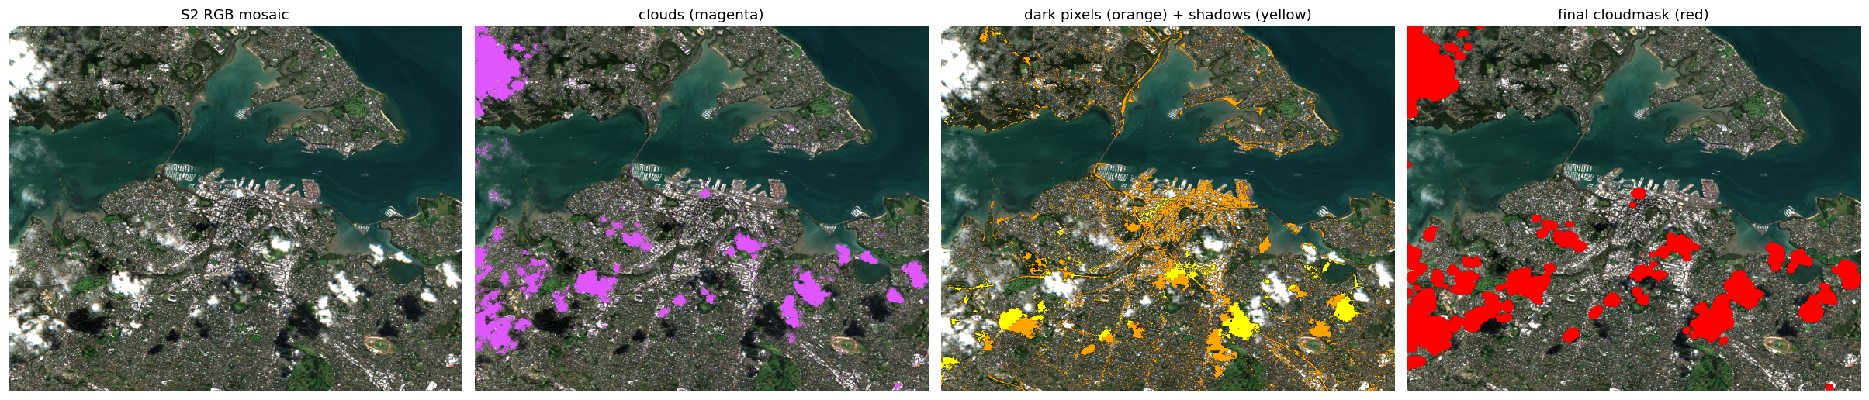
Figure 1: the component layers over the evaluation mosaic. From left: RGB, s2cloudless clouds in magenta, dark pixels in orange with accepted shadows in yellow, and the final cloudmask in red. Shadows survive only south west of clouds, matching the solar geometry, while the widespread urban dark pixels are rejected.

(2) Exercise: change the above CLD_PRB_THRESH, NIR_DRK_THRESH, CLD_PRJ_DIST, and BUFFER input variables and rerun the previous cells to see how the results change. Present a fgiure that compares between the first version you ran and your final version. State the values you have selected and describe the improvements in performance you have managed to achieve in the figure caption.
(10 pts)
I selected CLD PRB THRESH 40, NIR DRK THRESH 0.18, CLD PRJ DIST 2 and BUFFER 60, against the baseline values of 50, 0.15, 1 and 50. Lowering the probability threshold pulls thin cloud and cumulus edges into the cloud class, raising the NIR darkness threshold admits the brighter penumbral parts of shadows, doubling the projection distance catches shadows displaced further from tall cloud, and the wider buffer swallows the semi transparent halo around every cloud. I first tried a much more aggressive setting of 40, 0.20, 2 and 100, but that pushed the no data fraction of the composite to 3.4 percent, so I stepped back to the values above. In the figure, where I render composite gaps in black so they cannot be confused with white cloud, the improvement is that the milky semi transparent veil that the baseline smears across the Waitakere forest and the north western fringe is replaced either by clean ground, where a clear observation exists somewhere in the stack, or by an explicit gap where one does not. The cost is that the mean masked fraction across the collection rises from 44.6 to 50.8 percent and the no data fraction of the composite rises from 0.48 to 1.28 percent, concentrated over the ranges where orographic cloud sits in every scene of the three month window. I consider this a good trade: for any downstream machine learning an explicit nodata pixel is far less damaging than reflectance that is silently contaminated by cloud.
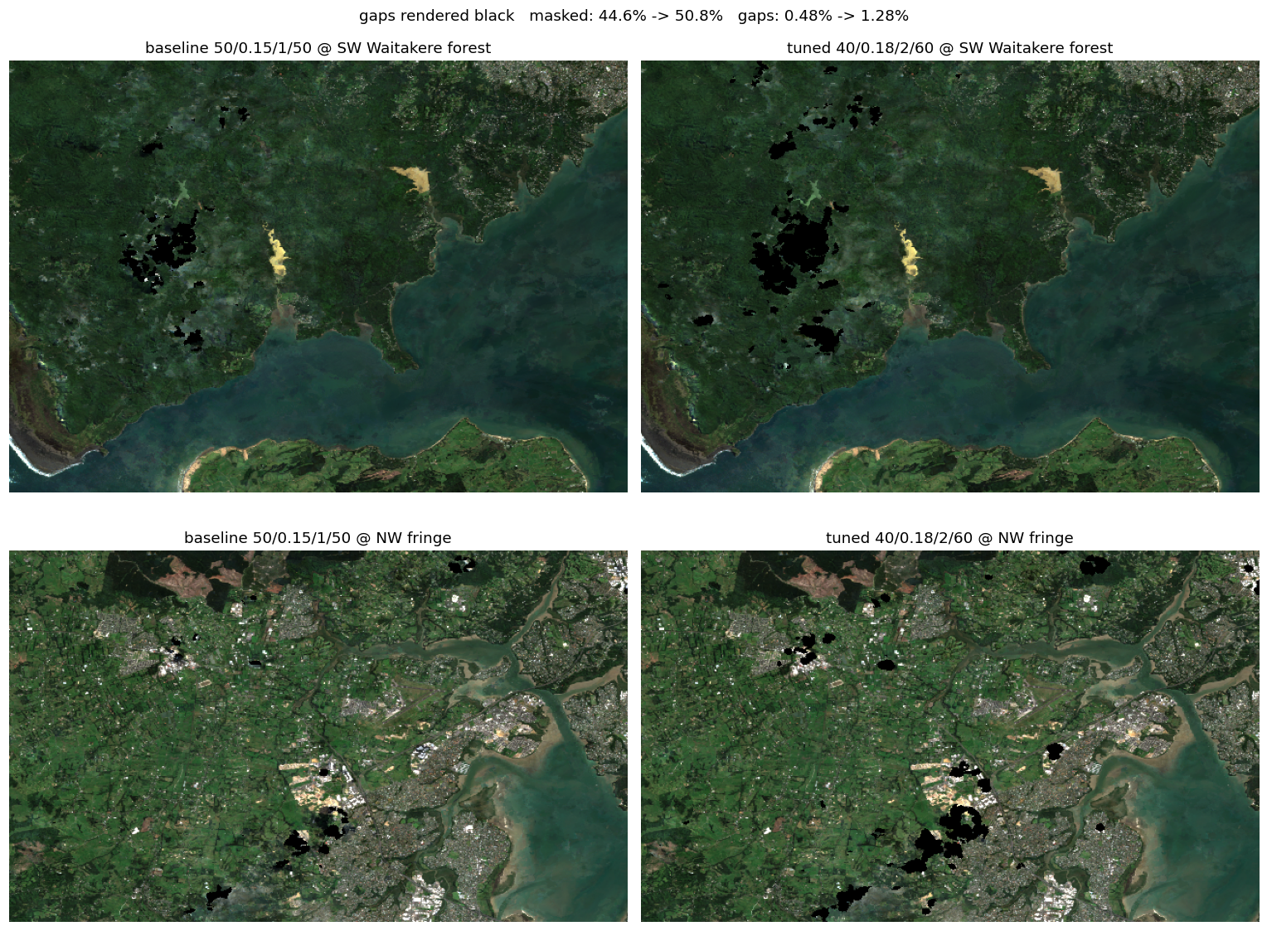
Figure 2: median composites at two problem areas, left the baseline parameters 50, 0.15, 1, 50 and right my final parameters 40, 0.18, 2, 60, with composite gaps rendered black. The semi transparent veil over the south western forest and the north western fringe is removed, at the price of masking 50.8 instead of 44.6 percent of the observations and of explicit gaps rising from 0.48 to 1.28 percent.

(3) This process has managed to avoid masking out the many bright white roofs of Auckland as cloud despite them appearing very similar to cloud in RGB visualization. How has the algorithm achieved this?
(5 pts)
The separation is not made in RGB space at all. s2cloudless is a machine learning classifier trained on a very large body of labelled Sentinel 2 scenes and it sees the full spectral vector of each pixel rather than the three visible bands in which a white roof and a cloud look the same. Outside the visible the two materials diverge. A roof sits at the bottom of the full atmospheric column, so at band B9 at 945 nm its signal is strongly attenuated by column water vapour, while a cloud top rides above much of that vapour and stays bright. Cloud droplets also scatter strongly and smoothly across the whole VNIR and carry a characteristic droplet signature in the SWIR, whereas roofing materials have flatter and drier spectra. The classifier therefore assigns roofs a low cloud probability and the threshold never fires on them. Two further details help: the focalMin erosion removes any residual single pixel false positives, which is exactly the spatial scale of a roof, and a roof can never be corroborated through the shadow branch because there is no matching dark patch displaced from it along the solar azimuth at cloud height.

(4) What do the histograms of cloud detection probability (as judged by s2cloudless) plotted in the three classes we have set here, AND the pair plot of all bands available tell us about our ability to tell cloudy vs non-cloud pixels apart? (5 pts)
The clear and edge populations behave as designed: both pile up at low probability, the clear class most extremely, and the edge class occupies the low to middle range, which is exactly the genuinely ambiguous population we want to hand to the clustering step. The cloud interior class is the surprise: instead of a clean spike near 100 its histogram is small and spread almost flat across the whole axis, with only a modest peak above 95. This happens because the cloudmask that defines the cloud zone is the union of detected cloud and projected shadow, so many pixels labelled cloud are actually shadow pixels whose s2cloudless probability is low, and because the weakened threshold of 30 also admits haze sitting just above the cut. The pair plot carries the same warning into spectral space. The visible bands B2, B3 and B4 show cloud and clear distributions lying nearly on top of each other, with a standardized mean difference of only about 0.15 to 0.05 sigma, partly because the compositing has filled many flagged locations with clear spectra from other dates and partly because the remaining cloudy spectra are thin cloud mixed with ground signal. Real separation survives only where there is a physical reason for it: B9 at 945 nm gives d of about 0.9 sigma because column water vapour darkens every true surface pixel while an elevated cloud top escapes most of that absorption, followed by the NIR and red edge bands B8 and B6 and the SWIR band B11. Statistically this is the textbook requirement of separability in feature space: an unsupervised method like k means can only recover class structure along directions where between class variance is large relative to within class variance, so feature choice decides in advance whether clustering can succeed at all.
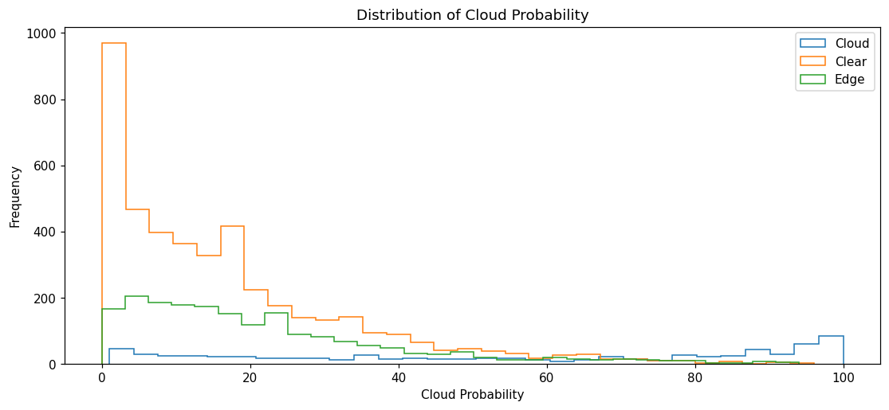

(5) Which bands are the best to use in our K-means clustering approach and why? (5 pts)
The best bands are B9, B6, B8 and B11, in that order, because they carry the largest standardized separation between the cloud and clear training samples, about 0.9, 0.6, 0.6, 0.4 sigma respectively, while the visible bands carry almost none. The physics matches the statistics: B9 sees cloud bright because cloud tops sit above most of the atmospheric water vapour column, the NIR and red edge bands respond to strong droplet scattering against moderate land reflectance, and the SWIR band adds sensitivity that separates cloud from bright dry surfaces. Rerunning the k means step with these bands instead of the default B2, B3 and B4 raises the cluster to class purity on the training samples from 51.8 percent, which is barely better than chance, to 64.9 percent, and the share of edge pixels labelled cloud falls from 78.3 to 58.8 percent, consistent with the default visible bands over calling cloud on bright urban pixels.

(6) Exercise: take all you have learned in this lab and carry out the following improvements:
1. Increase the K-means sampling to be more representative of the whole scene. This means; sample regions for cloud, clear and cloud edge that are not just over downtown Auckland but from across multiple landcover types.
2. Take the model that you have trained here using SciKitLearn and use it to classify edge pixels across a whole satellite image.

Present your results in two figures. The first should show the results of upgrades to pt.1, the second the results of pt.2.
(15 pts)
For the first upgrade I replaced the single 2 km sampling circle over downtown with four sites of different landcover: central Auckland for urban, the Waitakere ranges for forest, the Hauraki gulf for open water and the Karaka pastures for farmland, each sampled within 2.5 km at 10 m scale, and I drew the cloud interior, clear interior and cloud edge zones from the uncleared mosaic so that cloud samples now contain genuine cloud spectra instead of composited ground. The sampling itself is instructive: 839 cloud samples were returned and 84 percent of them come from the forest site, because orographic cloud hangs over the ranges, while the water site contributes none. With genuine cloud spectra every band recovers separability, the recomputed ranking selects B9, B12, B5 and B6, and all nine bands now sit above one sigma. The representative clear class also exposed a model weakness: clear pixels now span very dark water, dark forest, bright suburbs and pasture, a strongly multimodal distribution, and a two cluster k means collapses into one cluster that swallows nearly everything, with training purity falling to 25.6 percent. I therefore cluster with k equal to 8, label each cluster cloud or clear by majority vote of the training samples inside it, and run ten k means initialisations rather than the single default. The cluster then label model reaches 83.0 percent training purity across all four landcover types. The first figure shows the three sample populations drawn across the four sites.
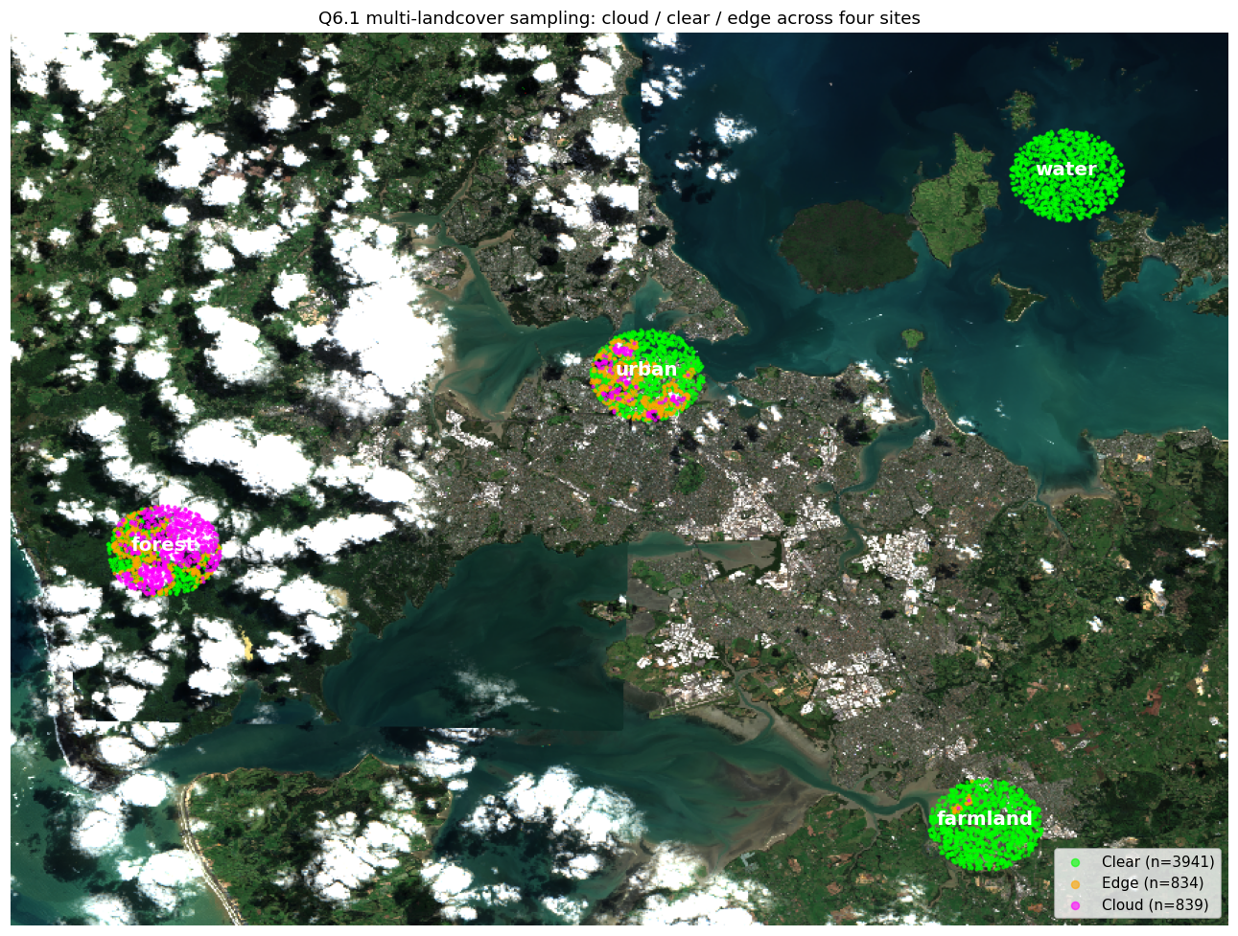
Figure 3: multi landcover sampling for question 6. Cloud samples in magenta, clear in green, edge in orange, drawn around the urban, forest, water and farmland sites across the wider scene. Most cloud samples sit over the forested ranges where orographic cloud persists.
For the second upgrade I moved the trained model into Earth Engine, since a fitted scikit learn object cannot be uploaded. I exported the fitted standardization constants, the per band means and standard deviations, together with all eight cluster centres and the cluster to class lookup, as Earth Engine constants, standardized the feature bands of the whole mosaic server side, computed the squared euclidean distance from every pixel to each centre, kept a running nearest centre with where operations, and translated the winning centre into its class. This classifies the entire satellite image in one server side operation, labelling 28.3 percent of the scene as cloud, which is plausible for this deliberately weakened stack in which thin haze was admitted as cloud. The second figure compares the raw mosaic, the whole image nearest centre classification and the s2cloudless mask: the k means layer recovers the cloud bodies and the bright edges that the weakened threshold mask missed, while remaining mostly quiet over the open gulf, the eastern suburbs and the farmland, with some residual confusion over bright estuary sediment that shares the high brightness of thin cloud.
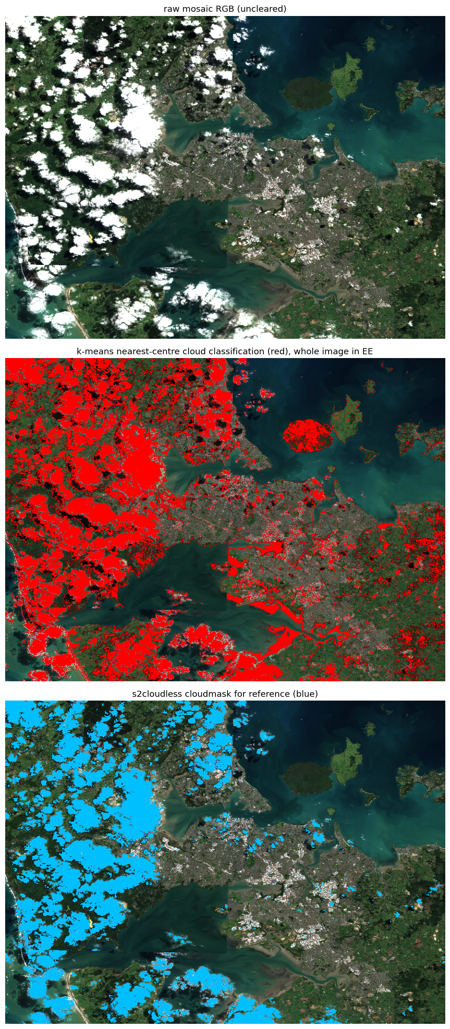
Figure 4: whole image classification for question 6. Top: uncleared mosaic. Middle: per pixel nearest centre k means classification computed inside Earth Engine with eight centres, cloud in red. Bottom: the s2cloudless cloudmask in blue for reference.

To get you started on item 2, this might be how you plan out your workflow given that you cannot upload a python ML model directly to Earth Engine:
- Extract cluster centres from Python k-means.
- Pass centres as constants into EE.
- Write a per-pixel classification function assigning nearest cluster centre.
- Apply this function to edge pixels or the whole image as needed.

