Gemini Image Prompts: Radiation Lessons
21 images for the Lesson 1 and Lesson 2 slides. Each one replaces an IMAGE placeholder box on a slide.

How to use this
- Open a new Gemini chat. Paste the style block below first.
- Then paste one prompt at a time. Ask for the ratio listed (16:9 for cards, 1:1 for the rest).
- If Gemini adds any words or letters, reply: "Redo this with no text, no letters, and no numbers."
- Check the "Check" note for each image. Gemini often gets science details wrong, so look before you use it.
- Save each image as PNG with the filename listed, then drop it onto the slide in place of the placeholder.

Style block (paste this first)
Flat vector illustration for a 6th grade science class. Friendly and clean, with bold dark-navy outlines (#14213D) and simple shapes. Limited palette: navy #14213D, sun amber #F5A524, sky blue #3A86FF, red #D7263D, teal #2EC4B6, with a plain white or very light gray-blue (#EEF2F9) background. No text, no letters, no numbers, no logos, no brand names, and no real people or human faces. Scientifically accurate cartoon details.
Tip: If a later image looks off-style, paste the style block again and say "Keep the same style as before."

Murphy (add him to the pictures)
Murphy is a small shih tzu. He has a fluffy cream and white coat with light tan and gray patches, dark (black or gray) ear tips, round dark eyes, a black nose, a short muzzle, and a tiny underbite.
- Upload the three reference photos below to Gemini in the same message as each prompt.
- Add this line to the prompt: "Draw the small dog to look like Murphy, the shih tzu in the reference photos, but in the same flat cartoon style. Keep him small so the science stays clear."
- Each image below has a Murphy line. Add it to the prompt, or skip it if you want that picture without him.
- If the dog looks like the wrong breed, say: "Make the dog a small shih tzu with a fluffy cream and white coat, short muzzle, and dark ear tips, like the photos."
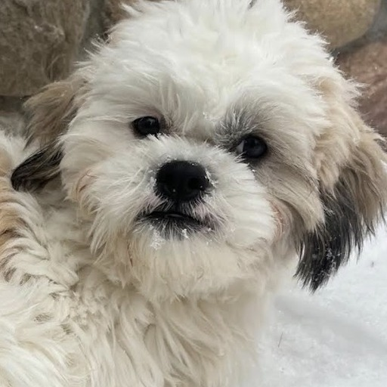 | 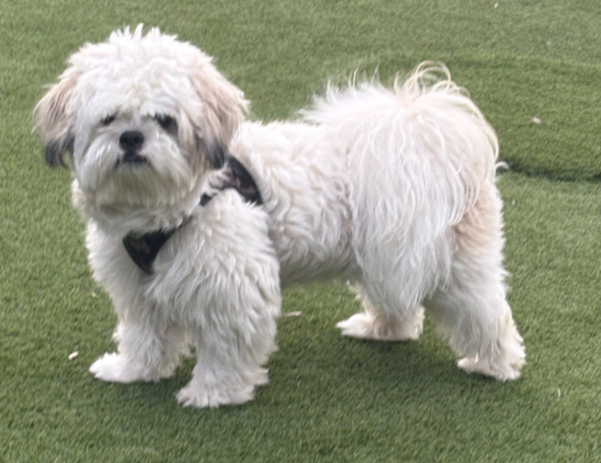 | 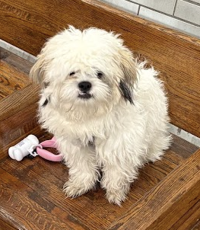
Reference photos (also saved in the murphy-reference folder): face, standing, sitting.

Lesson 1 images

L1-01: Slide 4, Conduction card
File: L1_01_conduction.png Ratio: 16:9
Prompt: A hot metal frying pan on a stove. A cartoon hand with no face is pulling away from the pan handle. Small red wavy heat lines rise from the handle. A small magnified circle shows red fast-moving particles bumping into blue slower particles along the handle.
Murphy: Murphy sits near the stove at a safe distance, watching the hand and the pan.
Check: Particles should bump into each other. Do not draw glowing "energy" separate from the particles.

L1-02: Slide 4, Convection card
File: L1_02_convection.png Ratio: 16:9
Prompt: A pot of water on a stove seen from the side as a cross-section. A small flame under the pot. Red arrows rise in the center of the water and blue arrows sink along the sides, forming two circular loops. Small dots as particles: red near the bottom, blue near the top.
Murphy: Murphy sits next to the pot, looking up at the rising arrows.
Check: Hot goes up in the middle, cool goes down on the sides.

L1-03: Slide 4, Radiation card
File: L1_03_radiation_campfire.png Ratio: 16:9
Prompt: A cozy campfire at night. A cartoon child silhouette with no face stands a few steps away holding hands toward the fire. Wavy orange lines travel through the air from the fire to the hands. No smoke.
Murphy: Murphy sits next to the child a few steps from the fire, facing it, warm and happy.
Check: The hands should NOT touch the fire. The waves travel across the gap.

L1-04: Slide 6, Radiation
File: L1_04_thermal_person.png Ratio: 1:1
Prompt: A false-color thermal camera view of a simple cartoon person silhouette standing: body in warm yellow, orange, and red; background and edges in cool purple and blue. A rounded handheld thermal camera frame around it. No face details.
Murphy: Murphy stands next to the person as a thermal image: warm yellow-orange body, cool blue nose and ear tips.
Check: Warm = yellow/red, cool = blue/purple. This matches the red/blue style in the deck.

L1-05: Slide 9, Back to the fire in space
File: L1_05_fire_in_space.png Ratio: 1:1
Prompt: A small campfire floating in outer space among stars. A cartoon astronaut with a reflective visor and no visible face floats a few meters away, hands out. Warm orange wavy lines travel through empty black space from the fire to the astronaut. A small Earth in the background.
Murphy: Murphy floats next to the astronaut in a small clear space helmet, looking at the fire.
Check: There should be no particles or air between the fire and the astronaut. Radiation crosses empty space.

L1-06: Slide 10, Light is radiation
File: L1_06_prism.png Ratio: 1:1
Prompt: A triangular glass prism. A single white beam enters from the left and spreads into a rainbow fan on the right in order: red, orange, yellow, green, blue, violet. Red is bent the least (top of the fan) and violet is bent the most (bottom of the fan).
Murphy: Murphy sits in front of the rainbow with his head tilted.
Check: Check the color order: red on top, violet on the bottom.

L1-07: Slide 11, Absorbed card
File: L1_07_absorbed_asphalt.png Ratio: 16:9
Prompt: A black asphalt road on a hot sunny day. Heat shimmer wavy lines rise from it. Yellow sun-ray arrows end at the road surface as if soaked in. A small plain thermometer with a full red bulb and tall red line.
Murphy: Murphy stands on grass at the edge of the road, watching the heat shimmer.
Check: Arrows should stop at the road, not bounce.

L1-08: Slide 11, Reflected card
File: L1_08_reflected_mirror.png Ratio: 16:9
Prompt: A flat mirror. A yellow sunbeam hits the mirror and bounces off at the same angle on the other side. A faint dashed line shows the angle. Simple background.
Murphy: Murphy sits in front of the mirror, and his reflection looks back at him.
Check: Angle in equals angle out.

L1-09: Slide 11, Transmitted card
File: L1_09_transmitted_window.png Ratio: 16:9
Prompt: A clear glass window. A yellow sunbeam passes straight through the glass and makes a bright patch of light on the floor inside. Simple room.
Murphy: Murphy lies in the bright patch of sunlight on the floor.
Check: The beam goes through, not around.

L1-10: Slide 13, Why it looks blue
File: L1_10_blue_shirt_reflect.png Ratio: 1:1
Prompt: A diagram: white sunlight shown as a bundle of red, orange, yellow, green, blue, and violet arrows hits a blue t-shirt. The red, orange, yellow, green, and violet arrows stop and fade into the shirt (absorbed). A bright blue arrow bounces off the shirt toward a cartoon eye.
Murphy: Murphy sits where the eye is, looking at the blue shirt.
Check: Only the blue arrow reflects. The rest are absorbed.

L1-11: Slide 14, Black vs. white shirt
File: L1_11_black_white_shirts.png Ratio: 1:1
Prompt: A clothesline in bright sun with a black t-shirt and a white t-shirt hanging side by side. A big sun with rays above. Red wavy heat lines over the black shirt and none over the white one. Two small thermometers below: the black shirt's is high and red, the white shirt's is low and blue.
Murphy: Murphy lies in the shade under the clothesline.
Check: The black shirt is clearly hotter.

L1-12: Slide 16, Blue sky, red sunset
File: L1_12_sunset.png Ratio: 1:1
Prompt: A calm landscape at sunset with simple dark hills. The sky fades from blue at the top to orange and red near the horizon. A low sun on the horizon.
Murphy: Murphy sits on the hill silhouette, watching the sunset.
Check: Keep it simple. No text.

Lesson 2 images

L2-01: Slide 4, Light is FAST
File: L2_01_light_circles_earth.png Ratio: 1:1
Prompt: The Earth as a globe on a deep navy space background with a few stars. A glowing yellow beam of light races around it in a loop that circles the planet several times, with motion streaks.
Murphy: Murphy floats near the Earth in a small clear space helmet, ears blown back as the light zips past.
Check: About 7.5 loops. A rough number of loops is fine.

L2-02: Slide 13, Radio waves
File: L2_02_radio.png Ratio: 1:1
Prompt: A tall radio broadcast tower with curved gray-blue broadcast arcs spreading outward. A retro tabletop radio and a small rooftop TV antenna on a house on the right, receiving the arcs.
Murphy: Murphy sits next to the retro radio with his head tilted.
Check: Radio is the longest wavelength: use wide, lazy arcs.

L2-03: Slide 14, Microwaves
File: L2_03_microwave.png Ratio: 1:1
Prompt: A cartoon microwave oven with the door open showing a bowl of soup inside with small teal wavy lines passing through it and a little steam. Beside it, a small home Wi-Fi router sending teal arcs.
Murphy: Murphy sits in front of the microwave, waiting for the soup.
Check: The wavy lines are teal to match the spectrum bar in the deck.

L2-04: Slide 15, Infrared
File: L2_04_infrared_hand.png Ratio: 1:1
Prompt: A false-color thermal camera view of a cartoon hand holding a mug. Fingers in warm yellow and orange, the mug glowing red where it is hot. Cool blue and purple background. A handheld thermal camera frame.
Murphy: Murphy's face in the thermal camera: warm yellow-orange face, cool blue nose and ear tips.
Check: Same warm = red, cool = blue idea as L1-04.

L2-05: Slide 16, Visible light
File: L2_05_rainbow.png Ratio: 1:1
Prompt: A bold rainbow arc made of seven flat color bands in order: red, orange, yellow, green, blue, indigo, violet, with a simple white cloud at each end.
Murphy: Murphy sits under the rainbow.
Check: Red on the outside, violet on the inside.

L2-06: Slide 17, Ultraviolet
File: L2_06_uv.png Ratio: 1:1
Prompt: A cartoon sun with purple ultraviolet rays shining on a beach. A plain sunscreen bottle with a blank label and a pair of sunglasses on the sand. In one corner, a glowing violet black-light bulb with a purple glow.
Murphy: Murphy wears sunglasses on the beach.
Check: No text on the sunscreen bottle.

L2-07: Slide 18, X-rays
File: L2_07_xray_tooth.png Ratio: 1:1
Prompt: A friendly cartoon tooth beside a dental X-ray film. The film is a dark navy rectangle showing a white-blue outline of a row of teeth with one small cavity highlighted. No people.
Murphy: Murphy sits beside the tooth X-ray, smiling so his little underbite shows.
Check: No faces on the tooth.

L2-08: Slide 19, Gamma rays
File: L2_08_gamma_sterilize.png Ratio: 1:1
Prompt: Sealed clear packages of medical instruments (scissors, scalpel, syringe) on a conveyor belt passing under a machine that sends very tight purple-white zigzag lines down onto the packages. No people and no warning symbols.
Murphy: Murphy watches from far away, in a tiny hard hat.
Check: Gamma waves are very tight (short wavelength).

L2-09: Slide 21, Energy per wave matters
File: L2_09_energy_scale.png Ratio: 1:1
Prompt: A horizontal row of seven wave icons that get tighter from left to right. The background shifts from calm green on the left through yellow and orange to red on the right. A small calm cloud icon on the left and a small caution triangle with no text on the right.
Murphy: A relaxed Murphy sits on the calm green side.
Check: Loose waves on the left, tight on the right.

Checklist
Done | ID | Where | File
 | L1-01 | Slide 4, Conduction card | L1_01_conduction.png
 | L1-02 | Slide 4, Convection card | L1_02_convection.png
 | L1-03 | Slide 4, Radiation card | L1_03_radiation_campfire.png
 | L1-04 | Slide 6, Radiation | L1_04_thermal_person.png
 | L1-05 | Slide 9, Back to the fire in space | L1_05_fire_in_space.png
 | L1-06 | Slide 10, Light is radiation | L1_06_prism.png
 | L1-07 | Slide 11, Absorbed card | L1_07_absorbed_asphalt.png
 | L1-08 | Slide 11, Reflected card | L1_08_reflected_mirror.png
 | L1-09 | Slide 11, Transmitted card | L1_09_transmitted_window.png
 | L1-10 | Slide 13, Why it looks blue | L1_10_blue_shirt_reflect.png
 | L1-11 | Slide 14, Black vs. white shirt | L1_11_black_white_shirts.png
 | L1-12 | Slide 16, Blue sky, red sunset | L1_12_sunset.png
 | L2-01 | Slide 4, Light is FAST | L2_01_light_circles_earth.png
 | L2-02 | Slide 13, Radio waves | L2_02_radio.png
 | L2-03 | Slide 14, Microwaves | L2_03_microwave.png
 | L2-04 | Slide 15, Infrared | L2_04_infrared_hand.png
 | L2-05 | Slide 16, Visible light | L2_05_rainbow.png
 | L2-06 | Slide 17, Ultraviolet | L2_06_uv.png
 | L2-07 | Slide 18, X-rays | L2_07_xray_tooth.png
 | L2-08 | Slide 19, Gamma rays | L2_08_gamma_sterilize.png
 | L2-09 | Slide 21, Energy per wave matters | L2_09_energy_scale.png
When you have the images, send them back and I can add them to the site too (demo, radiation, light and color, and the EM spectrum stage).

