Lesson 2 Pictures: Gemini Prompts
12 images for the Lesson 2 slides and site pages. Nine go on both the slides and the site. Three (L2-10 to L2-12) are for site pages only.

How to use this
- Open a new Gemini chat. Paste the style block below first.
- Upload the three Murphy photos (face, standing, sitting) in the same message as each prompt, and add the Murphy line shown with each image. Skip his line if you want that picture without him.
- Ask for the ratio listed (16:9 or 1:1).
- If Gemini adds any words or letters, reply: "Redo this with no text, no letters, and no numbers."
- Check the red "Check" note on each image. Gemini sometimes gets science details wrong.
- Save each image as PNG or JPG with the filename listed. Send them to me and I will put them on the right slide and site page.

Style block (paste this first)
Flat vector illustration for a 6th grade science class. Friendly and clean, with bold dark-navy outlines (#14213D) and simple shapes. Limited palette: navy #14213D, sun amber #F5A524, sky blue #3A86FF, red #D7263D, teal #2EC4B6, with a plain white or very light gray-blue (#EEF2F9) background. No text, no letters, no numbers, no logos, no brand names, and no real people or human faces. Scientifically accurate cartoon details.

Murphy
Murphy is a small shih tzu. He has a fluffy cream and white coat with light tan and gray patches, dark (black or gray) ear tips, round dark eyes, a black nose, a short muzzle, and a tiny underbite.
Add this line to each prompt: "Draw the small dog to look like Murphy, the shih tzu in the reference photos, but in the same flat cartoon style. Keep him small so the science stays clear."
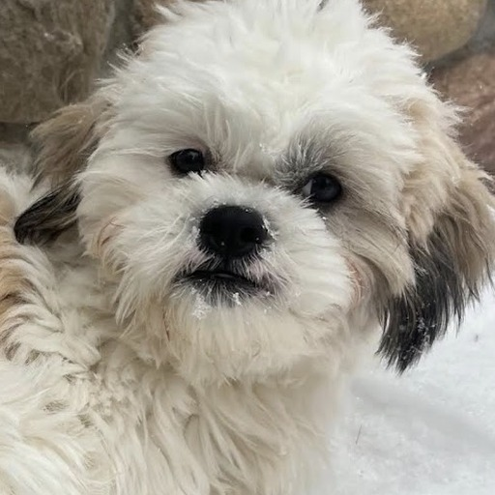 | 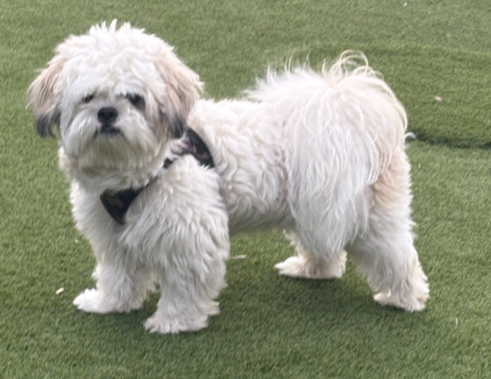 | 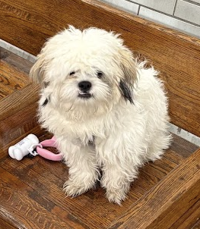
The same three photos are in the murphy-reference folder.

L2-01: Deck slide 4 · Site: Do-now page
File: L2_01_light_circles_earth.png Ratio: 1:1
Prompt: The Earth as a globe on a deep navy space background with a few stars. A glowing yellow beam of light races around it in a loop that circles the planet several times, with motion streaks.
Murphy: Murphy floats near the Earth in a small clear space helmet, ears blown back as the light zips past.
Check: About 7.5 loops. A rough number is fine.

L2-02: Deck slide 13 · Site: EM tour, Radio
File: L2_02_radio.png Ratio: 1:1
Prompt: A tall radio broadcast tower with curved gray-blue broadcast arcs spreading outward. A retro tabletop radio and a small rooftop TV antenna on a house on the right, receiving the arcs.
Murphy: Murphy sits next to the retro radio with his head tilted.
Check: Radio has the longest wavelength: use wide, lazy arcs.

L2-03: Deck slide 14 · Site: EM tour, Microwave
File: L2_03_microwave.png Ratio: 1:1
Prompt: A cartoon microwave oven with the door open showing a bowl of soup inside with small teal wavy lines passing through it and a little steam. Beside it, a small home Wi-Fi router sending teal arcs.
Murphy: Murphy sits in front of the microwave, waiting for the soup.
Check: Wavy lines are teal to match the spectrum bar in the deck.

L2-04: Deck slide 15 · Site: EM tour, Infrared
File: L2_04_infrared_hand.png Ratio: 1:1
Prompt: A false-color thermal camera view of a cartoon hand holding a mug. Fingers in warm yellow and orange, the mug glowing red where it is hot. Cool blue and purple background. A handheld thermal camera frame.
Murphy: Murphy’s face in the thermal camera: warm yellow-orange face, cool blue nose and ear tips.
Check: Warm = red, cool = blue, same idea as the Lesson 1 thermal picture.

L2-05: Deck slide 16 · Site: EM tour, Visible light
File: L2_05_rainbow.png Ratio: 1:1
Prompt: A bold rainbow arc made of seven flat color bands in order: red, orange, yellow, green, blue, indigo, violet, with a simple white cloud at each end.
Murphy: Murphy sits under the rainbow.
Check: Red on the outside, violet on the inside.

L2-06: Deck slide 17 · Site: EM tour, Ultraviolet
File: L2_06_uv.png Ratio: 1:1
Prompt: A cartoon sun with purple ultraviolet rays shining on a beach. A plain sunscreen bottle with a blank label and a pair of sunglasses on the sand. In one corner, a glowing violet black-light bulb with a purple glow.
Murphy: Murphy wears sunglasses on the beach.
Check: No text on the sunscreen bottle.

L2-07: Deck slide 18 · Site: EM tour, X-ray
File: L2_07_xray_tooth.png Ratio: 1:1
Prompt: A friendly cartoon tooth beside a dental X-ray film. The film is a dark navy rectangle showing a white-blue outline of a row of teeth with one small cavity highlighted. No people.
Murphy: Murphy sits beside the tooth X-ray, smiling so his little underbite shows.
Check: No faces on the tooth.

L2-08: Deck slide 19 · Site: EM tour, Gamma
File: L2_08_gamma_sterilize.png Ratio: 1:1
Prompt: Sealed clear packages of medical instruments (scissors, scalpel, syringe) on a conveyor belt passing under a machine that sends very tight purple-white zigzag lines down onto the packages. No people and no warning symbols.
Murphy: Murphy watches from far away, in a tiny hard hat.
Check: Gamma waves are very tight (short wavelength).

L2-09: Deck slide 21 · Site: Waves page (after the explorer)
File: L2_09_energy_scale.png Ratio: 1:1
Prompt: A horizontal row of seven wave icons that get tighter from left to right. The background shifts from calm green on the left through yellow and orange to red on the right. A small calm cloud icon on the left and a small caution triangle with no text on the right.
Murphy: A relaxed Murphy sits on the calm green side.
Check: Loose waves on the left, tight on the right.

L2-10: Site: PhET page
File: L2_10_phet_murphy.png Ratio: 16:9
Prompt: A cartoon tablet showing a long rope-like string with a wave traveling along it and a small wrench-shaped handle at one end. Next to the tablet, a pair of simple ruler icons. Simple light background.
Murphy: Murphy sits in front of the tablet with his head tilted, watching the wave.
Check: The wave on the string should have clear crests and troughs.

L2-11: Site: Game page
File: L2_11_game_murphy.png Ratio: 16:9
Prompt: A cartoon game controller and a small gold trophy on a table, with confetti around them.
Murphy: Murphy sits next to the controller wearing a tiny party hat, with the trophy beside him.
Check: No text on the trophy.

L2-12: Site: Exit ticket page
File: L2_12_exit_murphy.png Ratio: 16:9
Prompt: A cartoon tablet lying flat with a pencil beside it and a small gold star floating above the screen. Simple light background.
Murphy: Murphy sits next to the tablet, wearing a tiny graduation cap, as if he just finished writing.
Check: No text on the tablet screen.

Checklist
Done | ID | Where | File
 | L2-01 | Deck slide 4 · Site: Do-now page | L2_01_light_circles_earth.png
 | L2-02 | Deck slide 13 · Site: EM tour, Radio | L2_02_radio.png
 | L2-03 | Deck slide 14 · Site: EM tour, Microwave | L2_03_microwave.png
 | L2-04 | Deck slide 15 · Site: EM tour, Infrared | L2_04_infrared_hand.png
 | L2-05 | Deck slide 16 · Site: EM tour, Visible light | L2_05_rainbow.png
 | L2-06 | Deck slide 17 · Site: EM tour, Ultraviolet | L2_06_uv.png
 | L2-07 | Deck slide 18 · Site: EM tour, X-ray | L2_07_xray_tooth.png
 | L2-08 | Deck slide 19 · Site: EM tour, Gamma | L2_08_gamma_sterilize.png
 | L2-09 | Deck slide 21 · Site: Waves page (after the explorer) | L2_09_energy_scale.png
 | L2-10 | Site: PhET page | L2_10_phet_murphy.png
 | L2-11 | Site: Game page | L2_11_game_murphy.png
 | L2-12 | Site: Exit ticket page | L2_12_exit_murphy.png

