Lesson 2: Waves and the EM Spectrum
Name: ______________________ Date: ____________ Class: ________

Part A: Parts of a wave
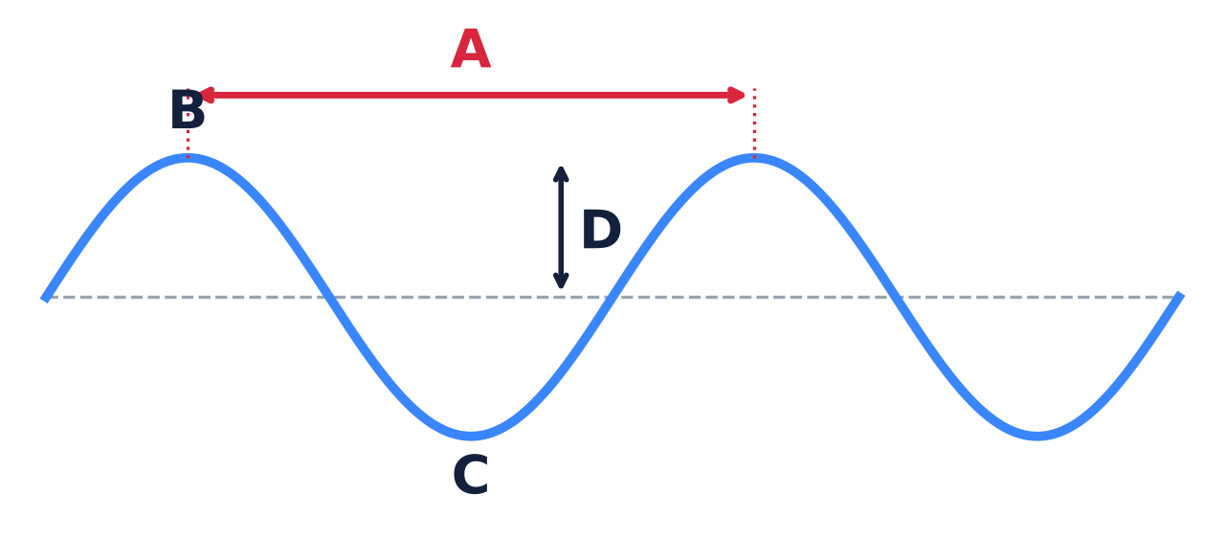
Word bank: crest trough wavelength amplitude
A: ____________________ B: ____________________
C: ____________________ D: ____________________

Part B: Frequency and energy
1. Frequency = how many ____________ pass a point each ____________.
2. The unit for frequency is ____________ (Hz).
3. Circle one: A SHORTER wavelength means a HIGHER / LOWER frequency.
4. Circle one: A SHORTER wavelength means MORE / LESS energy per wave.
5. In empty space, all EM waves travel at about ______________ km/s.

Name: ______________________ Date: ____________ Class: ________

Part C: The EM spectrum, in order
Word bank: Gamma Infrared Microwave Radio Ultraviolet Visible X-ray
Wavelength | Type | One everyday example or use
Longest | 1.
 | 2.
 | 3.
 | 4.
 | 5.
 | 6.
Shortest | 7.

Part D: Which radiation can hurt you?
Circle every type that has enough energy per wave to damage DNA:
Radio Microwave Infrared Visible Ultraviolet X-ray Gamma
Radio waves pass through you all day. Why are they harmless?

Part E: Colors of light
Different colors of light are different wavelengths.
1. The color with the LONGEST wavelength is ______________ (about 700 nm).
2. The color with the SHORTEST wavelength is ______________ (about 400 nm).
3. Circle one: Blue light has a LONGER / SHORTER wavelength than red light.
4. Circle one: Violet light has MORE / LESS energy per wave than red light.

