Name_________________________ Date_____________

Section____________ Exercise Project Methods Worksheet

Partner Name________________________ Due Date: ____________ [ /1pt]
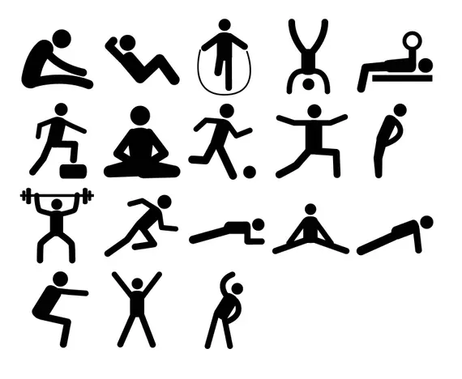
Directions: Use the space below to ideate (brainstorm) things that you may want to test.
Consider the following when making your plan:

- What is my independent variable?
- What is my dependent variable?
- What can I realistically control? (location, time of day, rest, etc)
Experiment Idea 1 of 2

Thing that we can test…

My independent variable is…

My dependent variable is…

A few (minimum 3) controls are…
[ /1pt]
[ /1pt]
[ /1pt]
[ /3pt]

Congrats on your great idea! Now let's do another one!

Experiment Idea 2 of 2

Thing that we can test…

My independent variable is…

My dependent variable is…

A few (minimum 3) controls are…
[ /1pt]
[ /1pt]
[ /1pt]
[ /3pt]

Directions: Now, pick your favorite of these two plans, and answer the questions below about it to consider your experiment.

Which experiment did you pick (circle one)

Experiment 1 Experiment 2 Partner Experiment

If partner, provide a brief description_______________________________________________

- What materials do I need to complete this experiment? [ /2pt]

____________________________________________________________________________

____________________________________________________________________________

____________________________________________________________________________

____________________________________________________________________________

- What are the steps to collect this data? List them out. [ /3pt]

____________________________________________________________________________

____________________________________________________________________________

____________________________________________________________________________

____________________________________________________________________________

____________________________________________________________________________

____________________________________________________________________________

____________________________________________________________________________

____________________________________________________________________________

- Establish your hypothesis AND your null hypothesis (in correct format). [ /4pt]
Hypothesis: If ____________, then ____________, because ____________.
Null hypothesis: There will be no difference in ________ between ________ and ________.

____________________________________________________________________________

- Select an experiment between you and your partner. Explain why this experiment was the best choice for your project. [ /2pt]

____________________________________________________________________________

____________________________________________________________________________

____________________________________________________________________________

____________________________________________________________________________

Total [ /24pt]

