Decoding Deception: An Integrated Cognitive Model of User Response to Online Bank Fraud Attempts

Solveig Bourgeon, Ed Fitzhugh, Jurjen Jansen, and Rick Wash1

Highlights
- Combines Dual Process Theory, Wash’s Theory of Suspicion Formation, and Protection Motivation Theory
- Develops a new model of how individuals detect and respond to email-based fraud
- Tests this model using a survey, and finds much support for the model
- Refines the model based on these tests
- Illustrates how this model can be used both by researchers and practitioners

Corresponding Author
Rick Wash
University of Wisconsin-Madison
1205 University Ave.
Madison, WI 53706
+1 734-730-1188
rwash@wisc.edu

Acknowledgements
The authors thank an unrestricted gift from Google to Rick Wash for providing the funding used for this project.

Author contributions: CRediT
Solveig Bourgeon: Conceptualization (lead); Formal analysis; Methodology; Investigation; Project Administration; Writing — Original draft; Writing — Review and Editing. Ed Fitzhugh: Conceptualization (lead); Methodology; Project Administration; Visualization; Writing — Original Draft; Writing — Review and Editing. Jurjen Jansen: Conceptualization; Methodology; Project Administration; Writing — original draft; Writing — review and editing. Rick Wash: Conceptualization; Data curation; formal analysis (lead) Funding acquisition; Methodology; Project Administration; Software; Visualization; Writing — original draft; Writing — review and editing.

Decoding Deception: An Integrated Cognitive Model of User Response to Online Bank Fraud Attempts

Anonymous Authors

Abstract
In recent years, there has been a significant increase in both the prevalence and complexity of online fraud, with fraudsters often relying on social engineering techniques to convince individuals to voluntarily disclose sensitive information or transfer their money. This study aims to advance our understanding of the psychological dimensions of fraud by integrating three complementary theories grounded in psychology and human behaviour: Dual Process Theory (DPT; System 1 and 2), Wash's Model of Suspicion Formation (MSF), and Protection Motivation Theory (PMT).
We propose a holistic model of decision-making in the context of fraud detection and response. This model accounts for the initial sense-making and suspicion formation a user experiences when receiving fraud content (MSF), explores a user's cognitive shift from an intuitive response of System 1 to the more deliberative response of System 2 (DPT) and, describes how, once shifted to System 2, people respond more systematically to an instance of fraud (PMT).
We derived and tested ten hypotheses through a survey of over 500 U.S. respondents, who were presented with a simulated phishing email modeled on actual bank fraud scenarios. The findings largely support the hypotheses, though a subset were either partially supported or refuted. These findings lead to a refined version of our proposed model. This study provides a theoretical framework for understanding fraud-related decision-making and offers a foundation for future research and the development of more realistic fraud education and awareness initiatives, grounded in human behaviour and psychology.

Keywords
Fraud; Phishing; Dual Process Theory; Protection Motivation Theory

Introduction
In an increasingly interconnected world, more services, including retail, government, and banking, are available online. The perceived convenience benefits of this are tempered by concerns about security and privacy, such as the risk of financial loss and privacy breaches (e.g. NCTV, 2024). Criminals can operate anonymously and remotely, using digital tools to reach large numbers of victims with minimal effort. Digital assets are easily transferable, and the anonymity provided by the internet, enhanced by privacy technologies, makes it difficult to catch offenders. Online crime (i.e., cyber-enabled and cyber-dependent crime) is scalable, allowing criminals to innovate and collaborate while digital resilience struggles to respond (NCTV, 2024). Fraudsters use personal data from leaks and social media to create convincing scams, assisted by generative AI, and the availability of phishing and spoofing tools makes cybercrime easier and cheaper (i.e., cybercrime-as-service).
In 2023, online banking fraud continued to pose a significant financial threat across multiple countries. In the Netherlands, financial losses from online banking fraud amounted to nearly €36 million, with the majority attributed to bank helpdesk fraud—scams in which perpetrators impersonate bank employees to extract sensitive information or convince victims to transfer funds (Dutch Banking Association, 2024). Other contributing forms of fraud included card-not-present transactions, stolen or lost debit cards, and phishing. Similarly, in the United Kingdom, online banking fraud resulted in over £1 billion in losses, primarily driven by authorised push payment (APP) fraud, where victims are deceived into authorising payments to fraudsters (UK Finance, 2024). Other significant losses stemmed from unauthorised transactions, including card-not-present and remote banking fraud. In the United States, the financial impact of fraud surpassed $10 billion in 2023 (Federal Trade Commission, 2024). The most common fraud types included imposter scams, online shopping fraud, and prize or lottery scams, underscoring the growing scale and complexity of online financial crime globally.
The escalation of the issue, combined with the gravity of the consequences (Borwell et al., 2025; Jansen, 2018), underlines the importance of continuing to develop frameworks for understanding and preventing online banking fraud.
Our study aims to identify and evaluate a theory-based model of online banking fraud, with a particular focus on human factors. Previous research has demonstrated that technical measures alone, such as advanced encryption, biometrics and multi-factor authentication, are not capable of mitigating online (banking) fraud (Furnell & Clarke, 2012; Jansen, 2018; Rothrock & Clarke, 2018). Despite significant efforts in other areas, such as public-private partnerships between banks and the police, voluntary codes of conduct, and education and awareness campaigns, the scale of the problem has continued to increase. Because users of technology and their behaviour play a crucial role in combating online banking fraud (Jansen, 2018), this study aims to further explore a psychological approach to the problem.
According to Dadà et al., fraud victimization can be conceptualized as a two stage process of exposure and vulnerability (Dadà et al., 2025). First, potential victims can be exposed to attempts at fraud, and different potential victims might have greater or lesser potential to be exposed. Second, once exposed, some victims are more susceptible to fraud; susceptibility determines whether a person, once exposed, is actually victimized by fraud (Dadà et al., 2025; Fan & Yu, 2022). Dadà et al. review a variety of literature that looks at factors that predict both exposure and vulnerability. For example, older adults are frequently both exposed and susceptible (Dadà et al., 2025; Shao et al., 2019) to fraud, though younger adults seem to be more susceptible to phishing than older adults (Sarno et al., 2023). Financial literacy in particular seems to have a strong, but asymmetric relationship with fraud victimization. This is a U-shaped relationship; fraudsters tend to target and victimize both individuals with low financial literacy and with high levels of financial literacy more than individuals in the middle (Du & Chen, 2023; Yu et al., 2023). This relationship holds both for exposure and for susceptibility.
Most literature in this area considers both exposure and susceptibility to be innate properties of individuals, and treats the process by which people become victims as opaque. Our work, by contrast, focuses on the process that individuals use to detect fraud attempts, or instead make choices that lead to victimization. Dadà et al. refer to this as "Person-Task Fit", or the alignment of characteristics of a decision-maker with the demands of the task (identifying phishing) (Dadà et al., 2025; Finucane & Lees, 2005). This process-focused research is focused specifically on the susceptibility stage (we do not contribute anything about exposure) and helps to shed light on why some people may be more susceptible than others.
A substantial cohort of the professional cybersecurity field still consider humans to be the weakest link (Dupont et al., 2023; Sasse et al., 2001; Zimmermann & Renaud, 2019). Zimmerman and Renaud (2019) introduced an innovative approach to digital resilience whereby humans are no longer seen as the weakest link (human-as-problem), but as a crucial factor (Jansen, 2018) contributing to the strengthening of digital resilience (human-as-solution). According to Zimmermann and Renaud (2019), the core problem of cybersecurity does not lie in human actions, but in the complexity and hyper-connectedness of the digital environment in which modern life is embedded. In a follow-up article, Zimmermann et al. (2024) emphasized that we should view end users as ‘partners’ in cyber security. In this paper we view end users as a component of the solution to overcoming fraud, rather than the problem itself (Jansen, 2018; Spithoven et al., 2024; Zimmermann & Renaud, 2019), and we argue there is value in integrated approaches that build a robust defense against fraud.
Considering end users of online services as “partners” to tackle the problem of cyber security necessitates the development of effective education and awareness campaigns to empower people to accurately identify, avoid and report fraud attempts. Traditional methods of “warnings” and “broadcasting facts” have shown limited efficacy in changing users’ behaviour. Prümmer et al. (2025) conducted a meta-analysis that drew from a systematic review of the existing literature, supplemented by an updated search, to evaluate the general effectiveness of cybersecurity training programs. Their findings indicate that such training tends to positively influence end users, especially in terms of behavioural predictors like knowledge and attitudes. However, when examining actual behavioural change, studies consistently fail to show comparable improvements, highlighting a significant shortcoming in current training strategies when it comes to modifying real-world behaviour.
Given the persistently high levels of fraud and online crime, it is evident that current measures are inadequate (Cross & Kelly, 2016; Herley, 2009; Stewart & Lacey, 2012). Fraudsters exploit psychological principles to deceive individuals, making it essential to employ similar principles for protective purposes (e.g. Jansen, 2018). Over the past decade, practitioners in behavioural economics and behavioural science have successfully applied nuanced models of human decision-making across various domains, including public policy, government services, and business (Hallsworth, 2023). These approaches have yielded significant impacts by moving beyond simplistic assumptions of what is required to change behaviour, and we believe that applying similarly realistic models of decision-making models to fraud prevention can guide education and awareness practitioners in government and financial institutions towards more effective interventions.

Related Literature

In this section, we present an overview of three models of human decision-making that we believe explain how people detect online bank fraud.

Systems 1 and 2
The first theoretical foundation for our study is a core idea in recent applied behavioural sciences; a dichotomy between a slow, deliberative, reflective style of decision making, and a faster, automatic, reflexive style. The idea of multiple systems of decision making is ancient in origin and emerges in multiple accounts in both psychological and philosophical literatures (Evans & Stanovich, 2013; Kahneman, 2011; Stanovich & West, 2000).

In the domain of information systems security (and associated strategies to guide technology users towards safer behaviours) it is easy to assume technology users are highly engaged rational actors primarily driven by System 2 style of decision making, who are making rational calculus of the costs, benefits, rewards and threats of every interaction. Kahneman (2011) describes how people frequently operate on a low effort System 1, which runs automatically based on a set of impressions, intuitions and cognitive biases. This can be effective in many tasks, with no need for the more effortful and deliberative System 2 to be invoked - System 2 endorses the System 1 perspective without modification. However, when System 1 runs into problems, it may invoke the more effortful and deliberative System 2: “System 2 is activated when an event is detected that violates the model of the world that System 1 maintains” (Kahneman, 2011, p. 24).

Research in recent years has built on earlier DPT, for example to illuminate the conditions under which individuals switch from System 1 to System 2 (Pennycook et al., 2015), and addressing conceptual difficulties in explaining the switch between the two systems (De Neys, 2023).

Pennycook et al. (2015) have proposed a three-stage model to explain the shift between System 1 and System 2. In stage 1, multiple intuitive responses can be activated in System 1 by a particular situation or problem. In stage 2, System 1 assesses whether these intuitive responses conflict with each other. In stage 3, if conflict is detected, this causes System 2 analytic thinking to be invoked, either to rationalise the intuitive answer, or override it with a more reasoned response.

There is limited research on the importance and influence of DPT on information security or fraud, although some papers have raised the distinction (e.g. Dennis & Minas, 2018). A DPT lens may help inform a realistic model of decision making in the domain of bank fraud prevention, which could naturally lead to more effective interventions to support protective behaviours.

We also see the System 1 / System 2 distinction as a framework to integrate two distinct strands of research - mental models / suspicion formation (Wash, 2020) and protection motivation theory (Rogers, 1975). Research suggests that both mental models and Protection Motivation Theory have explanatory power, and potentially aim to describe different aspects of the decision-making process. An integration of these two strands may lead to a more cohesive account of how people initially notice - then decide how to respond to - the threat of a fraud. As far as we are aware, there have been no previous attempts to consolidate suspicion formation, protection motivation and DPT.

Wash’s Model of Suspicion Formation
In studying how IT experts detect fraudulent phishing emails, Wash (2020) developed a theory to explain how people become suspicious of fraudulent communications. He identified that people generally go through three stages when facing fraud. When people first receive a communication, they tend to take it at face value and treat everything contained in it as correct and valid. In doing so, they try to understand the communication by integrating it with what they know about their situation and life. In the second stage, the person becomes “suspicious” of the communication. Wash defines suspicion as holding two competing ideas simultaneously: that the communication is valid and is what it says it is, and that the communication is fraudulent and cannot be trusted. In this second stage, the person is not sure which is true, and usually has an explicit goal of investigating and trying to determine which is accurate. In the third stage, the person has resolved this ambiguity and decided whether the communication is fraudulent or not, and then must decide how to proceed.

Wash (2020) identifies that the critical incident in this model is the transition from the first stage to the second stage, which he calls the process of “becoming suspicious” of the communication. In his theory, people - even the IT security experts he studied - naturally assume that a communication is valid and trustworthy when they receive it. The process of becoming suspicious, then, is the recognition that there is a potential alternative explanation for the communication. Becoming suspicious is not as simple as not believing the communication; instead, it is identifying a possible alternative explanation that the communication is an intentionally fraudulent communication created by someone intending to defraud.

In order to become suspicious, Wash claims that people need two important things to happen. First, in understanding the communication, the person needs to identify “discrepancies”: aspects of the communication that do not quite make sense. Often these discrepancies are ways that the communication is different from what is typical in similar communications. Discrepancies provide the clues that the communication might not be trustworthy, but alone are not enough to become suspicious. The second step is a trigger: something in the communication (or in the person’s life) needs to trigger the person to think about fraudulent communications. The trigger causes the person to identify an alternative explanation for the discrepancies. The discrepancies signal that something is wrong, and create a need for an alternative explanation; then the trigger leads the person to identify fraud as a possible alternative explanation.

The process that Wash describes could be considered to be aligned with the three-stage model of Dual Process Theory (Pennycook et al., 2015). The initial response of holding two competing ideas simultaneously is aligned with Stage 1 and Stage 2 of the three stage DPT model: multiple System 1 intuitive responses have been activated by the communication, the individual is processing multiple competing explanations simultaneously, and a conflict between these potential explanations has been detected. The competing responses - that the communication is legitimate, or that it is fraudulent - are System 1 outputs, with the fraud-recognition intuition arising from automatised prior experience with fraud or with typicality violations (De Neys, 2023). It is the similarity of activation strength between these competing intuitions that causes System 2 activation (De Neys, 2023). The second stage of Wash’s model aligns with Stage 3 of the three stage DPT model - System 2 analytic thinking has been invoked, with the explicit goal of investigating and trying to determine which of the possible explanations (is the message fraud, or is it not fraud) is correct.

Furthermore, Wash highlights that there are at least three different types of literacy (what he calls “expertise”) that are relevant to different parts of the detection process. First, there is email literacy, which involves knowing what emails like the one received typically look like. In our case, having experience receiving emails from banks in general, and the victim’s bank in general, and recognizing what those emails look like is critical for recognizing discrepancies or deviations from what is typical. In the banking context we study here, this is very similar to the financial literacy discussed by Jansen (2018).

Second, there is scam literacy, which involves recognizing that email-based scams exist and knowing what those typically look like. Scam literacy is not useful in Wash’s first stage (of recognizing discrepancies), but it is essential for the second stage where the potential victim identifies an alternative understanding of the email. This identification can only happen if they recognize some property of the email (a “trigger” in Wash’s terminology) that reminds them of scams. This is a related to information literacy and digital literacy (Dadà et al., 2025), but more specific about a specific piece of that literacy that is relevant.

Third, Wash discussed how technical literacy was used by the technical experts he studied, but that literacy was only used after the email was identified as potentially a scam, and was used to investigate the email and be sure it actually is a scam. In follow-up work, Wash found that people without technical expertise were able to do accomplish this through other means (usually through social support) (Wash et al., 2021).

Protection Motivation Theory
The third theoretical framework used for this study is Protection Motivation Theory, henceforth PMT (Maddux & Rogers, 1983; Rogers, 1975), a theory originally developed to study disease prevention and health promotion (Floyd et al., 2000). PMT provides opportunities to study end-users’ motivation to perform precautionary online behaviour and can be applied to the domain of cybersecurity in general (e.g. Boehmer et al., 2015; De Kimpe et al., 2022; Martens et al., 2019) and more specifically to online banking (Jansen & van Schaik, 2017, 2019).

Protection motivation is initiated by two appraisal processes: threat appraisal and coping appraisal. Firstly, a person evaluates the vulnerability to a threat occurring, and the severity of this threat. The second process evaluates components of a fear appeal that relate to a recommended strategy to prevent threats or to minimize their impact, i.e., an efficacy appeal. This relates to a person’s evaluation of the perceived effectiveness of a response (i.e., response efficacy), the perceived ability of oneself to perform a response (i.e., self-efficacy) and the perceived barriers in performing a response (i.e., response costs) (Milne et al., 2000). These two evaluations result in the intention to engage in safe behaviour, which can have a direct influence on actual behaviour. Note that intentions do not necessarily lead to the intended behaviour, a tendency discussed in considerable research into the intention-behaviour gap (Sheeran, 2002).

Regarding threat appraisal, the literature shows varying findings on the influence of perceived vulnerability on the intention to engage in safe online behaviour. Rogers (1975) originally suggested a positive influence, and De Kimpe et al. (2022) found a similar relationship. However, some studies report non-significant or negative influences of perceived vulnerability (Jansen, 2018; Martens et al., 2019; Tsai et al., 2016). For perceived severity, the findings are also mixed. Some studies suggest a positive influence (Jansen, 2018; Martens et al., 2019; Warkentin et al., 2016) while others report non-significant or even negative influences (Fisher, 2024; Thompson et al., 2017; Verkijika, 2018).

Regarding coping appraisal, the literature suggests that self-efficacy and response efficacy are key predictors of the intention to engage in online safe behaviour (Arachchilage & Love, 2014; Crossler & Bélanger, 2014; De Kimpe et al., 2022; Fisher, 2024). The literature presents mixed findings on the effects of response costs on the motivation for online safe behaviour. Gurung et al. (2009) suggest that response costs do not significantly influence the intention to engage in safe online behaviour, as many free measures are available. Other studies also report non-significant relationships (Fisher, 2024).

The three-stage model (Pennycook et al., 2015) describes two classes of System 2 processes that result from conflict detection – rationalisation of the intuitive response, or decoupling. They describe decoupling as additional cognitive processing that would be required to override an initial intuitive response. Our model proposes PMT as a nuanced and detailed description of a decoupling process that is specific to a fear or threat scenario, such as potential fraud.

Towards a Model of Human Fraud Prevention

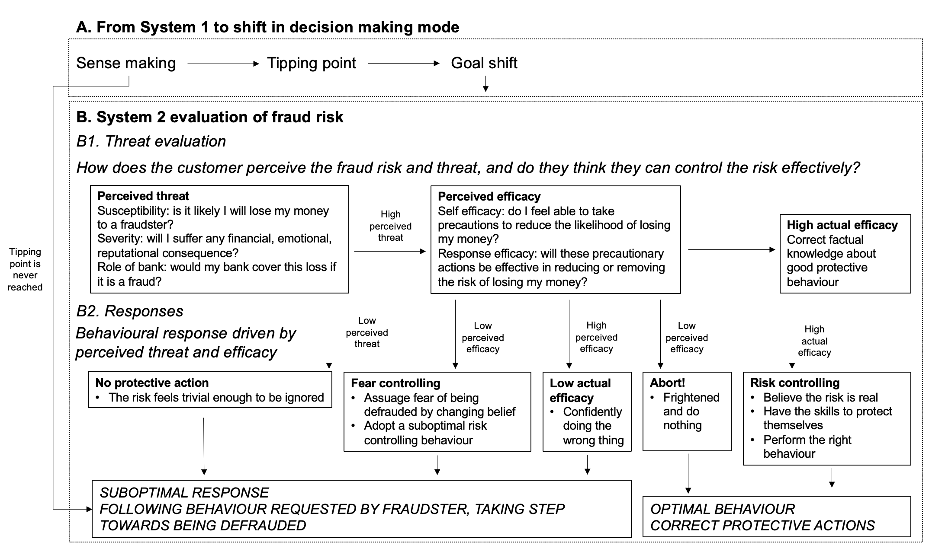
Figure 1: Integrated model of how humans detect and respond to fraudulent communications
We believe that Wash’s model of Suspicion Formation, and PMT, both explain key aspects of decision making in relation to security and fraud. Wash’s model aims to illuminate the conditions under which an initial contact or message represents some risk or locus of threat to the recipient. PMT offers a way to understand end-users’ motivation to perform precautionary behaviour, having already identified the situation as offering a non-trivial risk of potential threat.

Neither theory alone offers an account which is able to explain both how an initial threat was sensed, and the evaluation process that is subsequently followed, leading to a behavioural outcome. We propose that System 1 and System 2 offer an explanatory layer, potentially bridging the Wash model and PMT in a way that enhances the prediction of both observed and reported patterns of behaviour.

We conceptualize fraud response as a sequential process and argue that each theory explains a different stage within that process. Accordingly, our contribution extends beyond the mere combination of existing theories. We integrate Suspicion Formation, DPT, and PMT into a unified fraud-response framework in which threats are first identified, subsequently evaluated, and ultimately acted upon. This theoretical integration offers a more complete explanation of how end users detect, assess, and respond to fraudulent communications, thereby advancing current fraud and security research beyond accounts based on any single theoretical perspective.

Stimuli in the context trigger an automatic, and pre-conscious assessment of the similarity of this situation to already-held mental models of fraud or security (this may be done by category-based processing (Fiske & Neuberg, 1990)). In different situations, where System 1 detects no similarity between the experienced situation and the individual’s available mental model for what would constitute a fraud or security risk in that kind of situation, no competing intuitive responses are generated, therefore conscious System 2 evaluation is not invoked, and the individual being guided by their System 1 autopilot may passively perform a natural or habitual behaviour (such as clicking on a link in an email). This part of the process is explained by Wash’s model.

However, at some non or pre-conscious level, if System 1 detects similarity between the situation, and that individual’s mental model of fraud, this may be sufficient to generate the competing intuitions that result in System 2 become engaged. We might call this a “tipping point” - a detected event that violates the model of the world that System 1 maintains - at which time the individual first consciously recognises a potential threat – causing them to enter “problem detection mode”, where they actively evaluate the situation against their own knowledge, understanding of fraud threat and impact or capacity to deal with the situation.

Once this deliberative and considered System 2 has been invoked, PMT offers an account of the factors an individual may weigh up to create a risk calculus and decide how to respond.

Hypotheses
We combined Wash’s model of fraud detection, Jansen’s PMT-based model of bank fraud, and DPT, to create a theoretical model of how bank consumers might detect fraud (Figure 1). We identified 10 hypotheses that can be used to test this model; each hypothesis tests one step of the model.

Our model suggests that at the initial moment consumers receive a fraudulent communication (e.g., a phishing email), the initial stage is sense-making, which involves noticing issues with that communication (H1). This is a process initially driven by System 1.

They may reach a tipping point, at which point they become suspicious of the email (H3). If they do not reach that tipping point, then they may comply with the instructions or demand of the message, which includes taking steps toward fraud (H2).

Once they have reached the tipping point, this invokes a System 2 process, shifting their goal to investigating the email (H4) and reviewing or deleting the email (H5). In this investigation, they start by evaluating the severity of the threat. If they do not think the threat is severe, then they are more likely to do what the email asks (H6). If they do think the threat is a problem, then they evaluate whether they can do something about this threat (self-efficacy). If they feel like they do not know how to respond to this threat, they are likely to either just do what the email asks (H7) or abort and do nothing about the email (H8). If they do feel like they know what to do, and are right about that, then they are safe (H10), but if they are wrong, they may confidently take unsafe actions (H9).

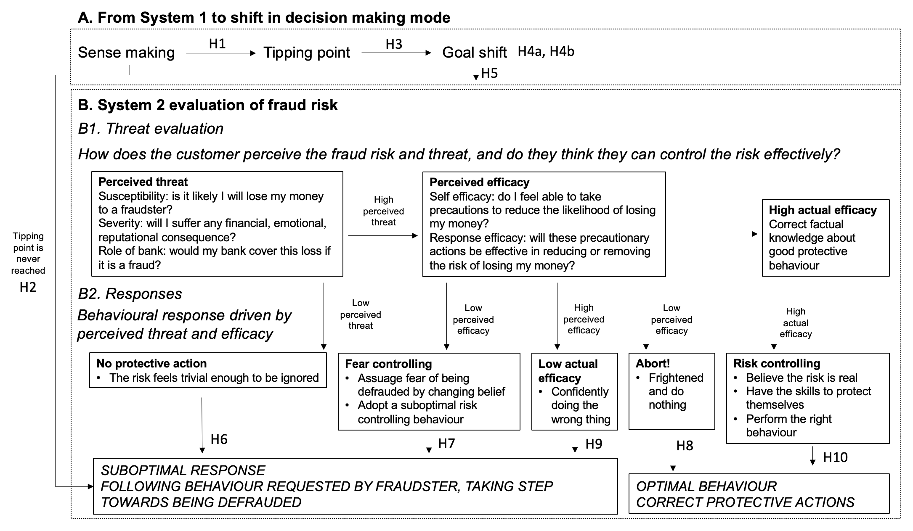
Figure 2: Integrated model with our hypotheses labeled

Methodology

To test these hypotheses, we conducted a survey at the beginning of which we presented survey participants with a screenshotted example of a typical fraudulent email, which purported to be from that participant’s bank, before asking them a number of questions about what they were thinking as they read it and the mental process they followed. The full questionnaire can be found at Appendix A.

We recruited over 500 respondents from the United States to review this email and answer questions about their thoughts as they read it. Before filling out the survey, participants were informed about the purpose of the study, the voluntary nature of their participation, the anonymity of their responses, and the intended use of the collected data through an informed consent procedure.

Prior to distributing the main questionnaire, a pretest was conducted to evaluate the clarity, reliability and overall usability of the survey items. Participants were asked to think out loud when completing the questionnaire and provide feedback on things they found confusing or ambiguous. The authors later discussed the outcomes and made several adjustments to the final version of the questionnaire.

To provide increased realism, we first asked survey respondents which of the nine largest consumer-facing banks in the US that they use, and then showed them a version of the email that purported to be from their bank. This email was modeled on an actual phishing email that one of the authors had recently come across. Figure 3 (below) shows the version of the email from Bank of America (the most popular bank at the time), in a screenshot designed to mimic the desktop version of Microsoft Outlook. We created eighteen screenshots; we had a version for each of the nine banks, and we showed a mobile-friendly variant to survey respondents who were taking the survey on a mobile device.

This email was intentionally chosen to be medium difficulty. It was modeled after a real phishing email received by customers of a real bank, and the only adjustment was to replace the logos for different banks. We could have chosen a more obvious phishing email, or a more difficult one; for this reason, we do not believe that the absolute percentage of people who “fall” for this email indicates vulnerability. Instead, we chose this email to create enough variability in responses to it so we can look for things that correlate with those responses. Real phishing emails (and other scams like SMS fraud, phone fraud, or scams that unfold over multiple interactions) may be more or less difficult to detect, and our findings may not directly generalize to those situations. It is a limitation of our study that we only included a single email as stimulus; other emails that are more or less realistic may elicit different patterns for detection.

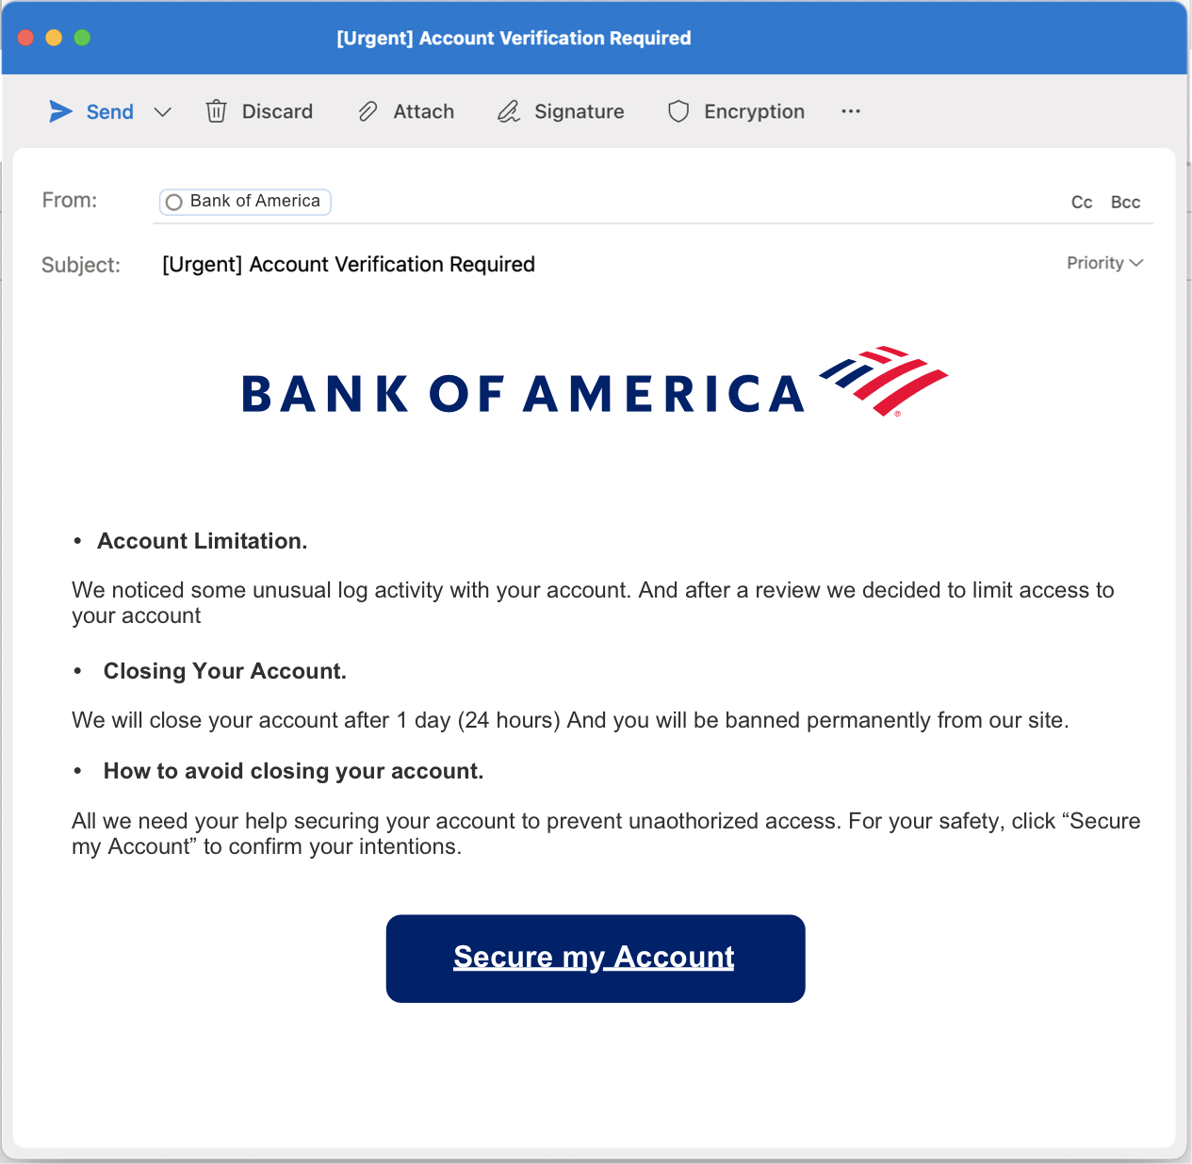
Figure 3: The email that was shown to users. This version is for desktop users who indicated that they bank with Bank of America.
After seeing the screenshot of the email, we followed up by asking the survey respondent a series of questions. First, questions were taken from an existing survey done by Wash et al. (2021) that were intended to measure aspects of Wash’s model of phishing detection. That survey had questions in six categories: noticing, expecting, suspecting, investigating, deciding, and acting. We initially used questions from the first four categories (noticing, expecting, suspecting, and investigating), and then removed questions that did not support testing our hypotheses.

A second set of questions came from an internal, unpublished corporate research questionnaire by one of the co-authors. A third set of questions came from a standard set of measures for PMT, adapted to the context of bank fraud.

We designed the survey to avoid common method bias (Podsakoff et al., 2003). We guaranteed all respondents anonymity to avoid social desirability bias, and also instructed respondents that there are no right or wrong answers. Respondents were informed that this was a study about email, but were not explicitly told that it was about phishing. Still, many of the questions make this fairly obvious. For this reason, we placed the questions asking what would the respondent do about the email first, before the topic of the survey is evident. The remaining questions are more about how they respond to the email, and are phrased in such a way that there is not a right or desirable answer; these questions are less likely to suffer from common method biases like social desirability or positivity bias.

We are not studying whether each respondent detected the phishing, but instead are studying how the respondents think through an email to determine for themselves whether it is phishing. Our results are focused on the cognitive processes participants use to decide whether an email is phishing, and developing a theory of these how these cognitive processes work in the presence of uncertainty.

Sample
We contracted with Qualtrics to field our survey to a panel of survey respondents in January-March 2023. We placed quotas on age and gender that roughly matched the US population to get a more representative sample. We received a total of 521 valid responses. Respondents were compensated by Qualtrics with points that could be redeemed for items.

Table 1 summarizes the demographics of our respondents. Our sample achieved the quotas, and so approximately matches the US population on age and gender. Our sample is more highly educated on average than the US population as a whole, which is common in online samples. Our sample also has more retired people than the US population.
Table 1
Demographics of the participants in our sample

Category | Option | N | %
Age
 | 17-29 | 84 | 16%
 | 30-39 | 86 | 17%
 | 40-49 | 50 | 10%
 | 50-59 | 63 | 12%
 | 60-69 | 87 | 17%
 | 70+ | 92 | 18%
 | Did not respond | 59 | 11%
Gender
 | Man | 257 | 49%
 | Woman | 261 | 50%
 | Prefer not to Answer | 1 | 0%
 | Other | 2 | 0%
Education
 | None, or grades 1-8 | 1 | 0%
 | Some High School | 10 | 2%
 | High School Graduate or GED | 77 | 15%
 | Technical, Trade, or Vocational | 22 | 4%
 | Some college, no 4-year degree | 129 | 25%
 | 4-year college degree | 170 | 33%
 | Some postgrad or professional school, no degree | 23 | 4%
 | Postgraduate or professional degree, including masters, doctorate, medical, or law degree | 89 | 17%
Employment
 | Employed Full Time | 221 | 42%
 | Employed Part Time | 59 | 11%
 | Unemployed and looking for work | 30 | 6%
 | Unemployed and not looking | 20 | 4%
 | Retired | 163 | 31%
 | Disabled | 17 | 3%
 | Student | 9 | 2%
 | Did not respond | 2 | 0%

We also asked participants about prior experience as a victim of identity theft or fraud. Over 80% of our respondents reported prior experience with fraud, though some of those only reported receiving fraud but not actually falling victim. Table 2 shows the breakdown of prior experience. (Note: since people could have been a victim of more than one type of fraud, or a victim more than once, this question was a “check all that apply” question.)
Table 2
Responses to Prior Experience as a victim of identity theft or fraud

Prior Experience | N | %
None of the above | 77 | 15%
received a notification from a company that your information was involved in a data breach | 249 | 48%
received fraud attempts via email or phone, but did not become a victim | 225 | 43%
had a virus on your computer or mobile device | 208 | 40%
stranger used your credit card number without your knowledge or permission | 168 | 32%
someone broke in or hacked your computer, mobile device, or account | 89 | 17%
fell victim to a phishing email message or other scam email | 79 | 15%
identity theft more extensive than use of your credit card number without permission | 51 | 10%
fell victim to a phone scam | 31 | 6%

Results

We organize our findings by the ten hypotheses presented above. Materials to replicate these analyses can be found at the Open Science Foundation: https://osf.io/ena23/overview?view_only=26856c476efa4c9e83e3228e57f37f10.

Hypothesis 1
People's initial attention when presented with an email is primarily directed to identifying the source, understanding the required action, and interpreting its relevance.

To examine our first hypothesis, we asked respondents two closely related questions. First, we asked respondents “When you first read this email, what were you trying to accomplish?”. This question is specifically about the email presented to them, and was the first question asked after they read the email. The second question was “When you first read emails similar to the one you have just seen, what are you usually trying to accomplish?”. This question is about emails like this in general. We asked this second question to see whether this email was being treated differently, and in case participants think they behave differently in normal circumstances than they did in this survey or for this particular email.

Table 3 shows the (check-all-that-apply) responses to these two questions.

Table 3:
Responses to the Question “When you first read this email, what were you trying to accomplish?” and a similar question about what the participant usually does.

 | This Message |  |  | Usually
Question Stem | N | % |  | N | %
Understand who the message is from | 276 | 53% |  | 276 | 53%
Understand what the message wants me to do | 276 | 53% |  | 256 | 49%
Understand why I receive the message | 289 | 55% |  | 273 | 52%
Review carefully each component of the message to see if it is genuine | 288 | 55% |  | 286 | 55%
Delete the message without reading it | 31 | 6% |  | 58 | 11%
Do quickly what the message asks me to | 43 | 8% |  | 24 | 5%
Something else (please describe) | 26 | 5% |  | 28 | 5%

The majority of respondents indicated that their main goal is to try to understand the message better – either by understanding who the message is from, what it is asking them to do, or why they received the message. Each of those responses had over 50% of respondents indicating them.

Respondents were able to check more than one option for this question. If we aggregate the three “understand” responses, and look at how many respondents choose at least one of those three understand responses. We find that 428 respondents (82%) chose at least one of the three “understand” responses as their goal. On the other hand, less than 10% of respondents indicated that they would delete the message or just quickly do what it asks (each).

When we look at the other question about what they usually do when they receive an email like this, we find similar numbers. Just over 50% of respondents chose each of the three “understand” options, and 414 (79%) of respondents chose at least one of the three “understand” options. This suggests that this particular email is not being treated significantly differently than other, normal emails.

Interestingly, over 50% of respondents also choose the option that they “review carefully each component of the message to see if it is genuine”. This is not necessarily a sense-making action, but it does show that many people are careful about messages like this from their bank.

We conclude that hypothesis 1 was supported. Most people engage in sensemaking as their first task when they receive an email.

Hypothesis 2
For people who did not notice something is off, they are more likely to comply with the request in the email

We explicitly asked subjects if they would do the action requested in the email that they were shown (Clicking the button to “Secure My Account”). This action is what the sender is trying to get the recipient of the email to do, and represents an unsafe action to take for this fraudulent email. 67 of our respondents (13%) did not answer this question. Of the remaining, respondents were approximately split about whether they would take the action or not, with slightly more people saying yes they would take the action than not.
Table 4
Responses to the question "This email asks you to do a specific action (e.g. click the button to 'secure your account'). Would you be willing to do that?

Response | N | %
Yes, take the action | 246 | 47%
No, don’t take the action | 202 | 39%
Did not respond | 67 | 13%

We asked respondents if they felt that something was “off” about the email they were shown. 307 (69% of) participants answered yes, they felt something was off about the email, and 51 (11%) said they were not sure.

We conducted a logistic regression to examine whether feeling that there was something off (the Independent Variable) influenced whether they were willing to take the action requested (the Dependent Variable). Table 5 shows the results of the regression. Additionally, since this was a categorical regression, we used the regression model to generate “predicted probabilities” – the probability of someone saying they would take the action for each of the three options for whether they felt something was off.
Table 5
Results of a logistic regression predicting whether the person would take the requested action (DV), as predicted by whether they felt something was off in the email (IV).

Logistic Regression Model |  |  |  | Predicted Probabilities of taking requested action
Variable | Coef | p-value
(Intercept) | -0.94 | < 0.001 |  | Yes, something was off | 28%
Off: No | 3.02 | < 0.001 |  | No, nothing was off | 89%
Off: Not Sure | 1.93 | < 0.001 |  | Not sure | 71%

This is a very large effect. People who said that something felt off only were willing to take the unsafe action in the email 28% of the time, whereas people who did not feel that anything was off were willing to take the unsafe action 89% of the time. This is a statistically significant, and quite large, difference. Interestingly, people who were not sure if something was off were willing to take the action 71% of the time, which is in between the two but closer to the group that thought nothing was off.

We also specifically asked about whether each of three different aspects of the email – the sender, the subject, and, the body of the email – felt off. Only the body of the email had a large (and statistically significant) effect. People who felt the body was off were only willing to take the unsafe action approximately 35% of the time, while people who did not feel the body was off were willing to take the unsafe action 72% of the time.

We conclude that hypothesis 2 was supported. People who felt that there was something off about the email were much less likely to take unsafe actions, and it was specifically feeling that something in the body of the email was off that drove most of this.

Hypothesis 3
People are more likely to find something is “off” if there is “violation of typicality”

This hypothesis uses the variable above, about feeling there is something off about the email. However, for this hypothesis, this “off” variable is the dependent variable. In Wash’s original work, there were two important concepts relevant to this hypothesis: first, the email has to be recognized as similar to a type of email seen before (i.e. you have to know what “typical” looks like), and then this email needs to be different somehow (the violation).

To measure this, we asked two separate questions: “I have received emails from [bank] or other organisations I bank with in the past”, which measures if they know what typical emails look like, and “This email seems similar to email I typically receive from [bank] or other organisations I bank with”, which measures whether this particular email is similar to those past emails, or is a violation of typicality. Both of these were measured with a 5-point Likert scale (Strongly Disagree -> Strongly Agree), coded numerically 1-5.

We conducted a logistic regression where the dependent variable is a binary version of the question about whether the email felt off, and the two independent variables were the two measures for typicality. Table 6 shows the results of this regression.
Table 6
Logistic regression predicting whether the email felt off (DV) based on whether they have received similar emails in the past (IVs)

Variable | Coef | p-value
(Intercept) | 1.73 | < 0.001
Have received similar emails | 0.36 | < 0.001
This email was similar to past | -0.72 | < 0.001

Both variables were statistically significant effects, and in the expected direction. People were more likely to feel like there was something off about the email if they have received similar emails from their bank in the past. People were more likely to feel like something was off if the email was not similar to past emails (i.e. the coefficient on the second IV is negative). Both of these effects are statistically significant.

To see how big of an effect this is, we used the logistic regression model to generate predicted probabilities. These are the probability of feeling like there is something off with the email, given a level of the two IVs. These probabilities are listed in Table 7.
Table 7
Predicted probabilities of feeling the email is off, based on whether respondents reported having received similar emails.

 | This email is similar to past
Have received similar emails |  | Strongly Disagree | Neutral | Strongly Agree
Have received similar emails | Strongly Disagree | 80% | 48% | 18%
Have received similar emails | Neutral | 89% | 66% | 31%
Have received similar emails | Strongly Agree | 94% | 80% | 48%

Reading this table down shows the effect of familiarity. Respondents who more strongly agree with the statement that they have received similar emails in the past are more likely to feel like there is something off about the email. This is a moderately large effect, and can lead to up to a 30 percentage point increase in the likelihood of feeling the email is off when someone is familiar with bank emails vs. when they are not. Familiarity with emails is important.

Reading this table across shows the effect of violations of typicality. The less similar an email is to prior emails (left hand column), the more likely a person is to feel like something is off. This is a very large effect. For people who are familiar with bank emails (bottom row), noticing a violation of typicality changes the likelihood that you feel something is off from 48% (if you don’t to 94% (if you do), another very large effect.

Together, these two variables (familiarity and violation of typicality) have a very large effect on whether someone feels that something is off. Therefore, we conclude that hypothesis 3 is supported.

Hypothesis 4
When people notice something is “off”, they pay more attention to it and take actions to investigate the email.

This is a double barrelled hypothesis concerning what happens after a person feels that an email is off; do they pay more attention to it, and do they take actions to investigate? For analysis, we split this into two hypotheses: Hypothesis 4.a is that when people notice something is off, they pay more attention to it; Hypothesis 4.b is that when people notice something is off, they take actions to investigate.

Hypothesis 4.a
When people notice something is “off”, they pay more attention to it.

To test this hypothesis, we asked two similar questions. First, we asked “On a scale of 1 to 7, how much attention were you initially paying to this email when you first read it?”. Second, after we had asked questions about feeling off, we asked “On a scale of 1 to 7, after you noticed something was off about the email, how much attention would you pay to the email?”. We can directly compare responses to these two questions to see if people decided to pay more attention after they noticed something was off.

124 respondents did not respond to both questions. This is mostly because people who did not feel like there was anything off about the email did not respond to the second question. Of the ones that did respond to both, the most popular response (178 respondents, about ⅓ of all respondents) was to answer that they would pay the same attention in both cases. Figure 4 shows the overall change in attention after noticing something is off:

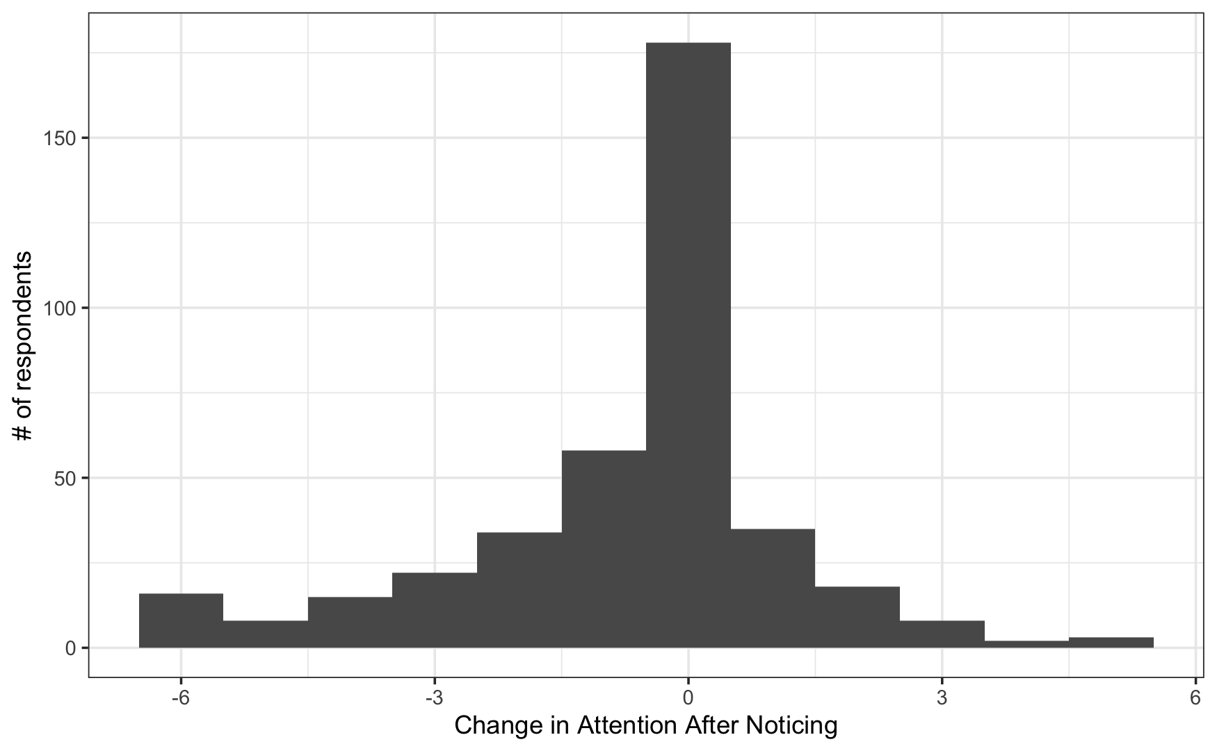
Figure 4: Change in how much attention (on a 1-7 scale) the participant paid to the email after noticing something was off
For many people, this change is negative. This means that they paid less attention after noticing something was off. On average, attention decreased by 0.68 points (on the 7-point scale) after noticing something was off about the email. This effect is statistically significant (t-test; t=-6.93; df=396; p-value<0.001).

We conclude that hypothesis 4.a is refuted. Rather than increasing attention (as we hypothesized), people report decreasing attention after they notice something being off. This important difference is discussed in the discussion section.

Hypothesis 4.b
When people notice something is “off”, they take actions to investigate the email.

To test this hypothesis, we asked to choose-all-that-apply questions about actions that the participant could take in response to the email. The first question contained a list of actions interacting with this specific email message: hover over the link (to see where it goes); click on the link (to see where it goes); look more closely at the email address the message came from; open the attachment; look at headers; or ask someone about the email. These are all actions that investigate the email further by interacting with the message itself. Some of them are relatively safe (e.g. hover, look at headers); others are definitely unsafe (e.g. click, open attachment).

The second question was very similar, but it included actions outside of the email address that are often recommended, such as following up with the sender. We included actions that involved contacting the sender via website, via phone, or face-to-face, and we also included variations on the first two based on whether the contact information came from the email (unsafe) or from another source you look up yourself (safe).

To analyze this, we can cluster responses together. Firstly, an analysis of the initial question, about message-specific actions. Overall, 475 people (91% of participants) reported taking some message-specific investigative action, and 369 (71% of participants) only took actions that we classify as a safe action. Table 8 shows the frequency each action was chosen.
Table 8
Percentage of respondents who reported taking each action

Safe/Unsafe | Action | N | %
Safe | Look more closely at the email address or phone number the message came from | 323 | 62%
Safe | Look at email headers | 202 | 39%
Safe | Hover over one or more of the links to see where it went | 124 | 24%
Safe | Ask someone else about the email | 88 | 17%
Unsafe | Click on one or more of the links to see where it went | 78 | 15%
Safe | Other | 64 | 12%
Unsafe | Open the attachment | 51 | 10%
 | None of the above | 46 | 9%

The hypothesis states that people are more likely to report taking investigatory actions after they notice something is off about the email. To test this, we clustered these responses to create two new variables: one variable is whether the respondent reported taking any action (i.e. any response other than “None of the Above”); and one variable is whether the respondent reported only taking safe actions (i.e. only chose actions we categorized as safe, and did not choose any actions we categorized as unsafe or None). We then ran two logistic regressions using these two binary outcome variables as the dependent variables, and whether the respondent reported feeling off as the independent variable.
Table 9
Logistic Regressions for whether respondents took any action or a safe action (DVs), based on whether the email felt off (IV).
 | Any Investigative Actions |  |  | Only Safe Investigative Actions
variable | coef | p-value | Signif. | coef | p-value | Signif.
(Intercept) | 2.32 | < 0.001 | *** | 1.19 | < 0.001 | ***
Off: No | 0.40 | 0.38 |  | -1.05 | < 0.001 | ***
Off: Not Sure | -0.41 | 0.33 |  | -0.59 | 0.04
Note: * p<0.05; ** p<0.01; *** p<.001

Table 9 shows the results of these two regressions. When considering whether the participant took any investigative action, there was little difference between participants who felt that something was off and participants that did not. 91% of participants who felt something was off took some action, whereas 93% of participants who did not took an action. This difference is not statistically significant. This is counter to our hypothesis, which posits that people who feel something is off are more likely to investigate.

However, when we look at whether the person was careful to report only taking safe investigatory actions, we see a slightly different story. Participants who feel like something is off are more likely to report taking only safe investigatory actions. 77% of participants who felt something was off reported taking a safe investigatory action, whereas only 54% of participants who did not feel something was off only reported taking safe investigatory actions (people who were not sure were in between, at 65%). This difference is statistically significant. Another way of saying this is that when people felt something was off, they were much less likely to report taking unsafe actions, and much more likely to only report taking safe actions when investigating the email.

Much of the security advice about fraudulent emails suggests that recipients of such communications should contact the sender. The second question we asked involved whether they would take actions to try to contact the sender, and if so, how they would go about doing that. Table 10 shows percentages of people who would try to contact the sender:
Table 10
Percentage of respondents who said they would contact the sender of the email

Safe/Unsafe | Response | N | %
 | I would not contact the sender | 163 | 31%
safe | Contact the sender via phone, on a number I looked up myself | 129 | 25%
safe | Other | 117 | 22%
unsafe | Contact the sender via phone, on the number that was presented in the email | 114 | 22%
safe | Go to the website of the sender, directly through my web browser | 100 | 19%
unsafe | Go to the website of the sender, using the link provided in the email | 91 | 17%
safe | Talk to the sender face-to-face about the email | 60 | 12%
safe | Contact the sender through another communications medium (texting, chat, social media) | 0 | 0%

This hypothesis states that people are more likely to take investigatory actions after they notice something is off. To test this, as above, we clustered these responses to create two new variables: one variable is whether the respondent reported taking any action (i.e. any response other than “I would not contact the sender”); and one variable is whether the respondent reported only taking safe actions (i.e. only chose actions we categorized as safe, and did not choose any we categorized as unsafe). Unsafe actions all involved using information in the email to contact the sender.

356 Participants reported taking some action to try to contact the sender, which is 68% of all respondents. 184 of the participants (35%) said that they would contact the sender, and only do so using a method we deem safe. As above, we ran two logistic regressions using these two binary outcome variables as the dependent variables, and whether the respondent reported feeling off as the independent variable.
Table 11
Logistic regression for whether people would contact the sender via any means or only safe means (DVs), by whether the email felt off (IV)
 | Contact the Sender |  |  | Only Safely Contact Sender
Variable | Coef | p-value | Signif. | Coef | p-value | Signif.
(Intercept) | 0.52 | < 0.001 | *** | -0.54 | < 0.001 | ***
Off: No | 1.18 | < 0.001 | *** | -0.41 | 0.10
Off: Not Sure | 0.72 | 0.027 | ** | 0.01 | 0.96
Note: * p<0.05; ** p<0.01; *** p<.001

Table 11 shows the results of these two regressions. When considering whether the participant reported taking any action to contact the sender, there was a statistically significant difference between participants who felt that something was off and participants that did not, but it is in the opposite direction of the hypothesis! 68% of participants who felt something was off indicated that they would try to contact the sender, and 85% of participants who did not feel something was off would. This is counter to our hypothesis, which posits that people who feel something is off are more likely to investigate.

When we only consider people taking safe actions to contact the sender, there is only a small difference that is not statistically significant. We estimate that 36% of participants who feel something is off will take only safe actions to contact the sender, whereas 28% of participants who do not feel something is off will do that. This difference is in the hypothesized direction, but is not statistically significant.

Our findings related to hypothesis 4.b are complicated. Hypothesis 4.b states that “When people notice something is ‘off’, they take actions to investigate the email.” When we showed people a potentially fraudulent email, 91% of participants indicated that they would take some action to investigate the email, and 69% said that they would try to contact the sender (which is a form of investigation). So investigations are fairly common.

But this hypothesis states that this is more likely to happen when people feel something is off about the email. Our results here are less clear. We found that participants who felt something was off were significantly less likely to report taking specific actions that are unsafe to investigate the email, such as clicking on the link to see where it goes or using information in the email to contact the sender. However, the overall incidence of investigation was not really affected by whether the email felt off, and participants who did not feel like something was off were actually more likely to contact the sender. Thus, we conclude that hypothesis 4.b was partially supported.

Hypothesis 5
When people noticed something was off their goal changed from understanding to reviewing / deleting the email.

Under our analysis for Hypothesis 1, we showed the results for a pair of questions about what the goal of the participant is (Table 3, above). Later in the survey, we asked a similar question: “Once you think something is off about the email, would you do anything differently? (Please check all that apply)”. The set of options are the same as the initial goals, with the additional option of “No, I would stick with my original reaction.” Table 12, below, shows the results for what people say they would do after noticing something is off:
Table 12
Reported goals of the participants both when first receiving the message and after noticing something feels off

 | This Message |  |  | After Something Feels Off
Goal | N | % |  | N | %
Understand who the message is from | 276 | 53% |  | 107 | 21%
Understand what the message wants me to do | 276 | 53% |  | 108 | 21%
Understand why I receive the message | 289 | 55% |  | 118 | 22%
Review carefully each component of the message to see if it is genuine | 288 | 55% |  | 162 | 31%
Delete the message without reading it | 31 | 6% |  | 107 | 21%
Do quickly what the message asks me to | 43 | 8% |  | 12 | 2%
Something else (please describe) | 26 | 5% |  | 0 | 0%
No, I would stick with my original reaction |  |  |  | 56 | 11%

This hypothesis has two pieces. First, that participants would be less likely to try to try to understand the email, and second, that they would be more likely to either review the email or delete it.

All three of the options that involve “understanding” the message dropped significantly – from the mid-50% down to 21%. The first part of the hypotheses seems to hold; participants appear to be much less likely to report wanting to understand the email.

The next two options involve “reviewing” and “deleting”. The second part of the hypothesis says these should increase. The “review” option started out quite high, with over 50% of participants reporting wanting to review initially. 31% of participants said they would want to review after noticing something off. This is lower, but it is not nearly as much of a drop as the understanding options.

The deleting option, on the other hand, got significantly more popular, with 21% of people reporting wanting to delete the email. That is, the change after noticing something is off about the email is large and in the right direction. However, still approximately the same number of people who reported wanting to understand the email also reported wanting to delete it.

To specifically test this hypothesis, we will combine options. The first options we will combine into an “understanding” variable, that is true whenever the participant indicated any of the 3 understanding options. The next two options we will combine into a “review/delete” option, which is true whenever the participant indicated either reviewing or deleting. Since this was a choose-all-that-apply question, it is possible for both variables to be true for an individual participant.

Table 13 shows the percentage of participants who reported indicating understanding vs. review/delete:
Table 13
Percentages of respondents whose goal is either understanding the email or reviewing/deleting the email

 | This Message |  |  | After Something Feels Off |  |  | p-value
Goal | N | % |  | N | % |  | P | Signif.
Understand | 428 | 82% |  | 190 | 36% |  | < 0.001 | ***
Review / Delete | 304 | 58% |  | 245 | 47% |  | < 0.001 | ***
Both | 234 | 45% |  | 108 | 21% |  | < 0.001 | ***
Note: * p<0.05; ** p<0.01; *** p<.001

The first part of the hypothesis shows a clear pattern; many fewer participants try to understand the email after it feels off than before. Counter to the hypothesis, the second part shows a decrease in reviewing/deleting. As shown above, there is a decrease in reviewing and an increase in deleting. From this, we conclude that this hypothesis is mostly supported; after feeling something is off, many fewer participants are trying to understand the emails, and more people are interested in deleting. There are fewer participants interested in reviewing (counter to the hypothesis), but this change is much smaller than the understanding and deleting changes.

Hypothesis 6
People with low perceived threat severity, even if they had noticed something is off are more likely to comply with the request in the email and less likely to investigate the email

We combined three questions that form the “threat severity” subscale of protection motivation theory into a single scale variable (mean=4.11, alpha=0.864). These questions measure the perceived severity of the threat posed by bank fraud, in general. Most people felt that bank fraud represented a fairly severe threat (as indicated by the high mean), and the 3 questions that form the scale have high reliability (high alpha).

To examine this hypothesis, we looked for the relationship between this threat severity and whether they 1) would be willing to take the action requested by the email, and 2) what other investigative actions they reported that they would take. The hypothesis is that the first is a negative relationship – lower perceived threat means more likely to report taking the action – and the second is a positive relationship – lower perceived threat means lower percentage of people reporting that they would investigate.

We find a statistically significant and negative relationship (as predicted) between threat severity and willingness to take the action (logistic regression, beta=-0.25, p=0.02). People with a 3 out of 5 on threat severity (about 1 standard deviation below the mean) have a 51.8% likelihood of doing the action the email requisitions; whereas people with a 5 out of 5 (about 1 sd above the mean) have a 39.4% likelihood of reporting that they would take the action. This supports the hypothesis.

We find a statistically significant and positive relationship (as predicted) between threat severity and reporting taking investigative actions that are safe (logistic regression, beta=0.21, p=0.02). People with a 3 out of 5 on threat severity report taking safe investigative actions approximately 65.9% of the time; people with a 5 out of 5 on threat severity report taking safe investigative actions 74.9% of the time. This also supports the hypothesis.

We also looked at all investigative actions that we asked about, not just safe actions. We did not find a statistically or practically significant effect here (beta=-0.04, p=0.79). We broke this down the actions to see if there are specific actions that people are more or less willing to take when they feel the email poses a more severe threat. We found 2 actions: people are much more likely to report asking other people about the email if they think the threat of bank fraud is more severe (logistic regression, beta=0.48, p=0.002) and slightly less likely to report clicking on the link in the email (logistic regression, beta=-0.27, p=0.04). All other actions were not statistically significant and have very small effects (beta<0.10).

Both of the predictions of this hypothesis were supported by our data. People with lower threat severity are more likely to report taking the action requested by the email and are less likely to report investigating the email.

Hypothesis 7
People with low perceived self-efficacy are more likely to comply with the request in the email and less likely to investigate the email. (Main Effect of self-efficacy)

We combined three questions that form the “self-efficacy” subscale of protection motivation theory into a single scale variable (mean=4.07, alpha=0.767). These questions measure the respondent’s perception of their ability to properly handle a dangerous email. For example, one question asked respondents whether they agree with the statement “I am able to contact my payment provider when I receive a suspicious message in order to prevent financial fraud”. In general, most people felt that they were able to handle dangerous emails (as indicated by the high mean), and the 3 questions that form the scale have moderately high reliability (high alpha).

To examine this hypothesis, we looked for the relationship between this self-efficacy and whether they 1) would be willing to take the action requested by the email, and 2) what other investigative actions they would take. The hypothesis is that the first is a negative relationship – lower self-efficacy means more likely to take the action – and the second is a positive relationship – lower self-efficacy means lower percentage of people investigating.

We found only a very small and non-significant relationship between self-efficacy and willingness to take the action in the email (logistic regression, beta=-0.02, p=0.87). People with a 3 out of 5 on self-efficacy (about 1 standard deviation below the mean) have a 45.5% likelihood of doing the action the email requisitions; whereas people with a 5 out of 5 (about 1 sd above the mean) have a 44.6% likelihood of doing the action. This is a very small difference.

We also found only a very small and non-significant relationship between self-efficacy and reporting taking investigative actions that are safe (logistic regression, beta=-0.05, p=0.67). People with a 3 out of 5 on threat severity report taking safe investigative actions approximately 72.2% of the time; people with a 5 out of 5 on threat severity report taking safe investigative actions 70.1% of the time. This also supports the hypothesis. We also looked at all investigative actions that we asked about, not just safe actions. We also did not find a statistically or practically significant effect here (beta=-0.28, p=0.17). When looking at individual actions, none has a statistically significant effect.

Both of the predictions of this hypothesis were not supported by our data. People with lower self-efficacy are not any more or less likely to report taking the action requested by the email and are not any more or less likely to report investigating the email.

Hypothesis 8
People with high perceived threat severity and low perceived self-efficacy are more likely to comply with the request in the email (interaction effect).

This hypothesis posits an interaction effect. It says that even when people perceive bank fraud to be a serious threat, if they don’t feel like they are able to do something about it (low self-efficacy) then they are likely to just do what the email asks anyway. This is an interaction effect.

To test this, we ran a logistic regression using the self-report of taking the action requested by the email as the dependent variable, and included both threat severity and self-efficacy, as well as the interaction between the two, as independent variables. Table 14 below shows the result of this regression.
Table 14
Logistic regression of whether people will take the requested action (DV) by self-efficacy and threat severity (IVs)

Variable | Coef | P-value | Signif.
Intercept | 6.53 | 0.002 | **
Self-Efficacy | -1.46 | 0.006 | **
Threat Severity | -1.80 | < 0.001 | ***
Interaction: Efficacy * Severity | 0.39 | 0.002 | **
Note: * p<0.05; ** p<0.01; *** p<.001

There is a statistically significant interaction effect between self-efficacy and threat severity. To better understand this interaction, we generated a series of predicted values – using the regression model, if we fill in some combination of possible values for threat efficacy and self-efficacy, what would this model predict as the probability of reporting taking the requested action. We graphed these predicted values in Figure 5, below.

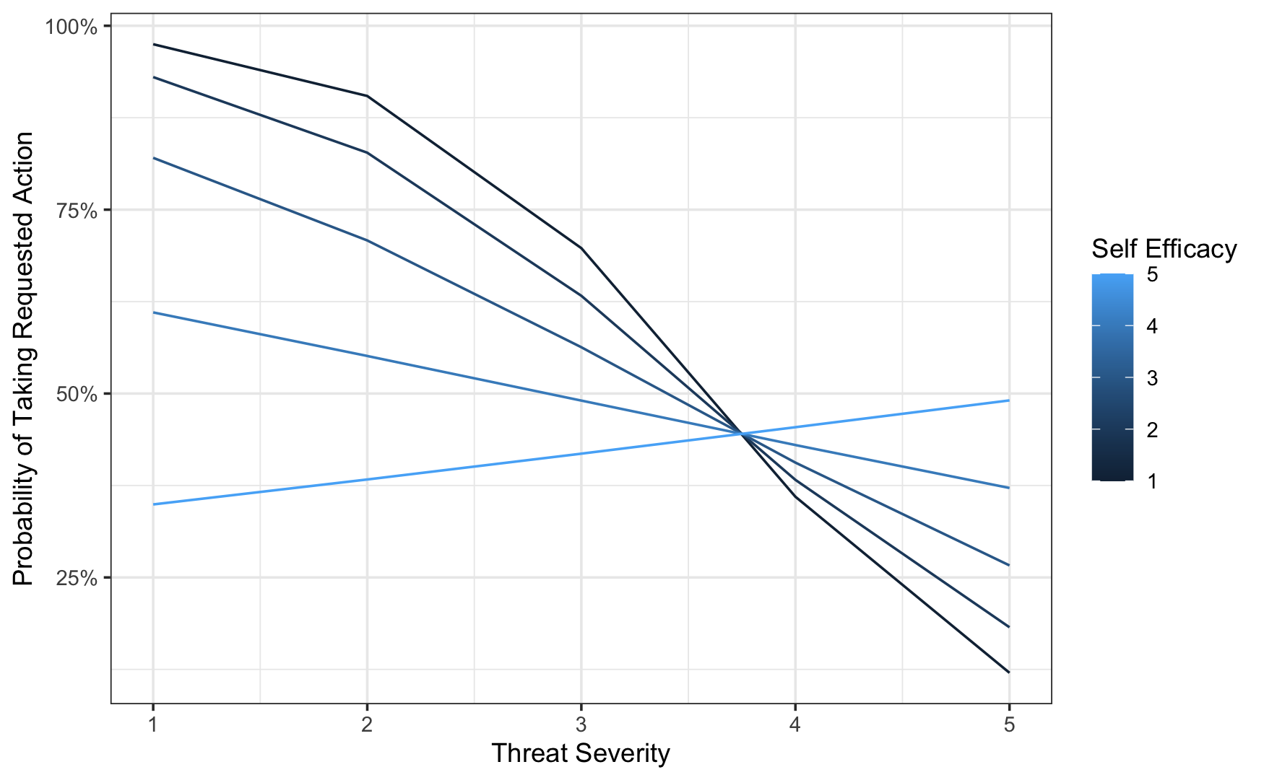
Figure 5: Predicted probability of reporting taking the requested action
People with the lowest threat severity (bank fraud is not a severe threat) and lowest self-efficacy (not able to deal with the threat) are by far the most likely to say they will take the action requested in the email. In general, as people perceive the threat of bank fraud to be more severe, they are less likely to report taking the requested action in the email. However, how much this matters depends on self-efficacy. People with low self-efficacy show a very large difference depending on whether they think bank fraud is severe or not. People with high self-efficacy treat emails similarly regardless of whether they think bank fraud is serious; they don’t show much of a difference between low threat severity and high threat severity.

H8 states that people who recognize the threat but don’t think they can do anything about it are more likely to take unsafe actions. This was not supported. However, the hypothesis is about an interaction effect, which is present. There is an interaction between self-efficacy and perceived severity. For people who have higher self-efficacy (think it is easier to contact the bank), whether they do the requested action doesn't really depend on how bad they perceive fraud to be (severity). But for people with low self-efficacy, the perceived severity of bank fraud makes a big difference in how likely they are to report doing the action requested in the email, with people who are more worried about bank fraud being less likely to do the action.

Hypothesis 9
People with high perceived threat severity, high perceived self-efficacy and low actual efficacy, even if they notice something is off, are more likely to comply with the request in the email

To analyze this hypothesis (and the next one), we need a measure of actual efficacy – how good people actually are at protecting themselves from fraudulent emails. Since this study was done as a survey, we could not directly measure actual efficacy. However, we do have an indicator of efficacy: we have an indication of what kinds of actions the person would take.

We categorize people to be of low actual efficacy if they state that they would be willing to click on a link, open the attachment, or try to contact the sender using either the email address or phone number in the email they received. All of these actions are highly unsafe actions and indicate that the participant does not actually possess the skills to protect themselves.

We also categorize people as having high actual efficacy if they express that they would contact the bank that sent the message using a means that requires 3rd party information such as a phone number they looked up themselves or by manually entering their bank’s website into a web browser (and not doing any of the unsafe actions that indicate low actual efficacy). These people have skills to address and report fraud, and to decide confidently whether an email is fraudulent or not. Finally, there is a 3rd group, which we call medium actual efficacy, that does none of the above; the medium actual efficacy group does not report taking unsafe actions but also does not report taking actions to protect themselves like contacting the bank.

While based on the questions about safe/unsafe actions that measure knowledge of specific phishing-related behaviors, our actual efficacy measure is a more holistic assessment of whether someone can ultimately respond to a phishing message in a way that protects them from harm. The safe and unsafe actions measure captures participants' evaluations of individual responses to a suspicious message. In contrast, the actual efficacy measure assesses participants' overall ability to respond effectively to a phishing attempt.

Table 15, below, shows the percentage of respondents in each of the three groups. It also shows the percentage of respondents in each group that reports that they are willing to take the action requested in the email. The difference between groups in the likelihood to take the requested action is statistically significant (chisq=142.9, df=2, p<0.001).
Table 15
Percentage of respondents groups into actual efficacy, along with the percentage of each group willing to take the requested action.

Actual Efficacy | N | % of respondents | % Take Action
Low | 204 | 39% | 78%
Medium | 157 | 30% | 14%
High | 160 | 31% | 32%

The low actual efficacy group is very likely to report taking the action requested in the email, and over three quarters of this group is willing to take the requested action. This is a very high likelihood.

Hypothesis 9 says that actual efficacy is important – which it is – and that it is important even for people who understand the threat (high threat severity) and who feel confident that they know how to deal with it (high self-efficacy). We ran a logistic regression model to see how threat severity and self-efficacy affect the group of people with low actual efficacy. Table 16 shows the results of the regression and Table 17 shows predicted probability of reporting taking the action requested by the email. None of these differences are statistically significant, but they show that even for people with high threat severity and/or high self-efficacy, if they are low in actual efficacy they then are not safe and are likely to take the wrong action.

Table 16
Logistic regression using only low efficacy participants, predicting whether they would take the requested action (DV) by self-efficacy and threat severity.

Variable | Coefficient | p-value
Intercept | -0.06 | 0.98
Self-Efficacy | 0.28 | 0.63
Threat Severity | 0.93 | 0.30
Interaction | -0.20 | 0.31
Table 17
Looking only at respondents classified as low actual efficacy, the predicted probability of taking the requested action.

 | Threat Severity
Self-Efficacy |  | 3 | 4 | 5
Self-Efficacy | 3 | 85% | 88% | 91%
Self-Efficacy | 4 | 80% | 81% | 93%
Self-Efficacy | 5 | 74% | 72% | 70%

We conclude that Hypothesis 9 was supported. People with low actual efficacy – that is, people who don’t actually know what to do to protect themselves from fraud – are highly likely to report taking unsafe actions (more than 70% of the time), even if they understand the threat and believe that they know what to do.

Hypothesis 10
People with high perceived threat severity and high actual efficacy are less likely to comply with the request in the email

Hypothesis 10 is almost identical to hypothesis 9, except that it says that people with high actual efficacy are less likely to take the action requested in the email. Table 18, above, shows that this is the case generally. People we categorized as medium or high efficacy are MUCH less likely to report taking the unsafe action – with the people in the medium group only reporting taking the unsafe action 14% of the time. This is much lower than the low actual efficacy group, and the difference is statistically significant. This, generally, supports the hypothesis.

However, the hypothesis is not entirely supported. The high actual efficacy group – the people who indicated that they know how to contact the bank correctly and are inclined to do so – actually is slightly more likely to report taking the unsafe action than the medium efficacy group (which do not do anything about the email).

We ran a similar logistic regression to examine whether self-efficacy and threat severity have an effect on the likelihood of taking the requested action. For the medium efficacy group, who has the lowest likelihood of taking the unsafe action, the results were not statistically significant. Self-efficacy and threat severity did not significantly affect whether the medium efficacy group would report taking the requested email action.

For the high efficacy group, a similar logistic regression did find a statistically significant effect, including a statistically significant interaction effect. Table 18 and Figure 6 show the regression and a graph of the estimated likelihood for high actual efficacy participants to report taking the requested action.

Table 18
Logistic regression using only high efficacy participants, predicting whether they would take the requested action (DV) by self-efficacy and threat severity

Variable | Coefficient | p-value
Intercept | 13.0 | 0.025 | *
Self-Efficacy | -3.23 | 0.030 | *
Threat Severity | -3.27 | 0.015 | *
Interaction | 0.76 | 0.025 | *
Note: * p<0.05; ** p<0.01; *** p<.001

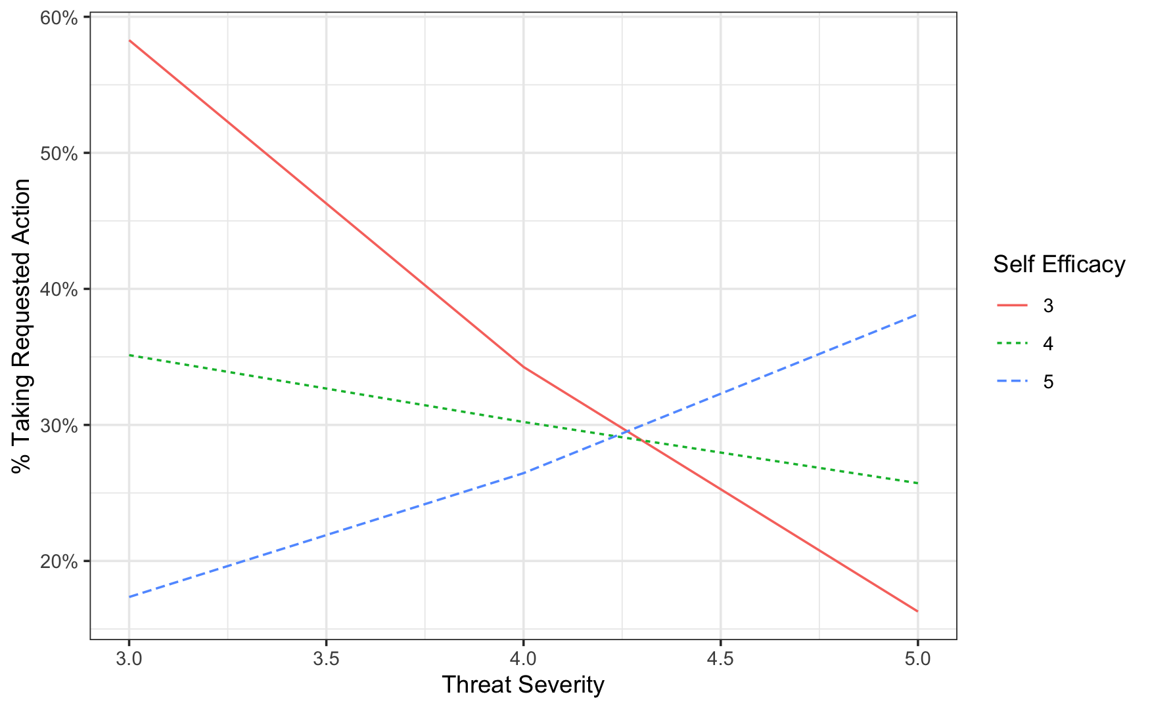
Figure 6: Predicted probability of taking the requested action, for respondents classified as high actual efficacy
For these high actual efficacy participants, we found that self-efficacy and threat severity do have an impact. When people have high threat severity, lower self-efficacy actually leads to slightly lower likelihood of reporting doing the requested action. This is the opposite of what was predicted in the model. However, for lower threat severity – when the participant does not think the threat is as severe, the opposite is true.

Overall, these results mostly support H10. People with higher levels of actual efficacy are much less likely to report taking the action requested in the email. This is generally true regardless of whether they understand the threat and see it as serious, and whether they believe that they know how to deal with it (self-efficacy). However, while people who demonstrated high actual efficacy were much less likely to do the action in the email than people who demonstrate low actual efficacy, they are still more likely to do the action than people who did not demonstrate efficacy (medium actual efficacy). Furthermore, for the high efficacy group, self-efficacy and threat severity had a complicated relationship (a statistical interaction) that was not covered by the hypothesis.

Discussion and Implications for our model of fraud detection

Overall, our survey findings offer a high level of support for our theoretical model, with five of the ten hypotheses fully supported (H1, H2, H3, H6, H9), four partially or mostly supported (H4b, H5, H8, H10), and two refuted (H4a, H7). Following these findings, we drafted an adjusted form of the model, which is summarised in Figure 7:

Updated Model
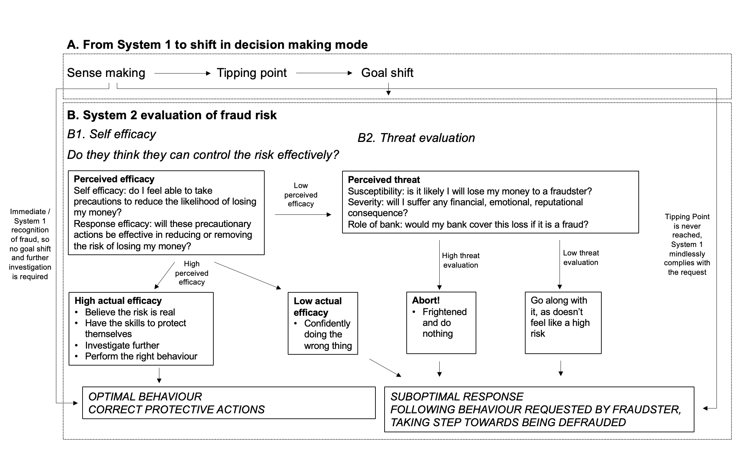
Figure 7: Proposed theoretical model after updates based on our result
Based on the findings from our survey, several key refinements were made to the second version of the model. First, threat evaluation appears to be relevant primarily for individuals with low perceived efficacy. For those with high perceived efficacy, actions — whether appropriate or misguided (depending on their actual efficacy) — are taken with confidence, regardless of the perceived threat level.
Second, limited evidence was found to support the fear control response as described in H7. Specifically, we did not observe the mechanism proposed by PMT, which suggests that individuals may mitigate their fear of fraud by altering their beliefs, thereby inadvertently increasing their susceptibility to fraudulent schemes.
Third, the results provided partial support for H4. Contrary to expectations, individuals did not appear to increase their attention to the message after detecting anomalies. While we cannot explain this, we offer two System 1 processes as potential reasons: 1) a rapid, automatic evaluation can lead individuals to follow instructions without critical reflection, and/or 2) a protective heuristic in which individuals immediately recognize the communication as fraudulent and automatically know what to do with it (delete). In both explanations, no further cognitive effort or goal re-evaluation is necessary, as the message is swiftly and confidently dealt with. This rapid detection allows individuals to bypass more deliberate System 2 processing. Future research could explore this more fully.

Relationship to Digital Literacy
Existing digital literacy studies often treat this cognitive process as a black box, looking at differences between individuals in their ability to recognize scams (Dadà et al., 2025). By looking in more detail at the specific cognitive processes involved in receiving and responding to a scam message, we are able to identify more specific knowledge that is needed by potential bank fraud victims, and identify how and when that knowledge is needed.

Specifically, financial literacy and familiarity with prior messages from banks is critical during the first stages, when System 1 is engaged. It is general financial literacy and familiarity with what bank messages normally look like that allows message recipients to notice when things are “off”, and reach a tipping point that can lead them to switch to System 2 processing.

General digital literacy, and specifically literacy about scams and fraud, become more useful once System 2 is active. Literacy about scams and fraud is important as people evaluate both how serious the threat of fraud is, and their own self-efficacy at being able to address the threat. Knowing that fraud exists and what that fraud commonly looks like is key to being able to make reasonable decisions.

By looking in detail at the specific cognitive processes that potential victims go through when receiving a fraudulent message, we are better able to understand how literacy matters and what kinds of mistakes people will make when they lack specific forms of digital literacy.

Practical relevance for anti-fraud practitioners
Through this paper, we aim to offer both a contribution to the academic literature but also a novel approach for fraud education and awareness (E&A) practitioners in organisations such as large banks.

We believe this theoretical model goes further than existing models or accounts of how people make assessment of threat, and then subsequently make behavioural decisions. For example, it goes further than the Dennis & Minas (2018) paper, which argues that the individual’s response is driven by the general heuristics they have developed over time: personality, culture, habits, and life experiences lead to different heuristics that have developed over a lifetime. Mental models go a step further to explain the underlying beliefs about the state of the world that drive the behaviour heuristics and observable behaviours.

By offering a dual account both of how suspicion is raised, and how people then decide to respond to that suspicion, the model offers several intervention routes to increase people’s abilities to protect themselves against fraud. The academic literature is relatively sparse in terms of guiding fraud E&A practitioners in large organisations on what they can practically do to train users to make more protective decisions, and research suggests that conventional awareness campaigns based on mass messaging can be ineffective (e.g. Jensen et al. 2025). We think this model offers a number of practical routes to interventions, and can be used in many ways by practitioners. It allows us to think about fraud prevention holistically and understand the end-to-end journey of potential victims. It helps organizations to think systematically about fraud education and awareness so they can put together a programme of research to understand people’s current mental models and the potential gaps preventing them from effectively performing the “sense making” activity.

Do people know what a “normal” interaction with an organisation looks like?
In public campaigns, organisations focus on helping people in identifying fraud, potentially forgetting a crucial aspect of communicating what “normal” looks like. It is not enough to warn someone that they should “watch out for fraudulent messages”; people need a clear understanding of which channels an organisation would communicate through, with what messages, from what number or email address, what call to action should be expected, such that a deviation from these norms would then become a “violation of typicality”, with the potential to invoke a System 2 response.

Are people aware fraud can happen and more importantly do they understand the mechanisms of fraud?
Once people are clear on what would be considered normal for a specific organization, the next step is to focus on potential negative impacts, or “what could go wrong”. People may have an outdated view of how fraud works and need to understand the current levels of sophistication. For example, people may still think of fraud as a very obvious email from a “Nigerian Prince”, ignoring the fact that today’s fraudsters include large criminal organizations which have more sophisticated technological and design capabilities, making it much harder to distinguish the real from the fake. Which is even further enhanced by the application of generative AI.

We would suggest to future proof the mental models of fraud by staying away from specific instructions (such as “fraudsters are impersonating your National tax authority”) and emphasising the commonalities instead (for example “A fraudster can impersonate ANY organisation you trust, for example your national tax authority”). A mental model built on the commonalities of fraud is more likely to enable people to identify a new or novel fraud, which uses similar Modus Operandi, but in a different context.

By building an alternative “suspicious” mental model in people’s minds, and by making this alternative mental model more complete and accessible, increases the sensitivity towards the tipping point. We might think of this as training System 1 to be more sensitive to recognising, or pattern matching the warning signs of fraud or threat, increasing the likelihood of multiple competing intuitions being invoked, and conflict between these being detected.

Do people accurately perceive the level of “threat” of a fraud message? (perceived threat)
When threat levels are misperceived, people may underestimate the severity of fraud risks and as a result exhibit greater willingness to engage in potentially harmful behaviours. This underscores the critical importance of communication strategies that convey both the individual and societal impacts of fraudulent activities. For instance, while people may perceive actions such as clicking fraudulent links or completing online forms as low-risk activities, these behaviours can precipitate far more significant consequences, including customer profiling, identity theft, and subsequent targeted scam attacks.
Understanding people’s existing knowledge regarding the consequences of engaging with fraudulent instances enables organizations to identify and address knowledge gaps, thereby facilitating more accurate risk assessment among their customer base. According to PMT, threat messages must be accompanied by efficacy messages to achieve optimal effectiveness. This theoretical framework emphasizes the importance of providing people with actionable solutions rather than inducing fear without offering constructive pathways for risk mitigation.

Do people perform the right checks once they suspect it is fraud? (perceived and actual efficacy)
It is common practice for organisations to advertise the top things to check to avoid fraud. While these tips may be helpful, they also present an opportunity for fraudsters to tailor their scam in ways that will pass the “top 10 tips” list. For example, one common tip customers are given when receiving a text message that purports to be from a particular organisation is to check the details of the sender. Using this criteria, customers may feel confident they will be able to spot a fraudulent text. If people were to then rely on the sender’s name that appears on their device to decide whether a text is genuine or not, they would miss the crucial risk of number spoofing, whereby a fraudster can “spoof” or imitate the number of a genuine organisation. So while the tip of “checking the sender” may prevent some unsophisticated low-level fraud, more sophisticated fraud using number spoofing will actually be facilitated as people will mistakenly feel safe if they rely on “senders details” as a key signal of a genuine approach.

It is important to understand the checks people are performing when they evaluate whether a message is fraudulent or not (perceived efficacy) and how confident they are with these checks (actual efficacy), such that any safety campaigns update or correct people’s knowledge in protective ways.

When trying to answer the questions above, we would encourage organisations to clearly identify at each stage of the model, the beliefs that make an individual do the right thing and most importantly the misbeliefs which lead their customers to perform suboptimal behaviours. For example, if a customer of an organisation who never sends text messages (mis)believes that the organisation could conceivably text them to discuss abnormal activities, she will unnecessarily be at risk of fraud by believing such a text could be genuine. However, if she had held the correct belief (i.e. this organisation will never communicate about such matters through the medium of text messages), then she would have discarded the text message as soon as it was received (in the sense making stage of our model).

Understanding (1) people’s misbeliefs, (2) their prevalence within a specific cohort of people, and (3) the level of fraud risks associated with these misbeliefs will help an organisation to optimise education and awareness messages so that the most prevalent and risky misbeliefs are prioritised. Going further, segmenting a population according to their misbeliefs will provide a more effective targeting of messages.

Potential directions of future research
The revised version of the model, as summarised in Figure 7, has not yet been (empirically) tested. We therefore encourage further research to validate this model. Furthermore, research could be continued to investigate the influence of personal characteristics and the nature of different fraud types.

Firstly, while we have supporting evidence in the context of banking fraud, it remains uncertain whether the model is applicable to other, potentially more complex types of fraud. This study employed a relatively straightforward yet realistic scam email, which may have been easily identifiable as fraudulent by some participants. To enhance the generalisability of the model, future research could use a diversified range of fraudulent stimuli, such as social engineering telephone calls, deceptive websites, and fraudulent social media content. This would allow researchers to explore whether distinct variations of the model emerge across different fraud contexts, or whether the model holds consistently across diverse scenarios.

Secondly, it may be interesting to investigate the role of individual differences or personality characteristics. It seems plausible that key individual differences such as levels of conscientiousness or nervousness interact with our proposed model, to form a significant component of how people respond to fraud. For example, highly conscientious people may always perform investigative action, irrespective of the perceived threat level. Future research could investigate the relationship between personality characteristics and the model’s components and outcomes.

We should also note methodological challenges posed in researching our integrated model. We are attempting to integrate three different strands of research, which in previous studies have each been evidenced using quite different research methodologies. DPT emerged from a large body of research, much of it grounded in psychology laboratory experimental findings, Protection Motivation Theory research has typically leaned heavily on large scale quantitative surveys, while Wash’s Model of Suspicion Formation has been researched using smaller-scale qualitative research. Integrating these bodies of work therefore raises important considerations regarding the appropriate methodological approach.

In this paper, we employed a quantitative survey design, which aligns with parts of the theoretical basis but cannot capture all dimensions equally. Other methodological approaches, such as experimental, qualitative, or mixed-methods designs, may yield additional insights, and future research could employ these to further test and refine the model.

Conclusion
In this paper, we have proposed a model that integrates three complementary theories grounded in psychology and human behaviour, and tested this model using a survey of 500 US respondents. This study investigated how individuals respond to potentially fraudulent emails, focusing on the cognitive, emotional, and behavioural processes that influence their decisions. Our findings offer nuanced insights into how people detect deception, assess risk, and choose actions in an online banking context.

We found strong support for H1: participants primarily directed their initial attention toward identifying the source, understanding the required action, and interpreting the email’s relevance—demonstrating a clear sensemaking process at the outset. Similarly, H2 was supported: individuals who did perceive something was suspicious were much less likely to take unsafe actions, highlighting the importance of initial impressions in shaping behaviour. Notably, it was the sense that something in the body text of the email was amiss that most strongly influenced participants’ reactions. This finding is noteworthy but also raises concerns in light of recent advancements in generative AI, which significantly enhance the linguistic quality and coherence of email content—particularly within the body of phishing messages—potentially making them more difficult to detect.

H3 was also supported. Participants were significantly more likely to feel that something was “off” when the email violated expectations of typicality or familiarity. These two variables had a substantial influence on suspicion formation, underscoring the role of schema-based processing in phishing detection.

In contrast, H4.a was refuted. Rather than increasing attention, noticing something suspicious led to a reported decrease in attention, suggesting a possible cognitive avoidance response. Noticing something suspicious may prompt a defensive behavioural shift—such as deleting the email or closing it—rather than continuing to engage with the email. This aligns with PMT, where perceived threat without sufficient coping mechanisms lead to avoidance rather than paying attention and taking action.

H4.b received partial support: while suspicion reduced unsafe investigative actions (e.g., clicking links), it did not significantly affect the overall likelihood of investigation. Interestingly, participants who did not feel something was off were more likely to contact the sender. It could be that feelings that something is off may increase perceived threat, leading to more (not observable) cautious behaviour (e.g., avoid clicking risky links), but not necessarily lead to more investigation. When perceived risk is lower, they might feel more comfortable taking liberties, such as contacting the sender, because they do not feel the need (or feel less need) to be on guard.

H5 was mostly supported. After noticing something suspicious, participants were less likely to try to understand the email and more likely to delete it. Although the predicted increase in reviewing behaviour was not observed, the shift from comprehension to deletion reflects a meaningful change in user goals.

H6 was supported: lower perceived threat severity was associated with greater compliance with and reduced investigation of the email. However, H7 was not supported. Low perceived self-efficacy did not significantly influence compliance or investigation. H8, which predicted an interaction effect between high threat severity and low perceived self-efficacy, was partially supported. While the main effect was not observed, an interaction emerged. For individuals with low self-efficacy, perceived severity significantly influenced behaviour, whereas for those with high self-efficacy, severity had little effect.

H9 was supported. Participants with low actual efficacy – those who perceive they lack the knowledge or skills to protect themselves from fraud – were highly likely to take unsafe actions, even if they understood the threat and believed they could handle it. Finally, H10 was mostly supported. Higher actual efficacy was associated with safer behaviour, although the relationship between perceived threat and self-efficacy was more complex than anticipated, particularly among those with high actual efficacy. However, the latter was covered by the hypothesis.

In sum, our findings highlight the critical roles of perceived and actual efficacy, perceived threat, and cognitive heuristics in shaping responses to suspicious emails. These insights have important implications for designing interventions, training programs that support safer digital behaviour.

Based on these findings, we proposed a refined version of our model. We have offered a number of suggestions for how practitioners working on the problem of fraud in large organisations may integrate this into their work, and have suggested some routes for further research.

References
Arachchilage, N. A. G., & Love, S. (2014). Security awareness of computer users: A phishing threat avoidance perspective. Computers in Human Behavior, 38, 304–312. https://doi.org/10.1016/j.chb.2014.05.046
Boehmer, J., LaRose ,Robert, Rifon ,Nora, Alhabash ,Saleem, & and Cotten, S. (2015). Determinants of online safety behaviour: Towards an intervention strategy for college students. Behaviour & Information Technology, 34(10), 1022–1035. https://doi.org/10.1080/0144929X.2015.1028448
Borwell, J., Jansen, J., & Stol, W. (2025). Exploring the impact of cyber and traditional crime victimization: Impact comparisons and explanatory factors. International Review of Victimology, 31(1), 156–181. https://doi.org/10.1177/02697580241282782
Cross, C., & Kelly, M. (2016). The problem of “white noise”: Examining current prevention approaches to online fraud. Journal of Financial Crime, 23(4), 806–818. (world). https://doi.org/10.1108/JFC-12-2015-0069
Crossler, R., & Bélanger, F. (2014). An Extended Perspective on Individual Security Behaviors: Protection Motivation Theory and a Unified Security Practices (USP) Instrument. SIGMIS Database, 45(4), 51–71. https://doi.org/10.1145/2691517.2691521
Dadà, C. B., Colautti, L., Rosi, A., Cavallini, E., Antonietti, A., & Iannello, P. (2025). Uncovering vulnerability to fraud and scams among adult victims in online and offline contexts: A systematic review. Computers in Human Behavior, 172, 108734. https://doi.org/10.1016/j.chb.2025.108734
De Kimpe, L., Walrave ,Michel, Verdegem ,Pieter, & and Ponnet, K. (2022). What we think we know about cybersecurity: An investigation of the relationship between perceived knowledge, internet trust, and protection motivation in a cybercrime context. Behaviour & Information Technology, 41(8), 1796–1808. https://doi.org/10.1080/0144929X.2021.1905066
De Neys, W. (2023). Advancing theorizing about fast-and-slow thinking. Behavioral and Brain Sciences, 46, e111. https://doi.org/10.1017/S0140525X2200142X
Dennis, A. R., & Minas, R. K. (2018). Security on Autopilot: Why Current Security Theories Hijack our Thinking and Lead Us Astray. SIGMIS Database, 49(SI), 15–38. https://doi.org/10.1145/3210530.3210533
Du, W., & Chen, M. (2023). Too much or less? The effect of financial literacy on resident fraud victimization. Computers in Human Behavior, 148, 107914. https://doi.org/10.1016/j.chb.2023.107914
Dupont, B., Shearing, C., Bernier, M., & Leukfeldt, R. (2023). The tensions of cyber-resilience: From sensemaking to practice. Computers & Security, 132, 103372. https://doi.org/10.1016/j.cose.2023.103372
Dutch Banking Association. (2024). Schade bankhelpdeskoplichting daalt met 45%. Schade Bankhelpdeskoplichting Daalt Met 45% [Damage from Bank Helpdesk Fraud down by 45%]. https://www.nvb.nl/nieuws/schade-bankhelpdeskoplichting-daalt-met-45/
Evans, J. St. B. T., & Stanovich, K. E. (2013). Dual-Process Theories of Higher Cognition: Advancing the Debate. Perspectives on Psychological Science, 8(3), 223–241. https://doi.org/10.1177/1745691612460685
Fan, J. X., & Yu, Z. (2022). Prevalence and Risk Factors of Consumer Financial Fraud in China. Journal of Family and Economic Issues, 43(2), 384–396. https://doi.org/10.1007/s10834-021-09793-1
Federal Trade Commission. (2024, February 8). As Nationwide Fraud Losses Top $10 Billion in 2023, FTC Steps Up Efforts to Protect the Public. Federal Trade Commission. https://www.ftc.gov/news-events/news/press-releases/2024/02/nationwide-fraud-losses-top-10-billion-2023-ftc-steps-efforts-protect-public
Finucane, M., & Lees, N. (2005). Decision-Making Competence of Older Adults: Models and Methods. National Council Workshop on Decision Making by Older Adults. National Council Workshop on Decision Making by Older Adults., Washington DC. https://www.researchgate.net/profile/Nancy-Lees/publication/228616561_Decision-making_competence_of_older_adults_Models_and_methods/links/58c43d0baca272e36dd6f32a/Decision-making-competence-of-older-adults-Models-and-methods.pdf?__cf_chl_tk=fqYjevL_Yovt5QDZ_X7KZcdURQhW_Y1J9fS1gNHToic-1773440970-1.0.1.1-TCmBCD_k4NIDNroRI3SuV28PW1JoqK8Cxg.bmNuD_iA
Fisher, T. (2024). Gone Smishing: An integration of decision-making and protection motivation in the context of identity theft victimization [University of South Florida]. https://digitalcommons.usf.edu/etd/10507
Fiske, S. T., & Neuberg, S. L. (1990). A Continuum of Impression Formation, from Category-Based to Individuating Processes: Influences of Information and Motivation on Attention and Interpretation. In M. P. Zanna (Ed.), Advances in Experimental Social Psychology (Vol. 23, pp. 1–74). Academic Press. https://doi.org/10.1016/S0065-2601(08)60317-2
Floyd, D. L., Prentice-Dunn, S., & Rogers, R. W. (2000). A Meta-Analysis of Research on Protection Motivation Theory. Journal of Applied Social Psychology, 30(2), 407–429. https://doi.org/10.1111/j.1559-1816.2000.tb02323.x
Furnell, S., & Clarke, N. (2012). Power to the people? The evolving recognition of human aspects of security. Computers & Security, 31(8), 983–988. https://doi.org/10.1016/j.cose.2012.08.004
Gurung, A., Luo, X., & Liao, Q. (2009). Consumer motivations in taking action against spyware: An empirical investigation. Information Management & Computer Security, 17(3), 276–289. https://doi.org/10.1108/09685220910978112
Hallsworth, M. (2023). A manifesto for applying behavioural science. Nature Human Behaviour, 7(3), 310–322. https://doi.org/10.1038/s41562-023-01555-3
Herley, C. (2009). So long, and no thanks for the externalities: The rational rejection of security advice by users. Proceedings of the 2009 Workshop on New Security Paradigms Workshop, NSPW ’09, 133–144. https://doi.org/10.1145/1719030.1719050
Jansen, J. (2018). Do you bend or break?: Preventing online banking fraud victimization through online resilience. Open Universiteit.
Jansen, J., & van Schaik, P. (2017). Comparing three models to explain precautionary online behavioural intentions. Information &amp; Computer Security, 25(2), 165–180. (world). https://doi.org/10.1108/ICS-03-2017-0018
Jansen, J., & van Schaik, P. (2019). The design and evaluation of a theory-based intervention to promote security behaviour against phishing. International Journal of Human-Computer Studies, 123, 40–55. https://doi.org/10.1016/j.ijhcs.2018.10.004
Jensen, R. I. T., Gerlings, J., & Ferwerda, J. (2025). Do Awareness Campaigns Reduce Financial Fraud? European Journal on Criminal Policy and Research, 31(4), 717-752. https://doi.org/10.1007/s10610-024-09573-1
Kahneman, D. (2011). Thinking, fast and slow. Farrar, Straus and Giroux.
Maddux, J. E., & Rogers, R. W. (1983). Protection motivation and self-efficacy: A revised theory of fear appeals and attitude change. Journal of Experimental Social Psychology, 19(5), 469–479. https://doi.org/10.1016/0022-1031(83)90023-9
Martens, M., De Wolf, R., & De Marez, L. (2019). Investigating and comparing the predictors of the intention towards taking security measures against malware, scams and cybercrime in general. Computers in Human Behavior, 92, 139–150. https://doi.org/10.1016/j.chb.2018.11.002
Milne, S., Sheeran, P., & Orbell, S. (2000). Prediction and Intervention in Health-Related Behavior: A Meta-Analytic Review of Protection Motivation Theory. Journal of Applied Social Psychology, 30(1), 106–143. https://doi.org/10.1111/j.1559-1816.2000.tb02308.x
NCTV. (2024). Cybersecuritybeeld Nederland [Cybersecurity Assessment Netherlands] 2024. Nationaal Coördinator Terrorismebestrijding en Veiligheid. https://www.nctv.nl/documenten/publicaties/2024/10/28/cybersecuritybeeld-nederland-2024
Pennycook, G., Fugelsang, J. A., & Koehler, D. J. (2015). What makes us think? A three-stage dual-process model of analytic engagement. Cognitive Psychology, 80, 34–72. https://doi.org/10.1016/j.cogpsych.2015.05.001
Podsakoff, P. M., MacKenzie, S. B., Lee, J.-Y., & Podsakoff, N. P. (2003). Common method biases in behavioral research: A critical review of the literature and recommended remedies. Journal of Applied Psychology, 88(5), 879–903. https://doi.org/10.1037/0021-9010.88.5.879
Prümmer, J., van Steen, T., & van den Berg, B. (2025). Assessing the effect of cybersecurity training on End-users: A Meta-analysis. Computers & Security, 150, 104206. https://doi.org/10.1016/j.cose.2024.104206
Rogers, R. W. (1975). A Protection Motivation Theory of Fear Appeals and Attitude Change1. The Journal of Psychology, 91(1), 93–114. https://doi.org/10.1080/00223980.1975.9915803
Rothrock, R., & Clarke, R. A. (2018). Digital Resilience: Is Your Company Ready for the Next Cyber Threat? HarperCollins Leadership.
Sarno, D. M., Harris, M. W., & Black, J. (2023). Which phish is captured in the net? Understanding phishing susceptibility and individual differences. Applied Cognitive Psychology, 37(4), 789–803. https://doi.org/10.1002/acp.4075
Sasse, M. A., Brostoff, S., & Weirich, D. (2001). Transforming the ‘Weakest Link’—A Human/Computer Interaction Approach to Usable and Effective Security. BT Technology Journal, 19(3), 122–131. https://doi.org/10.1023/A:1011902718709
Shao, J., Zhang, Q., Ren, Y., Li, X., & Lin, T. (2019). Why are older adults victims of fraud? Current knowledge and prospects regarding older adults’ vulnerability to fraud. Journal of Elder Abuse & Neglect, 31(3), 225–243. https://doi.org/10.1080/08946566.2019.1625842
Sheeran, P. (2002). Intention—Behavior Relations: A Conceptual and Empirical Review. European Review of Social Psychology, 12(1), 1–36. https://doi.org/10.1080/14792772143000003
Spithoven, R., Jansen, J., Verweijen, B., & Ebbers, S. (2024). Mensgerichte cyberweerbaarheid Een praktische uitwerking van het ‘human-as-solution’ -paradigma [Human-centered cyber resilience: A practical implementation of the “human-as-solution” paradigm]. Cyberweerbaar NL. https://cyberweerbaarnl.nl/wp-content/uploads/2024-09-13-Mensgerichte-cyberweerbaarheid-DEF.pdf
Stanovich, K. E., & West, R. F. (2000). Advancing the rationality debate. Behavioral and Brain Sciences, 23(5), 701–717. https://doi.org/10.1017/S0140525X00623439
Stewart, G., & Lacey, D. (2012). Death by a thousand facts. Information Management & Computer Security, 20(1), 29–38. https://doi.org/10.1108/09685221211219182
Thompson, N., McGill, T. J., & Wang, X. (2017). “Security begins at home”: Determinants of home computer and mobile device security behavior. Computers & Security, 70, 376–391. https://doi.org/10.1016/j.cose.2017.07.003
Tsai, H. S., Jiang, M., Alhabash, S., LaRose, R., Rifon, N. J., & Cotten, S. R. (2016). Understanding online safety behaviors: A protection motivation theory perspective. Computers & Security, 59, 138–150. https://doi.org/10.1016/j.cose.2016.02.009
UK Finance. (2024). UK Finance Annual Fraud report 2024. UK Finance. https://www.ukfinance.org.uk/system/files/2024-06/UK%20Finance%20Annual%20Fraud%20report%202024.pdf
Verkijika, S. F. (2018). Understanding smartphone security behaviors: An extension of the protection motivation theory with anticipated regret. Computers & Security, 77, 860–870. https://doi.org/10.1016/j.cose.2018.03.008
Warkentin, M., Johnston, A. C., Shropshire, J., & Barnett, W. D. (2016). Continuance of protective security behavior: A longitudinal study. Decision Support Systems, A Comprehensive Perspective on Information Systems Security - Technical Advances and Behavioral Issues, 92, 25–35. https://doi.org/10.1016/j.dss.2016.09.013
Wash, R. (2020). How Experts Detect Phishing Scam Emails. Proc. ACM Hum.-Comput. Interact., 4(CSCW2), 160:1-160:28. https://doi.org/10.1145/3415231
Wash, R., Nthala, N., & Rader, E. (2021). Knowledge and Capabilities that {Non-Expert} Users Bring to Phishing Detection. 377–396. https://www.usenix.org/conference/soups2021/presentation/wash
Yu, L., Mottola, G., Kieffer, C. N., Mascio, R., Valdes, O., Bennett, D. A., & Boyle, P. A. (2023). Vulnerability of Older Adults to Government Impersonation Scams. JAMA Network Open, 6(9), e2335319. https://doi.org/10.1001/jamanetworkopen.2023.35319
Zimmermann, V., & Renaud, K. (2019). Moving from a ‘human-as-problem” to a ‘human-as-solution” cybersecurity mindset. International Journal of Human-Computer Studies, 50 Years of the International Journal of Human-Computer Studies. Reflections on the Past, Present and Future of Human-Centred Technologies, 131, 169–187. https://doi.org/10.1016/j.ijhcs.2019.05.005
Zimmermann, V., Schöni, L., Schaltegger, T., Ambuehl, B., Knieps, M., & Ebert, N. (2024). Human-Centered Cybersecurity Revisited: From Enemies to Partners. Commun. ACM, 67(11), 72–81. https://doi.org/10.1145/3665665

- Full Survey

- I have read the information given above. I understand that my participation is completely voluntary, and that I may terminate my participation at any time. By clicking “I agree” below I voluntarily agree to participate in this study.
Please select "I agree" below if you would like to participate.
  - I agree
  - I do not agree
- What Gender do you identify as?
  - Man
  - Woman
  - Prefer not to say
  - Other
- What gender do you identify as? - Other (fill in the blank)
  - Text box response
- What is your age in years?
  - Text box response

Page Break

- What is the main banking or payment services provider that you are currently using?
  - Bank of America
  - Chase Bank
  - US Bank
  - Wells Fargo
  - PNC Bank
  - Paypal
  - Capital One
  - CITI
  - TD Bank

Page Break
Email Photo

- On a scale of 1 to 7, how much attention were you initially paying to this email when you first read it?
  - Slider
- This email asks you to do a specific action (e.g. click the button to 'secure your account') Would you be willing to do that?
  - Yes
  - No
- When you first read this email, what were you trying to accomplish? (please check all that apply)
  - Understand why I receive the message
  - Understand who the message is from
  - Understand what the message wants me to do
  - Review carefully each component of the message to see if it is genuine
  - Delete the message without reading it
  - Do quickly what the message asks me to
  - Something else (please describe)
- When you first read this email, what were you trying to accomplish? (please check all that apply) - Something else (please describe)
  - Text box response
- Do you think this email is legitimately from [Field-bank]?
  - Yes
  - No
- On a scale of 1-100, how confident are you in your answer to the previous question?
  - Slider

Page Break

- Overall, did you feel that something was "off" about this email?
  - Yes
  - No
  - Not sure
- Think about the subject line of the email. Did the subject line feel normal, or did it feel "off" in some way?
  - The subject line was different than I would expect
  - I didn't notice anything that felt off about the subject line
  - I don't remember much about the subject line of the email
- Think about who the email said it was from. Did this sender information make sense, or did it feel "off" in some way?
  - I didn't notice anything that felt off about the sender
  - The sender's name looked different than I would expect
  - The sender's email address looked different than I would expect
  - I don't remember who the email said it was from
- Think about the main body of the email. Did the main body of the email seem normal, or did you notice anything that felt "off" about it? Please check all that apply.
  - The main body of the email included typos or other issues that I didn't expect to be in an email like this
  - The main body of the email included something strange that I do not normally see in an email like this
  - The main body of the email was missing something that I would expect to be in an email like this
  - The main body of the email included more information than I expect to be in an email like this
  - The main body of the email included less information than I expect to be in an email like this
  - I didn't notice anything that felt off about the main body of the email
  - I don't remember much about the main body of the email
- On a scale of 1 to 7, after you noticed something was off about the email, how much attention would you pay to the email?
  - Slider
- Once you think something is off about the email, would you do anything differently? (Please check all that apply)
  - Understand why I received this message
  - Understand who the message is from
  - Understand what the message is asking me to do
  - Review carefully each component of the message to see if it is genuine
  - Do quickly what the message asks me to
  - Delete the email without further reading it
  - No, I would stick to my initial reaction
  - Something else (please specify)
- Once you think something is off about the email, would you do anything differently? (Please check all that apply) - Something else (please specify)
  - Text box response

Page Break

- When you first read emails similar to the one you have just seen, what are you usually trying to accomplish? (please check all that apply) - Selected Choice
  - Understand why I receive the message
  - Understand who the message is from
  - Understand what the message wants me to do
  - Review carefully each component of the message to see if it is genuine
  - Do quickly what the message asks me to
  - Delete the message without reading it
  - Something else (please describe)
- When you first read emails similar to the one you have just seen, what are you usually trying to accomplish? (please check all that apply) - Something else (please describe)
  - Text box response

- Please indicate your agreement or disagreement with the following statement: I feel like I had received other emails like this one before.
  - Strongly agree
  - Somewhat agree
  - Neither agree nor disagree
  - Somewhat disagree
  - Strongly disagree
- I have received emails from [Field-bank] or other organisations I bank with in the past
  - Strongly agree
  - Somewhat agree
  - Neither agree nor disagree
  - Somewhat disagree
  - Strongly disagree
- Please indicate your agreement or disagreement with the following statement: This email seems similar to email I typically receive from [Field-bank] or other organisations I bank with.
  - Strongly agree
  - Somewhat agree
  - Neither agree nor disagree
  - Somewhat disagree
  - Strongly disagree
- Many emails like this ask you to do a specific action (e.g. click the button to 'secure your account') Are you generally willing to do that?
  - Yes
  - No
- When you receive an email similar to this, which (if any) of the following actions would you take to learn more about it? Please check all that apply.
  - Look at email headers
  - Look more closely at the email address or phone number the message came from
  - Hover over one or more of the links to see where it went
  - Click on one or more of the links to see where it went
  - Open the attachment
  - Ask someone else about the email
  - None of the above
  - Other
- When you receive an email similar to this, which (if any) of the following actions would you take to learn more about it? Please check all that apply. - Other
  - Text Box Response
- Thinking about this email or similar emails to this you may have received in the past. In what ways would you attempt to learn about the sender of these emails? Please check all that apply. - Selected Choice
  - Talk to the sender face-to-face about the email
  - Go to the website of the sender, directly through my web browser
  - Go to the website of the sender, using the link provided in the email
  - Contact the sender via phone, on a number I looked up myself
  - Contact the sender via phone, on the number that was presented in the email
  - Contact the sender through another communications medium (texting, chat, social media)
  - I would not try to contact the sender
  - Other
- Thinking about this email or similar emails to this you may have received in the past. In what ways would you attempt to learn about the sender of these emails? Please check all that apply. - Other
  - Text box Response
- What action(s) would you take with an email like this? Please check all that apply.
  - Click a button to report the email as spam
  - Click on the link in the message to follow the instruction
  - Respond to the email
  - Leave the email in my inbox
  - Show the email to someone else to check it
  - Delete the email
  - None of the above
  - Other
- What action(s) would you take with an email like this? Please check all that apply. - Other
  - Text Box Response
- Please indicate whether you agree or disagree with the following statements: If I got an email from [Field-bank] suggesting my account is at risk but I was suspicious the email wasn't actually from [Field-bank], then... - I'd be able to deal with the email while checking my payment account is safe
  - Strongly Agree
  - Agree
  - Neutral
  - Disagree
  - Strongly Disagree
- Please indicate whether you agree or disagree with the following statements: If I got an email from [Field-bank] suggesting my account is at risk but I was suspicious the email wasn't actually from [Field-bank], then... - It's easy to check whether an email is genuine or not
  - Strongly Agree
  - Agree
  - Neutral
  - Disagree
  - Strongly Disagree
- Please indicate whether you agree or disagree with the following statements: If I got an email from [Field-bank] suggesting my account is at risk but I was suspicious the email wasn't actually from [Field-bank], then... - I know where to find information to check whether an email is genuine
  - Strongly Agree
  - Agree
  - Neutral
  - Disagree
  - Strongly Disagree
- If your account was being scammed, what do you think [Field-bank] would do? Please check all that apply.
  - They would text to warn me
  - They would email to warn me
  - They would call to warn me
  - They would give me a new account number or password
  - They would create a new account
  - They would block my account
- I am able to contact [Field-bank] when I receive a suspicious message in order to prevent financial fraud
  - Strongly agree
  - Somewhat agree
  - Neither agree or disagree
  - Somewhat disagree
  - Strongly disagree
- Contacting [Field-bank] when I receive a suspicious message is easy to do to prevent financial fraud
  - Strongly agree
  - Somewhat agree
  - Neither agree or disagree
  - Somewhat disagree
  - Strongly disagree
- Contacting [Field-bank] when I receive a suspicious message to prevent financial fraud is convenient
  - Strongly agree
  - Somewhat agree
  - Neither agree or disagree
  - Somewhat disagree
  - Strongly disagree
- Contacting [Field-bank] when I receive a suspicious message is time-consuming
  - Strongly agree
  - Somewhat agree
  - Neither agree or disagree
  - Somewhat disagree
  - Strongly disagree
- Contacting [Field-bank] when I receive a suspicious message requires a lot of mental effort
  - Strongly agree
  - Somewhat agree
  - Neither agree or disagree
  - Somewhat disagree
  - Strongly disagree
- Contacting [Field-bank] when I receive a suspicious message is inconvenient
  - Strongly agree
  - Somewhat agree
  - Neither agree or disagree
  - Somewhat disagree
  - Strongly disagree
- It is likely that I will become victim of financial fraud
  - Strongly agree
  - Somewhat agree
  - Neither agree or disagree
  - Somewhat disagree
  - Strongly disagree
- I am at risk for being victimized by financial fraud
  - Strongly agree
  - Somewhat agree
  - Neither agree or disagree
  - Somewhat disagree
  - Strongly disagree
- It is possible that I will become victim of financial fraud
  - Strongly agree
  - Somewhat agree
  - Neither agree or disagree
  - Somewhat disagree
  - Strongly disagree
- If I was a victim of financial fraud, the consequences would be severe
  - Strongly agree
  - Somewhat agree
  - Neither agree or disagree
  - Somewhat disagree
  - Strongly disagree
- If I was a victim of financial fraud, the consequences would be serious
  - Strongly agree
  - Somewhat agree
  - Neither agree or disagree
  - Somewhat disagree
  - Strongly disagree
- If I was a victim of financial fraud, the consequences would be significant
  - Strongly agree
  - Somewhat agree
  - Neither agree or disagree
  - Somewhat disagree
  - Strongly disagree
- Contacting [Field-bank] when I receive a suspicious message helps to prevent financial fraud
  - Strongly agree
  - Somewhat agree
  - Neither agree or disagree
  - Somewhat disagree
  - Strongly disagree
- Contacting [Field-bank] when I receive a suspicious message is an effective means in preventing financial fraud
  - Strongly agree
  - Somewhat agree
  - Neither agree or disagree
  - Somewhat disagree
  - Strongly disagree
- If I contact [Field-bank] when I receive a suspicious message, then I think the chance decreases of becoming a victim of financial fraud
  - Strongly agree
  - Somewhat agree
  - Neither agree or disagree
  - Somewhat disagree
  - Strongly disagree

Page Break

- What is the last grade or class you completed in school?
  - Some high school
  - Technical, trade, or vocational school AFTER high school
  - High school graduate or GED certificate
  - Some college, no 4-year degree
  - 4-year college degree
  - Some postgraduate or professional schooling, no postgraduate degree
  - Postgraduate or professional degree, including master’s, doctorate, medical or law degree
- What is your current employment status?
  - Disabled
  - Unemployed not looking for work
  - Unemployed looking for work
  - Student
  - Student and employed part time
  - Employed part time
  - Employed full time
  - Retired
- Have you ever had one of the following experiences? Select all that apply:
  - Someone broke in or hacked your computer, mobile device, or account
  - Fell victim to a phone scam
  - Had a virus on your computer or mobile device
  - Received fraud attempts via email or phone, but did not become a victim
  - Received a notification from a company that your information was involved in a data breach
  - Fell victim to a phishing email message or other scam email
  - Stranger used your credit card number without your knowledge or permission
  - None of the above

- Additional Analyses

In this appendix, we present additional analyses for some of our hypotheses. They support the same pattern as the analyses presented in the paper, but provide additional minor insights into user behaviour.

- Hypothesis 2
We also specifically asked about whether each of 3 different aspects of the email – the sender, the subject, and, the body of the email – felt off. We can look and see if feeling that something was off in one part of the email mattered. To do this, we conducted another logistic regression, with the three variables (sender was off, subject was off, body was off) as the independent variables and taking the requested unsafe action as the DV.

Table 6
Results of a logistic regression predicting whether the respondent would take the requested action (DV) based on what specifically about the email felt off (IV)

 | Coef | p-value
(Intercept) | 0.99 | < 0.001
Sender felt off | -0.09 | 0.70
Subject felt off | 0.02 | 0.94
Body felt off | -1.54 | < 0.001

The only part of the email that had a non-trivial effect on respondents’ willingness to take the requested action is the body of the email, which had a large (and statistically significant) effect. Generating predicted probabilities for this regression shows that people who felt the body was off were only willing to take the unsafe action approximately 35% of the time, while people who did not feel the body was off were willing to take the unsafe action 72% of the time. The subject or the sender feeling off only changed these predicted probabilities by less than 2 percentage points.

- Hypothesis 4.b:
We also ran a separate logistic regression for each of the investigatory actions. These are presented in Table 19, and the pattern here supports this same conclusion. Participants were statistically significantly less likely to click on the link or open the attachment (unsafe actions) if they felt something was off (note the negative coefficient), and they were more likely to look more closely at the email address or examine headers instead. (Note: Each row represents a separate logistic regression; the “Feel off” column is the coefficient for that variable, which is the only independent variable, in the regression.)
Table 19
Results of separate logistic regressions for each action (DV) based on whether the email felt off (IV)

Safe/Unsafe | Question | Feel Off | p-value
Safe | Look more closely at the email address or phone number the message came from | 0.43 | 0.02 | *
Safe | Look at email headers | 0.60 | 0.003 | **
Safe | Hover over one or more of the links to see where it went | -0.10 | 0.65
Safe | Ask someone else about the email | 0.47 | 0.08
Unsafe | Click on one or more of the links to see where it went | -1.09 | < 0.001 | ***
Safe | Other | 0.63 | 0.05
Unsafe | Open the attachment | -0.90 | 0.003 | **

We also conducted a similar series of logistic regressions to analyze contact actions separately: did feeling like there was something off influence the likelihood of each separate way of contacting the sender? Table 20 shows the results of these regressions:

Table 20
Separate Logistic regressions for each action to contact the sender (DVs), by whether the email felt off (IV)

Safe/Unsafe | Question | Feel Off | p-value
Unsafe | Go to Website, using link in mail | -0.92 | < 0.001 | ***
Unsafe | Call on phone, using number in mail | -0.98 | < 0.001 | ***
Safe | Contact face-to-face | -0.07 | 0.81
Safe | Go to website, using non-mail contact info | 0.21 | 0.35
Safe | Call on phone, using non-mail contact info | -0.04 | 0.85
Safe | Other | -0.15 | 0.51

Similar to the other investigative actions, participants who felt something was off were much less likely to report taking any of the unsafe actions. Participants who felt something was off were less likely to use the link in the email to visit the website (13% for people who felt something was off, vs. 28% for people who didn’t feel anything was off). And participants who felt something was off were much less likely to use the number in the email to call the sender (17% of people who felt something was off vs. 35% of people who did not). These differences are statistically significant. However, the incidence of taking safe actions was not significantly influenced by whether the participant felt something was off about the email.

Lloyds Banking Group, London, UK. solveig.bourgeon@lloydsbanking.com. The views presented in the paper represent the author personal view and does not reflect the views of Lloyds Banking Group.
Work was completed while author was employed at Lloyds Banking Group, London, UK. edfitzhugh@hotmail.com. The views presented in the paper represent the author personal view and does not reflect the views of Lloyds Banking Group.
NHL Stenden University of Applied Sciences, Cybersafety Research Group, Leeuwarden, The Netherlands. jurjen.jansen@nhlstenden.com
University of Wisconsin-Madison, School of Information, Madison, WI, USA. rwash@wisc.edu
Corresponding Author. Authors are listed in alphabetical order.
1 Some work completed while author was at Michigan State University, Department of Media and Information, East Lansing, MI, USA.
That variable has a third option (“not sure”), which in the above analysis was found to be more similar to No (not finding anything off) than to Yes (finding something off). To simplify the analysis for this hypothesis, we collapse the variable into a binary variable by combining the “No” and “Not Sure” responses into a single “no” response. We also conducted the same analyses using both an ordered logistic regression (which allows for all three values for the DV, but assumes that there is a logical ordering to them) and using an unordered logistic regression (which doesn’t assume an ordering), and the results were substantially similar in all cases and yielded no new insights. For conciseness and ease of understanding, we only report the results from our traditional (binary) logistic regressions here.
We also conducted another logistic regression to look for an interaction effect – do violations of typicality only apply when people are familiar with bank emails? We found almost no interaction effect – the regression coefficient was < 0.01 with a p-value of 0.95, and the estimated probabilities rounded to the same values as we presented.
We provided an “Other” option for this question, with a fill-in-the-blank option to “Please explain”. Analyzing these, almost all of them involved some form of reporting the email to the sender. Example responses include “Forward it to the company to see if it is legit” and “call customer service” and “call the bank”. For this reason, we categorized this response as a safe investigatory action.
Note that a logistic regression with a single binary or categorical independent variable is mathematically identical to a traditional chi-squared test.
Again, we provided an “Other” option for this question, with a fill-in-the-blank to “Please explain”. Analyzing these, almost all of them involved safe options for reporting. Example responses include “I would not contact the sender, BUT, I would call the bank DIRECTLY”, “go to my local branch”, “report phishing”, and “block sender”. For this reason, we categorized this response as safe also.
We provided an “Other” option for this question, with a fill-in-the-blank to “Please explain”. Analyzing these, almost all of them involved some form of reporting the email to the sender. Example responses include “Forward it to the company to see if it is legit” and “call customer service” and “call the bank”. For this reason, we categorized this response as a safe investigatory action.

