CSC2638 Data Structures AVL,2-3 Trees name____________________________

1. **8pts**

Build a height balanced AVL tree by inserting the following values, starting on the left:

11 23 19 7 5 37 43

Show the AVL tree after each step, including the before/after trees resulting from any rotations.

CSC2638 Data Structures AVL Trees name____________________________

1. **4 pts**

Consider the following AVL tree:

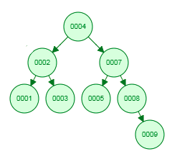

Show the tree after node 9 is deleted, then again after node 2 is deleted. Show the before/after trees resulting from any rotations.

CSC2638 Data Structures AVL Trees name____________________________

1. **4pts**

Show a 2-3 tree after each insertion:

23 47 19 11 113 119 17

CSC2638 Data Structures AVL Trees name____________________________

1. **4pts**

Discuss the node deletion algorithm for 2-3 trees. Give an example for each case.