CS3321

3d Transforms

V2.0 – a little realism

In the previous assignment you read in a blender generated list of vertices and faces which collectively define your object.

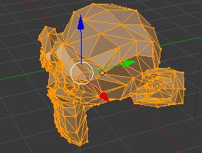

In this assignment you will:

* Use fixed pipeline openGL to draw your object
* Calculate a surface normal for each triangle
* Draw the triangle only if the normal says the face should be visible
* Set the color of each triangle as a function of the angle between the viewer and the surface normal.

Assume the viewer sits outside the screen on the z-axis.

You choose the base color and interpolation function.

**Calculate Surface Norma**l

To calculate a surface normal for a triangle:

Use the three vertices to create two vectors on the surface of the triangle. If your vertices are P1, P2, P3, use V = P2-P1 and W = P3-P1 as your two vectors.

Calculate the cross product of V and W to get the surface normal:

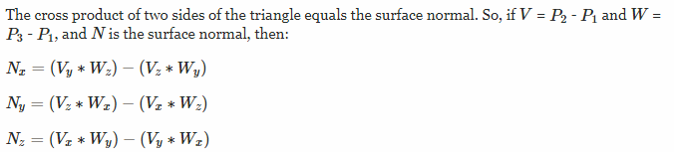

**Find the angle between the surface normal and the viewer**.

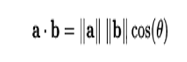

If **a** is the normal vector and **b** is the vector which points from the face to the viewer, you can use the formula above to solve for theta.

**Draw the triangles**

Use fixed pipeline openGL:

void

render() {

glClearColor(0.8, 0.8, 0.8, 0.5 );

glClear(GL_COLOR_BUFFER_BIT);

glBegin(GL_TRIANGLES);

glVertex3f(0.0f, 0.0f, 0.0f);

glVertex3f(0.75f, 0.0f, 0.0f);

glVertex3f(0.75f, 0.75f, 0.0f);

glVertex3f(0.0f, 0.0f, 0.0f);

glVertex3f(-0.75f, 0.0f, 0.0f);

glVertex3f(-0.75f, 0.75f, 0.0f);

glEnd();

glutSwapBuffers();

}

But of course loop through your face array instead of hardcoding two triangles. Don’t draw the triangle if it should not be visible. Pick a base color for your object. If a face is visible, use a color somewhere between your base color and black depending on the angle to the viewer. Linear interpolation is fine, but try experimenting with other options (our eyes are not linear)

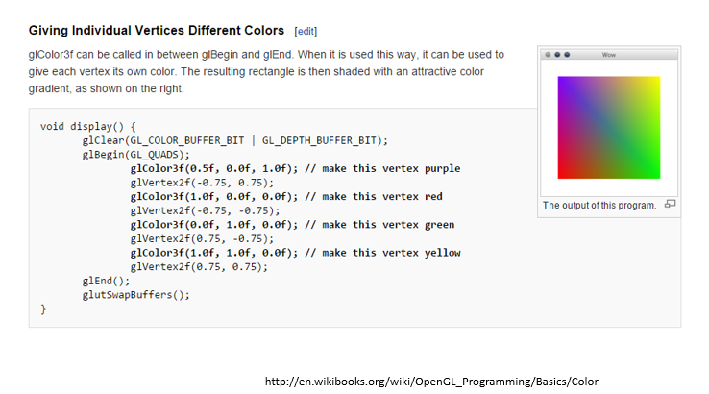

Compile your program like this:

cc -o displayProg displayProg.c -lGL -lGLU -lglut -lm

Show it to me in class, and email the source code by the deadline.