Computer Graphics Bezier Assignment
CSC3841, Spring 2018

Part 1.
Extend the bezier code we went over in class:

- increase the control points to 4, this is still in 2D
- implement an OpenGL program which will draw the resulting curve
- all points will stay in the range -1.0 < p < 1.0

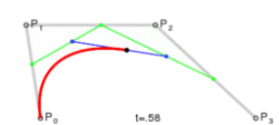

The four control points and the step size will be command line parameters like this:

./bezier1 -0.53 0.001 -0.0 0.5 0.8 -0.8 0.01

OpenGL has built-in Bezier primitives, but this is to be implements without using them, draw the individual point instead. Use GL_POINTS for the fixed pipeline.

Part 2
Further extend your code to implement draw a Bezier surface. Use a 4x4 array of control points and again render point by point with:

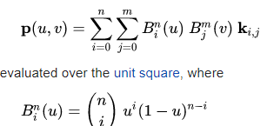
which should look like (toggle the control points on/off with a keyboard/mouse input):
