Computer Graphics IP Assignment 2 due midnight 5/16
CSC3841, Spring 2018

Extend the program below to implement the following functionName operators:

- sharpen
- Gaussian blur
- unsharp masking

Defined by the following masks respectively:

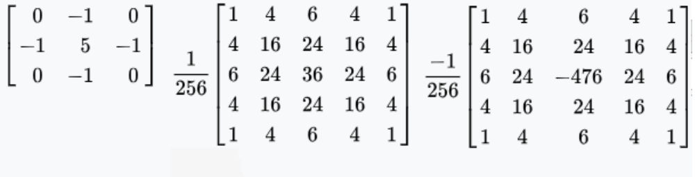

The original assignment:

Write a program which takes either 2 or 6 command line arguments:

ip imagefile functionName

or

ip imagefile x y width height functionName

ip is the executable name and will be your image processor.

imagefile is the image on which you will operate. You need only deal with image formats which are recognized by java ImageIO classes. For this assignment we will ignore any alpha channels if they are present.

x,y,width,height, if they are given, denote a rectangular sub-image within the image on which to operate. If they are missing, operate on the entire image.

functionName is a string which denotes the image processing primitive to perform. For this first assignment you need only recognize the string “sobel”.
When the function is sobel, pass the sobel masks from the slides over the image.
One mask is passed left to right, like a typewriter dropping down a line when it reaches the right edge. The other mask is passed down columns in a similar way. This will generate 2 values for each output pixel. Combine these two using the square root of the sum of the squares as discussed.

Note that you will do this for each of R,G, and B. For simplicity here at the beginning, you can use the getRGB() method of BufferedImage. It is slow but simple. No problem if you wish to read ahead and access the pixel data directly.

Display a window with the modified (sub)image.

