Project Moonlyhte

By Tom Tan

**Table of Content:**

1. **Overview**

* **Logline**
* **Pillars**
* **Concept**
* **Background**
* **Notable People**

1. **Moonlyhte**
2. **Iggdras**
3. **Society**

* **Bahu**
* **Gui**
* **Seilong**
* **Suza**

1. **Beastiary**

* **Fauna**
* **Floral**

1. **Conclusion**

**Overview**

**Logline:** In a world of perpetual night, humanity has grown accustom to a sunless world with the power of moonlyhte. However, a group of unlikely people journey together across the land to bring back the sun.

**Pillars:**

**The Infinite Loop:** There is a beginning and an end and a return to the beginning. During a cycle, things will grow and change, but at the very end, everything will return to how it was before just as each day begins at dawn and ends at dusk, but the cycle will just begin anew at dawn the next day. Is it ever possible to break free from this loop?

**Perspectives:** Everyone views the world differently. Even when those within your party share the same goal, they do not share the same opinions of the world. Understanding their point of view and helping them with their troubles will strengthen your bonds with them.

**The Ultimate Choice:** There are many tough decisions that must be made in every journey. It may be as simple as left or right or as tough as who gets to live and who gets to die. But at the very end, the Chosen of Iggdras must determine whether humanity is ready to return to the light or the cycle of darkness must continue again.

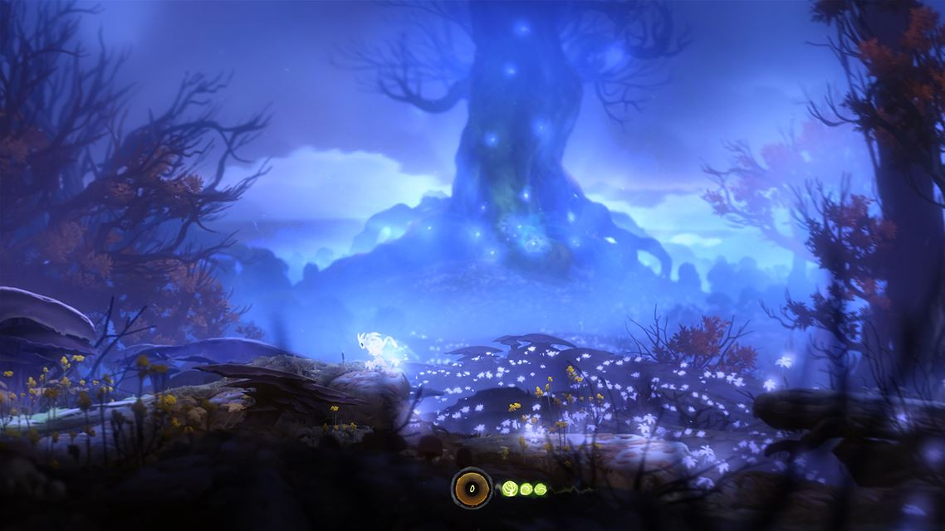**Concept:**

Welcome to Asra, a world in perpetual night. There is no sun that brightens the day and the moon is the only source of light in this dark world. However, in the center of this continent stands a tree so massive it can be viewed at any point on the continent. This tree is Iggdras, the World Tree, and it provides sustenance for all life on this continent with the power called Moonlyhte. Moonlyhte is an energy that is created from Iggdras by absorbing moonlight and process it into an energy and light source which is then release into the world as air, water, and ore.

Despite the lack of sunlight, life seems rather good but within the darkness lies a sinister evil. This evil is called the Shadows, creatures made from pure darkness born from the darkness in the hearts of man. Even worse, each country within Asra host a Guardian, gigantic monsters that destroy any living things in its path. During the “dark” season, when the moon is at the lowest point in the sky, the Shadows and Guardians freely roam the realm driving fear in the hearts of everyone.

However, when the world is at its darkest, Iggdras provides an individual with the Mark of the Sun, a mark giving its wielders the power to vanquish the darkness from the land and the power to return the sun to the world. Yet, despite many who became the Chosen of Iggdras, none have successfully brought back the dawn. The Chosen either succumbed to the darkness or judged the world too corrupted to save.

**Background:**

Lore

Legends tell how the sun goddess watches over humanity with her benevolent light. But as time passed, she saw how wicked humanity has become and in her grief she vanished from the world. The world fell into darkness, but the moon goddess showed mercy upon humanity by planting Iggdras at the center of the world, giving them the power of moonlyhte. Moonlyhte is both a blessing and a curse. It gave humanity the ability to adapt to their dark environment and advance faster than ever before, but it also brought forth the Four Guardians who becomes active during the Dark Season, when the moon is the least visible, and destroy everything in their path.

Current State

Asra is ruled by the Valryx Empire under the leadership of Emperor Thraun. Before he was emperor, he was part of a rebellion to overthrow the previous emperor who was a neglectful ruler. Thraun was a Chosen of Iggdras, but after witnessing the atrocities of humanity, he became emperor to fix the world himself. At first, he was respected but as time pass his methods became more aggressive and he was feared just as much as the previous emperor was hated. History repeats itself and a new rebellion rose to oppose him.

The Chosen

Every hundred years or so, a Chosen is selected by Iggdras to bear the Mark of the Sun. Some believe that the Chosen is just an individual who happens to stumble across the extremely rare Amaten Flower (which gives whoever plucks it the Mark of the Sun) found near Iggdras. Others believe that Iggdras will reveal the Amaten Flower to those destined to become a Chosen. When someone becomes a Chosen there is no clear goal they must undertake. Legends say that the Chosen of Iggdras is tasked with bringing back the sun, but they are given neither clues or task to reach that goal. Instead, it seems that large events are drawn to the Chosens. By simply proceeding as if they have never become a Chosen, they still manage to end up bringing about great changes and clues to end the neverending nights. Whether this is a coincidence or a grand design, no one will ever know.

**Notable People:**

Ascendants: These are the residents of Iggdras. People who live under the tree believe them to be divine beings who protect the tree from harm, but they are simply the remainders of the Solarian religion that live and tend to the tree.

Emperor Thraun: Rules the world with an iron grip. He wishes for a unification of the world, but resorts to violent tactics in order to achieve his goals. He has been in power for 80 years yet he is still vibrant and strong due to the power from the Mark of the Sun.

Emperor Orin: The previous emperor before Thraun. He was part of the original family that founded the empire, but unlike his predecessors who strive to protect the world, he destroyed it. His lax rule allowed crimes to grow rampant within the countries and his lavish lifestyle ruined the lives of many. Those who opposed him were instantly executed and he uses the army that was meant to protect the people to subjugate them.

The Four Guardians: The Four Guardians are giant beast that roam their respect lands, destroying everything in their path. The guardian of Bahu is a white tiger with a serpentine tail and the ability to control the wind. The guardian of Gengu is a rock tortoise that can manipulate gravity. The guardian of Seilon is a serpentine dragon that can manipulate the water currents. The guardian of Suza is a phoenix that spreads fire with its wings.

**Moonlyhte**

**What is moonlyhte?**

Moonlyhte is the energy source that fuels the world. Without sunlight, life could not be sustained but moonlyhte provided for what was lost. Moonlyhte is ubiquitous and is intertwined with the air people breath, the water people drink, and the land they walk. The source of moonlyhte stems from Iggdras, which takes in moonlight and process it into moonlyhte energy. The moonlyhte is then released and mix with whatever medium is available.

From the leaves, moonlyhte vapor is released and saturates the air with moonlyhte particles. This is the most abundant form of moonlyhte as the whole world breathes in the moonlyhte filled air. Since it is so abundant, it is the easiest type of moonlyhte to manipulate.

From the trunk, moonlyhte is mixed with the water that the tree intakes and then release the moonlyhte rich water into the lake surrounding the tree. From the above ground and underground lakes, the moonlyhte rich water is carried across the world by connecting streams and rivers. The farther the source of water is from Iggdras the less concentrated the water is with moonlyhte. However, in certain regions, it is not uncommon to run across a very pure pool of moonlyhte water that comes from the underground lakes.

The final form that moonlyhte comes in is a metallic form. The roots of Iggdras radiates moonlyhte energy throughout the earth and through heat and pressure, the moonlyhte turns into a mineral that carries massive amounts of energy.

**Effects:**

The properties of moonlyhte are abundant and varied. In its vaporous form, people who are intuned with moonlyhte (those who are adept with wielding it are called casters) can manipulate it by separating it with the other particles in the air. When separated, it loses its colorlessness and takes on a misty light blue color. In this form, the moonlyhte can manipulate physics. Hurling the energy can grant explosive force to those that come in contact. When channeled on an object, it can make the object lighter or even levitate. To the mass, using moonlyhte is compared to telekinesis. However, this is not its only use. By combining the pure moonlyhte with other elements, it allows the user to control the elements as well. For example, mixing it with intense heat can create fireball or the ability to manipulate fire. Mixing it with water can allow user to control the water and form ice or steam. And mixing it with air (which it usually is) condense air to the point that it can cut rocks.

The properties of moonlyhte in water slightly different from air. The natural state of moonlyhte is a gas so if it mixes with water and is separated it retains its gaseous form. However, liquid moonlyhte when separated from water is still a liquid. There is two main effects of liquid moonlyhte. Liquid moonlyhte in water can have a restorative effect on living creatures if there is a balance proportion of it in water. Pure liquid moonlyhte can be poisonous to the body due to moonlyhte overdose and its second effect. The other effect is gravitational control. The higher concentration of moonlyhte in water the more gravitational effect there is, so congesting pure liquid moonlyhte can potentially disrupt bloodflow. Most of the time, this effect is dormant unless there is a reaction from an active form of moonlyhte, which typically comes from moonlyhte manipulated by casters. When active, it gives unnatural buoyancy even to the point of allowing people to walk on water if it is compacted to a small area. However, its gravitational effect can be seen in natural, especially in the Uphill River where the water flows uphill from the base of Iggdras to a lake in the mountainous region of Bahu.

The final form of moonlyte is a mineral ore. This type of moonlyhte is called moonlite and it has a purple phosphorescent color. Moonlite is highly reactive and can give off massive amount of energy. When process, it gives off energy similar to electricity so moonlite has been used to power most of Asra’s technology. When ignited, moonlite gives off brilliant purple flames and can even create magnetic forces when reacting with manipulated moonlyhte by casters.

**Iggdras**

Iggdras is a massive tree that lies at the center of the continent. It is so large that it can be seen from any point of the continent. No one knows how Iggdras came to being except through the legends. Many believe that it is a gift from the moon goddess to help people survive the darkness and for the most part, they aren’t wrong. Iggdras is the source of all moonlyhte and moonlyhte is the nutrient that keeps the floral life prospering. Similarly, moonlyhte allows for humanity to protect themselves against the darkness and the dark creatures that lurk within.

The people who live on the ground worship Iggdras and often make pilgrimage to visit its roots. Then there are those curious individuals who wish to scale the tree to see what is above it. No one has ever managed to reach the branches of Iggdras because there is a society living amongst the branches tasked with protecting the tree. These people are known as the Ascendant and they nurture Iggdras and protect it from harm.

**Society**

**Land and Culture:**

The continent of Asra is split into 4 distinct landscapes. Each one is its own country and has its own distinct culture, but they are united under the Valryx Empire.

To the west is Bahu, the land of eternal forest. This land is covered with all kinds of tress and is known for having the most beautiful yet dangerous forest there is in all the land.

To the north is Gengu, the land of the treacherous dark mountains. From any one point, all one can see are the jagged snow covered peaks of Gengu. Majestic yet foreboding, these mountains are the homes for the hardiest of people. One of the major phenomenon of Gengu is the floating mountains, which is caused by gravitational flux from high concentration of metallic moonlyhte in the mountains.

To the east is Seilon, the land of a thousand islands. The people living in each island share a similar culture, but not a single one are united. Just as it is the land of a thousand islands, it is also the land of a thousand nations. Some islands create friendly relations with nearby islands by forming bridges and markets, while other invade their neighbors and pillage them for resources.

And finally, to the south is Suza, the land of the burning desert. Here many live nomadic lives wandering the endless sand. Those who aren’t nomadic migrate to the few cities scatter throughout the desert, the most prominent one being the capital of the continent. Despite the perpetual night, the sands provide warmth by hidden heat sources beneath the sand. One of the most spectacular sights is when these flames erupts onto the surface and lights the land with its raging flames.

While the world is capable of certain modern technology due to the abundance of energy source from moonlyhte, it is stuck in a medieval era because the constant fight against the Guardians and shadows hinders technological advancements.

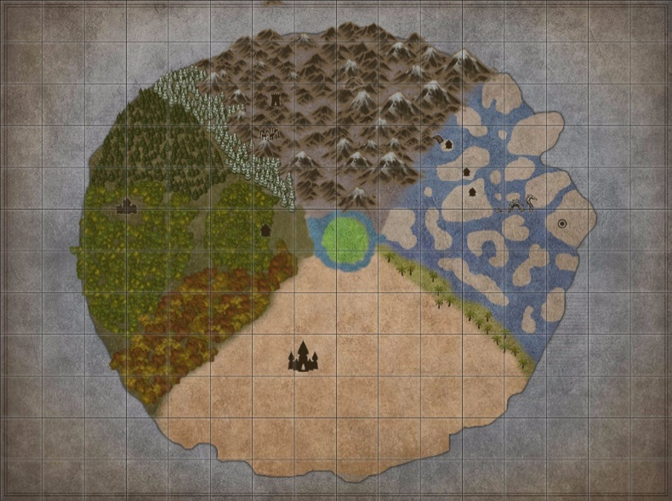

Bahu

This country lies to the west of Iggdras. It is known for being almost entirely covered by forests.

Gengu

Gengu is the nation north of Iggdras. It is completely covered by jagged snow-covered mountains and is the harshest environment to live in.

Seilon

Seilon lies to the east of Iggdras. Unlike the other countries, it isn’t a single landmass. Instead it consist of hundreds of islands ranging from tiny 100 meter islands to massive ones that can hold several towns.

Suza

**Conclusion**

There are three main dilemmas that are present within this world and each are tied to the others. The main dilemma is the lack of a sun and the main quest is for those who bear the Mark of the Sun to find a way to bring back the sun. This ties to the problem with the Four Guardians. The guardians are entities created from moonlyhte and the only real way of killing them is with the power of the Mark of the Sun. When a Chosen kills a guardian the Chosen collects the essence of the Guardian and that is one of the steps in bringing back the sun. The final dilemma is with the empire, or just the problems in the society of the world. The world is shackled by corruption, slavery, warfare, and attacks by Shadows and Guardians. Fixing the wrongs of the world is another quest that the Chosen must face.