Economic Balance of Enrichment, Burnup and Disposal for Commercial LWRs

Robert Carlsen

UW-Madison Research Assistant: 1500 Engineering Drive, Madison, WI, 53706, rcarlsen@wisc.edu

INTRODUCTION
The lack of back-end fuel cycle consensus and implementation in the United States and other countries around the world has driven the nuclear industry to an optimum state of economics that is unrealistic. Mining, enrichment, reactor operations, research spending, among other things have all been affected. Optimum fuel enrichment is chosen based on the cost of obtaining the fabricated fuel while its ultimate disposal and care are not generally considered. Because a back-end fuel cycle has not yet been implemented in the U.S., it is not clear how actual costs for back-end fuel cycle possibilities such as reprocessing, retrievable interim storage, and geologic disposal will affect economically optimum operations in the nuclear industry.
This analysis attempts to investigate one potential effect of this uncertain back-end fuel cycle cost - namely the potential for higher initial fuel enrichment to reduce the rate of spent fuel generation through increased fuel burnup in reactors. A rather naive approach is taken in order to limit the scope of this analysis.

ANALYSIS AND DISCUSSION
For the purpose of this analysis, ballpark values are selected for costs associated with mining/milling, conversion, and enrichment. The focus of the analysis is determining the impact of spent fuel disposal costs on ideal fuel enrichment for commercial power reactors. In order to limit the scope of the analysis, operation and maintenance costs, time required for refueling, changes in spent fuel properties with higher burnup, non-linearity in mass-based disposal costs, and other significant factors are ignored. In effect, this analysis is intended to provide economic insight into the effects of higher fuel enrichment on ejected spent fuel mass. Costs are normalized on a per kWh basis. Because the profit that offsets fuel cost (both front end and back end) is acquired through the sale of electricity (on an unit energy basis), a kWh cost normalization most appropriately reflects the economic tradeoffs between the enrichment process and fuel disposal. Burnup calculations as discussed in the “Burnup Limitations” section of this report are used to convert unit mass basis costs to unit energy basis costs.

Front End Fuel Costs
The front end of the fuel cycle consisting of mining/milling, conversion, and enrichment are considered in this analysis. Because fuel fabrication cost is very weakly correlated with fuel enrichment, fabrication costs are not considered. As the nuclear industry has aged, concerns regarding limited Uranium supply have diminished greatly. As such, for this analysis, a static, a figure of US $100/kg U3O8 is used for the cost of mining/milling of Uranium. A conversion cost of US $6.50/kgU is also included in the front end fuel cost. Several factors affect the cost of enrichment: the cost of the feed, the feed enrichment, the tail enrichment, and the product enrichment. The feed enrichment is assumed to be 0.0071 (U235 mass fraction). The product enrichment is varied over the range of 0.0071 to 0.20 (U235 mass fraction). The 0.20 enrichment maximum was chosen because civilian operations utilizing highly enriched uranium (enrichments greater than 20%) are not allowed by law. Because the tail enrichment is generally optimized with respect to feed cost and Separative Work Unit (SWU) cost (both assumed to be static in this analysis), a tail enrichment of 0.003 (U235 mass fraction) was chosen - a value typical of currently operating facilities.
Using standard separations potential and mass conservation techniques, the Seperative Work Units (SWU) required to achieve a specific enrichment per unit mass of product is calculated using equation 1.

Cost is calculated by applying the representative numbers as outlined previously using equation 2. Note that although the differing cost basis units of mining/milling (kgU3O8) and conversion (kgU) are taken into account, the conversion contribution to the total cost is still very small.

At typical commercial LWR fuel enrichments (3.5 to 4% U235) 60% of the fuel cost is driven by the cost of the Uranium resource itself (mining/milling) while only 40% is due to the actual enrichment process itself. At 20% enrichment, the cost split between the uranium resource and enrichment is approximately 50%-50%. Despite the dampening effect of the cost of the enrichment process, cost volatility in the uranium resource will have significant impact on the results of an analysis such as this.
Figure 1 shows that the SWU required per unit mass of product is approximately proportional to the product enrichment fraction. Because mining, milling and conversion are also constant-cost per unit mass of throughput, over the range of product uranium enrichment (0.71% to 20%), the front end cost per unit mass of product increases approximately linearly with enrichment. This is not particularly interesting because the profit that offsets fuel cost is acquired through the sale of electricity.
The front end fuel cost per unit energy extractable from the fuel grows and asymptotically approaches a maximum cost (see Figure 2). There is a diminishing cost penalty per unit energy of the fuel as enrichment increases. Ignoring factors such as reactor operations and maintenance costs and burnup limitations, the shape of the cost-per-kWh vs enrichment curve in Figure 2 indicates that the costs associated with running higher enrichments in fuel could be significant and prohibitive in the lower enrichment regime.
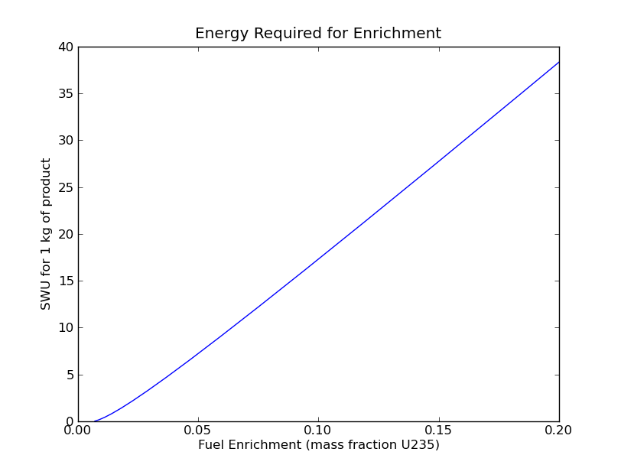Figure 1: Enrichment requirements normalized per unit mass of enriched product. Calculated using equation 1.
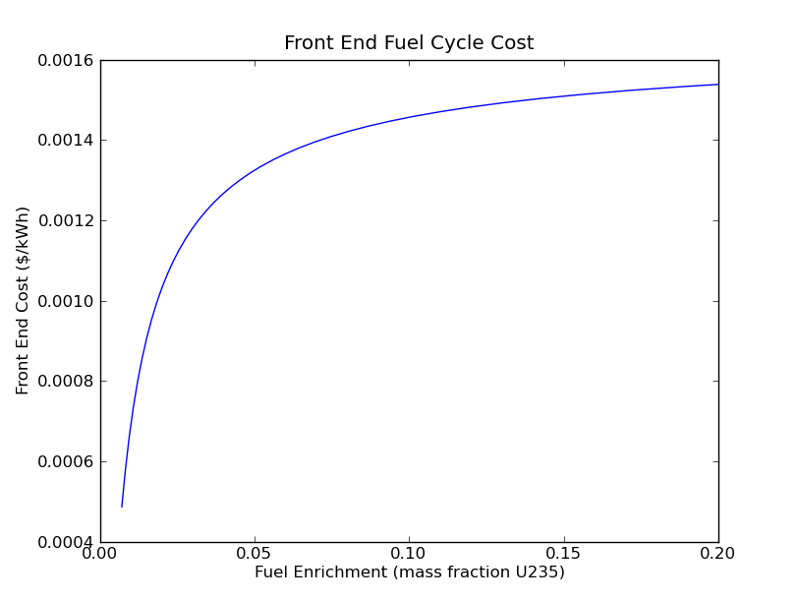Figure 2: Combined frontend cost of enriched fuel including mining/milling, conversion, and enrichment. Calculated using equation 2

Back End Fuel Costs
In the United States, efforts to complete the nuclear fuel cycle have been crippled by the 1 mill/kWh fee instituted by the Nuclear Waste Policy Act (NWPA). Traditional once-through disposal fuel cycle analyses, influenced by the 1 mill/kWh basis to varying degrees, often suggest back end fuel cycle costs of around $500/kgHM The INL publication “Advanced Fuel Cycle Cost Basis” section L-12. [1] exemplifies such estimates. Another analysis suggests that a more realistic cost for a back end fuel cycle that includes recycling is 2 to 3 mills/kWh. [2] A 2 mill/kWh back end cost is roughly equivalent to $2500/kgHM in this simple analysis (assuming 3.5% enrichment along with the other representative values discussed in the “Front End Fuel Costs” section).
The NWPA charges utilities on a per unit energy basis for the disposition of spent nuclear fuel. The majority of published resources identified during this analysis contained disposal economic analyses using a per unit mass basis for disposal. Although the cost of disposal will likely depend to some degree on the spent fuel characteristics (affected significantly by burnup), the per unit energy based fee seems extreme and effectively penalizes responsible consideration of spent fuel generation and disposal. As such, unit mass based disposal costs, while not a perfect approximation, are used in this analysis.
The uncertainty in the fuel cycle back end (e.g. once through vs LWR recycle vs. LWR and Fast recycle vs. etc.), and correspondingly back end fuel cycle economics, equates to uncertainty in the economics of enrichment. In order to gain an understanding of the interplay between enrichment and back end uncertainty, disposal costs ranging from 0 to $2000/kgHM are considered. In parts of this analysis that do not explicitly require varying disposal costs, a cost of $600/kgHM is used.

Burnup Limitations
Maximum burnup for specific enrichments are calculated using a simple linear extrapolation from known maximum single-batch burnup (B₁) for specific enrichments. Data for this extrapolation were obtained from Driscoll, Downar Linear Reactivity Model. For every 1% increase in enrichment, approximatly 10 GWD/MTU burnup is added to the maximum single-batch burnup. The discharge burnup is calculated using equation 3. [3] Reactor cores are assumed to run 3-batch cycles with a maximum burnup equal to 1.5 times the maximum single-batch burnup. Fuel enriched to 20% would achieve a maximum discharge burnup of 300 GWD/MTU for this analysis. The calculated burnup was used to convert front and back end fuel costs from a unit mass basis to a unit energy basis.

Several factors impact maximum achievable burnup in power reactors. These can be broken into two broad categories: safety and economics. Primary safety concerns include handling of higher-activity spent fuel, criticality safety for fresh fuel, fuel cladding integrity, and reactor transient characteristics. Economic issues include the cost of higher enriched fuel, systems for regulating larger reactivity swings (e.g. boron, burnable absorbers, more control rods, etc.), and local power peaking (requiring lower total power levels for the core). These factors actually limit practical maximum discharge burnup in LWRs to around 100 MWD/kgU. [4] This corresponds to a fuel enrichment of approximately 7%. Burnup toward 200 MWD/kgU and beyond will most likely will require fast reactor technology.

The Enrichment-Disposal Tradeoff
The economic penalty for enrichment approaches a maximum in an asymptotic fashion while the disposal costs drops with diminishing returns as enrichment increases. The drop in disposal cost as enrichment is increased is a manifestation of the reduced spent fuel volume (and mass) per kWh of electricity generated; this in turn is due to the higher burnups achievable with higher initial enrichment in the fuel. The economically ideal enrichment is a result of the balance between the increased front end fuel cost and the decreasing disposal cost. The total fuel cost is calculated as a linear combination of the energy basis normalized costs of the front end and back end costs (see Figure 3).
While cost volatility in the uranium resource could have a significant effect on the overall fuel price, its impact on the economics of fuel enrichment is much less significant, particularly with the uncertainty in the cost associated with the back end of the nuclear fuel cycle. While an increase in the uranium resource cost increases fuel prices, it has minimal impact on the shape of the cost-enrichment curve (see Figure 4). Increasing the uranium resource cost effectively just translates the entire curve upward. Variations in the disposal cost, on the other hand, affect the shape of the cost curve and even cause an inversion in the cost-enrichment curve near lower disposal costs (see Figure 5). Using the ballpark values with a $600/kgHM disposal cost, the analysis suggests that the economic benefit of increasing initial fuel enrichment is approximately zero. This reinforces the idea that the 1 mill/kWh fee has prevented the industry from moving forward on back end fuel cycle technology. At higher back end fuel cycle costs, around $2000/kgHM and beyond, increasing fuel enrichment above the typical 4% has the potential to reduce overall fuel cycle costs by 20% or more. For all disposal costs above a certain threshold (approximately $600/kgHM for the numbers used in this analysis), the optimum enrichment is as high as possible but with diminishing returns.
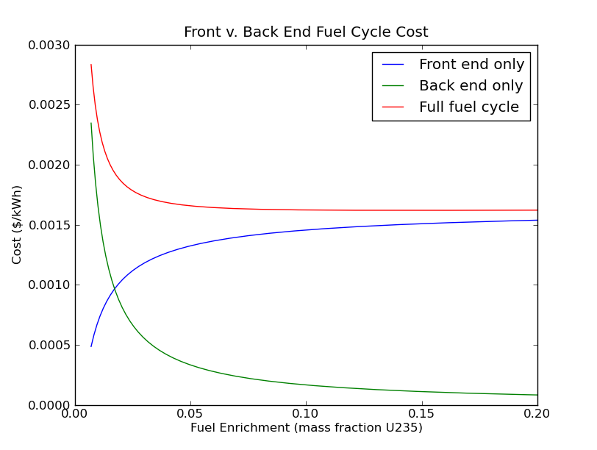Figure 3: Fuel cycle costs build from linear combination of front end and back end costs. Normalized to unit energy basis using burnup estimates from LRM.

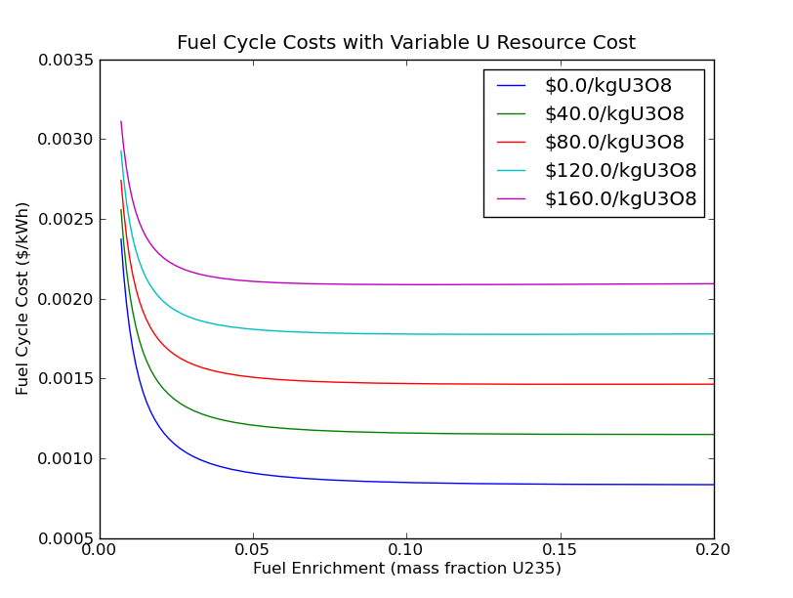Figure 4: Affects of mining/milling cost on the entire fuel cycle cost – enrichment fraction curve.

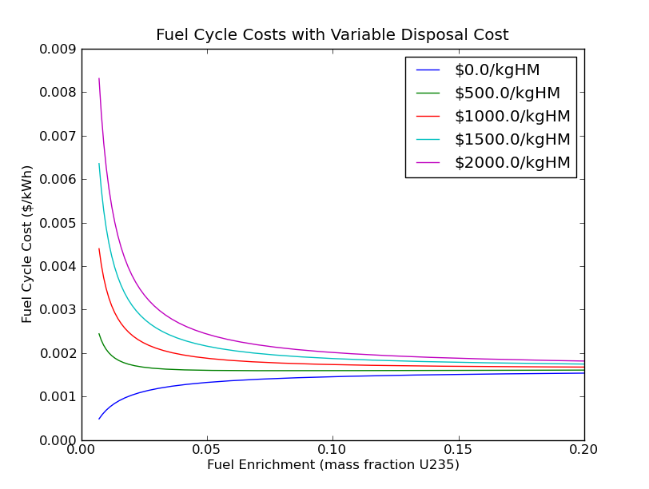Figure 5: Affects of disposal cost on the entire fuel cycle cost - enrichment fraction curve.

CONCLUSION
While the results of this analysis can provide understanding of tradeoffs, it is important to remember that the real-world problem has many issues that are not addressed here. These unaddressed issues include power reactor operations and maintenance, changes in spent fuel properties with respect to higher burnup, non-linearity in mass-based disposal costs, etc.
While changes in the cost of obtaining the uranium resource can have significant impact on overall fuel handling costs, it has negligible impact on the economically ideal enrichment. At current once-through disposal cost estimates, the cost of higher enriched fuel is not compensated for by the reduced disposal cost. Disposal costs above $500/kgHM begin to show an economic benefit to higher enrichment, but this benefit begins to become significant only above $1000/kgHM.
Although this analysis shows potential benefit to increasing enrichment, current U.S. Policy precludes enrichment cost recovery through reduced disposal mass. The NWPA energy based fee has removed much of the commercial industry’s incentive to pursue higher enrichment and smaller spent fuel volumes. The only way to offset costs of higher enriched fuel is to run to higher fuel burnup in reactors. Since the NWPA disposal fee effectively increases the disposal cost proportional to burnup, no savings results from reduced waste generation. The NWPA has stifled industry innovation and promoted less responsible behavior with respect to spent fuel generation.

References
- Shropshire, D. E. et al, 2008, “Advanced Fuel Cycle Cost Basis,” INL/EXT-07-12107, March 2008. http://www.inl.gov/technicalpublications/Documents/3667084.pdf
- E.A. Schneider , M.R. Deinert , K.B. Cady, “Cost analysis of the US spent nuclear fuel reprocessing facility, Energy Economics”, Vol. 31 pp. 627–634, (2009).
- M.J. Driscoll, T.J. Downar, E.E. Pilat, The Linear Reactivity Model for Nuclear Fuel Management, American Nuclear Society Press, LaGrange Park, IL, 1991.
- OECD, 2006. "Very High Burn-ups in Light Water Reactors," OECD Papers, OECD Publishing, vol. 6(9), pages 32.

Appendix A - Python Code

import math
import matplotlib.pyplot as plt

kWhkg2GWdMT = 24000

def linspace(start = 0, end = 1, count = 1):
vals = [0]*count
step = float(end - start) / float(count)
for i in range(count):
vals[i] = start + i * step
return vals

class Costs:
def __init__(self, enrich = 133, convert = 6.5, mine = 100, dispose = 600):
self.enrich = enrich
self.convert = convert
self.mine = mine
self.dispose = dispose

class Matl:
def __init__(self, mass = 1, enrich = 0):
self.Form = ''
self.E = 0
self.Enrich = enrich
self.Val = 0
self.M = mass

def ValPerKg(self):
return self.Val / self.M

def ValPerKWh(self):
return self.Val / self.E

def mine(m, cost):
m.Form = "U3O8"
m.Enrich = 0.0071
m.Val += cost * m.M
return m

def convert(m, cost):
m.Form = "U"
UvTot = 3. * 238 / (3. * 238 + 8 * 16)
m.M = UvTot * m.M
m.Val += cost * m.M
return m

def enrich(m, cost, tgt, tail):
P, nswu = swu(m.M, m.Enrich, tgt, tail)

m.Val += cost * nswu
m.M = P
m.Enrich = tgt

return m

def burn(m, nBatches):
# modify b1 formula to taste
b1 = 1000 * m.Enrich

# LRM discharge burnup
bd = 2.0 * nBatches / (nBatches + 1) * b1

m.E = bd * kWhkg2GWdMT * m.M
return m

def dispose(m, cost):
m.Val += cost * m.M
return m

def swu(F, xf, xp, xt):
P = (xf - xt) / (xp - xt) * F
T = F - P
return P, P * potential(xp) + T * potential(xt) - F * potential(xf)

def potential(x):
return (1 - 2 * x) * math.log((1 - x) / x)

def onceThrough(m, costs = None, prod = 0.035, tail = 0.003, nBatches = 3):
if costs is None:
costs = Costs()

mine(m, costs.mine)
convert(m, costs.convert)
enrich(m, costs.enrich, prod, tail)
burn(m, nBatches)
dispose(m, costs.dispose)

def frontend(m, costs = None, prod = 0.035, tail = 0.003, nBatches = 3):
if costs is None:
costs = Costs()

mine(m, costs.mine)
convert(m, costs.convert)
enrich(m, costs.enrich, prod, tail)
burn(m, nBatches)

def backend(m, costs = None, prod = 0.035, tail = 0.003, nBatches = 3):
if costs is None:
costs = Costs()

burn(m, nBatches)
dispose(m, costs.dispose)

def vary_dispose():
maxenr = .2
natenr = .0071
enrichments = linspace(natenr, maxenr, 10000)
disp_costs = linspace(0, 1000, 10)
for cost in disp_costs:
valkg = []
valkwh = []
for e in enrichments:
m = Matl()
onceThrough(m, Costs(dispose = cost), prod = e)

valkg.append(m.ValPerKg())
valkwh.append(m.ValPerKWh())

plt.plot(enrichments, valkwh, label = str(cost))

plt.title('Fuel Cycle Costs with Variable Disposal Cost')
plt.xlabel('Fuel Enrichment (mass fraction U235)')
plt.ylabel('Fuel Cycle Cost ($/kWh)')
plt.legend(['$' + str(c) + '/kgHM' for c in disp_costs])
plt.show()

def vary_mining():
maxenr = .2
natenr = .0071
enrichments = linspace(natenr, maxenr, 10000)
mine_costs = linspace(0, 200, 10)
for cost in mine_costs:
valkg = []
valkwh = []
for e in enrichments:
m = Matl()
onceThrough(m, Costs(mine = cost), prod = e)

valkg.append(m.ValPerKg())
valkwh.append(m.ValPerKWh())

plt.plot(enrichments, valkwh, label = str(cost))
plt.title('Fuel Cycle Costs with Variable U Resource Cost')
plt.xlabel('Fuel Enrichment (mass fraction U235)')
plt.ylabel('Fuel Cycle Cost ($/kWh)')
plt.legend(['$' + str(c) + '/kgU3O8' for c in mine_costs])
plt.show()

def swuplot():
maxenr = .2
natenr = .0071
enrichments = linspace(natenr, maxenr, 10000)

swus = []
feedswus = []

for e in enrichments:
p, s = swu(1, natenr, e, 0.003)
# s / p for swus/kg-product or just s for swus/kg-feed
swus.append(s / p)
feedswus.append(s)

plt.plot(enrichments, swus)
#plt.plot(enrichments, feedswus)
plt.title('Energy Required for Enrichment')
plt.xlabel('Fuel Enrichment (mass fraction U235)')
plt.ylabel('SWU for 1 kg of product')
#plt.legend(['1 kg of enriched U', '1 kg of feed U'])
plt.show()

def only_dispose():
maxenr = .2
natenr = .0071
enrichments = linspace(natenr, maxenr, 10000)

kgcosts = []
kwhcosts = []

for e in enrichments:
m = Matl(enrich = e)
backend(m, prod = e)
kgcosts.append(m.ValPerKg())
kwhcosts.append(m.ValPerKWh())

plt.plot(enrichments, kwhcosts)
plt.title('Back End Fuel Cycle Cost')
plt.xlabel('Fuel Enrichment (mass fraction U235)')
plt.ylabel('Back End Cost ($/kWh)')
plt.show()

def only_enrich():
maxenr = .2
natenr = .0071
enrichments = linspace(natenr, maxenr, 10000)

kgcosts = []
kwhcosts = []

for e in enrichments:
m = Matl()
frontend(m, prod = e)
kgcosts.append(m.ValPerKg())
kwhcosts.append(m.ValPerKWh())

plt.plot(enrichments, kwhcosts)
plt.title('Front End Fuel Cycle Cost')
plt.xlabel('Fuel Enrichment (mass fraction U235)')
plt.ylabel('Front End Cost ($/kWh)')
plt.show()

def front_back():
maxenr = .2
natenr = .0071
enrichments = linspace(natenr, maxenr, 10000)

frontcosts = []
backcosts = []
fullcosts = []

for e in enrichments:
m1 = Matl()
m2 = Matl(enrich = e)

frontend(m1, prod = e)
frontcosts.append(m1.ValPerKWh())

backend(m2, prod = e)
backcosts.append(m2.ValPerKWh())

backend(m1, prod = e)
fullcosts.append(m1.ValPerKWh())

plt.plot(enrichments, frontcosts)
plt.plot(enrichments, backcosts)
plt.plot(enrichments, fullcosts)
plt.title('Front v. Back End Fuel Cycle Cost')
plt.xlabel('Fuel Enrichment (mass fraction U235)')
plt.ylabel('Cost ($/kWh)')
plt.legend(['Front end only', 'Back end only', 'Full fuel cycle'])
plt.show()

if __name__ == '__main__':
#vary_dispose()
#vary_mining()
#only_enrich()
#only_dispose()
#front_back()
swuplot()

