Cardiac Illness Risk Assessment System
Gabrielle Vanderburgh
Robert Cost
CS4800 Wright State University

INTRODUCTION
PURPOSE
The purpose of this report is to fulfill the requirements of CS4800 in which a final report covering the final project is required. Also, the medical information field is very interesting as well as a good market for Computer Science skills.
Problem
Heart disease is the major cause of death for people in the U.S. Early detection of heart disease is critical for physicians to diagnose and treat the affected patients effectively. The National Institute of Health (1) has developed an early detection system named the “Framingham” method. This method uses vitals recorded from the patient and calculates a Risk Assessment Score (RAS). This method calculates the risk of heart attack of the patient in the next 10 years. This project uses an android phone to accept user identification and vitals, calculate the RAS, store it locally and then send it to a web site MySQL database. A web page is provided for the user to critical values using php server side connections to MySQL and java script client side coding for efficient data flow from user to the database. Additionally the MYSQL data is available for easy access of external RDF queries using a D2R server.

SCOPE
The scope of this report will be covering the application starting with the android collection of user vitals up and to the display the user will use on their browser to view critical RAS information.
BACKGROUND
The implementation of an early detection system for heart disease must be easy to use and be based on sound theory. The National Institute of Health through their National Cholesterol Education Program developed a method to evaluate a patient’s risk of heart attack in the next 10 years. This method called the “Framingham” method is based on medical research and uses Cholesterol, blood pressure, historical medical information and age vitals. This medical information is then entered onto an android phone. The phone calculates the score and displays it to the user. The user then has the option to send the data for permanent storage to the database on the CIRAS web site. Periodically, the user can browse to the CIRAS website, login and view all critical vitals and RAS scores stored on the MySQL database. Also the MySQL database schema is mapped for RDF queries for semantic searching.

Discussion
The object of this project is to allow a very convenient way for patients at risk of heart disease to calculate their RAS and together with their physician if treatments are having beneficial effect. The problem of entering data is always a cumbersome task if the user has to use an awkward and difficult platform for vitals’ collection. The android phone was selected for this project for multiple reasons. One is that the phone is very common and is very convenient for a user to use. Another reason for picking the android system is the wealth of applications and stability of the operating system. The user can enter vitals on the screen easily. Figure 1.0 shows the android screen used for entering vital data.
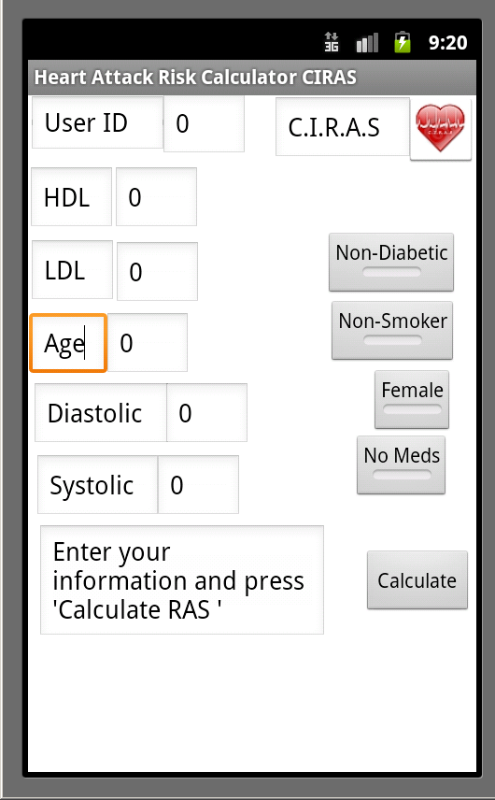
Figure 1.0

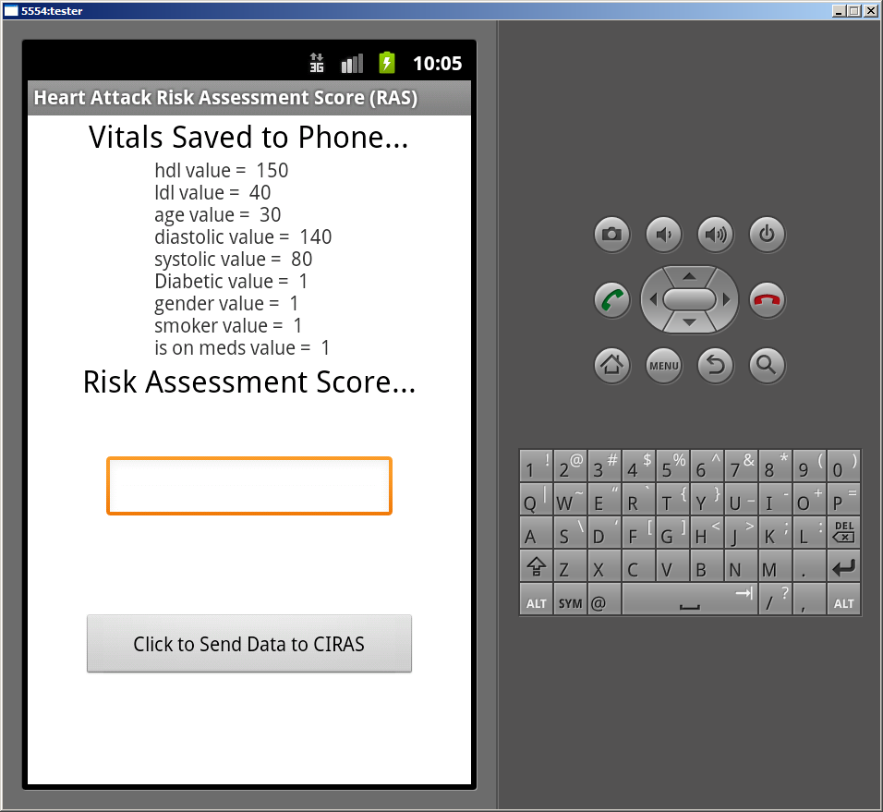
The android application stores the entered data on a SQLite database located on the phone. This database is already installed on every android phone and is already part of the system. SQLite is easy to use and access from the Java platform. Saving the information locally on the android phone will allow the user to backup information that is sent to the web site’s MySQL database. The android calculates the RAS based on the user’s vitals and the Framingham method formerly mentioned. The android phone uses Java programing language to do the calculation. Also the user can calculate a RAS score and send it later to the web site if phone is out of service area. Figure 1.1 is the android screen in which displays the saved data and RAS Score.
20
Figure 1.1

The android uses an http post to a php page on the web server to save the database to the CIRAS webpage’s MySQL database. An example is shown below in Figure1.2.
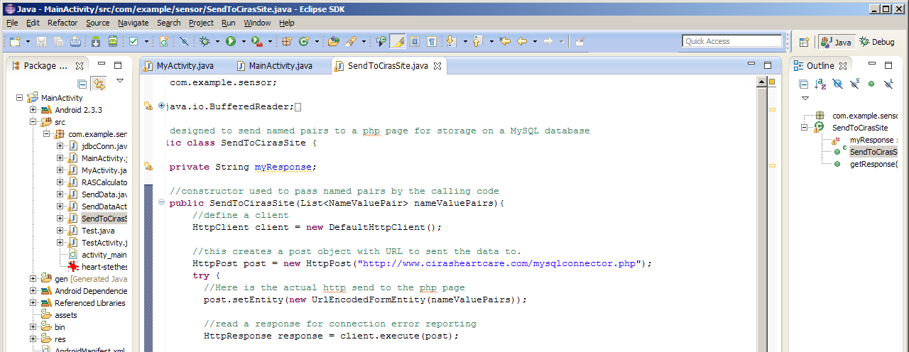
This example creates a http client object and a post object that includes the URL of the php page needed to accept and store the data sent by the phone. This form of MySQL connection was chosen because direct connection from android to a Database connection is risky because of unreliable cell service. Database connections require stable high bandwidth connections and cell technology is not at that level yet.
The next step in this data flow is the data being passed to the php server on the “CIRAS” website. The code below used to accept the named pairs sent by the phone to the php server and then insert them in a MySQL database located on the site. The php page mysqlconnector.php is shown below in figure 1.4
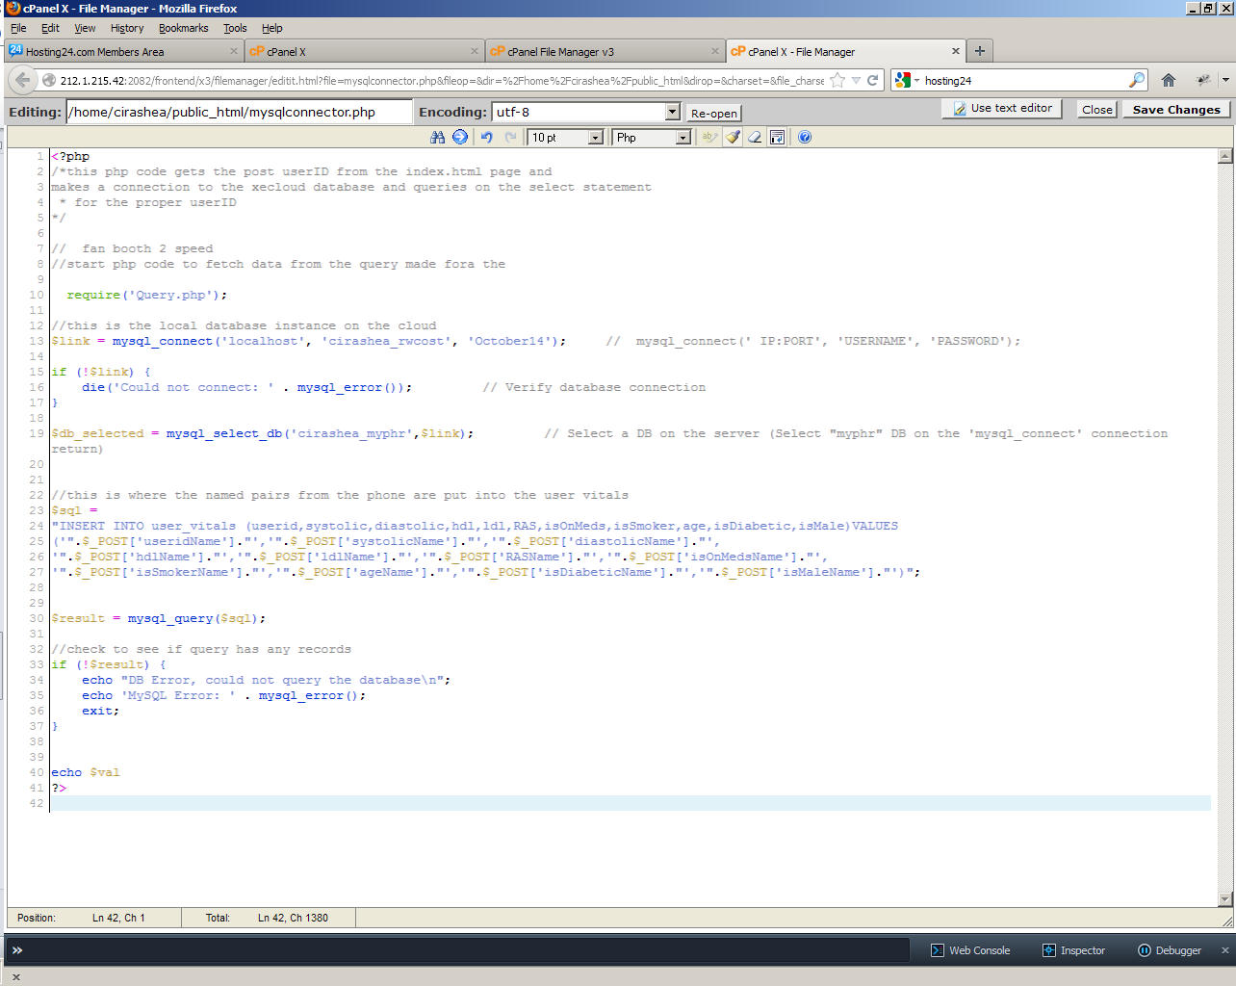
Figure 1.4
The data is stored in a table called “user_vitals” on database named “cirashea_myphr”. Views are created on the database to calculate and display maximum, average and minimum values of critical vitals. An example of one complete SQL statement for getting the maximum values of each critical vital…
select `user_vitals`.`userid` AS `userid`,max(`user_vitals`.`RAS`) AS `max(RAS)`,max(`user_vitals`.`ldl`) AS `max(ldl)`,max(`user_vitals`.`hdl`) AS `max(hdl)`,max(`user_vitals`.`systolic`) AS `max(systolic)`,max(`user_vitals`.`diastolic`) AS `max(diastolic)` from `user_vitals` group by `user_vitals`.`userid`

The result of this statement is in Figure 1.5
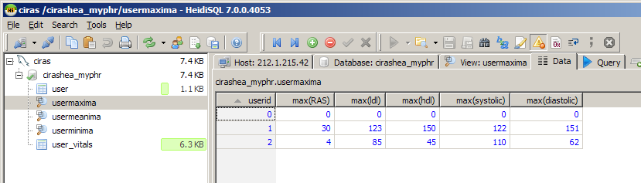
Figure 1.5

Similar statements are used for the average and minimum values. The datapage.php php code page will use the ‘userid’ sent to query the correct record as in the example below in Figure 1.6
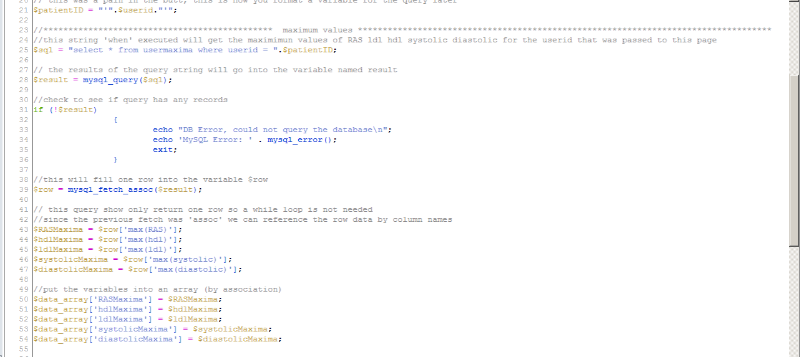Figure 1.6
Note that the ‘mysql_fetch_assoc’ command will use the ‘column’ names in the MySQL database for referencing the associative values in those columns.
RDF is an acronym for Resource Description Framework, which allows computers to search stored data on websites. The MySQL schema on the CIRAS site is mapped for RDF and html browsers by using the following command.
generate-mapping -o mapping.n3 -d driver.class.name
-u db-user -p db-password jdbc:url:..
The D2R server then uses that mapped file to serve the MySQL database information to the requesting computer. The D2R server can run as a service on your web server. For a graphical representation see Figure 1.7 (2)
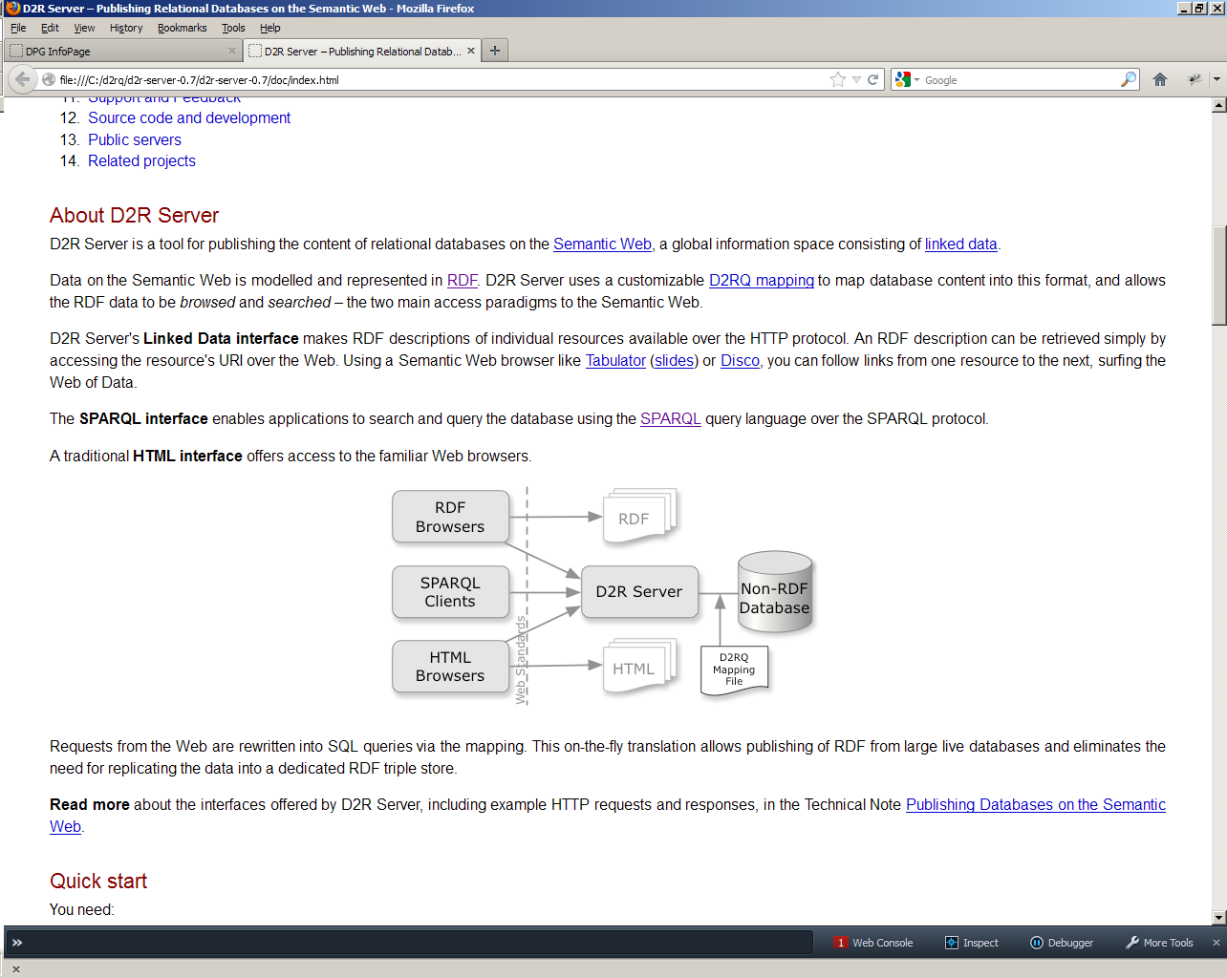
"D2R Server | The D2RQ Platform.
" The D2RQ Platform â€“ Accessing Relational Databases as Virtual RDF Graphs. N.p., n.d. Web. 6 Dec. 2012. <http://d2rq.org/d2r-server>.

Figure 1.7
The patient can use a web browser to view their data the android phone has passed to the web site’s MySQL database. The MySQL database Views as described earlier, can be requested by the PHP page on the server. The PHP has few calculations to perform because the database calculates the extreme values such as maximum, minimum and average. This data can easily be reference by the www.cirasheartcare.com web page as shown in Figure 1.8
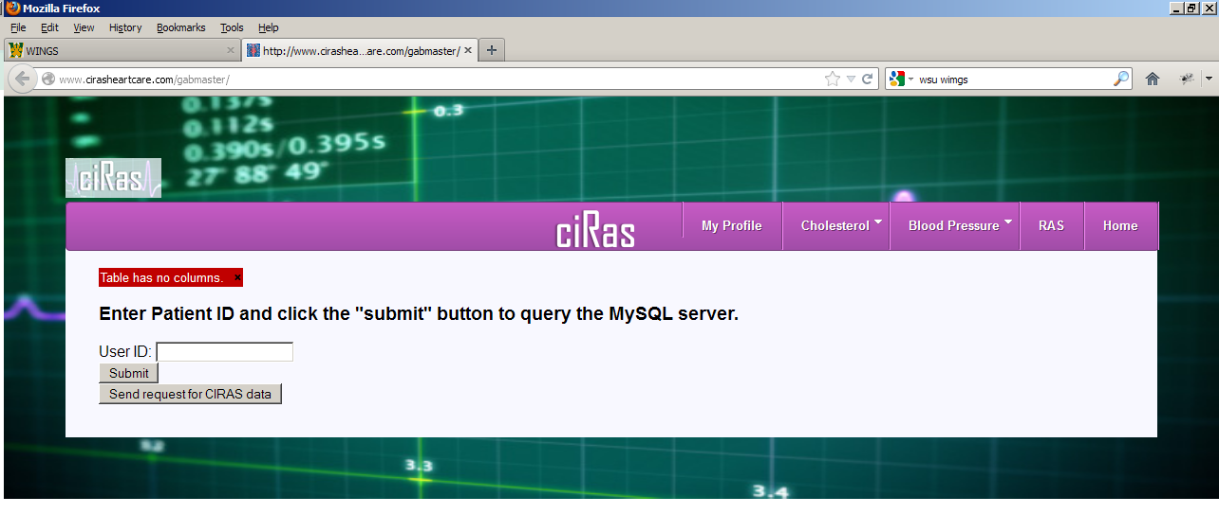
Figure 1.8
The client side of the web site incorporates javascript to send parameters to the server PHP page. Javascript then refreshes the client side page with data sent back (in json format) from the server (without reloading the entire page). The resultant data is then presented to the web user in the form of graphical data using the Google Chart Tools visualization tools residing on the server.
Conclusion
Heart disease is a voracious cause of deaths and it need not be. Early detection and treatment can dramatically reduce the number of deaths from this killer. Allowing people and their physicians to input vital health data will be a powerful tool to help them to analyze their progress against heart disease. Tracking of cholesterol and blood pressure values can give the physician a feedback loop to verify that a particular treatment is having a positive effective on the patient. The android phone is a very convenient way to enter the data. The application can be used with the CIRAS website or as a stand-alone application. Any android user can download it and use it to evaluate and store their RAS score. The D2R server will serve up data to outside clients requesting MySQL data using the MySQL mapping of the database schema in a stored map file in the D2R directory. The web page interaction is a powerful tool to see graphically the data collected over time. The object of this project is to help alert individuals to their risk of heart attack and also allow treated patients to gage their progress against the disease in the hope of extending the health of the user.

Works cited
- U.S. Department of Health and Human Services. National Heart, Lung, and Blood Institute. National Cholesterol Education Expert Panel on Detection, Evaluation, and Treatment of High Blood Cholesterol in Adults: Third Report. (NIH Publication No. 01-3670). Washington, DC, May 2001.
- "D2R Server | The D2RQ Platform." The D2RQ Platform â€“ Accessing Relational Databases as Virtual RDF Graphs. N.p., n.d. Web. 6 Dec. 2012. <http://d2rq.org/d2r-server>.

