Creative Midi
User Manual

1. what is creative midi.

Is Creative Midi a D.A.W (Digital Audio Workstation)? No.
Is Creative Midi like MixMaster ? No.

Creative Midi is a tool for communicating with a keyboard. The applications is tested with a Yamaha PSR-SX600. But in my believe, it can be extended to other keyboards also (Yamaha as well as other manufacturers like Korg, Roland, ...). I must tell that this application is built on missing or difficult desires.

2. Folder structure.

If you look at the directories, you will notice quite some. That is a choice made to present data to the user under dedicated directories and not keep them hidden.

The structure looks like

- Creative Midi
(the application folder which contains the run batch file to startup the application. It is called ‘run’. So, open a command window and execute the run file

d:/CM/run

At this point, you can pass also the ‘-l’ flag to switch on logging. This is useful when something should go wrong (I’m not all-knowing), so you can send me the logging file (my contact information is included at the end of this file.

The Creative Midi folder has many other folders:

- export
- logs
- midi
- playlist
- properties
- style
- sysex
- system
- voices

The remaining folders are explaning in next sections.

2.1 export folder

2.2 logs folder

2.3 midi folder

2.4 playlist folder

2.5 properties folder

2.6 style folder

2.7 sysex folder

2.8 system folder

2.9 voices folder

When you start up the application you are presented by with the main screen.

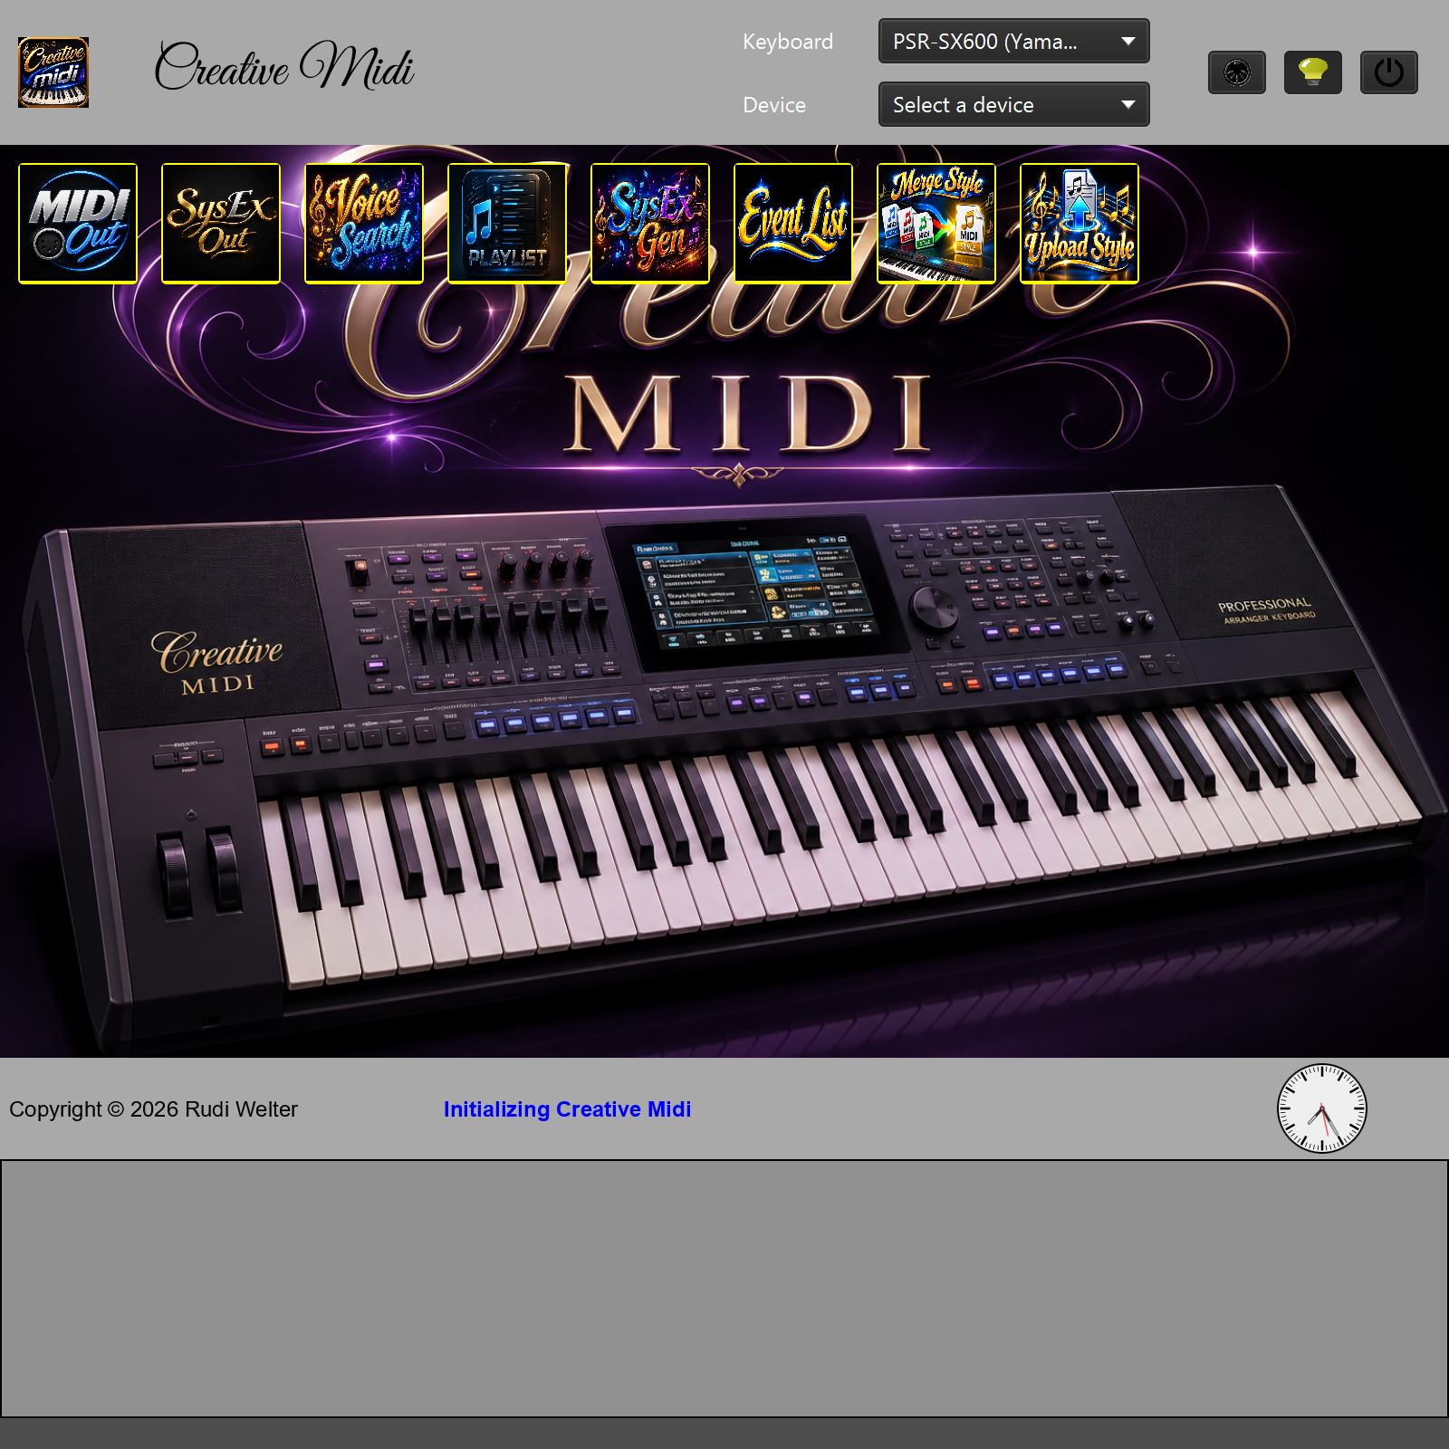
picture-1: The main screen.

The application has no usual windows or mac style look. You can’t close it by pressing a close window button (as the application is undecorated). You can move the screen around by clicking in the title screen and move it.

You’ll notice that the screen is divided into 4 parts:

1. Upper part
The Upper part is the header. It contains the title section on the left and a buttons section on the right. The title section just displays the application name and its icon. Besides this section we find the buttons section. It’s about these buttons

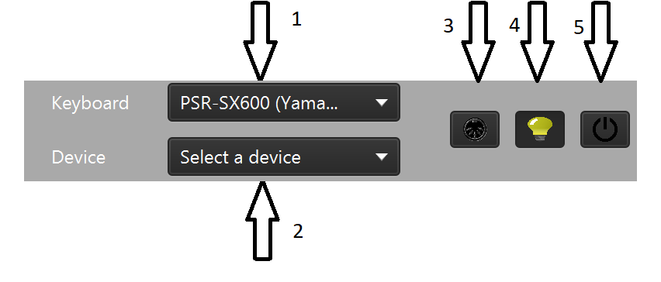

picture-2 : Main buttons section.

Button 1. Let us select the keyboard type.

Here we can select the keyboard we are going to use. These names are retrieved from the files found in the voices folder. These are the provided Yamaha files of the Midi Song To Style application. They can be downloaded from the Yamaha support site [TODO Link To Yamaha]. These files will also be used in the application to search for available voices. The keyboard file can also be and .ins file (I used one which I created myself for use with Cakewalk). Although the ins files are converted for use in the application, it is also good to have the official file as that will be used to find the voice on the keyboard. In the examples folder I included my ins file and the official PSR-SX600 voices file from Yamaha. When using an ins file, some functionality in the application is not usable because of invalid grouping. I’ll explain in detail that when we get there.

Button 2. Let us select the device. When we speak about the device, think of that as your keyboard. This selection box is empty when you’ve attached a keyboard to the computer but the keyboard is switched off. When you switch on the keyboard, CM detects that and the selection box is filled in. When you switch off the keyboard, CM detects it that the connection is lost and this selection box is cleared again.

TODO screen shot van ingevulde box.

Button 3. Shut-up button.

I noticed sometimes that when using the keyboard to play sounds (e.g. playing a midi), sometimes it keeps sounding, even when the used functionality is stopped. This button is used to shut-up the keyboard.

Button 4. Theme button.

The light-dark mode switch. Switches the application to light mode or dark mode. For start-up, this can also be controlled using a property (see property files). Screen 1 is taken using the dark mode.

Button 5. Exit button.

This button closes the application. It also closes connection to the keyboard (and will shut-up it).

2. Center part
The center part is used for all screens. I use what is called a SPA (Single Page Application). So, all detail pages will swap in the part. At startup, you’ll see the sceen as shown in picture-1, the startup screen.

3. Status part

This part is used to show a copyright notice and a clock. But also here, status messages will be shown. In picture-1, you’ll notice the status message ‘Initializing Creative Midi’.

4. Monitor

The monitor is used for monitoring the messages received from and send to the device (the keyboard). Later usage will be shown in its proper section. // TO DO add cross reference to this section.

x. The Main Screen.

The main screen provides us with buttons which take us to detailed pages.
The pages are:

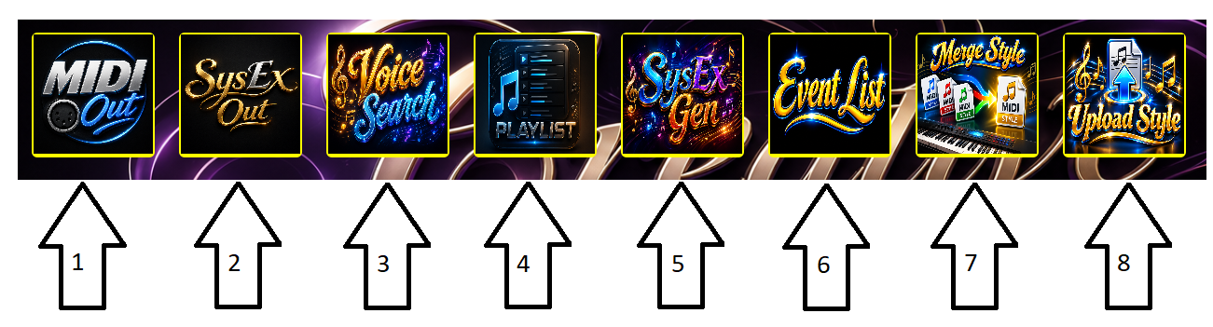
picture-3 : The Main Screen

1. Midi Out (to send midi commands to the keyboard)
2. SysEx Out (to send sysex to the keyboard)
3. Voice Search (to search for voices)
4. Playlist (to create and play a playlist)
5. SysEx Gen (to create system exclusive events)
6. Event List (to handle the event list from a midi file)
7. Merge Style (to merge a style with a new midi file)
8. Upload Style (to upload a style to the keyboard)

Each time an action button (Button1 .. 8) is pressed, a new screen is shown instead of the main screen). I’ll show here a screen (which will be empty for a new application).

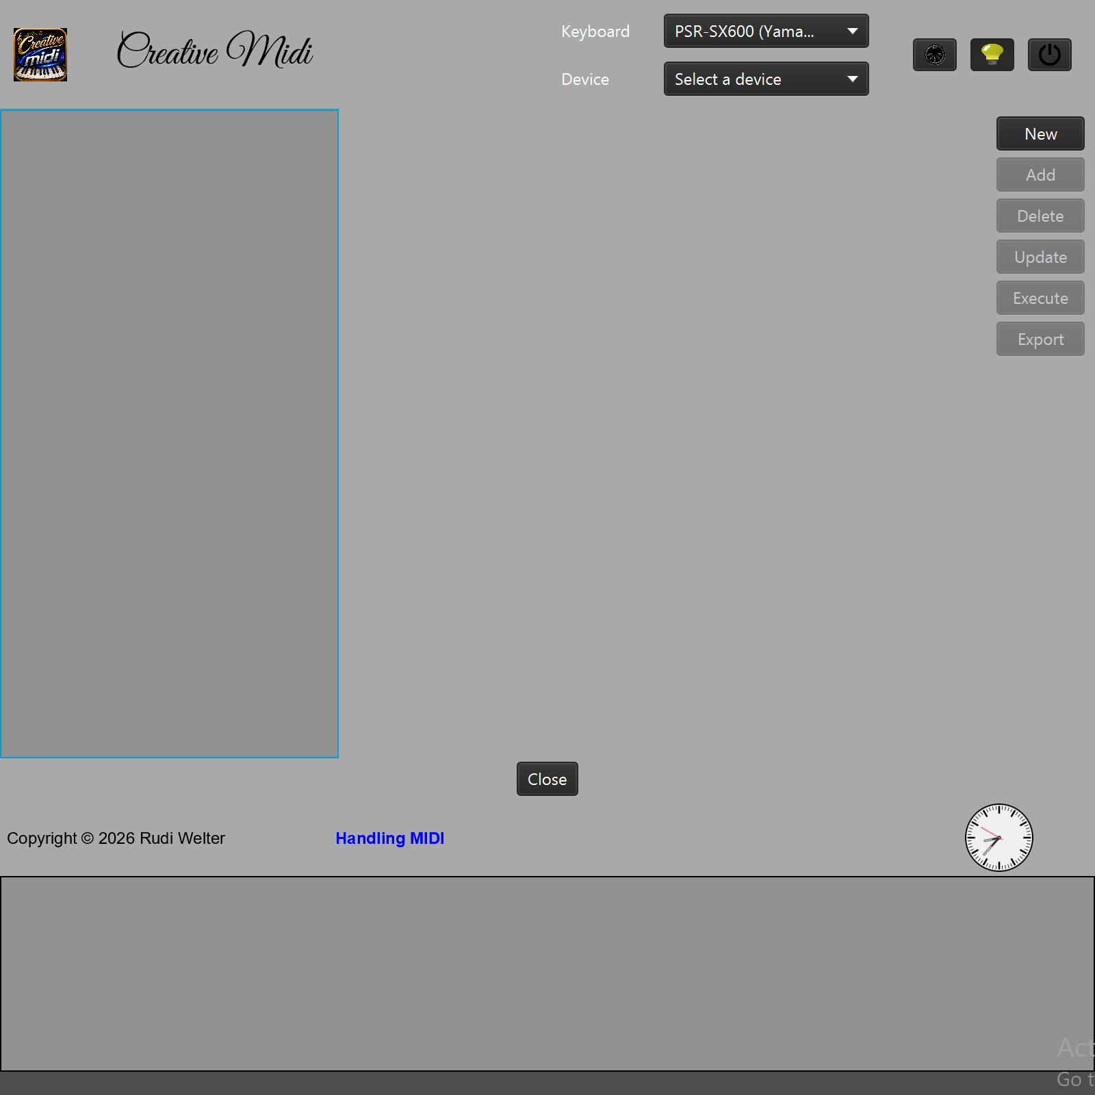
Picture-x : Another application screen

This screen appears when we click an action button (button 1..8 in picture-x) on the main screen.
So, the contents of the main screen are replaced by another screen. All screens in the application work like this. To return to the Main Screen, just press the Close button. That button closes this window and return to the main screen.

So, for now, we are ready to explore the other screens. However it is necessary that you set you keyboard with a proper MIDI connection otherwise the application won’t work as required. In section xx, the midi settings for the PSR-SX600 are shown and explained.

a. MIDI Out section.

In the midi out screen, we can define MIDI’s and send them to the keyboard. To get to the MIDI Out screen, press button 1.

TODO Image of button 1.

Ok, I admit. Sending out midi”s is not very spectacular and many applications have it. But it is first a nice warming up and it provides a way to send midi’s to the keyboard because that is necessary for later use. Let’s try a simple example. We are going to let the keyboard play a note. As we can find (e.g in the manuals of a keyboard such as the datalist) a note on midi message is

MIDI COMMAND: Note On,
beschrijven.

xx. Example
I’m going to try to get all functionality explained by using an example.

First of all we are going to create a midi. This is not so important, but keep in mind that this apllication send out quite a lot of midi messages to the keyboard. So it is important that the keyboard will receive those midis.

First we go to the midi screen by pushing the MIDI Out action button.

[SS midi out button.]

One of the he simplest midi commands we can send to the keyboard is the Note On message. As we can see int the datalist document of the keyboard, the Note On command is like this:

It is a channel message meaning we need to define a channel. And the message looks like

Channel: 0..15 (CM uses 1..16),
Status byte = 9nH (where n is the channel)
and the databytes are
data1 => kk = key number (where 60 is the central C)
data2 => velocity (from 0 to 127)

So, we’re going to send this a central C with velocity 100 on channel 1 so the message will look like: 90 3C 64.
90 is command 9nH with n = channel 1 (which corresponds to 0)
3C (is the hexadecimal representation of 60, the central C) and
64 (is the hexadecimal representation of 100) as velocity.

m. Keyboard MIDI settings.

n. Contact.

To contact me, you can send an email to rudi.welter@gmail.com with the Subject starting with Creative Midi. If necessary, attach the log file. If possible, if you can reproduce the problem and explain the steps you took will be very helpful.

Regards,

Rudi Welter
Belgium – Diest

