Main

boolean islanding

boolean isCalled

int passengerOutput

int count

intcallCount

int landingOutput

int attendantOutput

+ callAttendant(buttons : AttendantControl[], seat : int)

+ attendantAnswer(buttons : AttendantControl[], seat : int)

+ lightStatus(buttons : AttendantControl[], seat : int)

PassengerButton

- boolean isLit

- String indicatorLight

- String seatNumber

+ <<constructor>> PassengerButton(seat : String)

+ setLit(isLit : boolean)

+ getIndicatorLight() : String

+ setIndicatorLight(indicatorLight : String)

+ buttonPressed(isPressed : boolean)

+ clearCallLight(isCleared : boolean)

+ toString()

AttendantControl <<extends PassengerButton>>

- boolean islanding

+ <<constructor>> AttendantControl(seat : String)

+ setIsLanding(islanding : boolean)

+ getIsLanding() : boolean

+ acknowledgeSetCall(isAcknowledged : Boolean, seatNumber : int) : String

Ex. Setting up number of seats

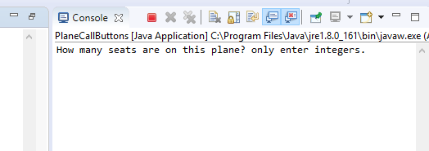

Ex. Making a call to attendant and attendant answering that call.

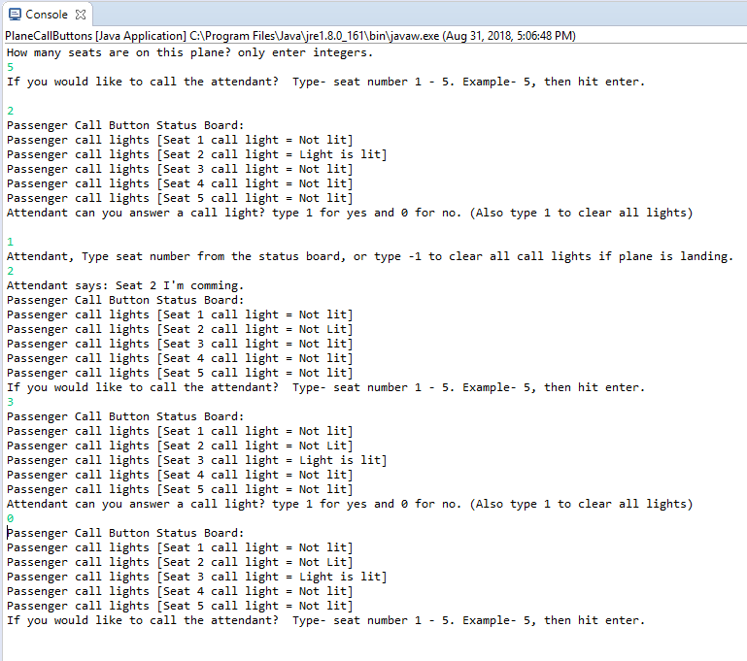

Ex. Of multiple calls and the attendant selecting to clear all lights.

