**Intro to coding workshop and Website Basics**

Have you ever wondered what coding is? Have you ever wondered how a website is made? Are you curious to what Computer Science is? Well this is the workshop for you! Microsoft Student Partner Ryan will be hosting a free workshop Thursday November 3rd on all of the said topics. You can bring your own computer, or you can use a computer in the Lab. We will be making a website like the one below! No experience is necessary. Hope to see you there!

**When: Nov. 3rd 6:00 – 8:00pm**

**Where: 301 MLH**

**Cost: FREE**

**Experience Necessary: 0 experience is needed! We will cover the basics!**

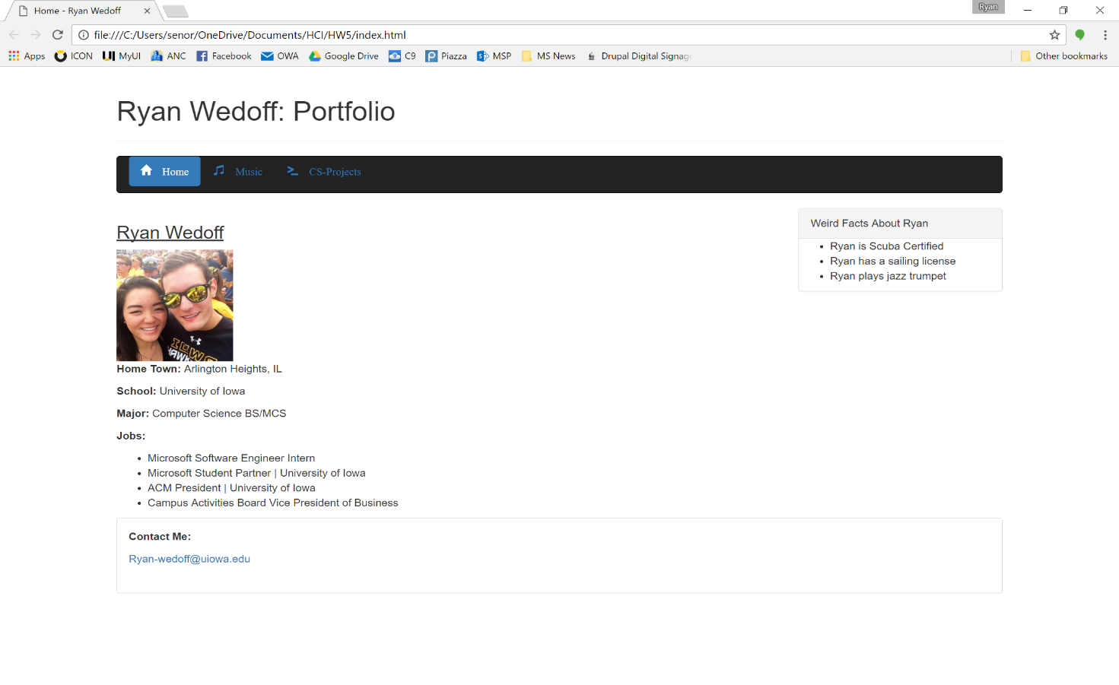**What will we build: A personal Website**