A novel approach for geoelectric field response scaling factors used in geomagnetic storm hazard assessments

A. Pulkkinen1, P. Schuck1, E. Bernabeu2, R. Weigel3 and R. Arritt4

1NASA Goddard Space Flight Center, Heliophysics Science Division.

2PJM Interconnection.

3George Mason University.

4Electric Power Research Institute.

Corresponding author: Antti Pulkkinen (antti.a.pulkkinen@nasa.gov)

Key Points:

* New ground response information is available for updating the existing geomagnetic storm benchmarks.
* Magnetotelluric survey data are used to update the regional scaling factors that characterize the ground response (beta scaling factors).
* The new beta scaling factors indicate a significantly wider range of ground responses than thought previously in the federal standards context.
* The Mid-West and north-East and areas along the Appalachian mountains appear to be particularly exposed to the hazard.

Abstract

In this work, we describe an approach to characterize the ground response to geomagnetic storm drivers and recalculate the scaling factors that are used in the NERC TPL-007 geomagnetic disturbance (GMD) standard based on magnetotelluric (MT) survey measurements.

The new ground response scaling factors indicate a significantly wider range of ground responses from the one-dimensional model responses used in the original NERC geomagnetic disturbance standards framework. Futher, the region Mid-West west of the great lakes and north-East around New England and areas along the Appalachian mountains appear to be particularly exposed to the geoelectric field hazard under extreme space weather conditions. A more complete validation of MT data in GIC applications is warranted before usage of the presented results as a basis for possible updates to the NERC GMD standard.

1 Introduction

High-voltage power transmission system exposure to geomagnetic hazards has been a key space weather interest for the latest scientific research as well as U.S. federal regulatory actions. In the U.S., actions are being taken pertaining both to National Space Weather Strategy and Action Plan (*National Science and Technology Council*, 2019) and Federal Energy Regulatory Commission (FERC) geomagnetic disturbance (GMD) standards (*FERC*, 2015). Both actions involve geomagnetic storm benchmarks that provide scenarios for how major storm events can evolve in time and space. These benchmarks provide the natural environment characterization for hazard assessments that are used quantify the exposure of systems to major space weather events. Under the North Americal Reliability Corporation (NERC) GMD standards framework - called Transmission System Planned Performance for Geomagnetic Disturbance Events, or TPL-007 - all U.S. utilities operating specific types of transformers with a terminal voltage at or above 200 kV are required to carry out hazard assessments using the benchmark that was developed as part of the standards development process. TPL-007 went into effect for U.S. transmission system operators in 2020, with a 5-year implementation cycle.

The NERC standards drafting team defined the storm benchmark that characterizes the spatiotemporal evolution of the geoelectric field within a given analysis footprint (*NERC*, 2016). In a TPL-007 vulnerability assessment, this benchmark geoelectric field is used to compute geomagnetically induced currents (GIC) and determine grid vulnerability. GIC can lead to a voltage collapse (a blackout) and/or equipment damange (*NERC*, 2013; see also *Pulkkinen et al.*, 2017 for description of the complete chain of GMD hazards analysis).

A key challenge in developing GMD benchmarks is in finding a balance between physical detail and practical applicability. It is of particular importance that, while capturing the core elements of the physical environment, benchmark results can be used by utilities in engineering vulnerability assessments. With this in mind, the NERC framework described the 1-in-100 year geoelectric field with four key elements: maxium geoelectric field amplitude at a reference location, “alpha scaling” of the field amplitude as a function of geomagnetic latitude of the location of interest, “beta scaling” of the field amplitude as a function of the local ground conductivity conditions and a waveform that provides a representative temporal evolution of the magnetic field. See Appendix A for the full definition of the scaling factors. All four elements involve simplifying assumptions and are subject to further improvements. In this work, we describe a new approach to update the beta scaling factors using electromagnetic transfer functions (EMTFs) (*Kelbert, 2011****-2022***), which are derived from the latest magnetotelluric (MT) surveys that have now covered most of the contiguous U.S *(Schultz,* 2010*).*

*Love et al.* (2016), *Lucas et al.* (2020), *Kelbert and Lucas* (2020) and *Love et al.* (2022) (and references therein) developed GMD hazard estimates using the latest MT survey data. In contrast to those works, we characterize the ground response in a manner that is integrated directly into the FERC benchmark framework, using the concept of scaling factors. Thus, the beta scaling factors computed here can be applied directly in engineering assessments as required by TPL-007.

An effort by the Electric Power Research Institute (EPRI) also used MT survey data to update the beta scaling factors within the NERC framework. In their work, the ground response was derived over broad regional areas using two different methods. They first calculated the mean and median values from ground response distributions over a given region using the full 3D response (EPRI, 2020a), and then compared to the results from 1D transfer functions based on the same MT data (EPRI, 2019b). They then derived beta scaling factors (*EPRI*, 2020c), using the more conservative (higher) of these two regional response estimates. They additionally used these models (scaling factors and MT-derived 1D transfer functions), as well as a full 3D response on a 1-degree grid (<100 km spacing at mid-latitudes), to perform a model validation assessment using a real system model and measured GIC data (*EPRI*, 2020b). In that assessment, the GIC estimated from the scaling factors was compared to the GIC estimated using the 1D transfer functions and gridded 3D response, and was found to be comparable, supporting the use of scaling factors in an application setting. In contrast to the EPRI work, here we derive scaling factors on a sub-regional scale, which provides a pragmatic scaling factor that still retains the smaller-scale spatial variation of the more detailed full 3D models.

In Section 2, we discuss the MT surveys and EMTFs that provide the foundation for the new characterization of the ground response. We then describe how the EMTFs can be used to compute improved beta scaling factors. Section 3 provides concluding remarks and recommendations and caveats for usage of the new results in the NERC standards framework. The NERC GMD benchmark is described in Appendix A.

2 Computation of the novel beta scaling factors

The NERC GMD benchmark is described in Appendix A. While all elements in Eq. (A.4) can and should be improved over time (see *Electric Power Research Institute* (2019) for a discussion about the possible improvements in alpha scaling factors), there is a significant opportunity for improvement in the beta scaling factors due to the new availability of MT measurements since the original NERC GMD standards development effort. MT surveys have now covered most of the contiguous U.S. (*Schultz*, 2010) and those observations can be used to better quantify regional ground responses. It is worth noting that, while at the time of its publication NERC’s GMD standard relied on one-dimensional (1D) ground models, the drafting team recognized that the scientific foundations were continuously evolving, and consequently, the standard allows engineers to utilize “technically justified” ground responses. The approach proposed in this work can pragmatically be applied to enhance the grid vulnerability assessment and reduce the overall risk exposure to geomagnetic disturbances.

U.S. MT surveys and their usage in geoelectric field modeling efforts are described in a series of papers by *Schultz* (2010), *Love et al.* (2016), *Lucas et al.* (2020), *Kelbert and Lucas* (2020) and *Love et al.* (2022) (and references therein). In summary, surveys that record both the geomagnetic and geoelectric fields were conducted on a semi-regular grid with a nominal spacing of 70 km (see Figure 1). For each site, an EMTF that maps geomagnetic field variations into geoelectric field in the frequency domain is derived for periods from 10 to 10,000 s. These transfer functions characterize the full three-dimensional (3D) electromagnetic response to external excitation, and can be used to compute geoelectric for any given geomagnetic field, including the one that is part of the benchmark event. In our approach, the beta factors are computed using EMTFs, instead of regionally-averaged 1D models. This approach will allow higher granularity local specification of the ground response and usage of the latest empirical information.

We obtained the EMTFs from the IRIS database (*Kelbert et al.,* 2011-2022). The EMTFs used in this work was downloaded from the database November 2, 2024. Importantly, the EMTFs cover now the entire contiguous U.S. as well as parts of Canada. EMTFs for individual locations were then used to compute the corresponding geoelectric field with the 10-s resolution Ottawa March 12-14, 1989 geomagnetic field . Per the computation method established in the NERC standard (see Appendix A), we then computed the corresponding beta scaling factors by taking ratio between the obtained maximum geoelectric field amplitudes over the time series at individual locations and the maximum geoelectric field amplitude obtained with the same reference used in the original benchmark derivation, i.e. the 1D Quebec ground conductivity model (*NERC*, 2016). The obtained scaling factors define the maximum geoelectric field amplitude at a location for a given geomagnetic field waveform.

We note that the peak geoelectric field amplitude is of particular importance from the power transmissions system voltage stability considerations standpoint (see *Pulkkinen et al.*, 2017, and references therein). Per the NERC standard, the maximum geoelectric field is rotated through 360 degrees to find the worst orientation for GIC generation thus accounting for different polarizations of the field.

The new beta scaling factors are shown in Figure 1. As is seen from the figure, some of the beta factors amplitudes can be very localized and vary by an order of magnitude from the nearest neighbors. We argue that this is a reflection of the sometimes highly localized response in the observed geoelectric field (one component of the MT surveys), but that variation does not necessarily represent the response in the spatial scales that are pertinent to the GIC problem. In MT surveys, the typical separation between anodes used to measure the geoelectric field is the order of 100 m. In GIC applications, the relevant spatial scale is related to the distance between individual nodes of the power transmission system over which the geoelectric field is integrated.

Figure 1. Beta scaling factors (see Appendix A) computed using the the latest 3D MT transfer functions available via the IRIS database. Ottawa Geophysical Observatory observations for the Halloween storm of October 29-31, 2003 are used for the geomagnetic field time series. Colorcoding indicates the beta value at individual MT survey locations. The three gray lines indicate contours of 60, 50 and 40 degrees of geomagnetic latitude, respectively. Alpha scaling factor falls from 1 to 0.1 across the band of 60-40 degrees of geomagnetic latitude

To account for the higly localized response, we apply a 100 km averging mask to the beta factors, centered at each MT site. The result is shown in Figure 2. As is seen from the figure, the 100 km averaging mask smoothes the spatial variation and emphasizes the regional characteristics of the ground response. We argue that these beta scaling factors are applicable for hazard assessment in the NERC GMD standards framework.

Figure 2. The same as in Fig. 1 but with 100 km averaging mask applied to the individual locations and linear color scale is used.

3 Discussion

There are two particularly striking features in Figure 2. First, the range of beta scaling factors using the 100km averaging (0.05 – 5.4) is significantly wider than the original factors obtained using the 1D ground models (0.21-1.17). *EPRI* (2020c) reported scaling factor ranges of 0.1 – 4.3 on regional scales. It is also seen from Figure 2 that, in many areas, the beta scaling factor is significantly larger than 1 indicating that 1D Quebec ground conductivity model is not necessarily a good representation of “resistive” ground. According to the MT survey data, many regions have significantly more resistive response as seen in large beta scaling factors.

The second striking feature in Fig. 2 are two specific regions where the beta scaling factors range between localized values of 3-5. These regions are the mid-West west of the great lakes and north-East around New England and areas along the Appalachian mountains. In the NERC GMD standards and 1-in-100 year benchmark event framework, some locations could experience geoelectric field amplitudes in the range of 20-30 V/km. These two regions correspond well to the two most significant regions with reported transmission system anomalies as displayed in *Love et al.* (2022), and is consistent with *EPRI* (2020c). It therefore appears that these regions are particularly vulnerable to the geomagnetic storms under extreme space weather conditions, and possibly more vulnarable than previously estimated.

Since the temporal evolution of the current NERC GMD benchmark framework is built around single geomagnetic waveform, or time series, from March 1989 Ottawa observations, it is reasonable to ask how much the beta scaling factors depend on the used storm and location of the geomagnetic field measurements. Appendix A shows the results using alternate time series from three additional stations: 10-s Memanbetsu (MMB) Geophysical Observatory observations for the Halloween storm of October 29-31, 2003; 10-s Nurmijärvi (NUR) Geophysical Observatory observations for the Halloween storm; 10-s Manook (MEA) Geophysical Observatory observations for March 12-14, 1989. NUR and MEA are high-latitude stations while MMB is geomagnetically a mid-latitude location (see Table 1 in Appendix A). Further, in Appendix B we show also the power spectra for the time derivative of two horizontal magnetic field components for all four stations and waveforms. Power spectral analysis is of importance as the spectral structure determines how magnetic field variations map to the corresponding geoelectric field.

As is seen from Appendix B, the overall beta factor results do not vary greatly between four different waveforms. This is also consistent with EPRI (2020c), which tested scaling factor invariance under storm conditions using several storms, including the measured magnetic field at the Ottawa observatory for the St. Patrick’s Day storm (March 17-19, 2015). Also, while the amplitude of the *dB/dt* variations at MMB is lower than at high-latitudes, the structure of the power spectra is very similar between all of the waverforms, which explains the similarity of the beta factors between the waveforms and stations. We also note that since the beta factor is computed from the maximum geoelectric field amplitude ratios, and since these peaks are generally generated by substorm-related higher frequency fluctuations (~10-300 second periods), the response reflects mostly crustal structures closer to the surface as opposed to upper mantle structures at depths of the order of ~100 km, where the MT response can be laterally more uniform.

Finally, while MT surveys provide a direct characterization of the ground response to the external geomagnetic storm excitation, the usage of survey data in GIC modeling requires further validation using measured GICs to ensure application-specific confidence in the results. This type of validation is one the recommendations also in the NERC standard TPL-007-3 (*NERC*, 2020). As was indicated above, in some instances MT data may reflect response on much smaller spatial scales than those applicable in the GIC modeling context. There may be also other presently unknown caveats that can be identified only via rigorous validation. Initial validation efforts efforts need to be expanded and also major to extreme geomagnetic storm conditions need to be included in the analyses. As a future work, we will utilize the novel beta factors to model and compare to observed GIC for the May 10-12, 2024 “Gannon storm.”

**Acknowledgments**

This work was carried out in close collaboration with our dear colleague Dr Jennifer Gannon. Her technical contributions to the work were invaluable and she was the lead for the related EPRI work that are referenced in this publication. We publish this work in honor of her legacy and memory. We miss you Jenn.

We thank National Science Foundation, NASA, U.S. Geological Survey (USGS), EarthScope project and Oregon State University for funding and conducting the U.S. MT surveys utilized in this study. IRIS and Dr Anna Kelbert are thanked for hosting and processing the MT transfer functions, respectively. We also acknowledge the often under-appreciated yet critically important work carried out by a large number of organizations around the globe to ensure the continuity of the ground geomagnetic field observations. The results presented in this paper rely on data collected at magnetic observatories. We thank the national institutes that support them and INTERMAGNET for promoting high standards of magnetic observatory practice ([www.intermagnet.org](http://www.intermagnet.org)*).* The facilities of EarthScope Consortium were used for access to waveforms, related metadata, and/or derived products used in this study. These services are funded through the Seismological Facility for the Advancement of Geoscience (SAGE) Award of the National Science Fo.undation under Cooperative Support Agreement EAR-1851048. This work was supported by NASA Living With a Star program.

Authors E Bernabeu and A Pulkkinen were members of the NERC standards drafting team.

**Open Research**

3D MT transfer functions used in this work are available from from the IRIS database (<https://ds.iris.edu/ds/products/emtf/>) and geomagnetic field observations are available from the International Real-time Magnetic Observatory Network (<https://www.intermagnet.org/>) as well as SuperMAG (<https://supermag.jhuapl.edu>).

**Appendix A: Benchmark description**

Geoelectric field is the primary physical quantity responsible for generating GIC and associated impacts in power transmission systems (e.g., *Pulkkinen et al.*, 2017, and references therein). Consequently, a description of the geoelectric field is necessary in order to model the power transmission system response to space weather conditions. This description involves full spatiotemporal details of the horizontal geoelectric field ***E***:

(A.1)

Where *x, y* and *t* are the geomagnetic longitude, latitude and time, respectively. Ideally, we would have a highly detailed and accurate description of ***E*** for all future storm events. In practice, we are bound to estimate the future using the data from the past and our understanding of the complex physical processes associated with storm conditions. Importantly, understanding of the processes includes knowledge about the mechanism that allow geoelectric field to impact the performance of the power transmission systems.

Further, it is critically important that while including the key physical ingredients, the benchmarks are simple enough to allow straightforward application in modeling efforts carried out by the industry. Finding the appropriate balance between scientific rigor and practical applicability is difficult and was one of the main challenges also in the FERC GMD standards development work.

In the FERC GMD framework, Eq. (A.1) was simplified with the following chain of steps. First, the peak geoelectric field amplitude as well as spatial and temporal evolution were factorized:

(A.2)

Where is the peak amplitude of the geoelectric field as a function of the horizontal coordinates, describes the temporal evolution of the field and captures the spatial structure of the field. Since the spatial structure of the field that is function of both the external driver and the ground response is poorly known for extreme storm conditions, as the zeroth order approximation, it is assumed homogeneous (i.e. ) in the footprint of the system of interest:

(A.3)

in Eq. (A.3) is then further factorized to account for the external excitation as a function of geomagnetic latitude and local ground conductivity conditions:

(A.4)

Where is the 1-in-100 year peak geoelectric field amplitude at a reference location, the “alpha scaling factor” that accounts for the fall of the geomagnetic activity across the auroral boundary and the “beta scaling factor” that accounts for the local ground response.

In the FERC GMD framework, is determined statistically from the high-latitude geomagnetic field observations and falls from 1 to 0.1 across the band of 60 to 40 degrees of geomagnetic latitude *y*. (waveform) in turn are the horizontal components of Ottawa geophysical observatory recordings during the March 1989 storm event. We point out that waveform description is required for transformer thermal response analyses and thus a critical element of usable geoelectric field benchmarks. Finally, is computed as ratio between the peak geoelectric field modeled using a reference ground conductivity model and peak geoelectric field computed using a ground model that best describes the local geological conditions. In the FERC GMD framework, reference ground model is “resistive” one-dimensional (1D) Quebec conductivity model and fields are computed using the March 1989 Ottawa waveform. In the original benchmark white paper (*NERC*, 2016), beta factors were computed using the so-called 1D “Fernberg models” that divide the contiguous U.S. into several different physiographics regions. For more details on the benchmark structure, see *NERC* (2016) and also *Electric Power Research Institute* (2019).

Eq. (A.4) allows regional specification of the geoelectric field and modeling of GIC in the systems of interest. Computed GIC are then used to characterize the power transmission system response. The FERC standard further requires a corrective action plan (CAP) in case analyses indicates that certain system stresses are beyond acceptable thresholds (e.g. high-voltage power transformer component temperatures).

**Appendix B: Waveform dependence analysis**

Figures 3-5 show the same beta scaling factors as in Fig. 2 but using the 10-s Memanbetsu (MMB) Geophysical Observatory observations for the Halloween storm of October 29-31, 2003; 10-s Nurmijärvi (NUR) Geophysical Observatory observations for the Halloween storm; 10-s Meanook (MEA) Geophysical Observatory observations for March 12-14, 1989, respectively. NUR and MEA are geomagnetically high-latitude stations while MMB is geomagnetically a mid-latitude location. Geomagnetic coordinates and time periods used for the waveforms for all four stations are shown in Table 1.

|  |  |  |  |
| --- | --- | --- | --- |
| **Station** | **Geomagnetic latitude** | **Geomagnetic longitude** | **Event used for the waveform** |
| OTT | 55.93o | 1.21o | March 12-14, 1989 |
| MMB | 37.1o | -144.52o | October 29-31, 2003 |
| NUR | 56.70o | 102.20o | October 29-31, 2003 |
| MEA | 62.10o | -54.40o | March 12-14, 1989 |

**Table 1**: Geomagnetic coordinates of stations used in computing beta scaling factors in Figs. 2-5.

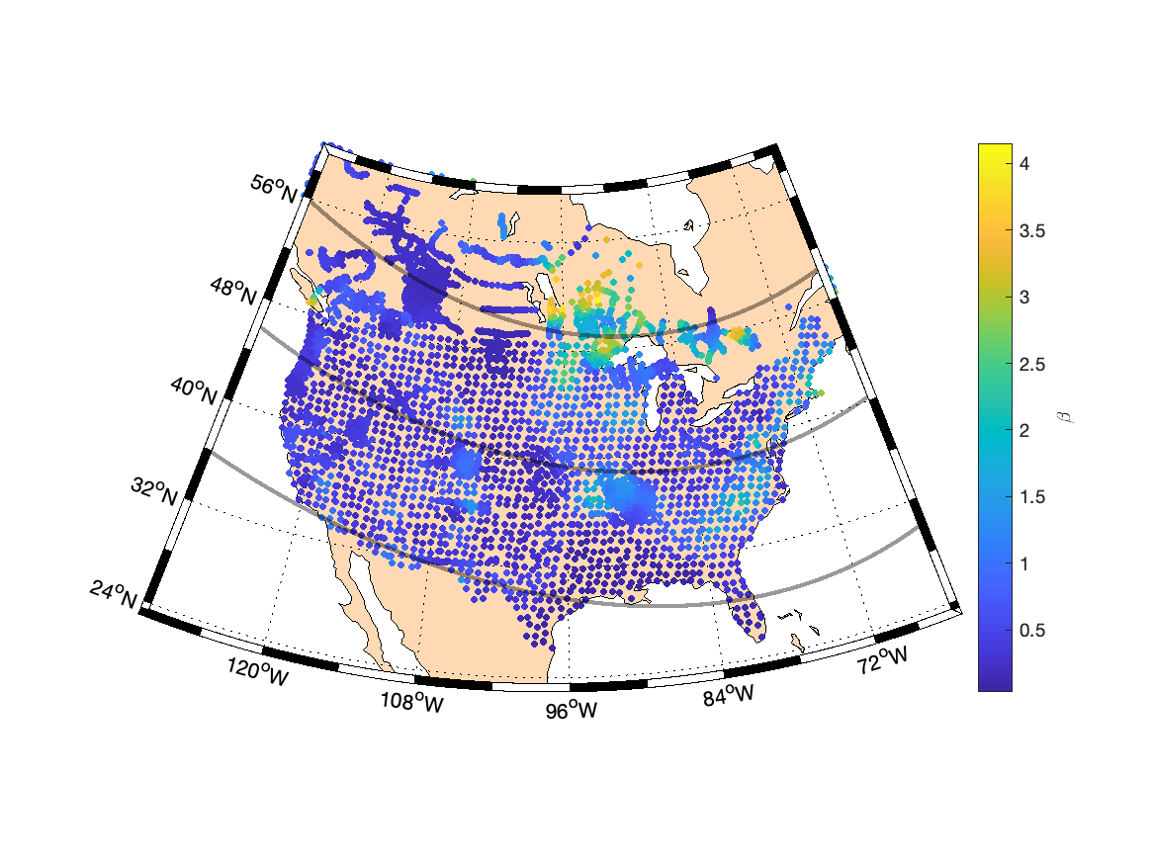

Figure 3. The same as in Fig. 2 but with the waveform from Memanbetsu Geophysical Observatory observations for the Halloween storm of October 29-31, 2003.

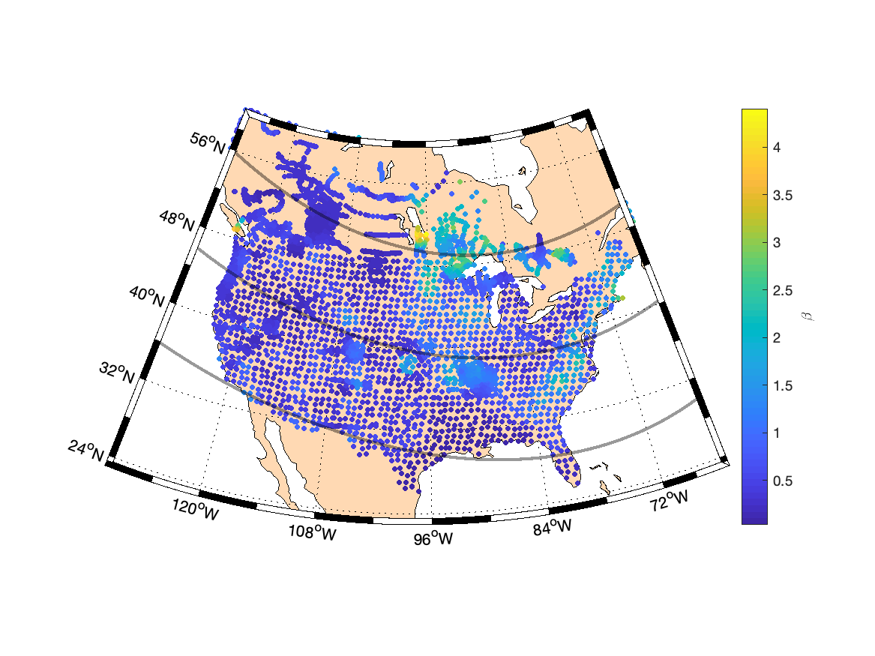

Figure 4. The same as in Fig. 2 but with the waveform from Nurmijärvi Geophysical Observatory observations for the Halloween storm of October 29-31, 2003.

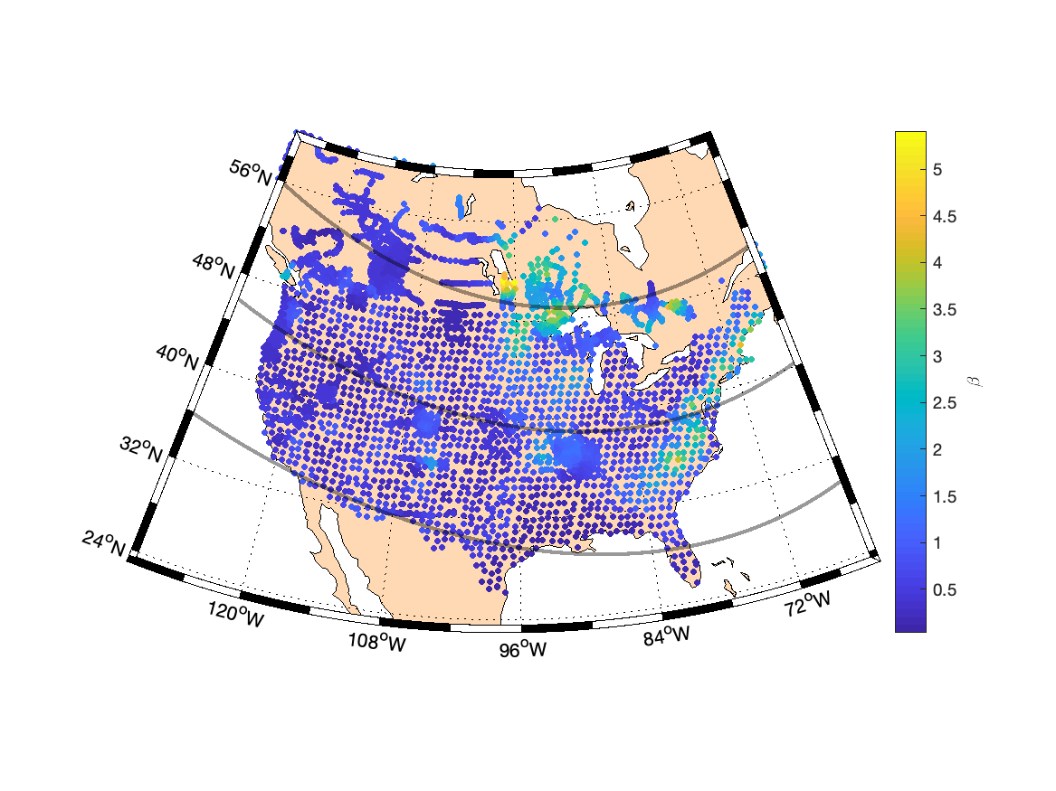

Figure 5. The same as in Fig. 2 but with the waveform from Meanook Geophysical Observatory observations for March 12-14, 1989.

Figures 6 and 7 show the power spectra for the time derivative of two horizontal magnetic field components for all four stations and waveforms indicated in Table 1.

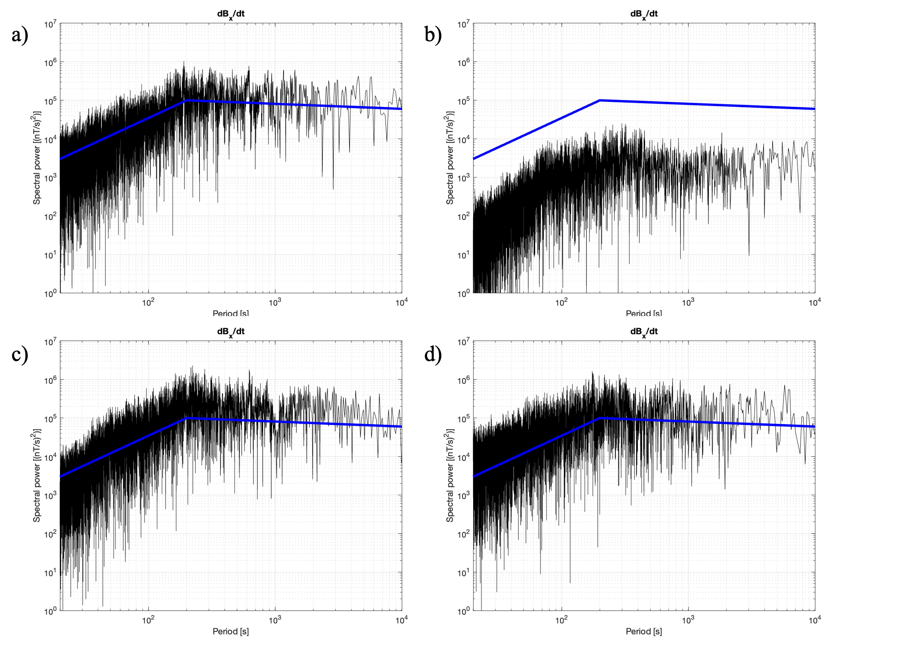

Figure 6. Power spectra for the time derivative of the north-south magnetic field component (*BX*) at four Geophysics Observatories: panel a) Ottawa March 12-14, 1989, panel b) Memanbetsu October 29-31, 2003, panel c) Nurmijärvi October 29-31, 2003, and panel d) XYZ (MEA) March 12-14, 1989. Blue lines show two power laws to guide the visual comparison between the panels.

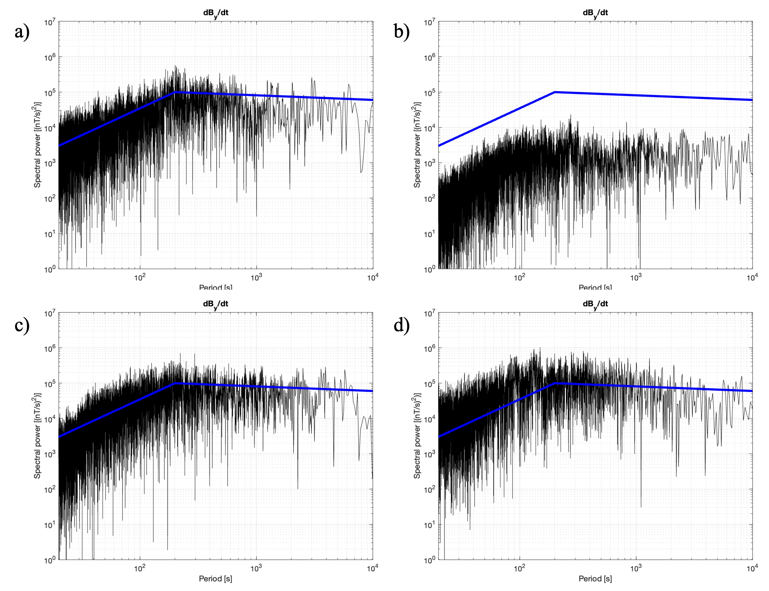

Figure 7. Same as Fig. 6 but for the east-west magnetic field component (*BY*).

**References**

Electric Power Research Institute (2019), Review of Peer-Reviewed Research Regarding the Effects of Geomagnetic Latitude on Geoelectric Fields, *EPRI technical reports*, product ID: 3002016885.

Electric Power Research Institute (2019b), Tool Evaluation and Electric Field Estimate Benchmarking Results, EPRI Technical Report, Palo Alto, CA:3002014853.

Electric Power Research Institute (2020a), Use of Magnetotelluric Measurement Data to Validate/Improve Existing Earth Conductivity Models, *EPRI technical reports*, product ID: 3002019425.

Electric Power Research Institute (2020b), Improving Conductivity Models for GIC Estimation: Guidance for Validation of GIC Models, EPRI Technical Report, Palo Alto, CA:3002017897, 2020.

Electric Power Research Institute (2020c), Update of regional scaling factors for GIC hazard assessments, EPRI Technical Report, Palo Alto, CA, product ID: 3002017899.

Federal Energy Regulatory Commission (2015), Reliability standard for transmission system planned performance for geomagnetic disturbance events, 18 CFR Part 40, Docket No. RM15-11-000.

Kelbert, A., G. Egbert, and A. Schultz (2011-2022), IRIS DMC Data Services Products: EMTF, the magnetotelluric transfer functions, *Tech. rep. National Geoelectromagnetic Facility*, <https://doi.org/10.17611/DP/EMTF.1>.

Kelbert, A., & Lucas, G. M. (2020). Modified GIC estimation using 3-D Earth conductivity. *Space Weather*, *18*(8), e2020SW002467. https://doi. org/10.1029/2020SW002467.

Love, J. J., et al. (2016), Geoelectric hazard maps for the continental United States, *Geophys. Res. Lett.*, *43*, 9415–9424, doi:10.1002/2016GL070469.

Love, J. J., Lucas, G. M., Rigler, E. J., Murphy, B. S., Kelbert, A., & Bedrosian, P. A. (2022). Mapping a magnetic superstorm: March 1989 geoelectric hazards and impacts on United States power systems. *Space Weather*, *20*, e2021SW003030. https://doi. org/10.1029/2021SW003030

Lucas, G. M., Love, J. J., Kelbert, A., Bedrosian, P. A., & Rigler, E. J. (2020). A 100-year geoelectric hazard analysis for the U.S. high-voltage power grid. *Space Weather*, *18*(2), e2019SW002329. https://doi.org/10.1002/2019SW002329.

National Science and Technology Council (2019), National Space Weather Strategy and Action Plan.

North American Eletric Reliability Corporation (2013), Geomagnetic Disturbance Planning Guide, Decemeber 2013.

North American Eletric Reliability Corporation (2016), Benchmark Geomagnetic Disturbance Event Description, Project 2013-03 GMD Mitigation Standard Drafting Team, May 12, 2016.

North American Eletric Reliability Corporation (2020), TPL-007-3 – Transmission System Planned Performance for Geomagnetic Disturbance Events, <https://www.nerc.com/pa/Stand/Reliability%20Standards/TPL-007-3.pdf>

Pulkkinen, A., et al. (2017), Geomagnetically induced currents: Science, engineering, and applications readiness, *Space Weather*, 15, doi:10.1002/2016SW001501.

Schultz, Adam, “EMScope: A Continental Scale Magnetotelluric Observatory and Data Discovery Resource,” *Data Science Journal*, Vol. 8, p. IGY6-IGY20, 2010.