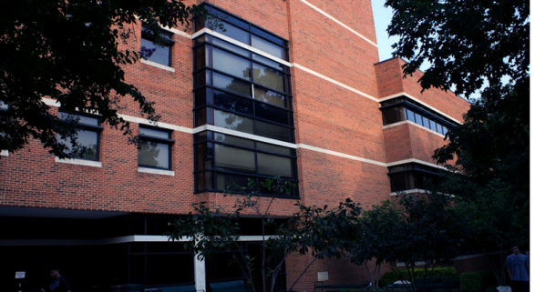

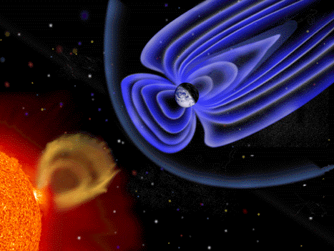

……………………………………..

The graduate program in Space Weather at GMU in Department of Physics and Astronomy offers degrees at the Masters (MS) and Doctoral (PhD) levels. A wide variety of relevant courses are offered on Space Weather,solar physics, magnetosphere physics, and ionosphere/thermosphere physics.

The primary objective of the PhD program in Space Weather is to train students to be researchers for future careers in academia, industry, and government. The program provides students with an interdisciplinary academic environment (physics, astrophysics, solar physics, and geospace physics) to comprehensively develop the student's ability/intellect to successfully pursue a scientific career. The graduates of this program will be better prepared to attack interdisciplinary research problems and new challenges than students whose graduate coursework and research is entirely within a single discipline. The graduate program provides students with a strong background in space sciences for working in programs or areas of technology affected by space weather.

The basic requirement for entry as a graduate student is a degree in physics, astrophysics, or electrical engineering and sufficient computational skills.

Dept. of Physics and Astronomy

4400 University Drive, MS 3F3 Fairfax , VA 22030 physics.gmu.edu

Space Weather Lab

Director: Bob Weigel

rweigel@gmu.edu

703-993-1361

Faculty

Dieter Bilitza

John Mariska

Robert Meier

Dusan Odstrcil

Art Poland

John Shebalin

Mike Summers

Robert Weigel

Erdal Yiğit

Jie Zhang

Affiliates

James Chen (NRL)

James Klimchuk (NASA)

Larry Paxton (JHU/APL)

Dean Pesnell (NASA)

**Angelos Vourlidas (JHU/APL)**



physics.gmu.edu

spaceweather.gmu.edu

**GRADUATE PROGRAM IN**

**Space Weather**

……………………………………..

About our program

GMU, located in Fairfax, Virginia, has an exciting and rapidly growing set of graduate programs in Astrophysics, Space Weather, and Planetary Sciences. The faculty in these programs is affiliated with the Department of Physics and Astronomy.

Our curricula emphasize multidisciplinary science that crosses traditional departmental boundaries. Space Weather/Solar-terrestrial physics is one of these multi-disciplinary areas. We expect our students to develop a solid understanding of the Sun, the heliosphere, geospace, ionosphere, upper atmosphere, and their interactions; we emphasize a systems view.

Solar-Terrestrial

Physics/Space Weather

The Solar System is a unique astrophysics laboratory because it is the only stellar planetary system that can be probed with both remote sensing and in situ techniques. Remote sensing techniques provide global and local views of space weather in the connected Sun-Earth system. In situ instruments observe fine details of the state of the various systems. The combined approach advances our understanding of important astrophysical processes and phenomena such as magnetic reconnection, acceleration of energetic particles, stellar variability, and stellar-planetary interactions, as well as the fundamental role of neutral particles.

It is also the system wherein we live. Space Weather can adversely affect humans and such human technological systems as satellites, electric power grids, pipelines, electromagnetic propagation, radars, communications, and navigation systems such as GPS. Space Weather also includes studies of the radiation exposure of astronauts in space and occupants of high altitude aircraft by energetic solar particles as well as incoming cosmic rays.

There is a wealth of empirical solar-terrestrial data available, especially from space missions launched since the early 1990s. A number of exciting new missions are currently in development and planned for launch in the next decade.  Three-dimensional numerical simulations are fast advancing in the area of space weather. As a result there are, and will continue to be, diverse and rich research opportunities for studying and understanding the complex, challenging behavior of the astronomical system in the universe that is most important to humans, the system which we inhabit.

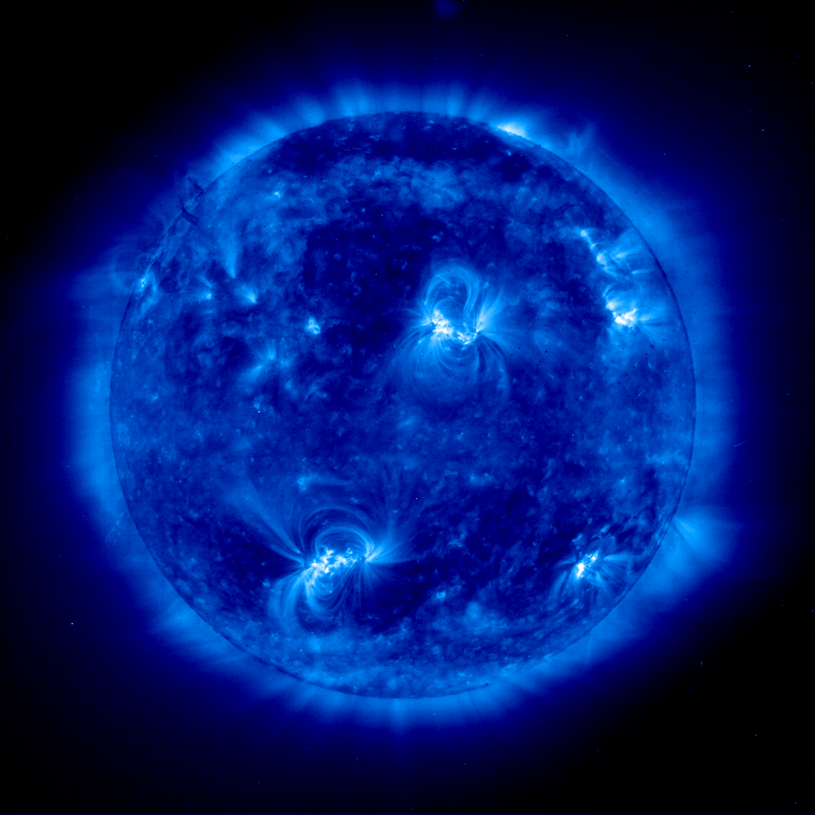

……………………………………..

……………………………………..

National and International Solar-Terrestrial

Research Programs

There are major national and international research programs to understand the physics of the connected Sun-Earth system and to forecast Space Weather, including the National Space Weather Program (NSWP), an interagency research effort involving a variety of US federal agencies, and the International Living With a Star (ILWS) program involving over 20 international space agencies. NASA, NSF, DOD and NOAA are the primary supporters of solar-terrestrial physics research in this country. Information about the National Space Weather Program can be found at: <http://www.nswp.gov/>.

Members of the GMU faculty are heavily involved in the national and international efforts to advance the current state of knowledge in solar-terrestrial physics.