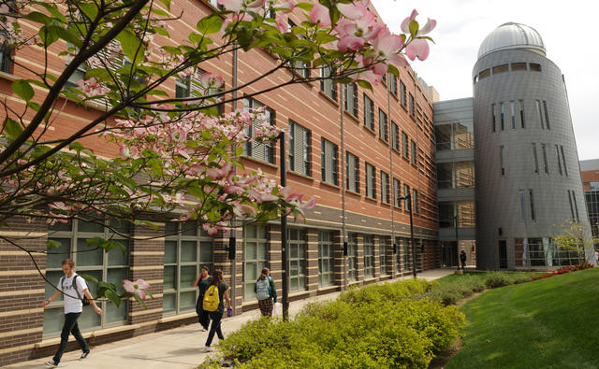

**GRADUATE RESEARCH IN**

**Space Weather**

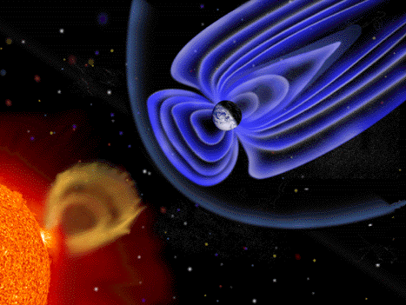

Department of Physics and Astronomy

spaceweather.gmu.edu

Dept. of Physics and Astronomy 4400 University Drive, MS 3F3 Fairfax, VA 22030

Space Weather Lab

Director: Bob Weigel

rweigel@gmu.edu

Faculty

Dieter Bilitza

Robert Meier

Dusan Odstrcil

Art Poland

John Shebalin

Mike Summers

Robert Weigel

Erdal Yiğit

Jie Zhang

Collaborating Institutes:

Naval Research Lab

NASA/Goddard Space Flight Center

The Graduate Program in Physics at GMU in the Department of Physics and Astronomy offers education and research opportunities in Space Weather at the Masters (MS) and Doctoral (PhD) levels. A variety of courses are offered on Space Weather, the Sun, the magnetosphere, and the ionosphere.

Our primary objective is to educate students for research careers in academia, industry, and government. The program provides students with an intellectual environment for developing skills in physics, astrophysics, solar physics, and geospace physics. The Space Weather program encourages broad collaboration among students and faculty in sharing ideas and breaking new ground in research. The graduates of this program will be better prepared to solve interdisciplinary research problems and new challenges than students with a narrow disciplinary focus. Graduates are well-suited to work not only on space research but also in the many areas of technology affected by space weather.

The basic requirement for entry as a graduate student is a major or minor in physics and sufficient computational skills.

About our program

GMU, located in Fairfax, Virginia, has an exciting and rapidly growing set of graduate courses in Astrophysics, Space Weather, and Planetary Sciences.

We expect our students to develop an understanding of the Sun, heliosphere, ionosphere, upper atmosphere, and their interactions. Our program focuses on how geospace works as a system.

Solar-Terrestrial Physics/Space Weather

The Solar System is a unique astrophysics laboratory because it is the only stellar/planetary system that can be probed with both remote and in situ techniques. Remote sensing techniques provide global and regional views of space weather in the connected Sun-Earth system. In-situ instruments observe fine details of the state of the various systems. The combined approach advances our understanding of important astrophysical processes and phenomena such as magnetic reconnection, acceleration of energetic particles, stellar variability, and stellar-planetary interactions, as well as the fundamental role of neutral particles and their chemical and dynamical interactions with plasmas.

Space weather can adversely affect many societal technological systems such as satellites, electric power grids, pipelines, electromagnetic propagation, radars, communications, and navigation systems such as GPS. Space weather also includes studies of the radiation exposure of astronauts in space and occupants of high-altitude aircraft by energetic solar particles and incoming cosmic rays.

A wealth of solar-terrestrial data is available, especially from space missions launched since the early 1990s. Several exciting new missions are currently in development and planned for launch in the next decade. GMU faculty are expected to participate directly in these missions.

Three-dimensional numerical simulations by our faculty are fast advancing our understanding of space weather. The Space Weather Lab is the center of development of the premier empirical ionosphere model. Many other geospace models have also been developed at GMU. As a result, there are diverse and rich research opportunities for studying and understanding the complex and challenging behavior of our local astronomical “laboratory” that is most important to humans and is the system we inhabit.

National & International Programs

There are significant national and international research programs dedicated to understanding the physics of the connected Sun-Earth system and to forecast Space Weather, including the National Space Weather Program (NSWP), an interagency research effort involving a variety of US federal laboratories, and the International Living With a Star (ILWS) program involving over 20 international space agencies. NASA, NSF, DOD, and NOAA are this country's primary supporters of solar-terrestrial physics research. Information about the National Space Weather Program can be found at [spaceweather.gov](https://secure-web.cisco.com/1JCq6secic9xs7NwoRL2sLmCuvWKDKf7aq7nwl7diObp00Oy-QB-UrshcICZhvaJ98o9oeKJDcSb0e4IgTysrD5nvWrnTdVI_p33k23nQc8REH82lQWc3qt6Z2T5WdrPsAdFI_-FAhrQO8RO0_uPfVSYLiyzWh5ndbf8fzVahQFJL05wv-kfXn1NikiTYlf3YKRkAMqoQBBKjgRad5u1lRVIu0ztC35431sUN0q0FEoqJn4tnhd9Z26Cl7lzX6K_wNRiu-6HL7NA9FklXca3xc3CclBYINNxFl-5fGXcyedWJcr4kctXv4lsd91GFxk-pCcYcbEt9oFtouHobxeNTz85zsj6OCQnoTtEW5pb56xQa2tqDCMw5W5PPcQqzOFvnpziUgKMpUD89xYQP8pL6Zbl5WJcJubiXihhOz8fQJe4/https%3A%2F%2Fwww.spaceweather.gov%2F).

Members of the GMU faculty are actively involved in these national and international activities.

