Steps to update the firmware
- First, disconnect the grid power of Venus and long press the power button until the light off, which will take 10 seconds.

2.Prepare a 485 tool. Connect the port a of the 485 cable to the Port 1 of 485 terminal on Venus, and connect the port b of the 485 cable to the Port 2 of 485 terminal on Venus. To recognize Port 1 and 2 of 485 on Venus, you have to carefully observe carving numbers on the 485 ports.
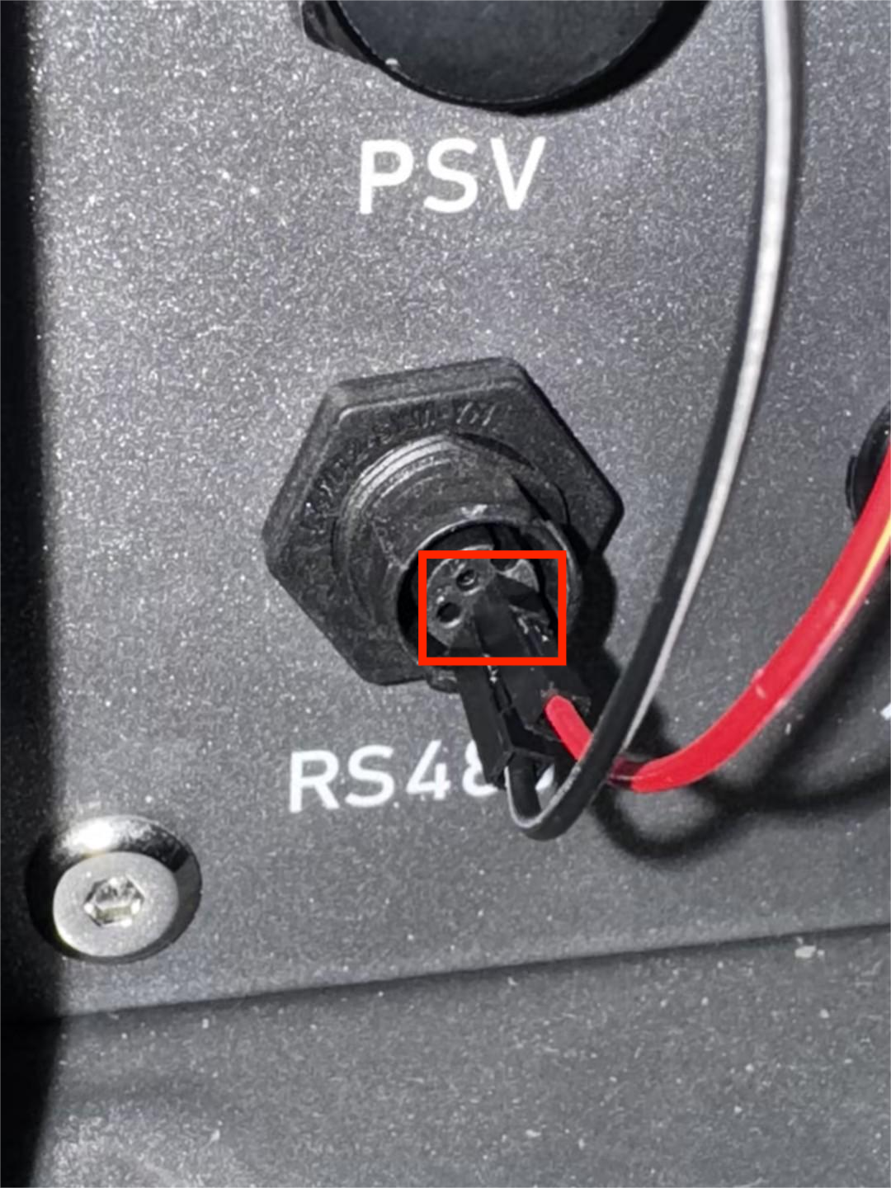
（1）Click on the software CRT, and do the process as the following pictures and steps to connect the device.
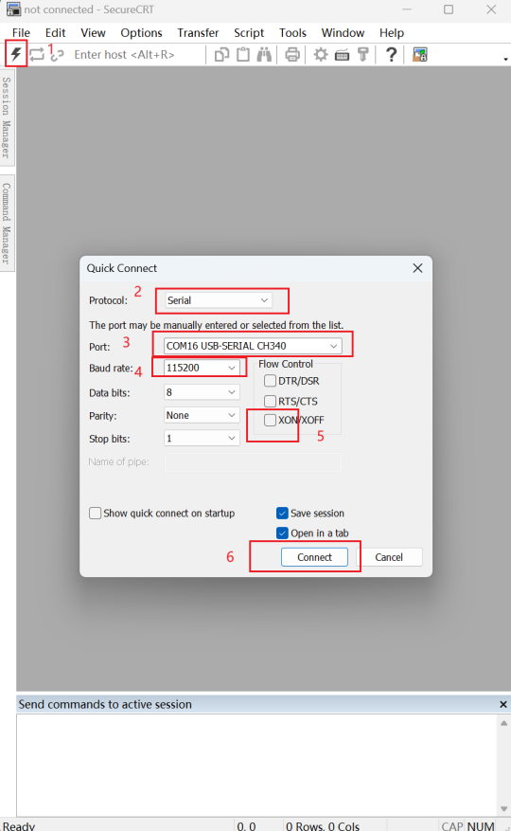
（2）After the software successfully connects to Venus, keep pressing the C key on your keyborad to input the character "c". During this process, the power light will automatically turn on (if it does not turn green, you need to manually press the start button), and the screen will display the character "c" and automatically send the character "c". (It will take some time before the character "c" is displayed. The entire process needs to start transmitting within 15 seconds. If it fails here, start over from the beginning of disconnecting the Grid power.)
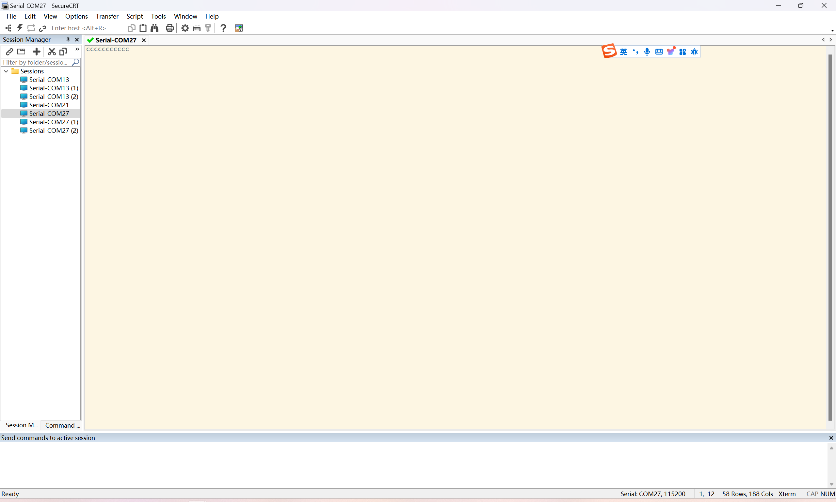
（3）Then drag the bin file to be updated to the window and select "Send Ymodem", and wait for the upgrade to complete.
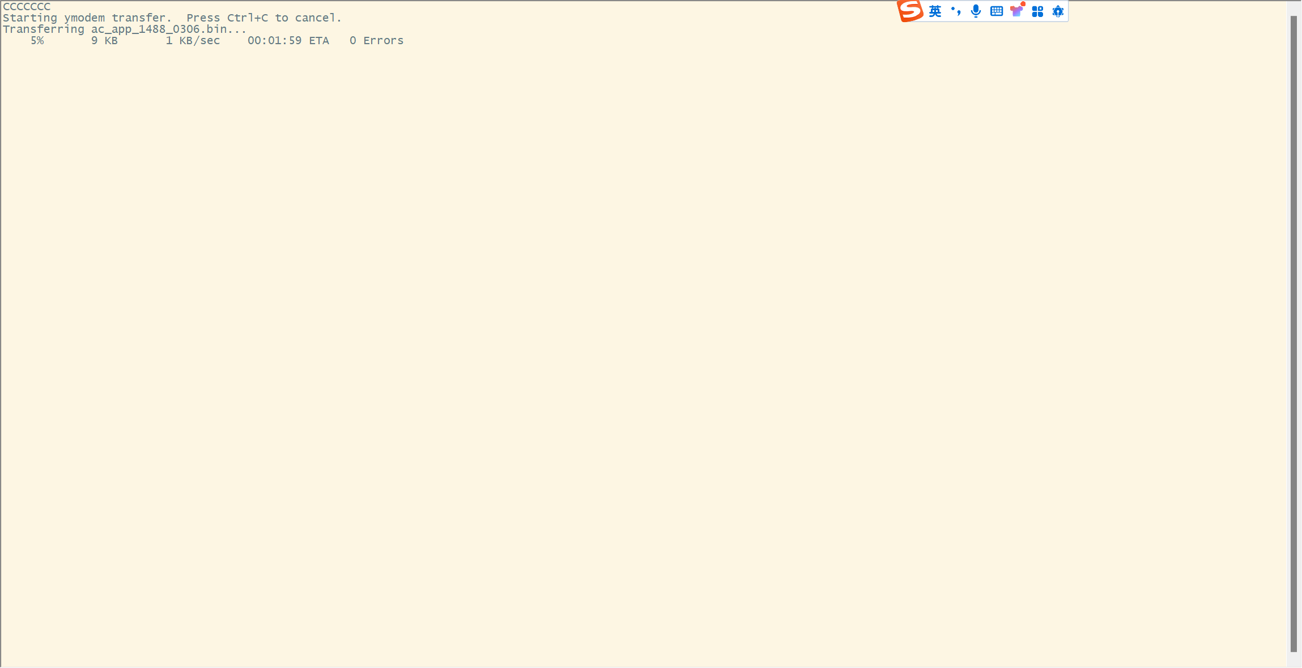
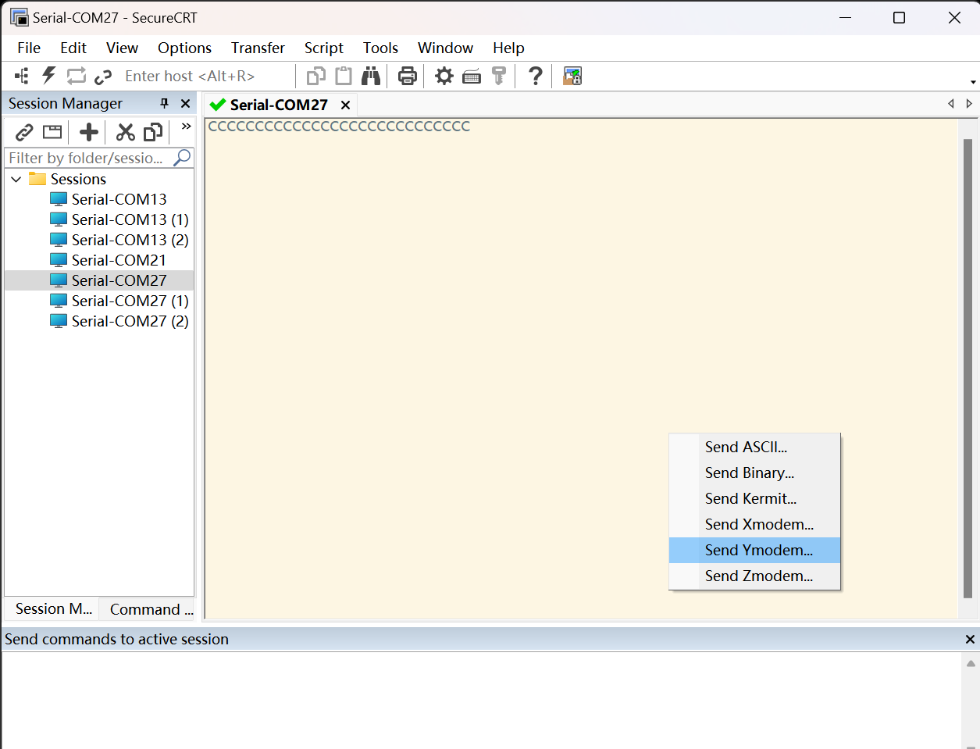

3. After the transmission is completed, the number of transmitted bytes will be printed. Wait for 10 seconds and then update to complete.
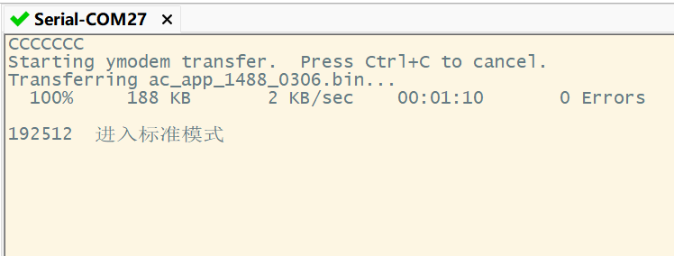

4.By using the "version" command to query the corresponding version number of the device, the red box indicates the current firmware version.
