About the Project/Project Title
Search and Rescue Animal Shelter
This project is meant to filter through different animals within the animal shelter system and find animals that meet the requirements for becoming different kinds of search and rescue animals.

Motivation
This project uses pyMongo and Jupyter as a way to create a dashboard for the database holding information on animals in animal shelters. The dashboard allows for filtering, mapping, and graph knowledge of the different animals. The data is able to be separated into animals that meet the requirements for water rescue, mountain rescue, and general search and rescue to allow for animals to be trained for these jobs.

Getting Started
To get a local copy up and running, follow these simple example steps. In a command prompt, get up your Mongo Database shell and import data on the animals if you already have a csv file for it. After the database is set up, you can begin working on creating a user and authorization for manipulating the database. Making sure your database works and can retrieve information properly is the first step of getting started.

Installation
Install Python by following the instructions here
Install MongoDB by following the instructions here
Install JupyterNotebook for testing by following the instructions here

Usage
The intended purpose of the project is to use the Python code to create, read, update, and delete documents being held in the associated Mongo Database. First, below will be examples of the code created for CRUD via python. Second, there are the tests done to confirm the code working with examples.

Code Example
PYTHON AnimalShelter CLASS:
CREATE method:
Parameters: Self and a dictionary (data) of the document to be added to the database
Returns: False if the data isn’t correct and True if the document is added correctly
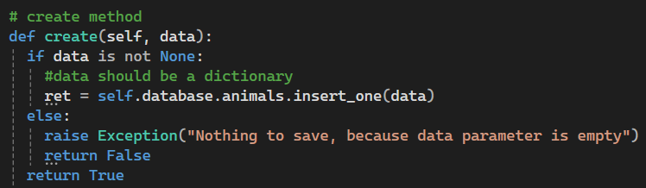
READ method:
Parameters: self and a dictionary (data) of the key pair to find data
Returns: a list (out) of the documents found using the key pair (data)
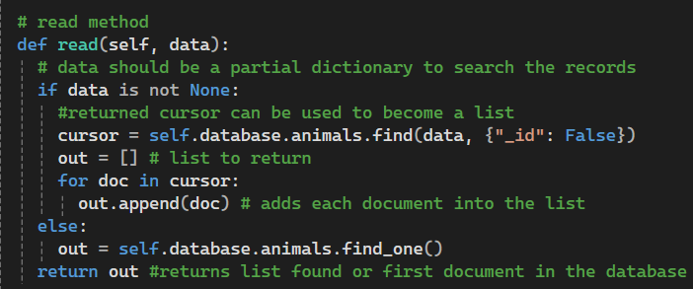

UPDATE Method:
Parameters: self, the key pair to find the document for update (query), and the data that is being updated
Return: the number of documents that were updated
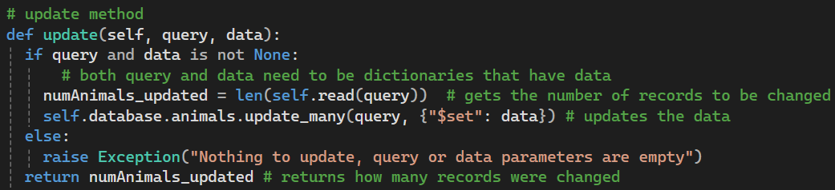
DELETE Method:
Parameters: self and key pair (data) that finds the documents to delete
Return: the number of documents that were deleted
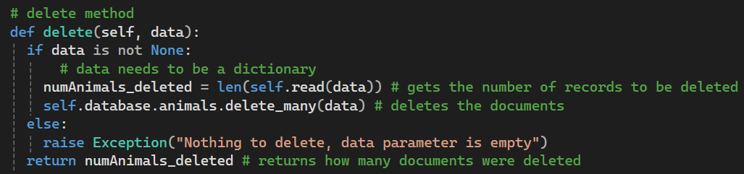
Jupyter Notebook Dashboard:
Making the Dashboard:
To make the actual dashboard including a logo and unique signature a lot of html is added to do formatting. Below is showing the code used to create the image and signature and the code used for populating the information on the table and allow for actions such as changing pages and selecting rows.
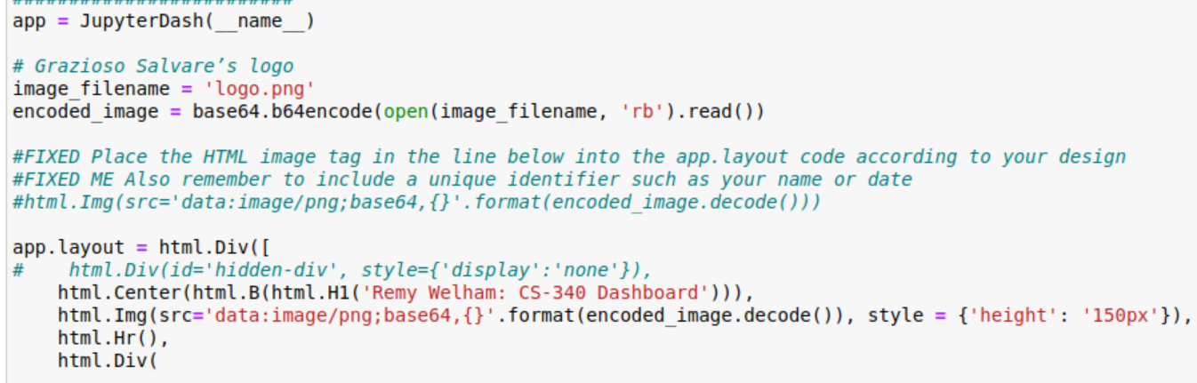
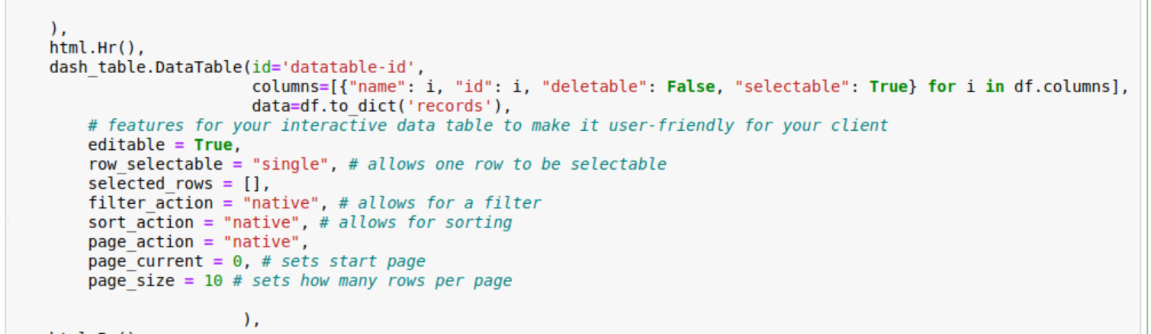
With all of this code shown above, it allows for this board to be created.
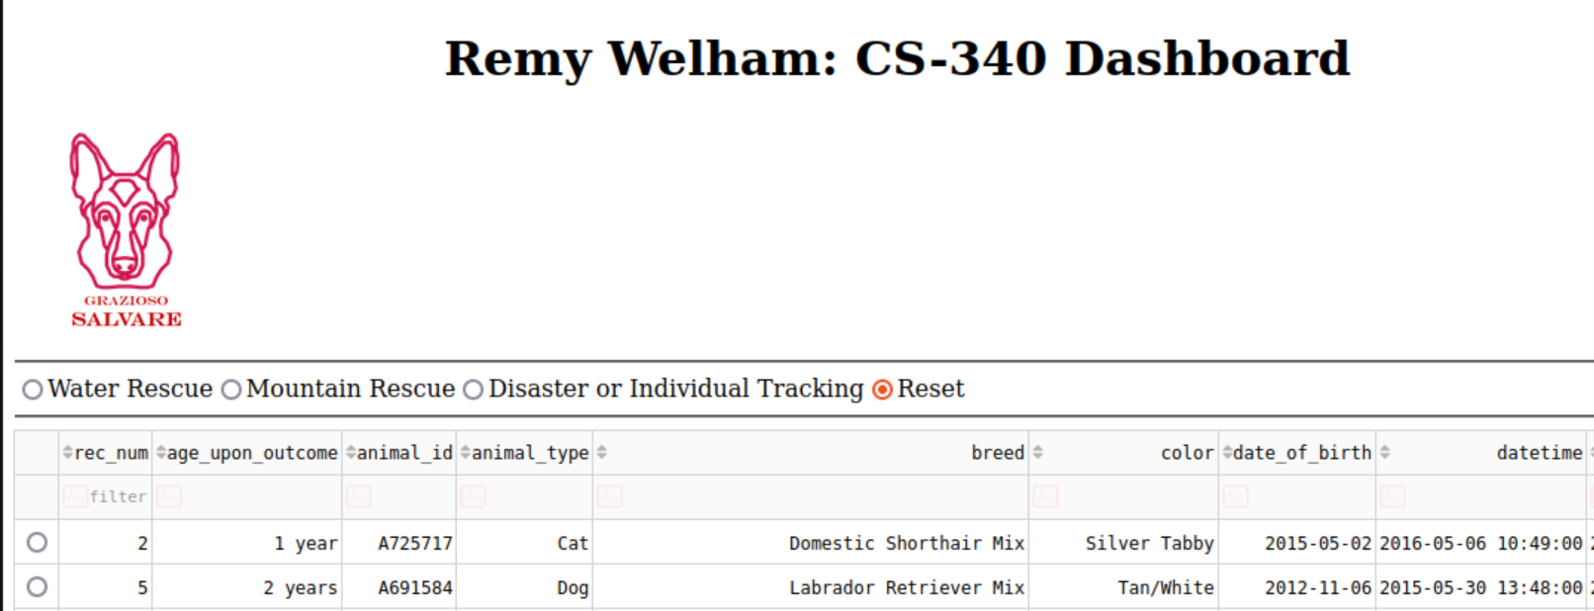
Filtering between types of Rescue:
To create the different filters of the different types of rescue, there are two sections of code needed. The first section of code is how the different filter types were made to be labeled on the dashboard as seen in the above screenshot of the basic dash.
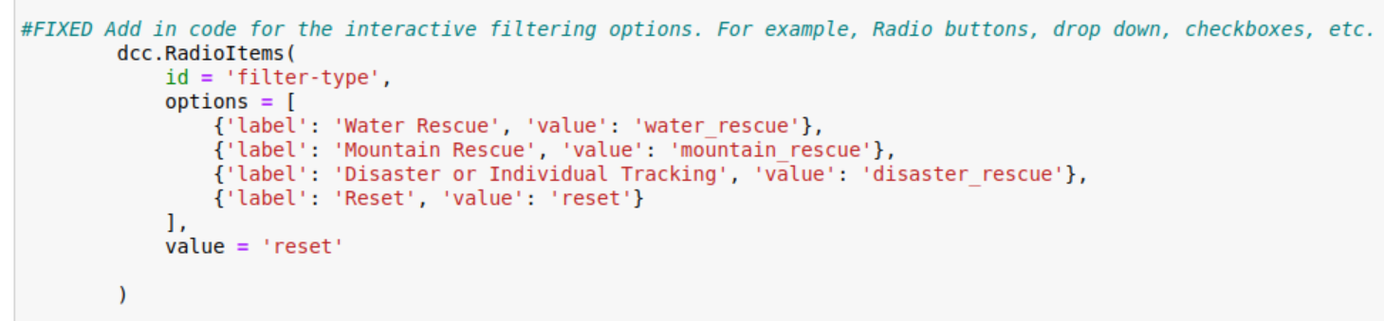
The next bit of code is how the dashboard filters through the data and decides which animals get displayed with the different filters selected.
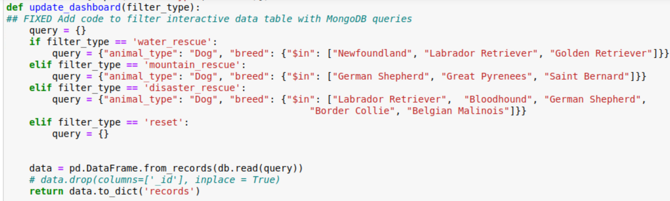
Finally, here are screenshots from the dashboard of what the list looks like for each different type of rescue. The default, or reset, dashboard is shown above in the second section of code explanation.
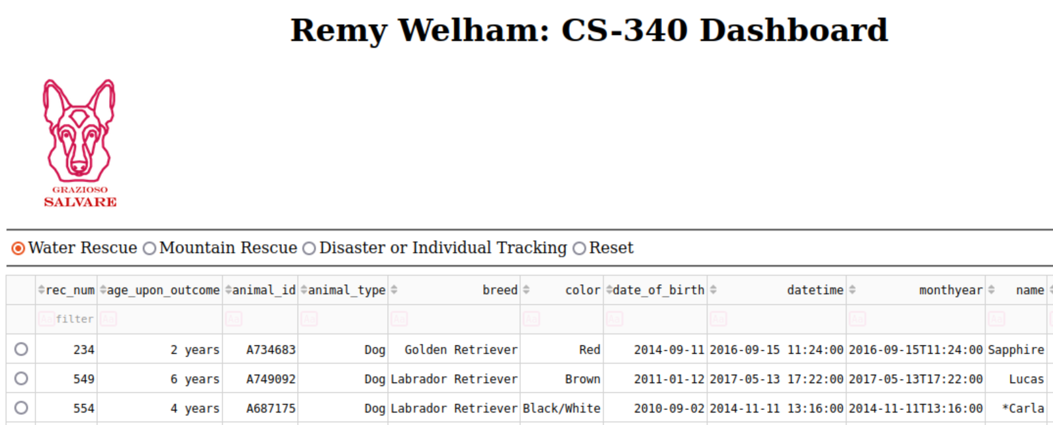
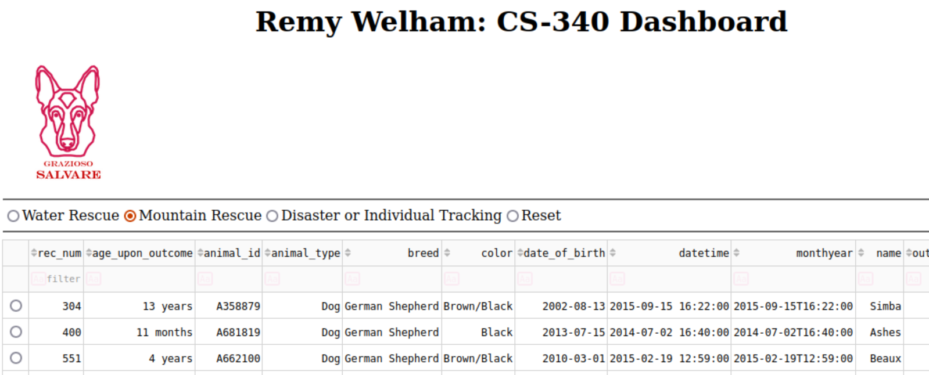
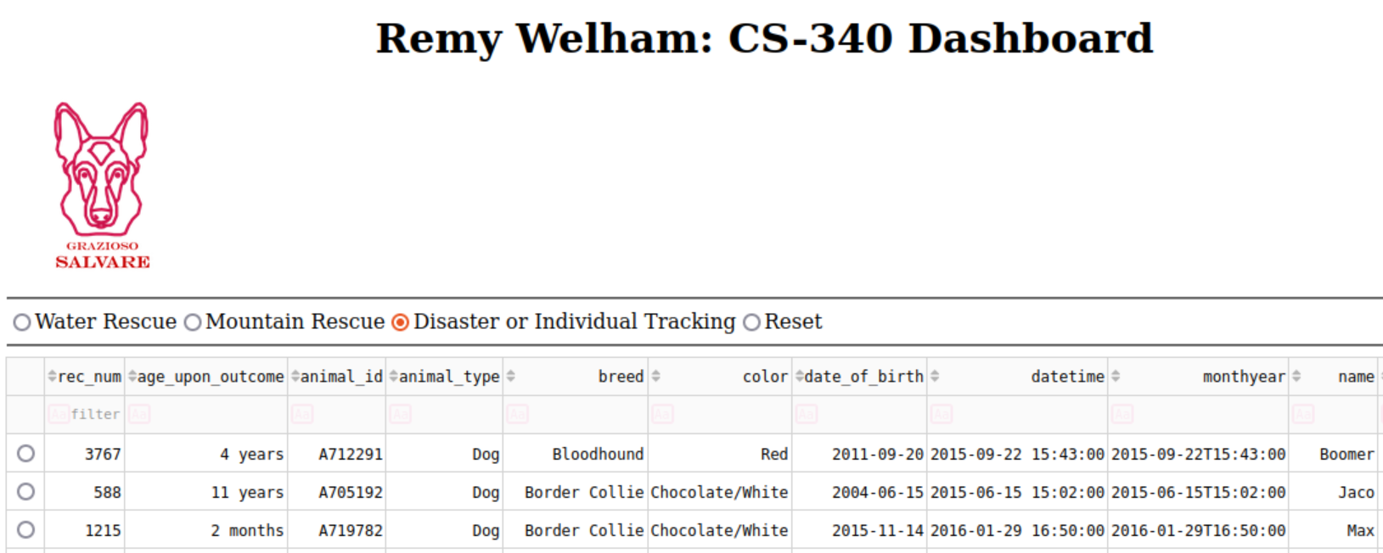
Creating Pie Chart:
Creating the Pie Chart code is below. The callback used the different graph id and datatable information that it was being passed over. There is a error catch for if there is no data. Then it uses the different breeds in the table to show which animal is most popular in the system.
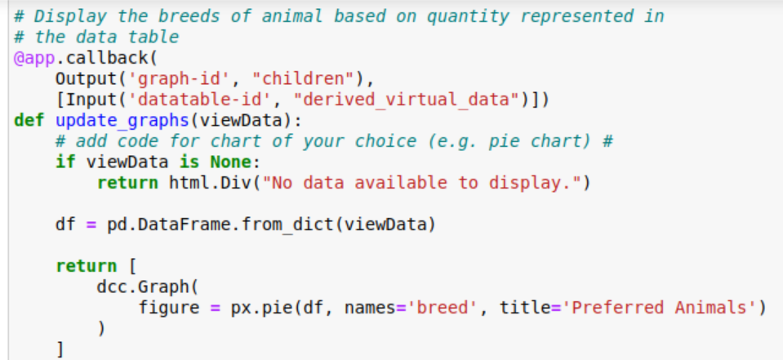
Below is a screenshot that shows what the pie chart looks like when the data table contains all of the different animals.
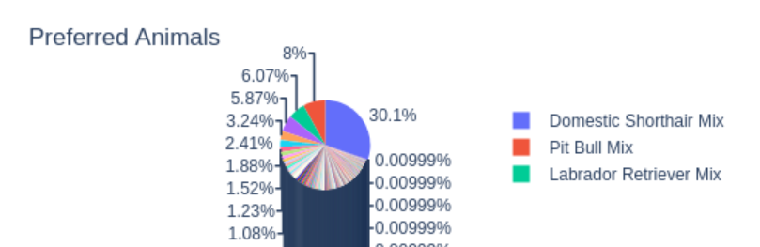
The Pie Chart also changes with the filtered types of rescue to show the different specified dog breeds that are preferred for each type of rescue. Below is a screenshot of the pie chart for disaster rescue dog breeds.
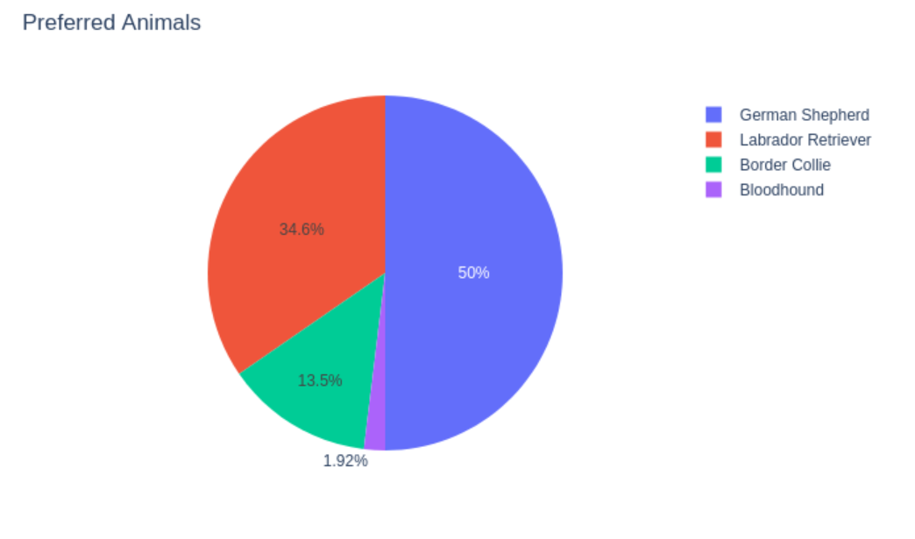
Creating the Map Widgit:
The last part of the code and project was creating a Map Widgit that is able to change the location based on the animal selected in the data table. This part was not working for me with the position argument trying to pass strings instead of floats. Telling it to read the information as floats helped the issue. Below is the code and a picture of the map with a marker on it.
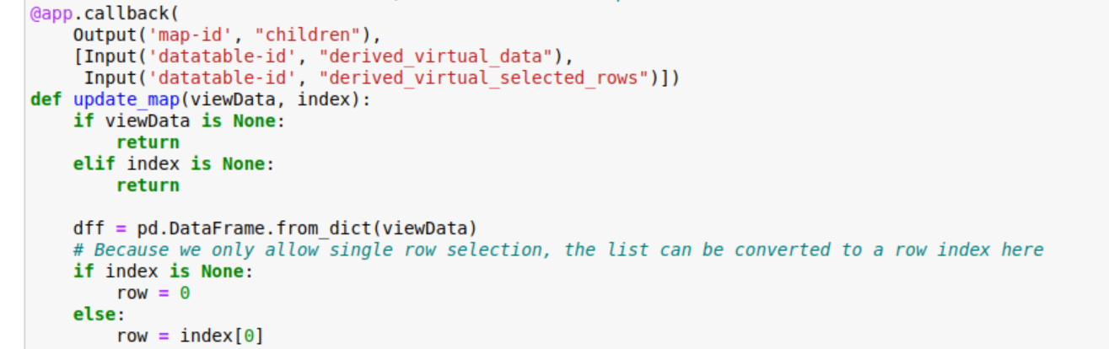
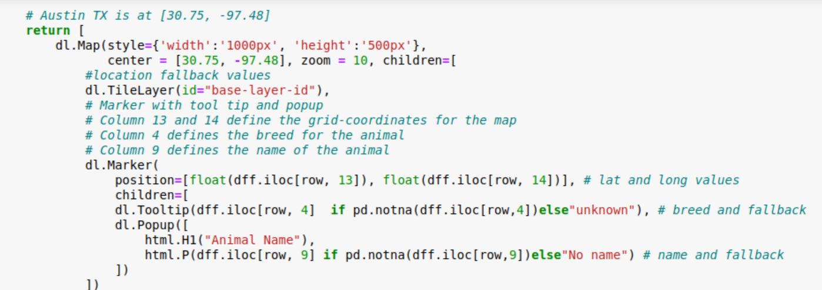
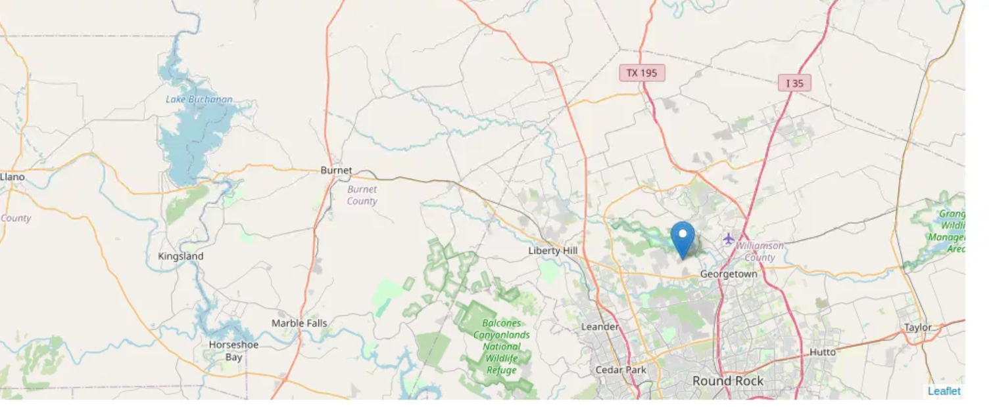

Contact
Remy Welham
remy.welham@snhu.edu

