CIS 579: Literature Review

Robert Werthman

Abstract—Neuroevolution is used to evolve neural networks with evolutionary algorithms to find solutions to problems. This is a literature review of five journal articles that use neuroevolution to solve their research problems. The articles use a combination of different fitness functions, different evolutionary algorithms, distributed and non-distributed techniques, and online and offline evolution.

Introduction

What are neural networks
Neural networks can be thought of as functions that have inputs, do a calculation on the inputs, and produce outputs. They were inspired by biology. A neural network can be thought of as neurons working together like in the human brain. A neuron can take an input and produce an output based on an activation function and a weight assigned to the input. The output could then be the input to another neuron or a solution you are looking for. A neural network can having a single neuron or multiple neurons. If it has multiple neurons it has multiple layers. The is usually an input layer, a hidden layer, and an output layer. The input layer neurons are connected to the hidden layer neurons which are then connected to the output layer neurons. You can see this in [8, Fig. 1].

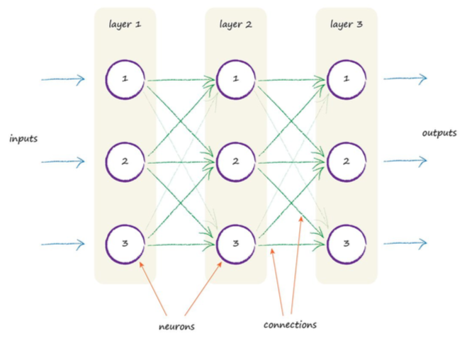
Figure 1: A neural network

Once you define your inputs you define how many layers you want to have and how many outputs you want to have. For example, if you made a game and the players in the game could only move left or right and they were trying to avoid each other, the input to the neural network could be the x position of the players. There would be 2 nodes/neurons in the input layer. The output could be what direction one of the players should move. There would be one output node in the output layer. It is up the developer to determine how many neurons they want in the hidden layer.

Weights are assigned to the connection between neurons. They tell the next neuron how much emphasis should be put on the output coming from a particular connection. To update the weights you use backpropagation. The outputs are used to determine the error. This is the difference between the output created by the neural network and the expected output. This error is then propagated back to the weights in the previous layer like in [8, Fig. 2].
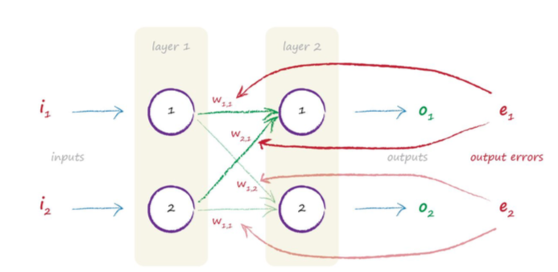
Figure 2: Backpropagation of error

What is neuroevolution
Neuroevolution takes neural networks to an even more biological level. It introduces “Darwinian evolution” to the process of creating neural networks. This process is about finding the weights and topology of the network that create the best outputs [4].

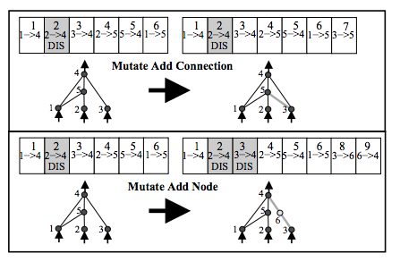
Figure 3

Now, a neural network is thought of as a genotype. In biology, a genotype defines the genes of an individual organism. This genotype is a single neural network or multiple neural networks and has the inputs and outputs of the networks that it consists of. A genotype is given a problem to work on with inputs and expected outputs. The genotype is evaluated based on its fitness. This is the error it produces according to a metric defined by the developer. Multiple genotypes are tested at the same time in what is called a population. Based on the fitness of these genotypes, a new population (generation) of genotypes is created by mutating [5, Fig. 3] the genotypes or combining (crossing-over) [5, Fig. 4] the genotypes [4]. This essentially means changing the weights or network topologies of the neural networks that make up the genotype. The goal is to find genotypes with a higher fitness rating. This process is repeated over and over again.

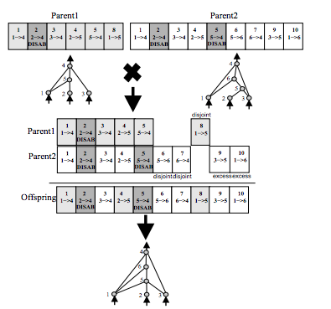
Figure 4

Brief description of nueroevolution in the literature review articles
In this literature review, five journal articles were read. The authors all used neuroevolution to solve their research problems. In [3] the authors’ goal was to find the best way to have a swarm of robots work together on a food gathering task. In [6] the authors’ goal was to have a helicopter hover above a single point with conditions like wind affecting its hovering pattern. In [7] the authors’ wanted to see how well neuroevolution worked to keep connectivity with multiple mobile network points moving around. Finally, in [1] the authors wanted to create a power plant controller to create the most energy output while “minimizing emissions” [1].

Literature Review

Distributed and non-distriubted neuroevolution
Distributed neuroevolution is defined as having “multiple software agents” working together to solve a problem. This is known as “distributed problem solving” [mobile ad hoc]. Two of the journal articiles used this kind of neuroevolution: [7] and [3].

Both the swarm robots and the mobile ad hoc agents were assigned a single, global goal: collectively gather food and create a communication network to cover the largest area possible, respectively. Each robot/agent had a neural network, also known as a controller, running inside of it. The goal in [3] was to figure out the best approach to sharing genomes among robots to optimize the food gather task. The goal of the [7] was to find the best evolutionary algorithm to have the agents set up a mobile communication network.

These are different from the other articles, because multiple physical entities had to work together to solve a problem. The authors had to establish ways for the entities to communicate each other while cooperating to achieve the goal. This is a more difficult than working with a single entity like a single computer. Not only do you have to evolve the neural networks for each of the entities, you have to figure out their communication between each other to achieve the goal. [7] found the more physical entities the more difficult it was to “coordinate” them to achieve the shared goal. [3] used previously established algorithms with slight changes to find a more optimized way for the robots to communicate with each other, share information, and achieve their goal. Although, [3] found that with more physical entities they were more successful in achieving their as seen in [3, Fig. x].

Online and offline neuroevolution
Offline evolution is defined as the evolution of the genome done before it is actually running on the goal. Online evolution means the genomes are “evolved during the execution of the task” [3]. [3] took the online approach, while [7], [6], and [1] took the offline approach. [2] tested both the online and offline approaches.

[3] wanted to test ways to evolve neural networks on each robot while the task was happening. They did not have data beforehand to train the robots before attempting to accomplish the forging task. This was different from [6] and [1] where they had training data they could use to train their genomes ahead of time. In fact, [6] was part of a competition where the participants were evaluated on how well their system did on the training data [6]. Depending on the problem and time constraints, it was not always be possible to train the system online. In the [6] and [hybrid] their were a lot of variables to perform calculations on they had to be done quickly. Otherwise the helicopter might crash or the power plant would fail. This meant that the calculations had to be done before hand.

Part of the testing done by the [2] was to evaluate how well it did with training online and offline. It found that the best genomes “were evolved from driving data collected offline”, see [2, Fig. 5] but they said it wasn’t possible to “anticipate” all driving scenarios with this data . Their suggestion was to use some sort online system that could continuously learn through new, real time data [2]. A combination of offline and online evolution would be necessary in an automobile crash system.

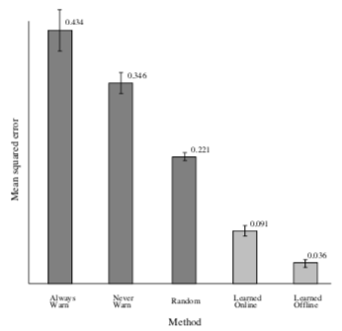
Figure 5: Error from different methods [2]

Evolutionary algorithms
Evolutionary algorithms are techniques for evolving neural networks and representing, also known as encoding, them in genomes. Much like before with distributed vs. non distributed, and online vs. offline, that task and goals of the authors typically dictate what type of evolutionary algorithms applies to a specific situation.

For the [2] the authors used the NeuroEvolution of Augmenting Topologies (NEAT) method. NEAT is a strategy that describes how to mutate and combine genomes [5]. NEAT can evolve both the topology of the network and the weights [4]. [2] found NEAT to be an effective algorithm to predict car crashes.

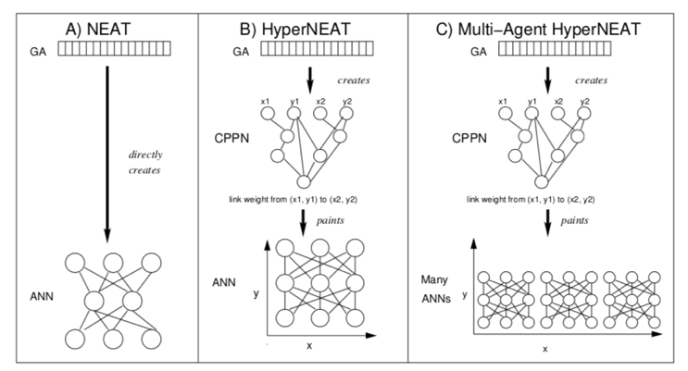
Figure 6: How different evolutionary algorithms create genomes [7]

NEAT was also used by [7] along with hyperNEAT which a different version of NEAT. hyperNEAT encodes each gene/node in the genome differently than NEAT. This means that when a network is combined or mutated it will turn out differently if the NEAT algorithm is used over the hyperNEAT strategy. [7] also used Multi-agent HyperNEAT to enable one genome to represent multiple neural networks. This means that the genome can represent the controllers/neural networks from multiple agents in one genome. With hyperNEAT and NEAT, a genome represents the neural networks from one entity. [7, Fig. 6] explains more about the three techniques. CPPN stands for Compositional Pattern Producing Network. CPPN takes the coordinates of two neural network nodes and creates a “weight for the link connecting them” [7]. Doing this for every node eventually creates a neural network. [7] achieved “70%...maximum possible grid coverage” with these techniques. This meant that given a certain area they were able to cover 70% effectively with their choice of evolutionary algorithm.

[3] came up with their own evolutionary strategies and compared them to the minimal Environment-driven Distributed Evolutionary Algorithm. They found their techniques to be a “viable approach” to achieve the common goal shared between the robots. The robots were able to collect equal to or more food items using their approaches as compared to the mEDEA algorithm, see [3, Fig. 7].

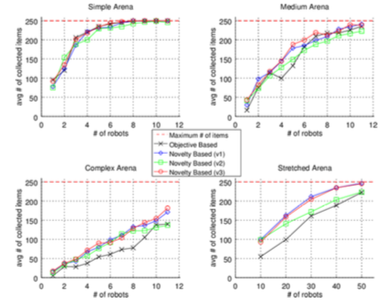
Figure 7: Collected food items for different approaches [3]

Fitness evaluations
The fitness function is a performance measure of how well a genome is doing in accomplishing a task, and usually determines if the genome will be used for the next population of genomes. The articles used two main fitness functions: novelty-based and objective-based.

An object-based fitness function rewards outputs that get the genome/neural network closer to a goal. A novelty-based fitness function rewards outputs that are unique and different. Novelty-based fitness functions were developed to overcome a weakness in objective-based fitness functions where the objective-based fitness function might not always be headed in the right direction. It is possible that an objective-based fitness function won’t find the best solution. With a novelty-based fitness function you are more likely to find the best solution because you will try a variety of different solutions [1]. A good example is given in [1] describing a Chinese finger trap. An objective-based fitness function would use genomes that would decide to move the fingers away from each other in the trap. More distance between the fingers is logically the best indicator to say that you are no longer in the trap. The problem is this only causes the trap to tighten around the fingers. The most optimal solution is to push the fingers together to release the trap. This could only be found with a novelty-based approach, because moving the fingers towards each other would be novel output not found by an objective-based fitness function.

[1] and [3] used the novelty-based approach. They believed this was a better technique than the objective-based approach because of the aforementioned problems with objective-based technique. [6] and [2] used the objective-based approach. In [6] they were supposed to hover over a point. If the novelty-based approach were used it is possible that the genome would choose to crash the helicopter just because that choice would be a different one. This would be a catastrophic result in the simulation. The same thing applies to [2]. Their goal was to avoid crashes. If the genome was rewarded based on novelty it could end up choosing to crash the car, because, again, that would be a unique and different output.

Conclusion

Neuroevolution is a viable tool that can be applied to a lot of different problems. The authors from [6], [7], and [2] were able to find solutions to their research problems with neuroevolution. The authors from [3] and [1] were able to improve upon previous research with changes to the fitness functions and evolutionary algorithms. The articles, themselves, indicate that more work can and should be done to apply neuroevolution to other unsolved problems. Another take-way is to apply neuroevolution to previously solved problems to improve upon the solution to those problems.

References

- Shauharda Khadka, Kagan Tumer, Mitch Colby, Dave Tucker, Paolo Pezzini, and Kenneth Bryden. 2016. Neuroevolution of a Hybrid Power Plant Simulator. In Proceedings of the Genetic and Evolutionary Computation Conference 2016 (GECCO '16), Tobias Friedrich (Ed.). ACM, New York, NY, USA, 917-924.
- Kenneth Stanley, Nate Kohl, Rini Sherony, and Risto Miikkulainen. 2005. Neuroevolution of an automobile crash warning system. In Proceedings of the 7th annual conference on Genetic and evolutionary computation (GECCO '05), Hans-Georg Beyer (Ed.). ACM, New York, NY, USA, 1977-1984.
- M. Galassi, N. Capodieci, G. Cabri and L. Leonardi, "Evolutionary strategies for novelty-based online neuroevolution in swarm robotics," 2016 IEEE International Conference on Systems, Man, and Cybernetics (SMC), Budapest, 2016, pp. 002026-002032.
- S. Risi and J. Togelius, "Neuroevolution in Games: State of the Art and Open Challenges," in IEEE Transactions on Computational Intelligence and AI in Games, vol. 9, no. 1, pp. 25-41, March 2017.
- Kenneth O. Stanley and Risto Miikkulainen. 2002. Evolving neural networks through augmenting topologies. Evol. Comput. 10, 2 (June 2002), 99-127.
- Rogier Koppejan and Shimon Whiteson. 2009. Neuroevolutionary reinforcement learning for generalized helicopter control. In Proceedings of the 11th Annual conference on Genetic and evolutionary computation (GECCO '09). ACM, New York, NY, USA, 145-152.
- David B. Knoester, Heather J. Goldsby, and Philip K. McKinley. 2010. Neuroevolution of mobile ad hoc networks. In Proceedings of the 12th annual conference on Genetic and evolutionary computation (GECCO '10). ACM, New York, NY, USA, 603-610.
- Tariq Rashid. 2016. Make Your Own Neural Network (1st ed.). CreateSpace Independent Publishing Platform, USA.

