KILIMANJARO INSTITUTE OF TECHNOLOGY AND MANAGEMENT


DEPARTMENT OF COMPUTING AND INFORMATICS
PROJECT TITLE:
DESIGN AND IMPLEMENTATION OF A SECURE MULTI-DEPARTMENT NETWORK
A Project Submitted in Partial Fulfillment of the Requirements for the Award of
Diploma/Certificate in Information Technology
PREPARED BY: ARON NIWAGIRA
STUDENT NAME: ARON NIWAGIRA
REGISTRATION NUMBER: NS3742/0122/2022
SUPERVISOR: MR JESSE
ACADEMIC YEAR: 2025/2026

TABLE OF CONTENT

ABSTRACT 3
CHAPTER ONE 4
INTRODUCTION 4
1.1 Background of the Study 4
CHAPTER TWO: 6
NETWORK DESIGN 6
2.1 Network Topology 6
CHAPTER THREE: 8
NETWORK IMPLEMENTATION 8
3.1 VLAN Configuration 8
CHAPTER FOUR: 11
NETWORK TESTING 11
4.1 DHCP Testing 11
CHAPTER FIVE: 14
RESULTS AND DISCUSSION 14
CHAPTER SIX: 15
CONCLUSION 15
REFERENCES 15
APPENDICES 15

ABSTRACT
Modern organizations rely heavily on computer networks to facilitate communication, data sharing, and resource management. This project focuses on the design and implementation of a secure and scalable network infrastructure connecting five departments within a training institution. The departments include Administration, Finance, ICT, Library, and the Computer Laboratory.
The network was designed using Virtual Local Area Networks (VLANs) to separate departmental traffic, improving security and network efficiency. Inter-VLAN communication was achieved using the Router-on-a-Stick technique, while Dynamic Host Configuration Protocol (DHCP) was configured to automatically assign IP addresses to devices. Network Address Translation (NAT) was also implemented to allow internal devices to access the internet using private IP addresses.
The network was simulated and tested using Cisco Packet Tracer, ensuring that devices could communicate across VLANs and access internet services successfully.

CHAPTER ONE

INTRODUCTION

1.1 Background of the Study
Computer networking plays an important role in modern organizations by enabling communication between departments and facilitating access to shared resources such as printers, databases, and internet services.
In institutions with multiple departments, it is important to design a network that is:
- Secure
- Scalable
- Efficient
- Easy to manage
Without proper network segmentation, traffic from different departments may interfere with each other, leading to congestion, reduced performance, and security risks.
To address these challenges, modern networks use technologies such as VLANs, routing, and automated IP address allocation systems.

1.2 Problem Statement
Many organizations experience network inefficiencies due to poorly structured network designs. When all devices share the same network, issues such as excessive broadcast traffic, security vulnerabilities, and poor management arise.
Therefore, there is a need to design a structured network that separates departments logically while still allowing controlled communication between them.

1.3 Objectives of the Project
The main objective of this project is to design and implement a secure multi-department network.

Specific Objectives
- To design a network topology connecting five departments.
- To implement VLANs for network segmentation.
- To configure Router-on-a-Stick for inter-VLAN routing.
- To configure DHCP for automatic IP address allocation.
- To implement NAT for internet connectivity.
- To test network communication between departments.

CHAPTER TWO:

NETWORK DESIGN

2.1 Network Topology
The network topology used in this project follows a hierarchical consisting of three layers:
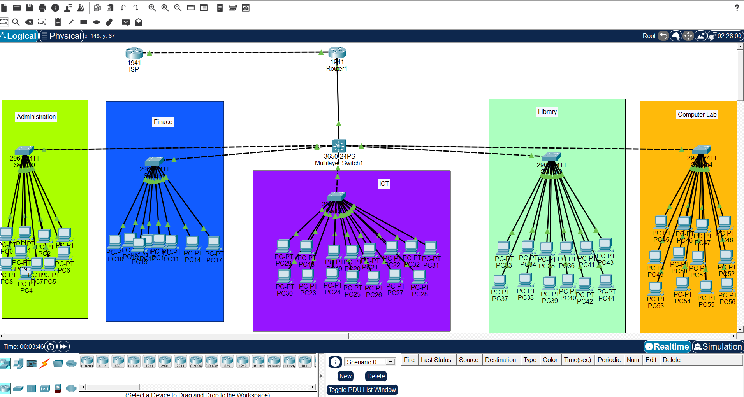

- Core Layer – Routers connecting the network to external networks
- Distribution Layer – Multilayer switch managing VLAN traffic
- Access Layer – Access switches connecting end devices
The network includes:
- 2 Routers
- 1 Multilayer Switch
- 5 Access Switches
- Multiple PCs in each department
Each department is connected to its own switch to improve network organization.

2.2 VLAN Design
Virtual Local Area Networks (VLANs) were implemented to logically separate the network into different departments.
Each department was assigned a unique VLAN ID.
Department | VLAN ID
Administration | VLAN 10
Finance | VLAN 20
ICT | VLAN 30
Library | VLAN 40
Computer Lab | VLAN 50

Advantages of VLANs
- Improved network security
- Reduced broadcast traffic
- Better network performance
- Easier network management

2.3 IP Addressing Scheme
Each VLAN was assigned a separate IP network.
Department | Network Address | Gateway
Administration | 192.168.10.0/24 | 192.168.10.1
Finance | 192.168.20.0/24 | 192.168.20.1
ICT | 192.168.30.0/24 | 192.168.30.1
Library | 192.168.40.0/24 | 192.168.40.1
Computer Lab | 192.168.50.0/24 | 192.168.50.1
This addressing scheme ensures that each department operates in its own network segment.

CHAPTER THREE:

NETWORK IMPLEMENTATION

3.1 VLAN Configuration
VLANs were configured on the switches to separate departmental traffic.
Each switch port connecting to end devices was assigned to the appropriate VLAN.
Example:
Administration devices were connected to ports assigned to VLAN 10.

3.2 Inter-VLAN Routing
Inter-VLAN communication was implemented using the Router-on-a-Stick technique.
In this method:
- A single router interface is divided into multiple subinterfaces.
- Each subinterface is associated with a VLAN.
- Routing occurs between VLANs through the router.

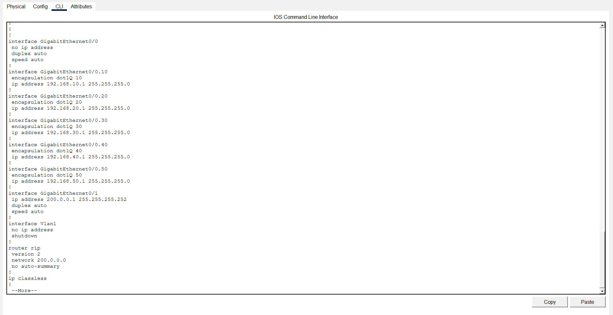
This allowed devices in different departments to communicate when necessary.

3.3 DHCP Configuration
Dynamic Host Configuration Protocol (DHCP) was configured on the router to automatically assign IP addresses to network devices.
DHCP performs the following functions:
- Assigns IP addresses
- Provides default gateway
- Provides DNS server
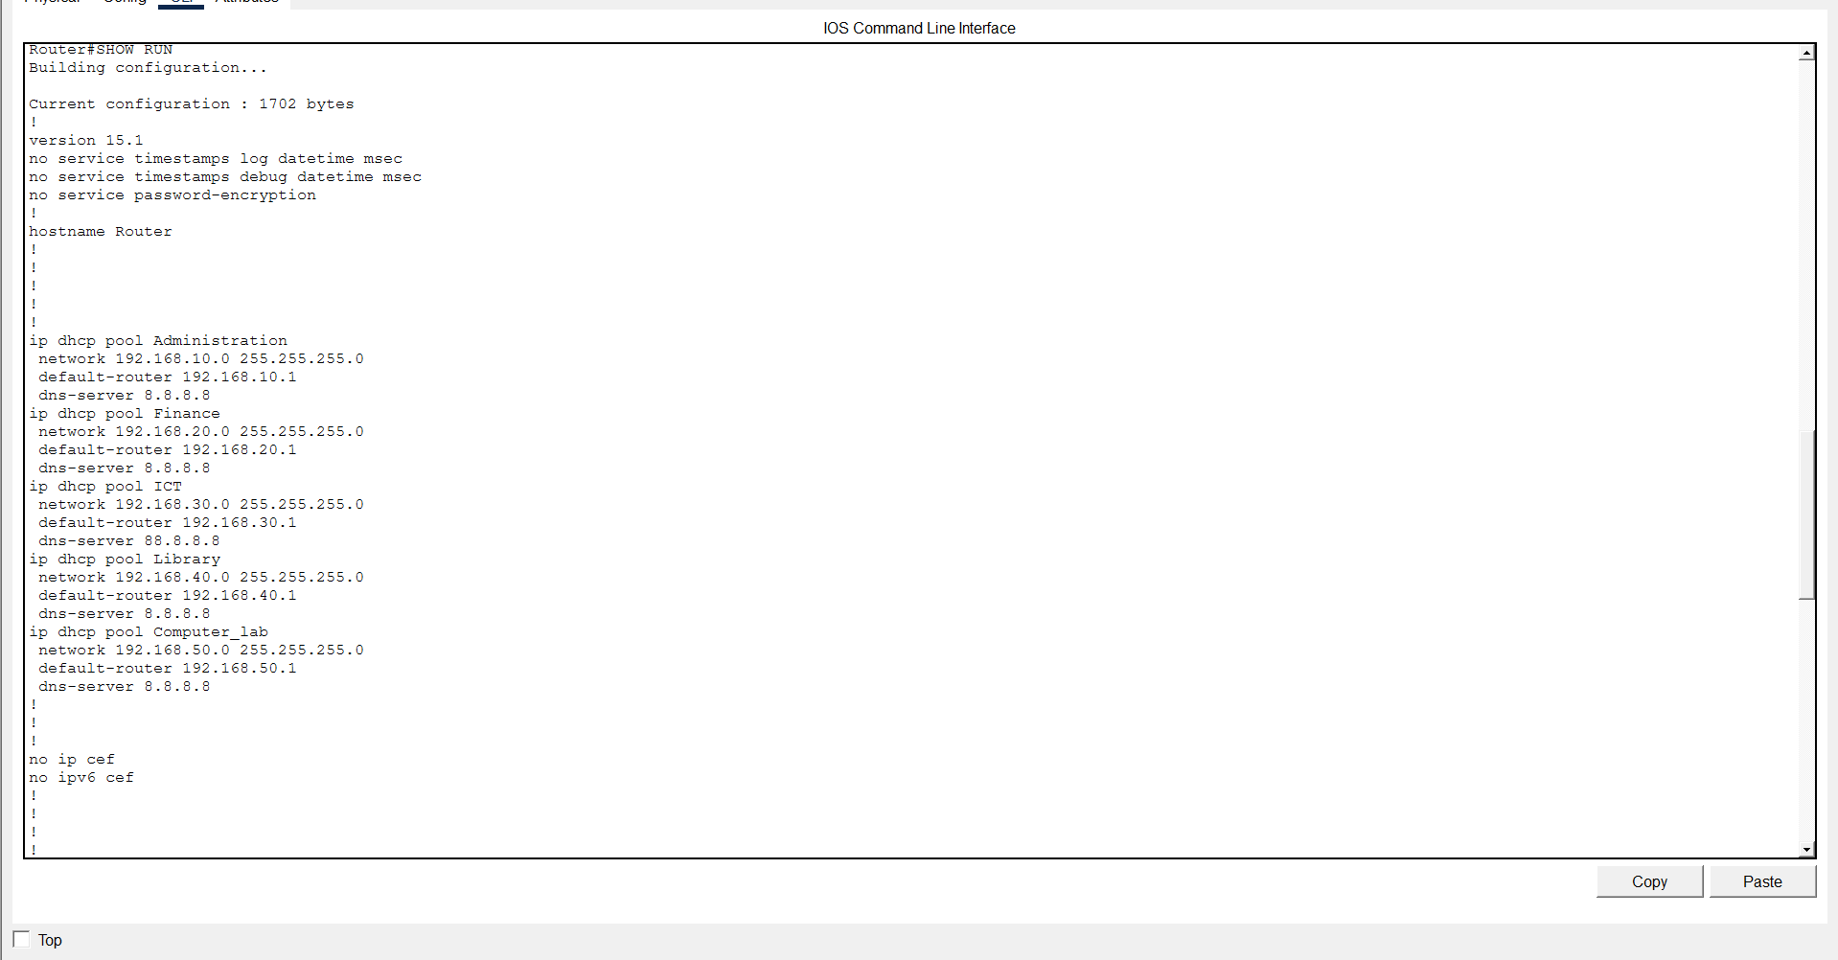

Benefits of DHCP include:
- Reduced manual configuration
- Faster device setup
- Fewer configuration errors

3.4 NAT Configuration

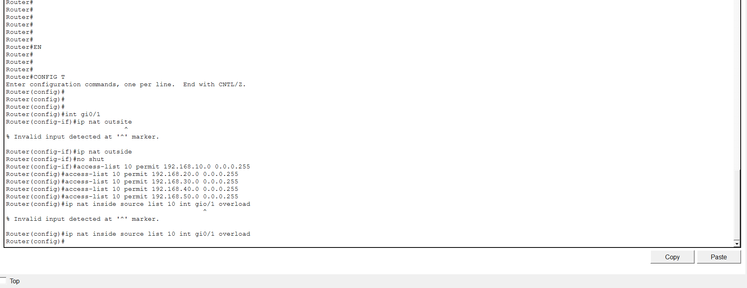
Network Address Translation (NAT) was implemented to allow internal network devices to access the internet.
Since internal devices use private IP addresses, NAT translates them into a public IP address when communicating with external networks.

Advantages of NAT include:
- Conserving public IP addresses
- Increasing network security
- Allowing multiple devices to share a single public IP

CHAPTER FOUR:

NETWORK TESTING
After completing the configuration, the network was tested to ensure proper operation.
Testing was performed using Cisco Packet Tracer simulation tools.

4.1 DHCP Testing
Each PC was configured to obtain an IP address automatically.
The DHCP server successfully assigned IP addresses to devices in all VLANs.
Example assigned address:
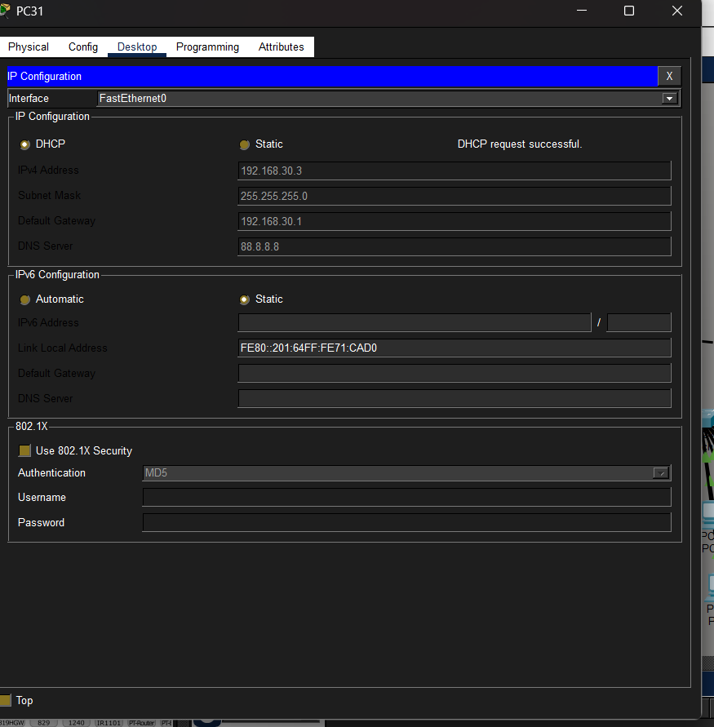

4.2 Inter-VLAN Communication Test
Ping tests were conducted to verify communication between different VLANs.
Example test:
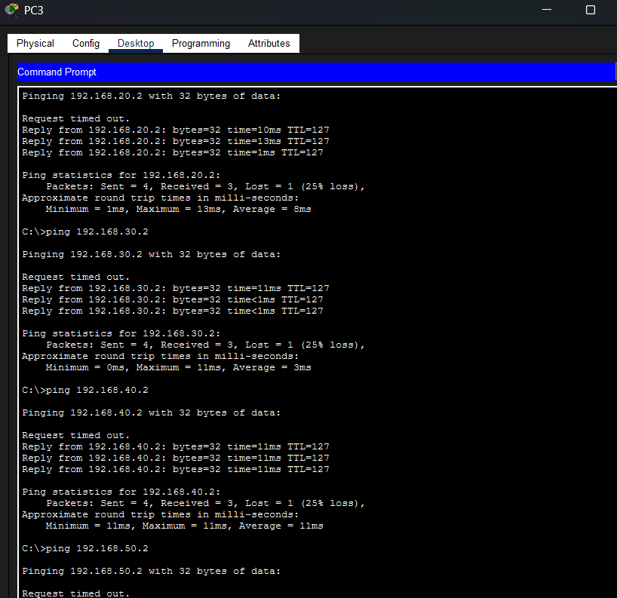
The successful reply confirmed that inter-VLAN routing was functioning properly.

4.3 Internet Connectivity Test
Internet connectivity was tested by pinging a public address.
Example:
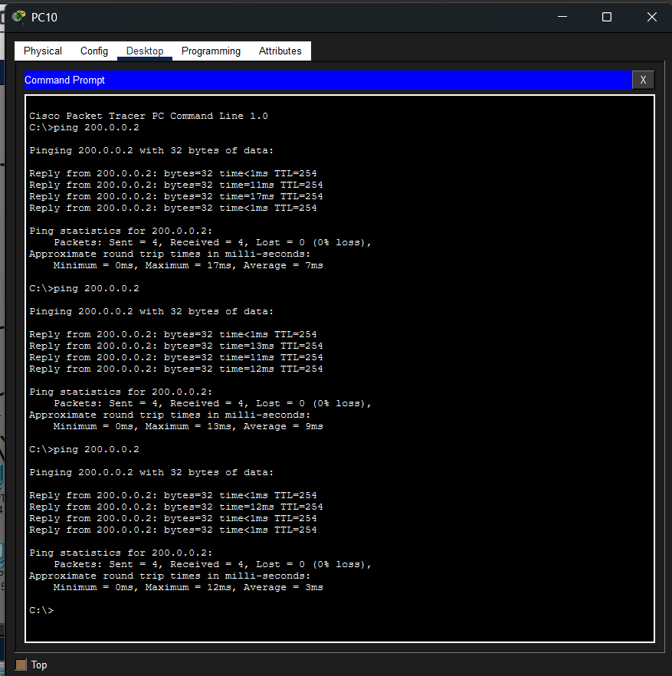
The successful response confirmed that NAT and routing were configured correctly.

CHAPTER FIVE:

RESULTS AND DISCUSSION
The network implementation achieved the intended objectives.
The use of VLANs significantly improved network organization and security by separating departmental traffic.
Inter-VLAN routing enabled communication between departments without compromising network segmentation.
DHCP simplified device configuration, while NAT allowed internal users to access internet resources efficiently.
The simulation results demonstrated that the designed network is scalable and suitable for institutions with multiple departments.

CHAPTER SIX:

CONCLUSION
This project successfully designed and implemented a secure and efficient multi-department network using modern networking technologies.
Key technologies implemented include:
- VLAN segmentation
- Router-on-a-Stick routing
- DHCP automatic addressing
- NAT for internet access
The network design ensures efficient communication, improved security, and simplified network management.
The implementation demonstrates how structured network design can improve performance and reliability in institutional environments.

REFERENCES
- Cisco Networking Academy – Introduction to Networking
- Computer Networking: A Top-Down Approach
- Cisco Network Fundamentals Documentation

APPENDICES
The following materials are attached with this report:
- Network topology diagram
- Router configuration commands
- Switch configuration commands
- Screenshots of successful ping tests
- Cisco Packet Tracer project file (.pkt)

