

Handout
embedded vending machine

Agile Engineering

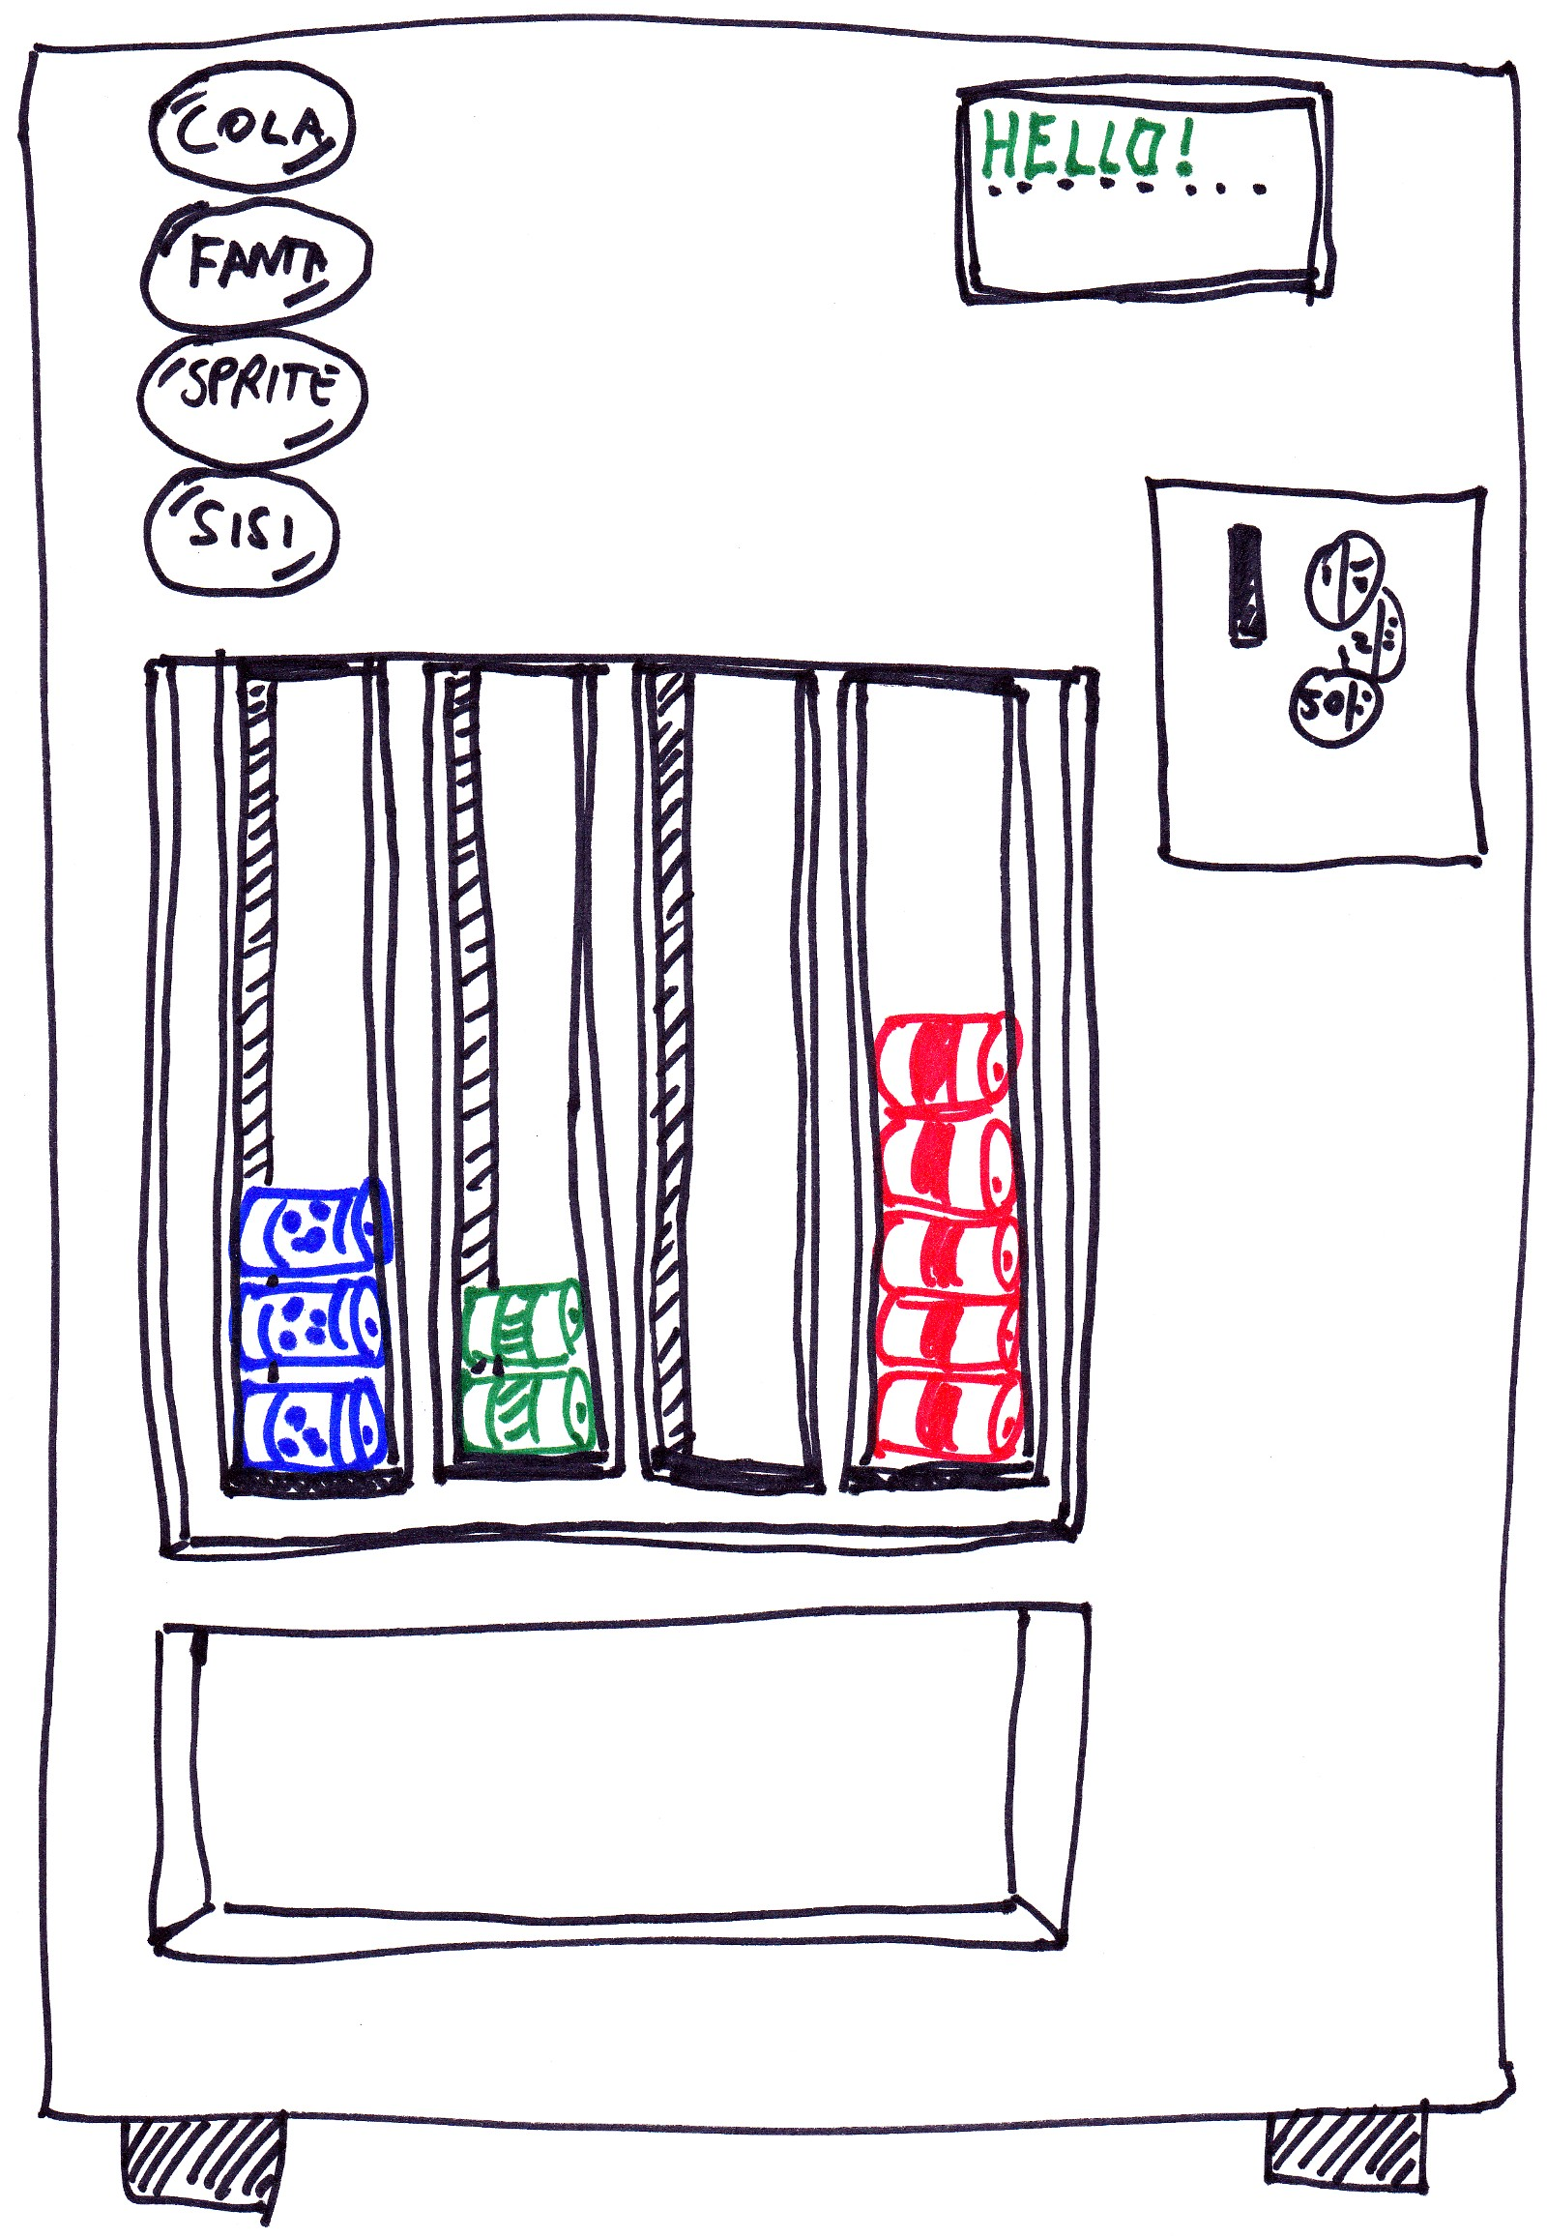
→ button_press_0

→ button_press_1

→ button_press_2

→ button_press_3
← display_show(line #, text)
→ drawer_fill_can_0
→ drawer_drop_can_0
← drawer_drop_can_0
→ drawer_fill_can_1
→ drawer_drop_can_1
← drawer_drop_can_1
→ cash_insert_200
→ cash_insert_100
→ cash_insert_50
→ cash_fill_200
→ cash_fill_100
→ cash_fill_50
← cash_drop_200
← cash_drop_100
← cash_drop_50
→ bin_fetch_all
→ bin_entry

Overview
Vending machine is a piece of hardware containing sensors and actuators for its components.
- Sensors register events from hardware components in the machine
Sensors are therefore input for the software and output for the hardware.
- Actuators pass information to the hardware components
Actuators are therefore output for the software and input for the hardware.
sensor

SOFTWARE
HARDWARE
actuator

Development

Ruby Code organization
Module | Location | Description
Hardware | lib/hardware | Contains hardware components (that simulate the hardware)
Gui | lib/gui | Contains the simulator GUI
bin | bin | Contains the vendingmachine.rb executable
Control | lib/control | Contains the control software than you need to write
Adapter | lib/adapter | Contains the sensor collection and the actuator collection that control should use to respond to sensor events and initiate actuator events

C# Code organization
The solution consists of 5 projects:
Project | Description
VendingMachine.Controller | Contains the control software that you need to write.  The Adapter directory contains the sensor collection and the actuator collection that control should use to respond to sensor events and initiate actuator events
VendingMachine.Controller.unittests | Unit tests for the control software.
VendingMachine.Controller.specs | Feature tests for the control software
VendingMachine.Simulator | Contains hardware components simulating the hardware (directory Hardware) and the simulator GUI. This is also the startup project.
VendingMachine.Simulator.unittests | Unit tests for the hardware components

Where's the main?
Ruby:
Your objects controlling the machine are loaded by the executable in lib/control/main.rb , which contains:
module Control
def self.load
# here, you should load your vending machine control software
end
end

C#:
Your starting point for the control software is the VendingMachineController class, which has an OnLoad method that is called on startup:
public class VendingMachineController
{
public void OnLoad()
{
// here, your vending machine control software will be loaded
}
}

Subscribe to a sensor event
Ruby:
Adapter.sensors.on(:button_press_0) do
self.button_pressed
end

C#:
SensorCollection.Instance().On(":button_press_0", delegate() {
this.ButtonPressed();
});

Fire an actuator
Ruby:
Adapter.actuators.fire(:drawer_drop_can_3)

Adapter.actuators.fire(:display_show, 0, “credits: 0”)

C#:
ActuatorCollection.Instance().Fire(":drawer_drop_can_3");

ActuatorCollection.Instance().Fire(":display_show",
new Object[] {0, "credits: 0"});

Hardware components

Buttons
Buttons register presses and contain sensors to notify software. The system contains the following buttons:
button_no | description
0 | The cola button
1 | The fanta button
2 | The sprite button
3 | The sisi button

Sensors
- button_press_<button_no>
fires on a button press
<button_no> is the number of the button

Drawers
Drawers contains cans of beverage. Drawers can drop cans into the bin. They contain actuators to drop a can and sensors to notify that a can is put in the drawer (fill) and to notify that a can has been dropped (drop). The system contains the following drawers:
drawer_no | description
0 | The cola drawer
1 | The fanta drawer
2 | The sprite drawer
3 | The sisi drawer

Sensors
- drawer_drop_can_<drawer_no>
fires on dropping a can
<drawer_no> is the number of the drawer
- drawer_fill_can_<drawer_no>
fires on putting a new can in the drawer
<drawer_no> is the number of the drawer

Actuators
- drawer_drop_can_<drawer_no>
tells a drawer to drop a can
<drawer_no> is the number of the drawer

Display
The display can show messages to the user. It contains a two line display. The system contains only one display.

Actuators
- display_show (<line_no>, <message>)
tells the display to show a message
<line_no> is the number of the line (0 based)
<message> is the message to display

Cash register
The cash register can accept coins an drop them into the bin. They contain actuators to drop a coin and sensors to notify that a coin is put in the cash register. The cash register recognizes the following coins:
coin_type | description
50 | 50 cents
100 | 1 euro
200 | 2 euro

Sensors
- cash_fill_<coin_type>
fires on filling a coin in the cash registers' stock
<coin_type> is the type of coin added
- cash_insert_<coin_type>
fires on inserting a coin in the cash register as a paying action
<coin_type> is the type of coin added

Actuators
- cash_drop_<coin_type>
tells cash_register to drop a coin in the bin as a change return action
<coin_type> is the type of coin to drop

Bin
The bin catches cans and change and contain sensors to register catch and fetch events,

Sensors
- bin_entry
fires on something (a coin or a can) falling in the bin
- bin_fetch_all
fires on something (a coin or a can) fetched from the bin by a user.

