Contents
Notifications 1
Privacy 1
Static Notifications 2
Responsive Notifications 4
Parameters 4
checkList 6
Sample Uses 7
User Settings 7
Update Version 10
Compatibility Testing 13
Publishing Notifications 16
Validating menu.json 16
Trialling menu.json 17
Log File 18
Appendix 19
List of System Information 19

Notifications
Notifications messages may be static or responsive. Responsive messages change depending on the user’s installation, settings and content. For example, if the user’s Update Mode is set to Stable, then a message intended to announce updates will report new updates for the Stable Version but not for the Testing Version.

Privacy
Notifications are fetched from the Open Rails web server and all users get the same notifications. They are just presented differently depending on the user’s settings. Privacy Note: No information is returned to the Open Rails web server.

Static Notifications
A notification which is static might be used to convey a simple message for all users, such as:
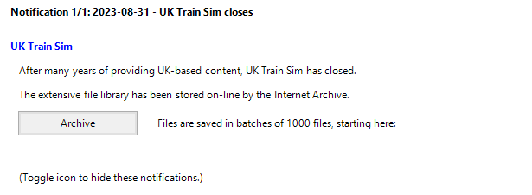
The JSON must specify a date and title which appears in the top line.
The “comment” is optional.
The “itemList” section is required and provides a list of items of several possible types which are specified in their initial “$type” field. The construction “ORTS.<ClassName>, Menu” is recognised by the Newtonsoft JSON reader as a class in the Menu executable.
This example makes use of Heading, Text and Link classes. The Link class provides a button which launches the default browser and opens it at the given URL.
The “$type” property must come first in the list of properties.

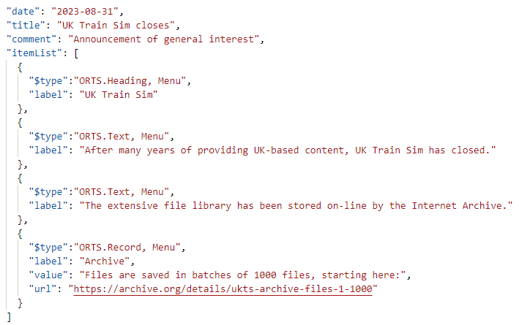
Items may also be of type “Record” and type “Update” as described below. There are optional fields for font color and for indent from the left.

Responsive Notifications
An example of a responsive notification is one that announces news about a route that the user already has installed.
If the user has the Demo Route 1 installed (as an installation profile), then he is shown this notification:
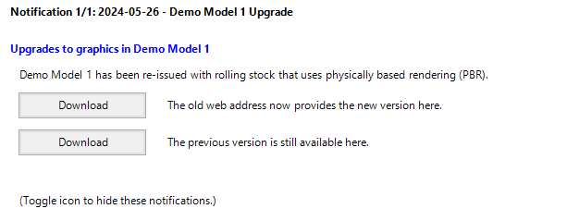

But if he hasn’t, then he is shown a different one:

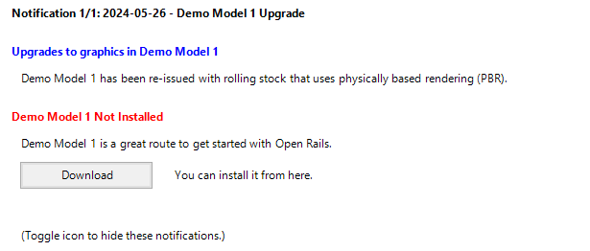

Parameters
The different behaviour is achieved by testing whether the parameter “{{installed_routes}}” includes the route folder “SCE” – as used by Demo Model 1.

“{{installed_routes}}” is recognised as a parameter because it is enclosed by “{{ . . }}”. Parameters are converted into current values automatically. The “installed_routes” parameter is converted into a string of route folders, which will contain “SCE” if the user has installed Demo Route 1.
This behaviour is achieved with the following JSON:

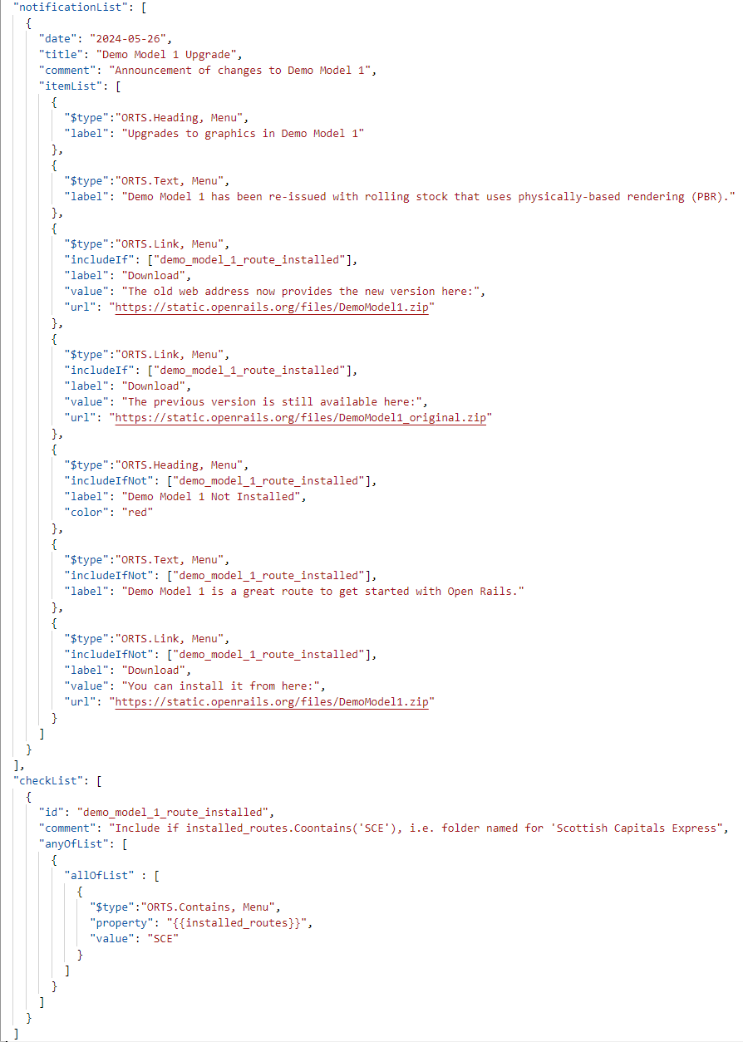

In the “itemList” we have a “Heading” item and a “Text” item followed by a “Link” item. This has a field “IncludeIf” which is used to show or to hide the item.
The array of values which the “IncludeIf” provides names of one or more checks that all must succeed before the item will be shown. Otherwise, it will hidden.
There are 3 more items in the “itemList” which have the opposite field “includeIfNot”. These items are shown if all of the checks in the array of values fail.
Note that an optional field has been used in one of the items to set the Heading color to “red”. All the Windows system colors are recognised.

checkList
The “notificationList” is followed by a “checkList” to define the criteria for each of these checks.
Each check in the “checkList” has a string “id” which is matched to the values in the “includeIf” and “includeIfNot” array values.
The “comment” in checkList is optional.
“anyOfList” allows a check to consider multiple tests. Once a test succeeds, the check has succeeded. This implements a logical OR operation.
The “anyOfList” contains an array of one or more “allOfList”. Each “allOfList” is an array of criteria and all of these must succeed if the test is to succeed. This implements a logical AND operation.
In this example, there is only one constraint - “ORTS.Contains, Menu”. This constraint requires that “{{installed_routes}}” contains “SCE”.
As noted in the “comment” field, “SCE” is the name of the folder containing the route “Scottish Central Express”. “{{installed_routes}}” is a parameter which is converted to a string containing all the route folder names in the installation profiles.
The “Contains” operator is not case-sensitive.
A “ORTS.NotContains, Menu” alternative is also supported.

Sample Uses

User Settings
Notifications can also change behaviour based on the settings which a user chooses in the “Options” menu. In this example, we are assuming that adhesion has been greatly improved in Stable Version 1.6 and this notification is prompting users to try it out.
Only users who have the setting Advanced Adhesion turned off will see this notification. The notification has been configured so that users with Advanced Adhesion turned on will see no notification at all.
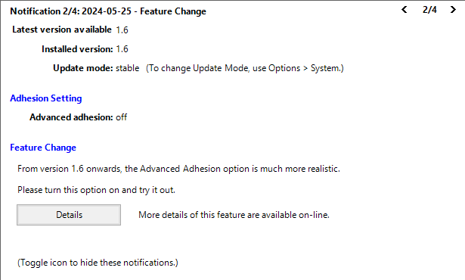
Pressing the “Details” button launches the user’s browser to show the specified webpage.
In this JSON, the parameter “{{Settings.UseAdvancedAdhesion}}” appears twice; once as a confirmation to the user of its current value - “off” and again in the “checkList”. If the check fails, then the notification is not shown at all. This behaviour is specified by the “includeIf” in the notification itself. An “IncludeIfNot” is also available.
In this example, the check is for 2 conditions, that the setting is “off” and also that the “{{installed_version}}” contains the value “1.6”. This notification will not be shown while the user stays at version 1.5 and will disappear again once the user upgrades to version 1.7.
As mentioned earlier, the JSON element “allOfList” indicates a logical AND, so that this notification will only be shown if all the properties have the correct values.
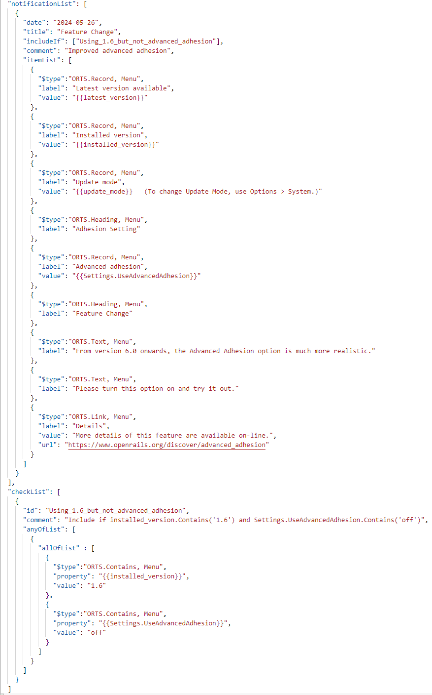
This example also introduces the type “ORTS.Record, Menu” which is used to set out individual records aligned as in a table format.
Note: the parameter for user settings is case-sensitive (in Pascal case) and the possible names are listed in https://github.com/openrails/openrails/blob/master/Source/ORTS.Settings/UserSettings.cs
The other parameters are not case-sensitive and a full list is appended.

Update Version
Notifications are also used to advise that a new version is available. If a new version is available, then the notification might be shown as:
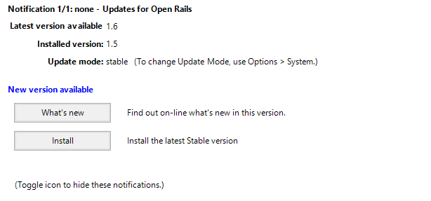

Once the user has upgraded, this is no longer appropriate and the notification is shown as:
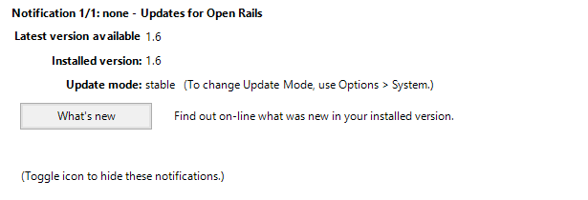

This example introduces a new JSON element “ORTS.Update, Menu” which is used here to provide the button “Install” and its action.
The link items include 3 URL elements, and the program uses the one appropriate to the update mode that the user has chosen – stable, testing or unstable.
The check with id=”ready_to_update” makes use of the “NotContains” condition, so that an update button is offered only if both the version installed is not the same as the latest version available and also the update mode is not “none”.
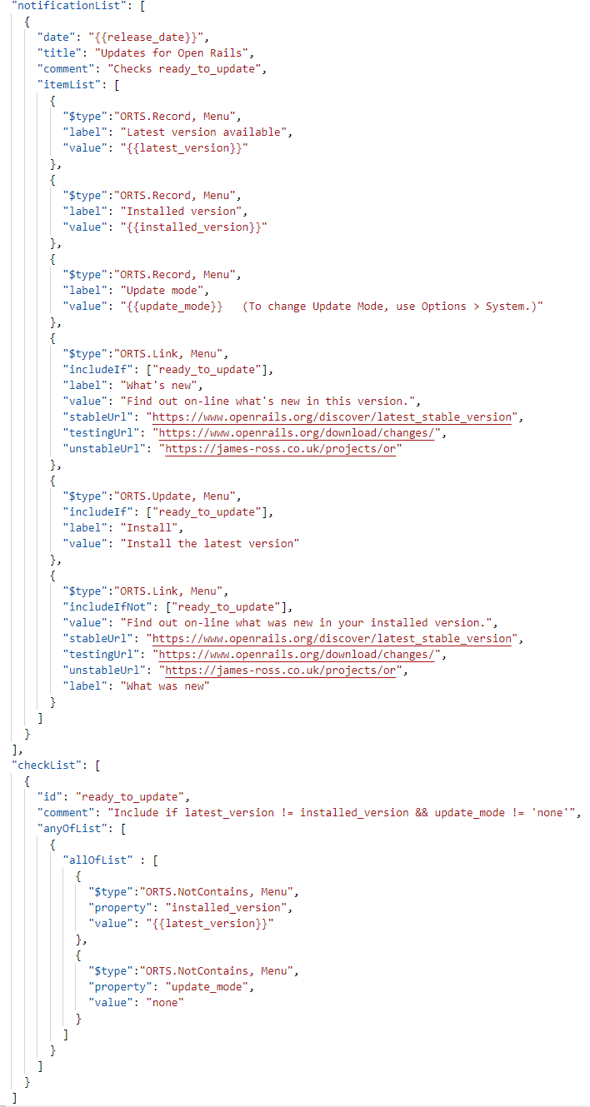
For the “ORTS.Link, Menu”, “url” overrides “stableUrl” and the other 2 URL properties. If the user has chosen Update Mode = “none”, then the url used will the same as “stableUrl”.

Compatibility Testing
An upgrade which includes the Physics Based Rendering (PBR) provided by the Graphics Library Transission Format (glTF) requires hardware that supports Direct3D version 10.0 or greater. Previously Open Rails has only required Direct3D version 9.3.
By adding a second check, the notification of a new version can also indicate that an upgrade of the system is required, such as:
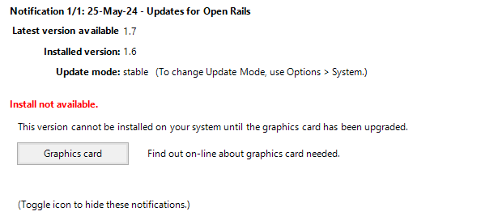
This example is very similar to the previous one, but there are now 4 check ids listed in the “checkIdList” of the notification, one for the update, two for the version and one for the system information Direct3D.
The example represents the situation where the Stable Version does not support PBR or require Direct3D v10.0. However, we assume that the Testing and Unstable Versions have been improved to support PBR, so are ahead of the Stable Version and require Direct3D v10.0.
The item “$type: ORTS.Update, Menu” which provides the install button needs 2 checks for the Stable Version:
"includeIf": ["ready_to_update", "is_stable"]

However the item for the Testing or “Unstable Versions needs 3 checks:
"includeIf": ["ready_to_update", "is_testing_or_unstable", "pbr_compatible"]

A red message “Install not available” is shown when all the folllowing checks succeed:
"includeIf": ["ready_to_update", "is_testing_or_unstable"],
"includeIfNot": ["pbr_compatible"],

These conditions are ANDed together as:
ready_to_update AND is_testing_or_unstable AND NOT pbr_compatible
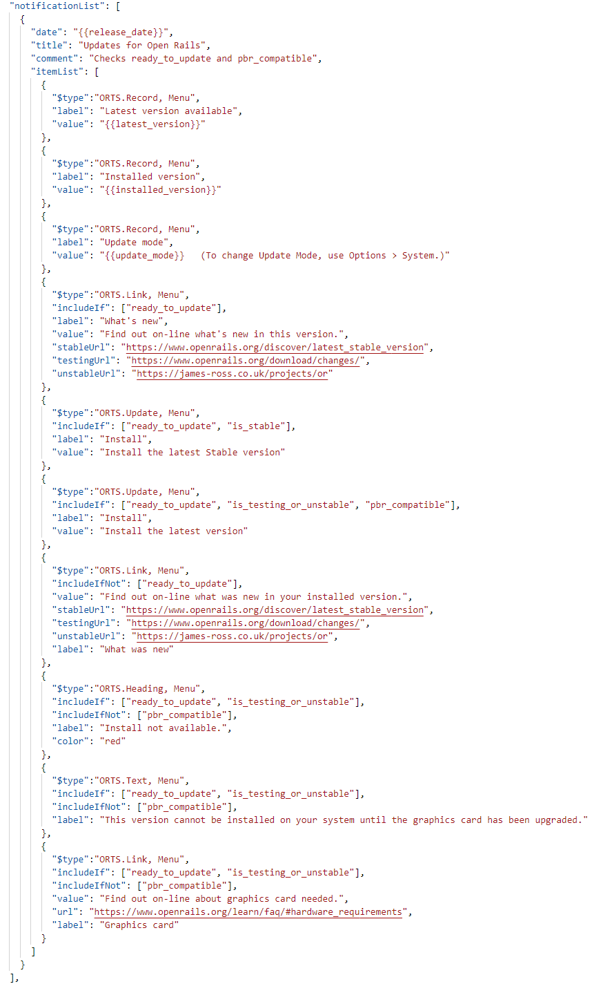
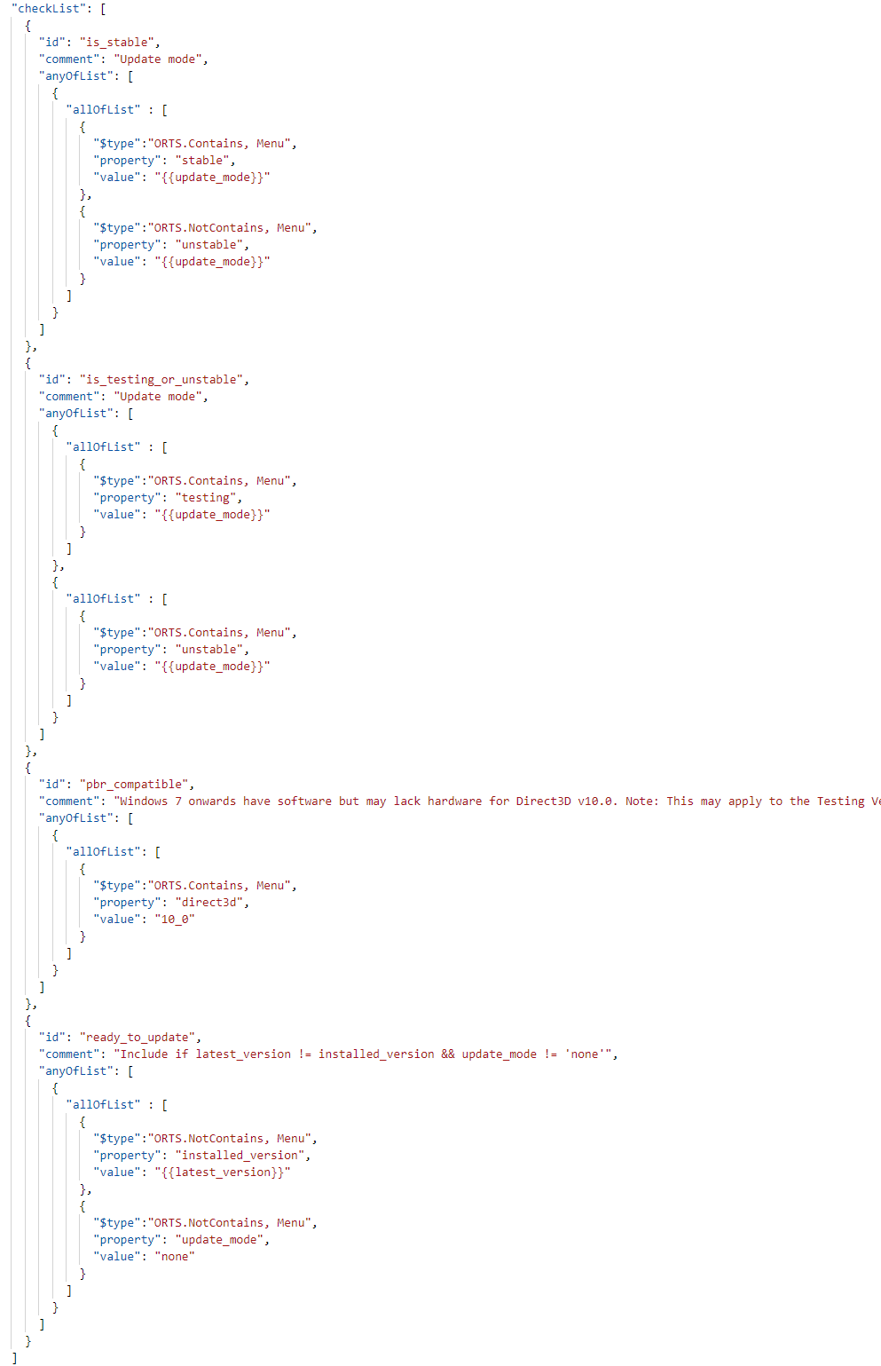

Publishing Notifications
Changes to menu.json can be submitted as a Pull Request to the repository openrails/notifications on GitHub.
Please note that notifications are intended to be short, so there is no provision for scrolling lengthy text. There is no provision either for images. More detail can be provided by including a link to a webpage along with an incentive for clicking the link.

Validating menu.json
A schema file is provided at https://static.openrails.org/api/notifications/schema.json which can be used to validate the menu.json file before publishing a new version.
Validation is offered automatically when editing JSON using Visual Studio Code or can be done on-line using tools such as https://www.liquid-technologies.com/online-json-schema-validator

The menu.json file is not validated at run-time by Menu.exe, so any errors will lead to an exception such as:
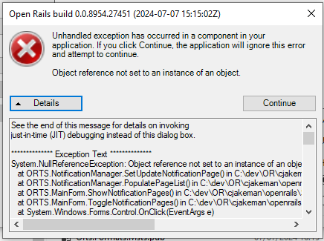

Trialling menu.json
The “notificationList” is downloaded and extracted from the JSON file at https://static.openrails.org/api/notifications/menu.json
In order to test new versions of this file, the Notifications code will first look for a file in the Program folder of Open Rails – Program\notifications_trial.json
If this exists, then it will be used instead of the published file.
As part of trialling new version of this file, it may be helpful to simulate system information or user settings or installed routes that do not exist on the trial system. Another JSON file can be added to the Open Rails Program folder to simulate these.
This file is named Program\notifications_trial_parameters.json and contains a list of parameters and values. The following example was used to produce the previous notification image.
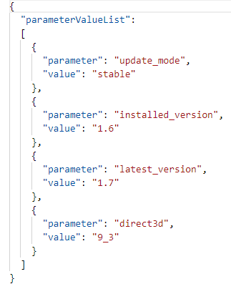

Log File
If the file Program\notifications_trial.json exists, then a log file will be generated also in the folder - Program\notifications_trial_log.txt
For example:
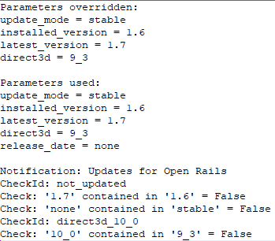

Appendix

List of System Information
This is similar to the list of system information that appears at the top of OpenRailsLog.txt:
- installed_version
- runtime
- system
- memory
- cpu
- gpu
- direct3d

OpenRailsLog.txt sample:
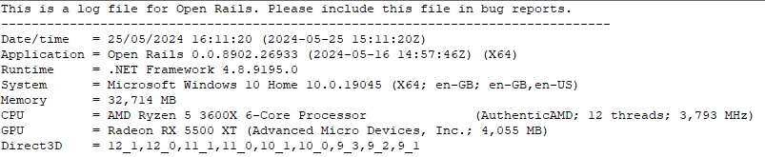

https://static.openrails.org/api/notifications/menu.json
The date must be in ISO format (YYYY-MM-DD) so that dates can be sorted.
https://learn.microsoft.com/en-us/dotnet/api/system.windows.media.colors?view=windowsdesktop-8.0
https://github.com/openrails/notifications

