Part A — Theory (Short Answers)

Q1. Mean, Median, Mode
In the context of employee salaries:
- Mean — the average salary of all employees. Add up all salaries and divide by the total count. Example: salaries [40k, 50k, 60k] → Mean = 50k. Gets pulled by very high or low values.
- Median — the middle value when sorted. For the same example, Median = 50k. More reliable than mean when there are outliers like a very high CEO salary.
- Mode — the most frequently occurring salary. If 300 employees earn 45,000, then Mode = 45,000. Useful for HR to find the standard pay level.

Q2. Range vs Variance
- Range = Max − Min. E.g., Salary Range = 1,20,000 − 25,000 = 95,000. Easy to calculate but ignores how all middle values are spread.
- Variance = Average of squared differences from the mean. Captures how spread out ALL salaries are, not just the extremes. A high variance means salaries differ a lot; low variance means they are close to the average.

Q3. Normal Distribution vs Poisson Distribution
Feature | Normal Distribution | Poisson Distribution
Shape | Bell curve, symmetric | Right-skewed
Data Type | Continuous | Count / integers
Example | Salary, Performance Score | Projects completed per month

Q4. Skewness — Workplace Example
Skewness tells how lopsided a distribution is.
- Positive Skew (right tail): A few employees earn very high salaries; most earn moderate — the distribution has a long tail to the right.
- Negative Skew (left tail): Most employees score high in performance; very few score low — tail goes to the left.
- Zero Skew: A perfectly balanced bell curve. The mean, median, and mode are all equal.

Q5. Conditional Probability in Promotions
Conditional Probability P(A|B) = probability of A given that B has already happened.
Workplace example: P(Promotion | Performance_Score > 80)
= Out of all employees who scored above 80, what fraction actually got promoted?
This helps HR verify whether the promotion policy is truly rewarding high performers or just using arbitrary criteria.

Q6. Independent vs Mutually Exclusive Events
- Independent Events: One event doesn't change the probability of another. Example: Employee A getting promoted has no effect on Employee B's promotion chances.
- Mutually Exclusive Events: Both events cannot happen at the same time. Example: An employee can only belong to one department — being in HR and IT simultaneously is impossible.

Q7. Bayes Theorem in Real-World Decisions
P(A|B) = [P(B|A) x P(A)] / P(B)
Example: Given an employee was promoted, what is the probability they scored above 80?
We use prior information (how many high scorers get promoted) to update our belief. Bayes Theorem is used in spam filters, medical diagnosis, fraud detection, and HR analytics.

Q8. PCA — Principal Component Analysis (Simple Words)
PCA reduces many columns into a few summary columns (called components) while keeping most useful information.
Example: Instead of separately analyzing Salary, Working Hours, Projects, and Score, PCA combines them into 2-3 components we can easily plot and compare.
Think of it as finding the main patterns in high-dimensional data and removing the noise.

Part B — Practical (Python Results)

Step 1 — Central Tendency & Dispersion
Salary Statistics
Measure | Value
Mean | 54,978.97
Median | 54,983.00
Mode | 25,000

Projects Completed Statistics
Measure | Value
Variance | 4.9171
Standard Deviation | 2.2175

Step 2 — Probability & Events
Overall Promotion Probability
Metric | Result
Promoted employees | 1,978 out of 4,000
P(Promotion) | 0.4945 = 49.45%
P(Promotion | Score > 80) | 0.5916 = 59.16% (from 617 high performers)

Contingency Table — Promotion Status vs Department
Department | Not Promoted | Promoted | Total | Promo Rate
Finance | 409 | 368 | 777 | 47.4%
HR | 417 | 412 | 829 | 49.7%
IT | 400 | 368 | 768 | 47.9%
Marketing | 399 | 418 | 817 | 51.2%
Operations | 397 | 412 | 809 | 50.9%

Step 3 — Distributions & Visualization
Skewness & Kurtosis
Variable | Skewness | Kurtosis | Interpretation
Salary | 0.0499 | -0.1664 | Nearly symmetric, balanced pay
Performance Score | -0.0659 | -0.1013 | Slightly left-skewed, uniform spread

Visualization Output
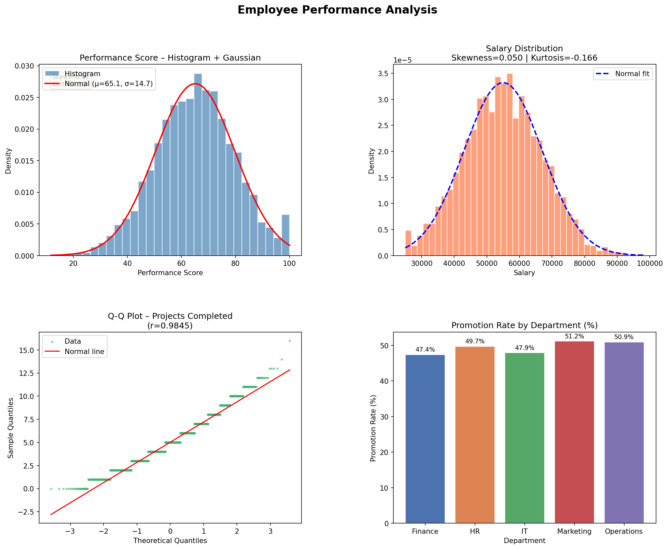
Figure: (Top-left) Performance Score Histogram + Gaussian curve | (Top-right) Salary Skewness/Kurtosis | (Bottom-left) Q-Q Plot of Projects Completed | (Bottom-right) Promotion Rate by Department

Step 4 — Linear Algebra Application
Employee Vectors [Projects_Completed, Working_Hours]
Employee | Projects Completed | Working Hours
Employee 1 (v1) | 3 | 46.1
Employee 2 (v2) | 7 | 45.8

Linear Algebra Results
Operation | Result
Dot Product (v1 . v2) | 2132.38 — measures similarity in work profile
Norm 1 of v1 (Manhattan) | 49.1000 — sum of |Projects| + |Hours|
Norm 2 of v1 (Euclidean) | 46.1975 — straight-line distance from origin
Angle between v1 and v2 | 4.97 degrees — very similar working styles

Key Insights (3-5 Points)

1 | Employees with Performance Score > 80 have a 59.2% chance of promotion — 10% higher than the overall rate of 49.45%. High performance clearly correlates with promotion.
2 | Marketing department has the highest promotion rate at 51.2%, while Finance is the lowest at 47.4%.
3 | Average salary is Rs. 54,979 with mean and median almost equal (54,979 vs 54,983), indicating a well-balanced, non-skewed salary structure.
4 | Only 15.4% of employees score above 80 in performance — top performers are a small, high-value group deserving special attention.
5 | The Q-Q plot of Projects_Completed deviates from the normal line, confirming it follows a Poisson distribution — as expected for count data.

