“Solar-Server” on a Raspberry Pi

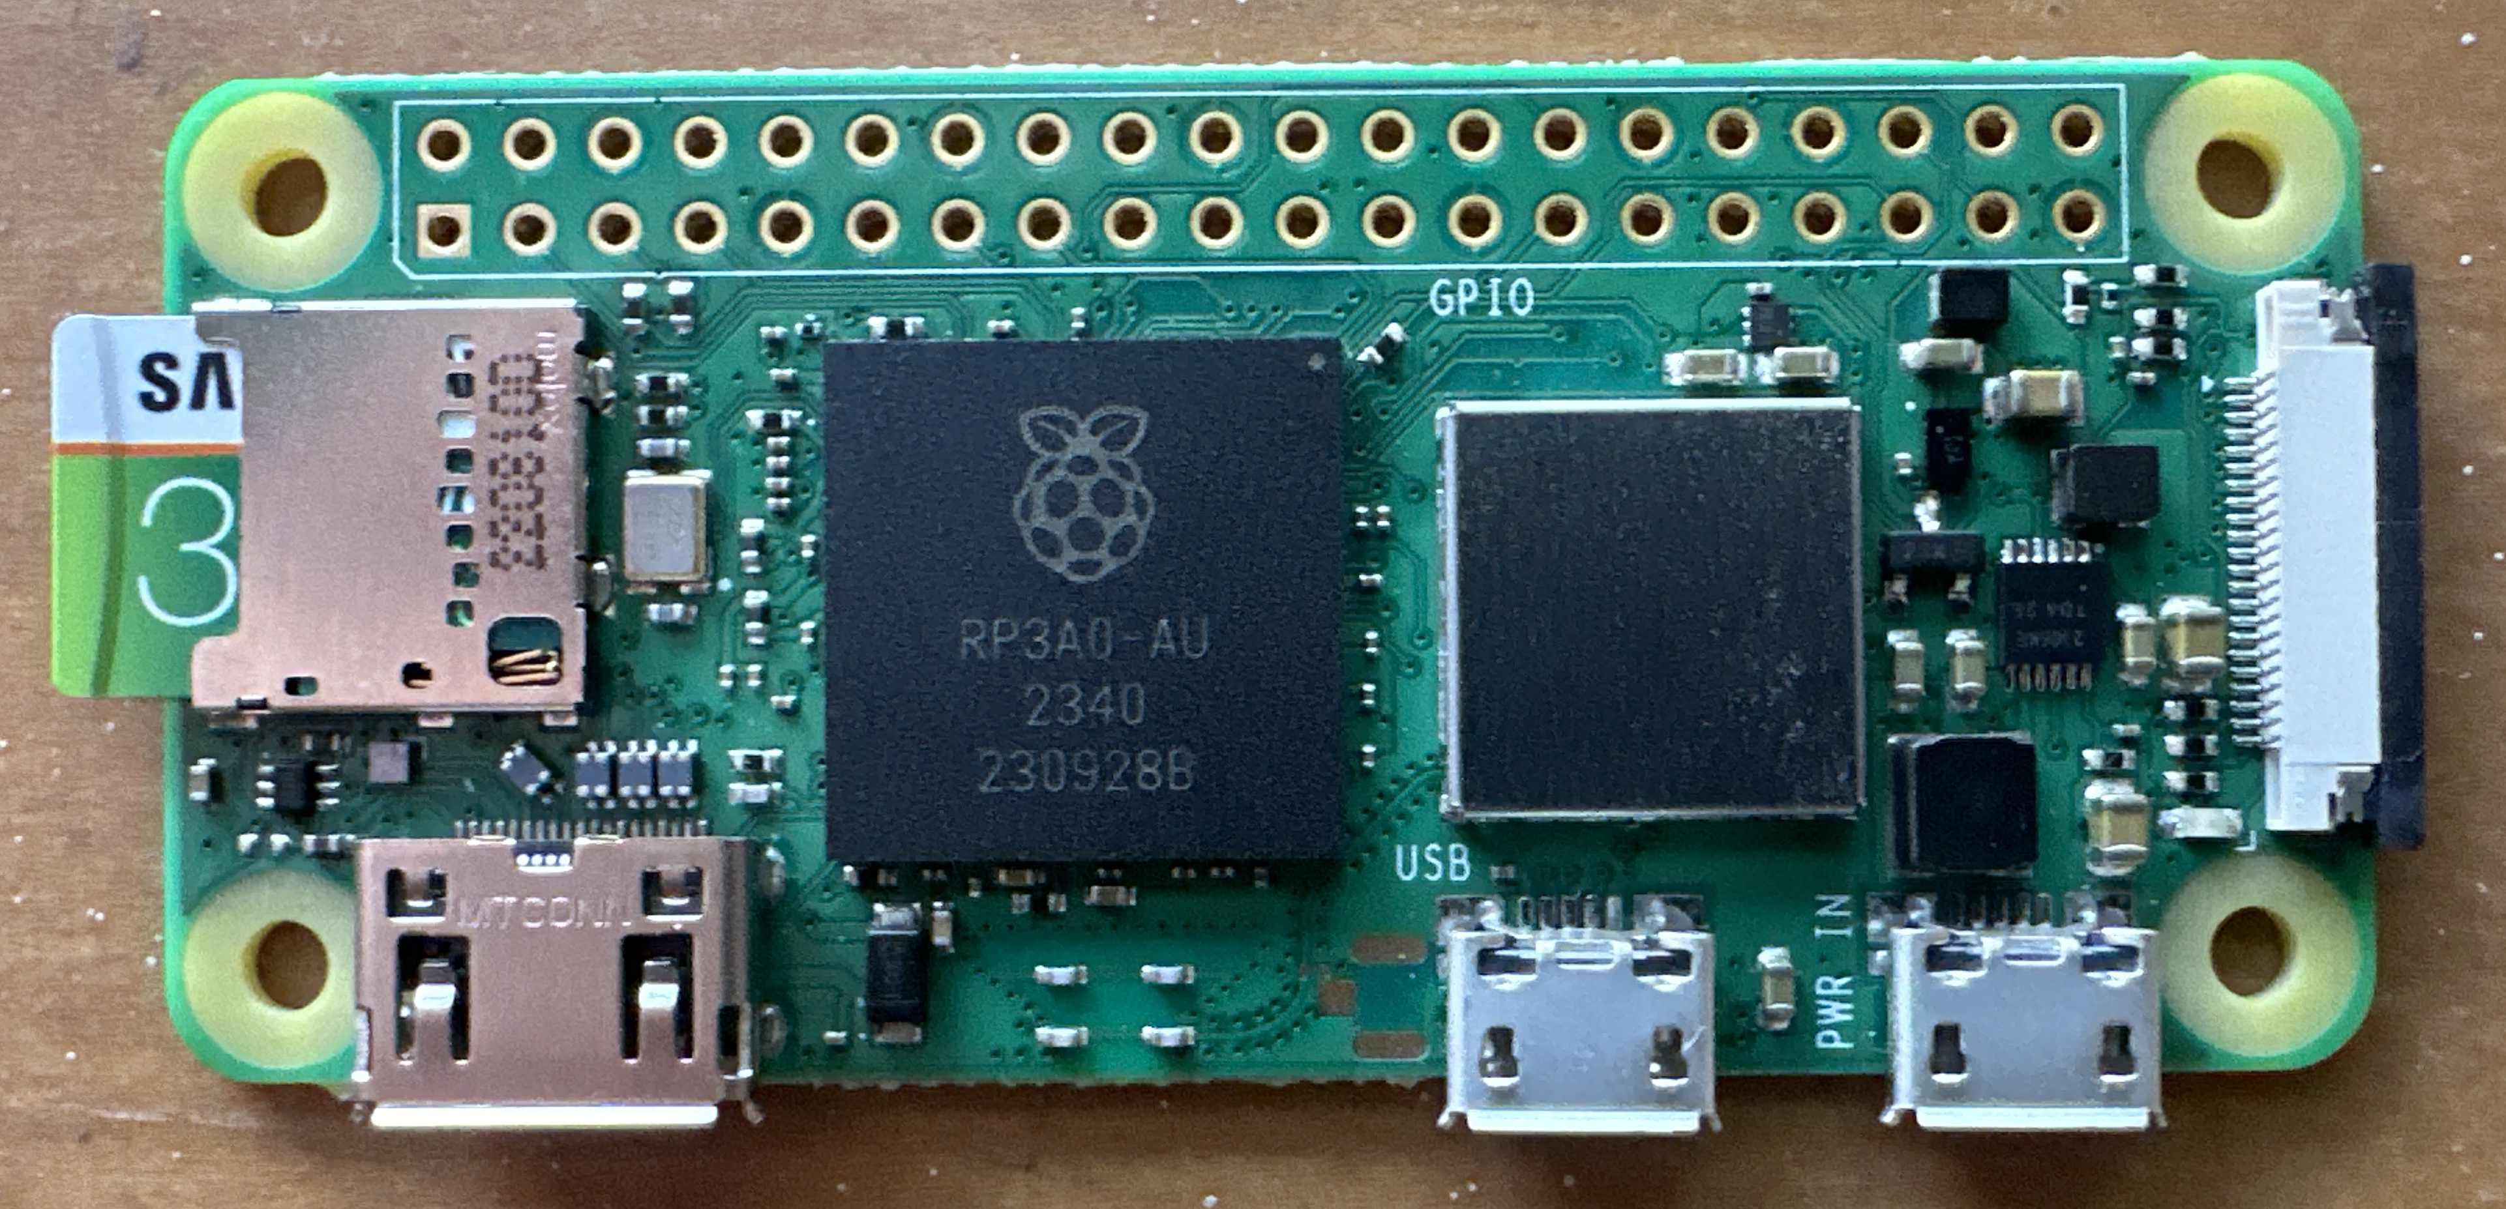
The World Wide Web, part of the larger Internet, runs on an immense number of computer “servers,” most of which are housed in large computing centers that use enormous amounts of energy.

The “solar-server” here, on the other hand, uses only the power from a 12-volt battery which is kept charged by the visible solar panel.

This server is not connected to the Internet. Instead, it acts as a digital “Little Free Library!” When you sign on to the server using your phone or computer, you can read and/or download free books, art, and music.

Try it out!
With your phone or computer, connect to the open wifi network SolarServer, password panthers
- With a browser on your phone or computer, go the URL http://192.168.10.30.
- From the webpage here you can:
  - Learn more about the project
  - Read/download some books
  - Listen/download art or music

References
For further information on this project, see the “book” How I Did It, by Richard White, located on the server. Or, view the notes online at github.com/rwhite5279/SolarServer .
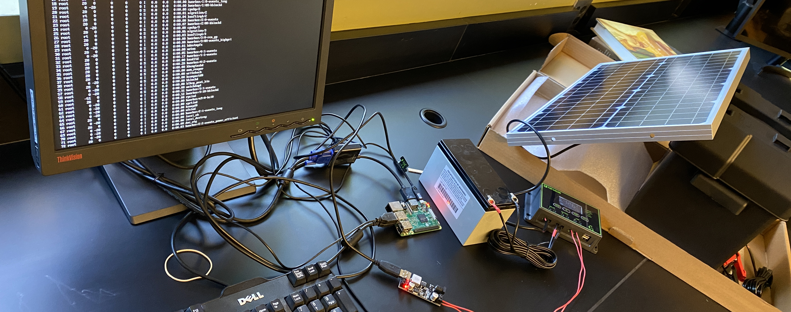
See other side for additional information on this demonstration.

“Solar-Server” on a Raspberry Pi
Solar panels are a fascinating form of “clean energy” in which photovoltaic cells exposed to light result in excited electrons that create electrical current in a circuit.

This particular solar panel and its controller cost $60, and it produces a little more than 12 Volts of DC potential. By connecting it to a 12-Volt motorcycle battery, the solar panel can:

- keep the 12-Volt battery charged as long as the sun is shining, and
- power the small Raspberry Pi unit connected to it.

When the sun is no longer sufficient to charge the battery, the controller ensures that the Raspberry Pi continues to operate.

Science Challenge!
A solar panel 1.00 meter wide x 1.00 meter tall would have an area of 1.00 m², and produce about 220 Watts of Power. This panel is actually 31 cm x 57 cm.

- What is the solar panel’s total surface area, in meters-squared?
- How much power can this panel produce?
- This Raspberry Pi unit uses 5 Volts and 2.5 Amps of current. How much power does it use? (Power = Current x Voltage)
- In theory, how many total Raspberry Pis could be run off of this solar-powered system?

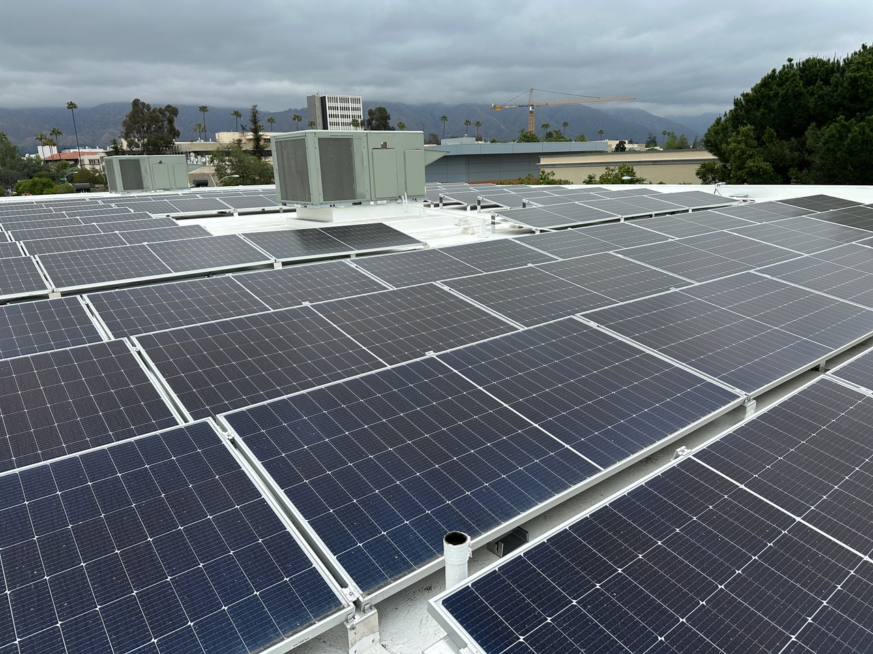Solar panels on the roof of the Polytechnic School gym

Answers:
1. 0.57 m x 0.31 m = 0.178 m².
2. 0.178 m² x (170 W / 1.00 m²) = 30 Watts.
3. P=IV = (5)(2.5) = 12.5 Watts
4. 2.4 Raspberry Pi

