Face Detection on the Raspberry Pi

The Raspberry Pi is a small computer that runs an open-source operating system. This particular Pi has been loaded with OpenCV, a computer vision package that can be used for analyze images. In this demonstration, OpenCV is looking for patterns of colored pixels that might represent a face..

Try it out!

- Using a Terminal on the screen, at the prompt $ enter the command
$ python ~/Desktop/face_detection.py
and hit the [Enter] key. You should see a video image based on the web camera that is attached to the Raspberry Pi. Place the web camera on the table where it will have a view of people in the room.
- What happens on the monitor when a person’s face is presented to the webcam?
- What factors affect the computer’s ability to recognize a person’s face? Try:
  - A face that’s closer and a face that’s farther away
  - A lighter-skinned face and a darker-skinned face
  - A drawing of a face
  - A photograph of a face
  - Tilting your face
  - Covering part of your face
  - Wearing a cap

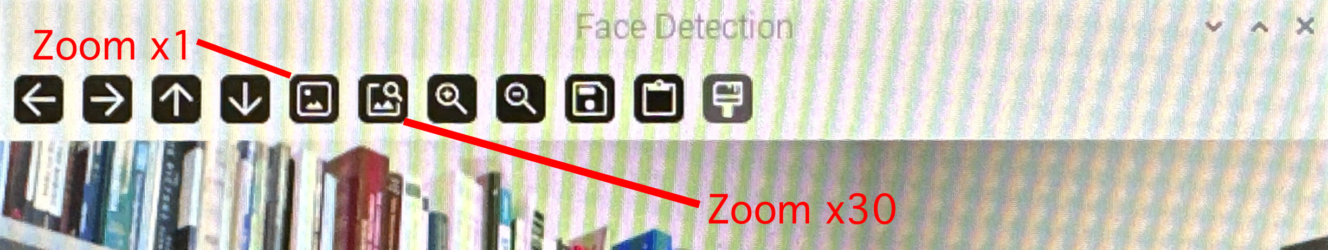
- In the window labeled “Face Detection” are a series of buttons.
Click on the “Zoom x30” button, and observe what happens as the camera’s view of the world shifts.
  - What do the individual squares of color represent?
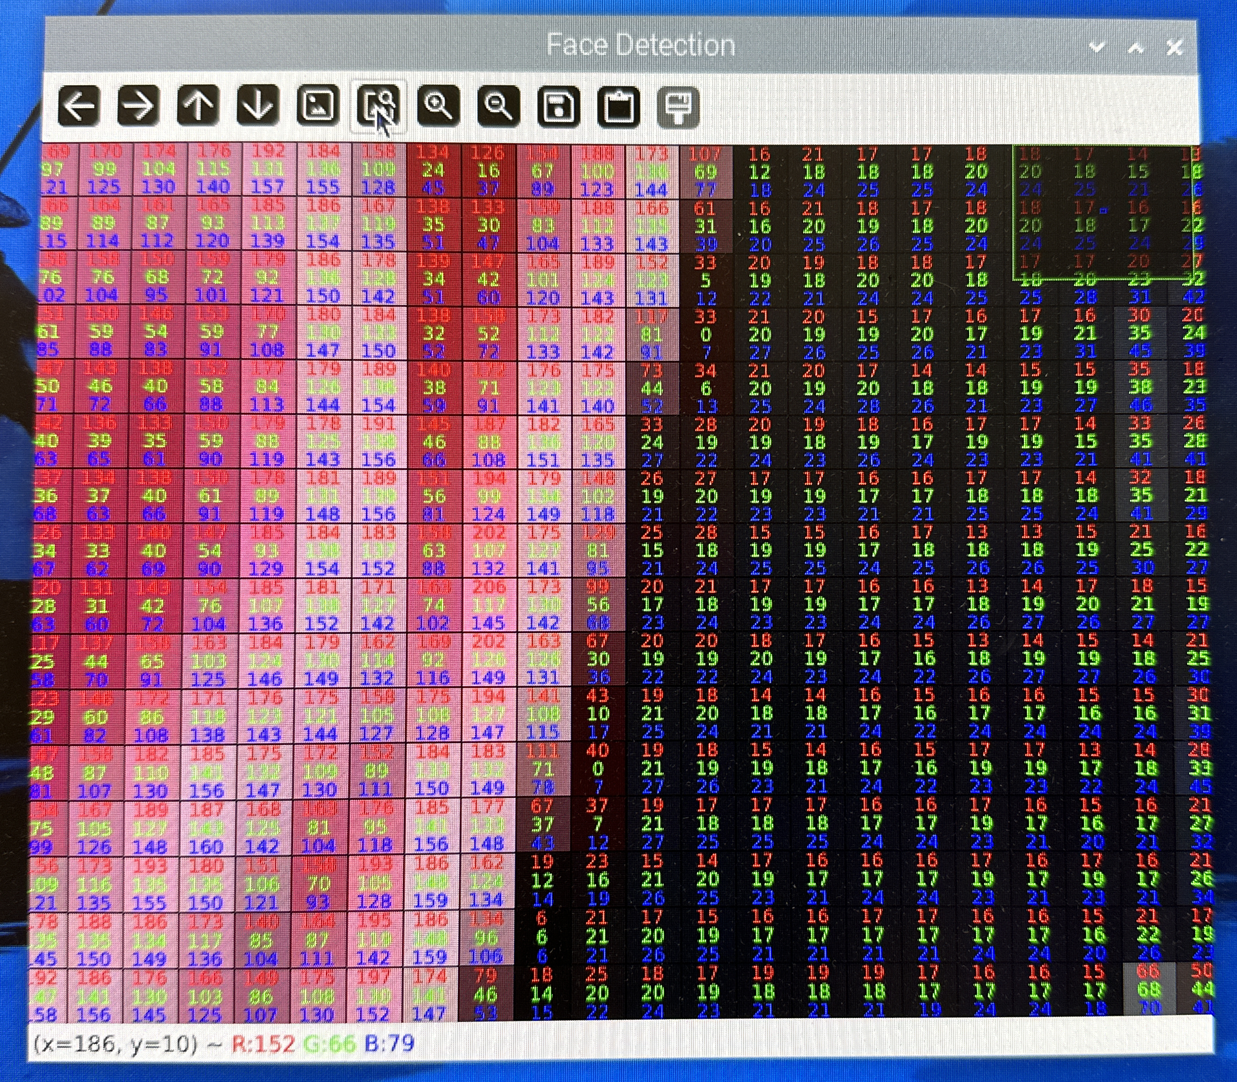
  - What do the numbers in each square represent?
- Computers can’t actually “see” images, although they can work with the arrangement of numbered values shown on the display. What arrangement of values do you think would be recognizable to the computer as a face?
- This program is able to detect the general shape of a face, but it can’t identify specific faces. Do you think it would be easier or harder to train a computer program to identify a specific face? How would you go about doing that?
- Trying to detect faces is difficult—it requires lots of ongoing calculations. If you have access to the Raspberry Pi computer itself, gently touch one of the silver metal “heat sinks” on the computer board. Careful—it may be quite hot!
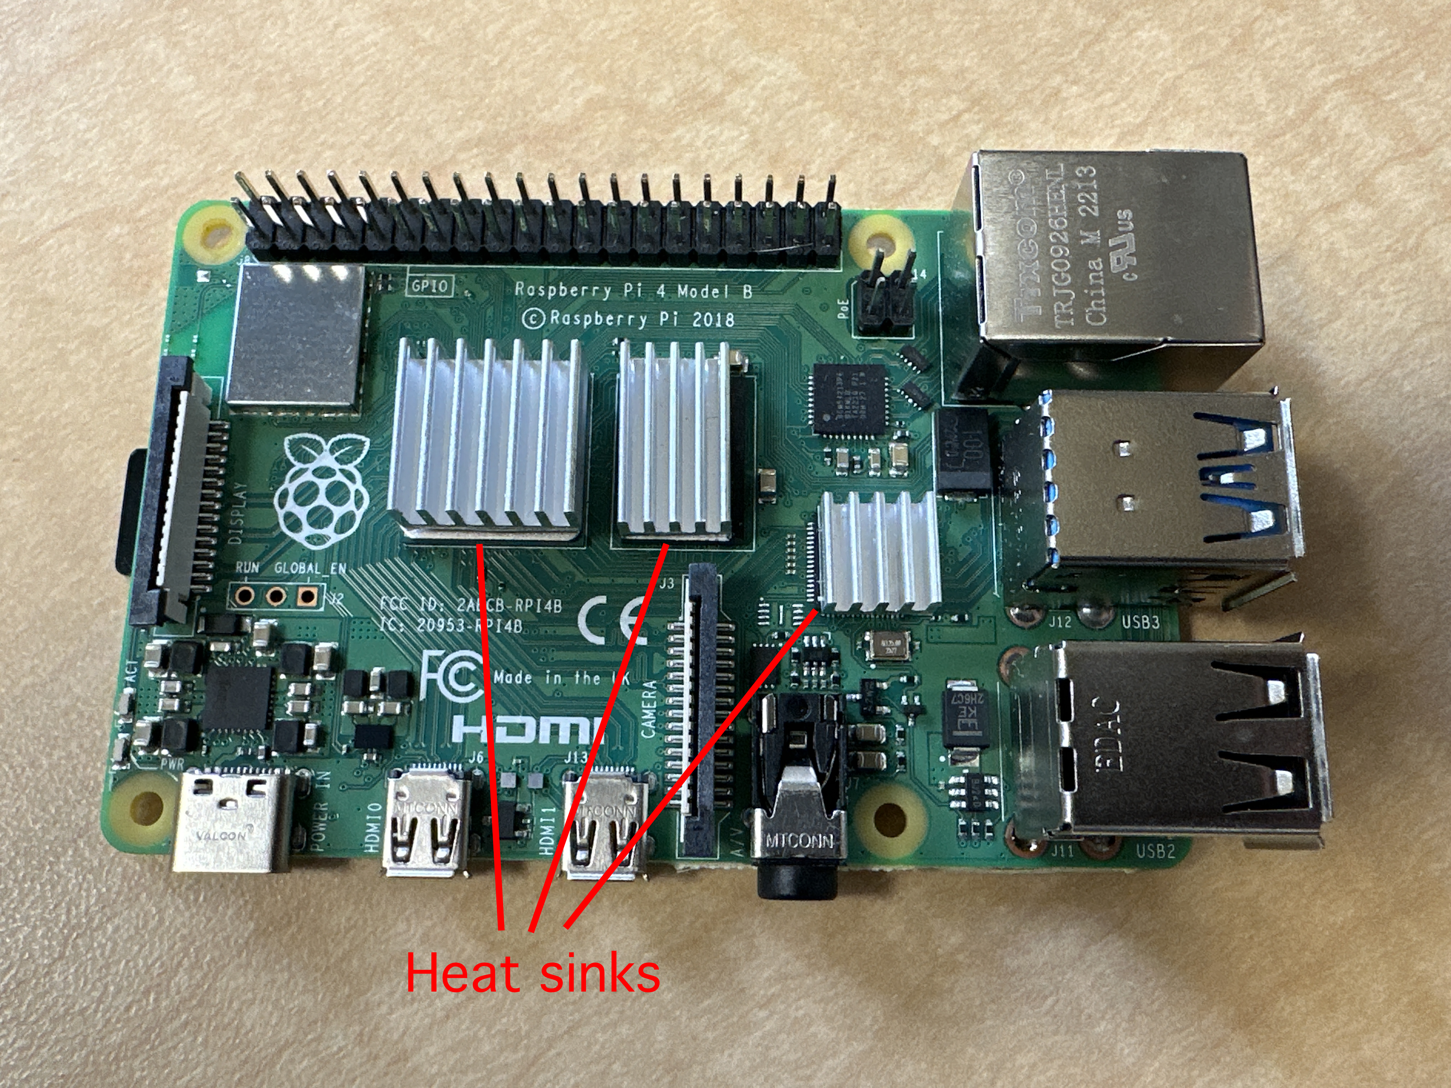

Additional Questions for you to think about

- With additional training, computers can start to recognize the features of an individual; your mobile phone, for example, may use facial recognition to unlock for its user. How confident are you in this type of security?
- What do you think of the idea of facial recognition being used by the government to monitor people, or even arrest them? After seeing this demonstration, do you have more or less confidence in that process?

