Intersight Kubernetes Service and Google Boutique Application with Terraform Lab Guide

# Introduction

This lab guide will walk through the process of deploying an on-premise Kubernetes cluster via the Intersight Kubernetes Service (IKS). This deployment will be achieved using Terraform as its Infrastructure as Code (IaC) tool of choice.

As the IKS environment within the DC is lab local access only, this guide will focus on using the Horizon VDI Windows desktops for orchestration and management. The Terraform configurations will work equally well on Linux for those who have jump hosts within the lab itself.

# Required Tools Installation

* Git
* Terraform Client
* kubectl
* Microsoft Visual Studio Code (Optional, but cool)

## Git Installation

<https://gitforwindows.org/>

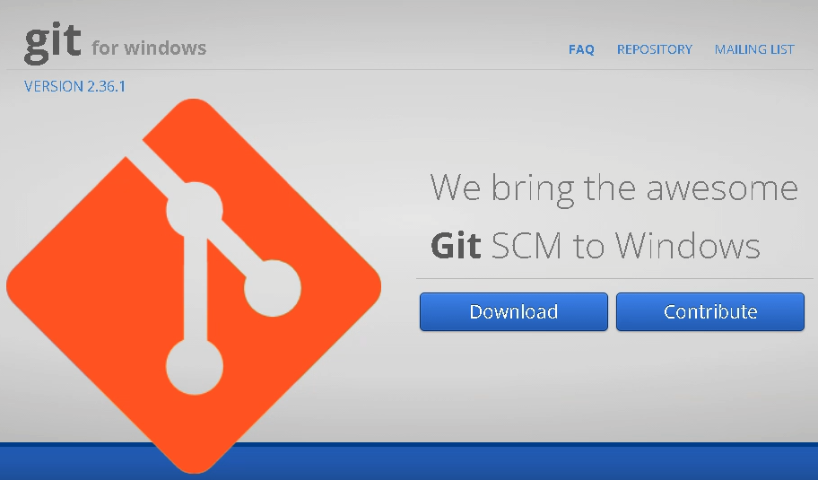



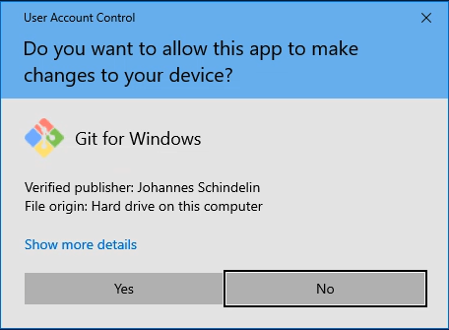

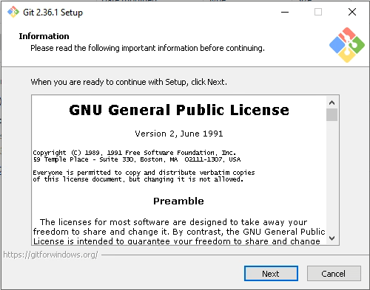

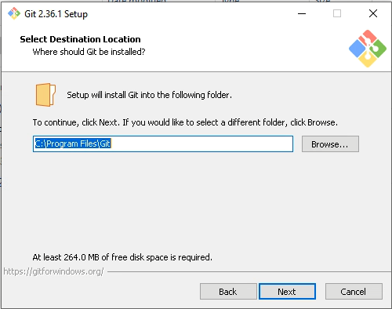

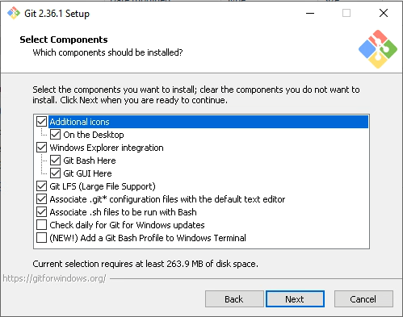

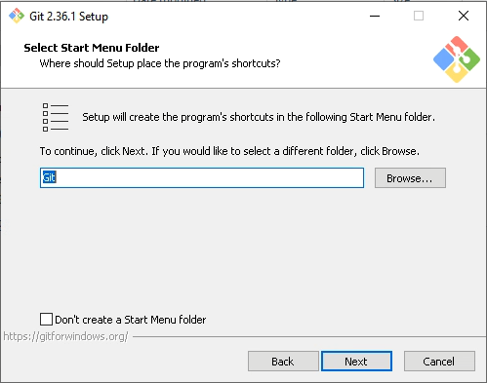

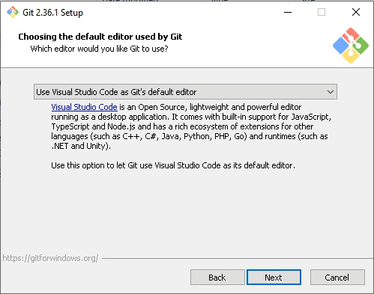

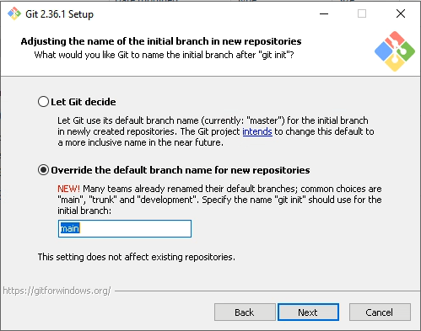

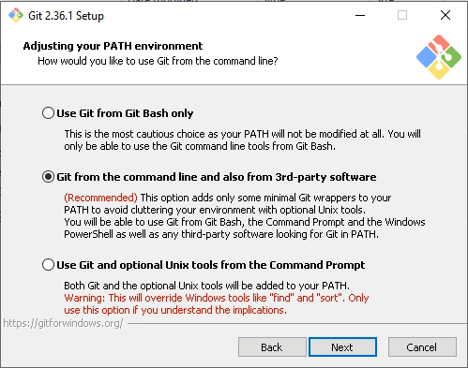

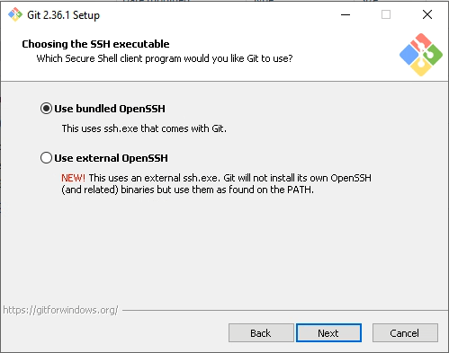

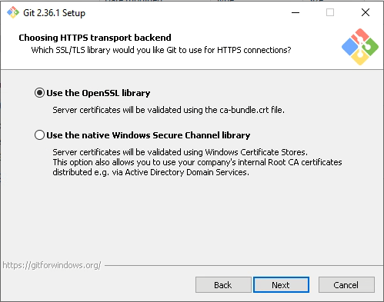

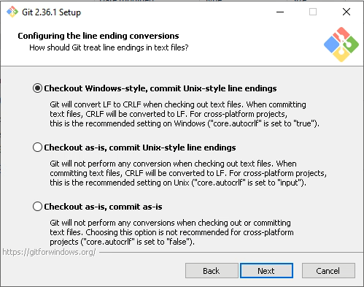

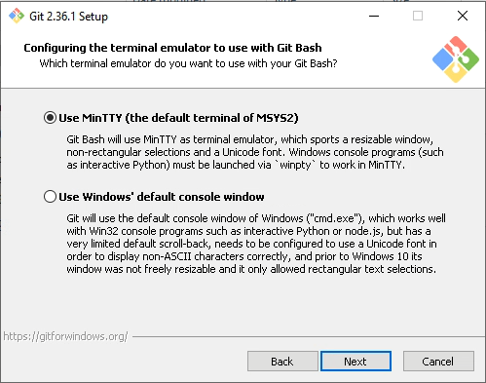

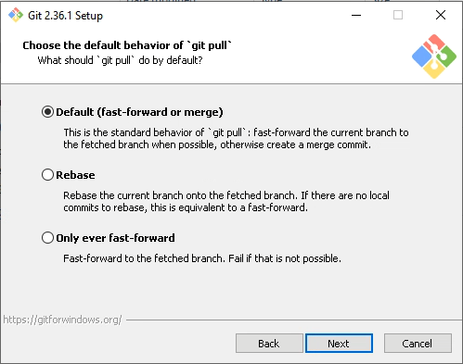

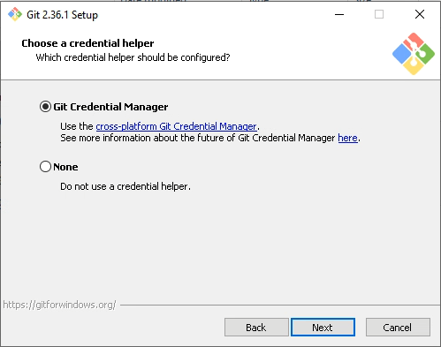

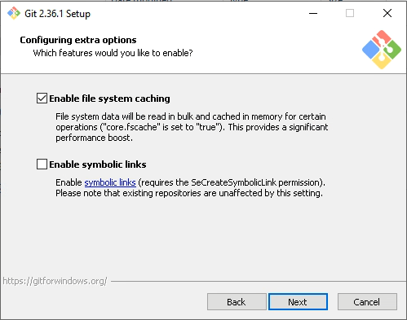

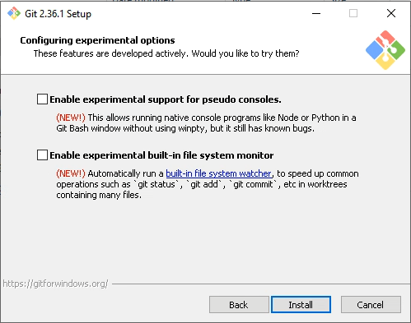

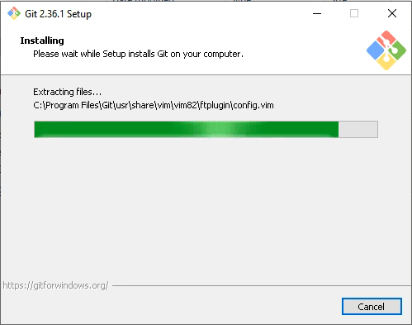

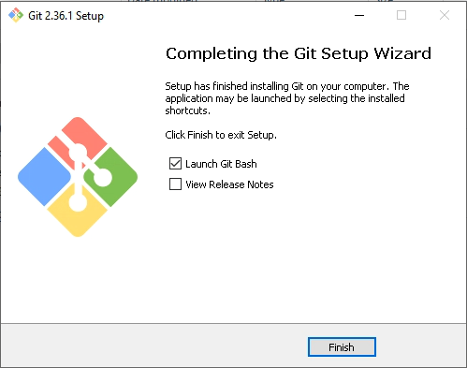

## Terraform Client Installation

## Kubernetes CLI Client (kubectl) Installation

## Microsoft VSCode Installation