Become a Member
Give back to your community and neighbors!
Complete and send the following information to the address below.
Name________________________
Address____________________________________________________
City__________________________
State____________Zip__________
Home Phone___________________

Circle what you are interested in:
- Emergency Medical Technician
- Ambulance driver
- Providing a specialty talent
I can’t volunteer, but am willing to make a tax-deductible donation of…

$ Amount_____________________

We thank you……
Mores Creek Ambulance
Recruitment
54 Burnett Dr.
Boise, Idaho 83716

WWW.MCAEMS.ORG


Mores Creek Ambulance
54 Burnett Dr.
Boise, Idaho 83716

Mores Creek Ambulance
Giving back to the Community

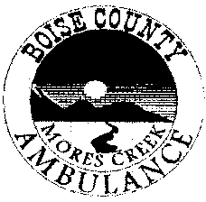



Mores Creek Ambulance
Mores Creek Ambulance first began in 1990 with a group of about 13 volunteers. At this time we had only a tin shed and a very used van to respond as a basic life support emergency medical transport unit. Since then, we have grown and have acquired a fully equipped transport ambulance and our own ambulance building. But we still rely on volunteers to staff the ambulance.
The only way this unit is able to respond to the aid of Boise County residents and recreational enthusiasts is through the support of the community.
“We are here to provide quick response for the community and our own families..”

Coverage Area
Mores Creek Ambulance covers approximately 700 square miles.
Our coverage begins at the Ada/Boise county line on Highway 21, and extends north to milepost 29. Coverage extends from Grimes Creek Road at Highway 21, west 4 miles to the wooden bridge, including the Clear Creek area. We also cover Spring Shores Marina and up Arrowrock Road 11 miles during the summer and all the way to Atlanta City in the winter.
Our response area includes the major subdivision and recreational areas of Spring Shores Marina, Mores Creek, Robie Creek, Wilderness Ranch, Clear Creek and Osprey.
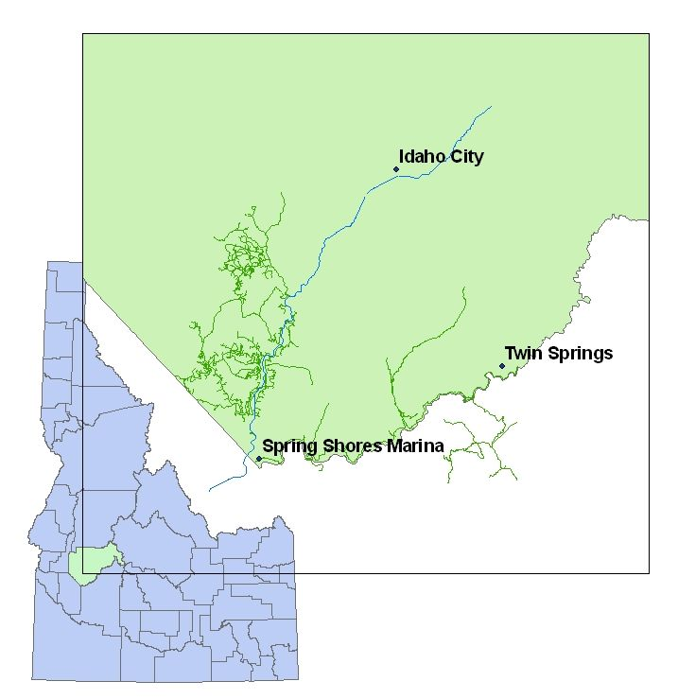

OUr mission-- to MAKE A difference
Our mission is to provide safe emergency response to medical or trauma incidents within our service area and extended service area of East Boise County.
We do this by providing training, educational tools, equipment and support to all of our volunteers. Local EMT volunteers are certified by the State of Idaho, and Drivers are trained to assist with patient transport.

teamwork
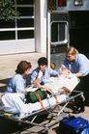
Mores Creek volunteers believe in working together towards a common goal. We are a member of the East Boise County Ambulance District, and work with local fire and law enforcement departments to provide the best emergency care possible.

call out procedures
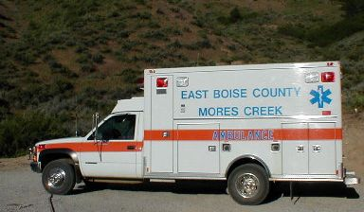
To activate the Mores Creek Ambulance, call one of these emergency response numbers:
- Dial 911
- State Emergency Medical Service Communications Center at 1-800-632-8000
VISIT OUR WEBSITE
WWW.MCAEMS.ORG

