1-4 ePortfolio Selection and Refinement Plan

Richard S. Whittaker

Artifact Origin: CS-250 Software Development Lifecycle

Artifact Name: Java Web Based Travel Application Slideshow

This application will allow me to demonstrate my knowledge and skills in three areas of this program/degree. Those areas are software design/engineering, algorithms and data structures, and databases, while using a single artifact from CS-250 Software Development Lifecycle. The final project in this course was a simple application that displayed a list of five health and wellness destinations. The output of the destinations where displayed in a slideshow format. I will transform this project, building on its complexity and enhance its functionality in all three areas. First, I will demonstrate my software engineering and design skills by redesigning it from a simple java slideshow to a full Travel Application using Java language and XAML. I am redesigning it as an Android Studio mobile application with a full framework, navigation, and user interaction capabilities.

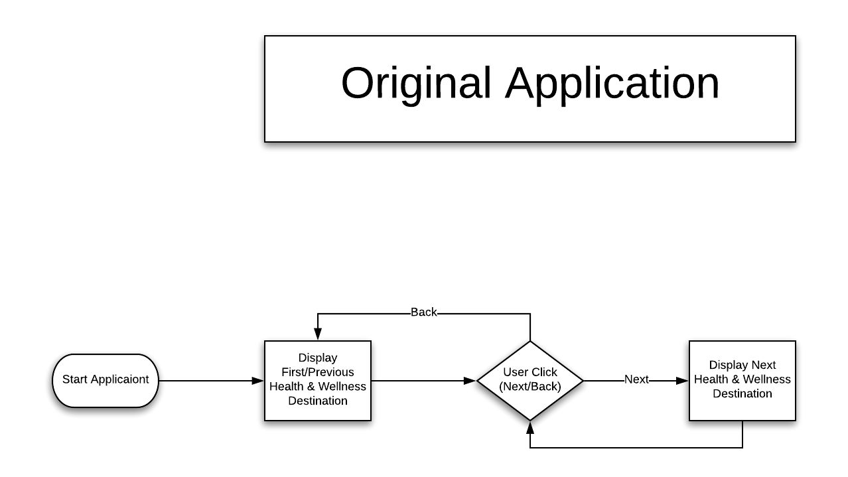

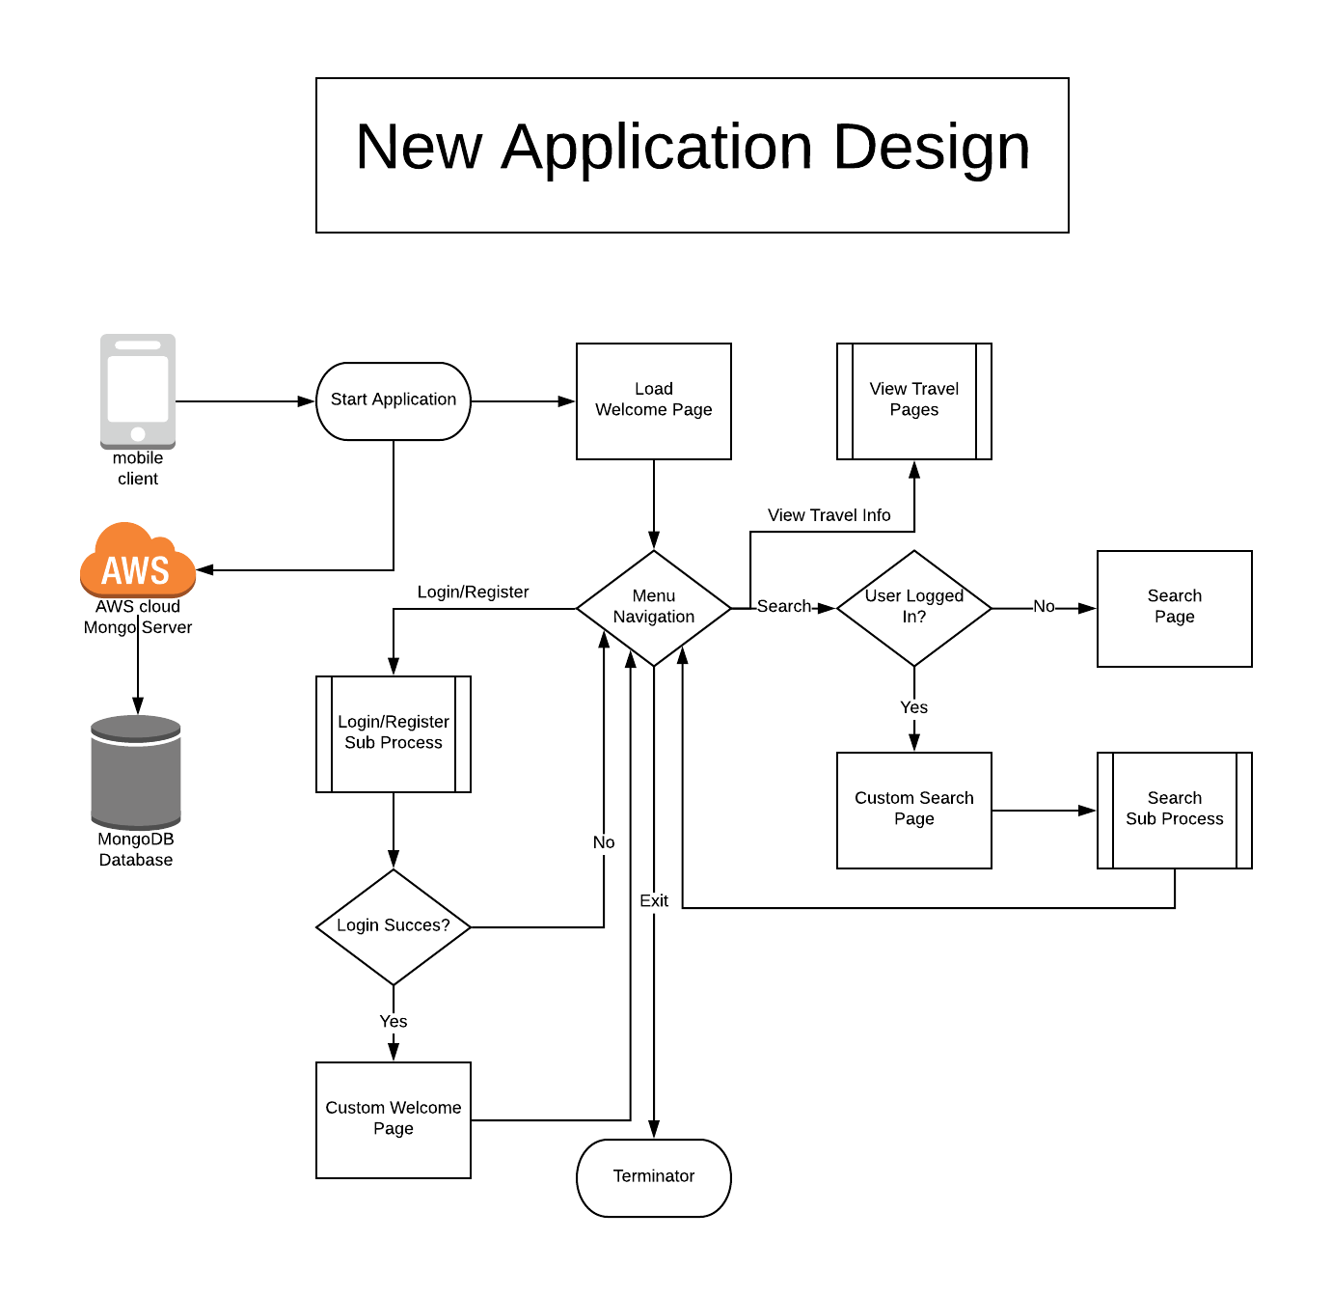

I will demonstrate my knowledge of Algorithms and Data Structures by creating a picklist of destination options that a user can select from. This will generate a customized top five destination list that the user can select from. I will also enhance the previous application by including sorting and filtering of the data for user consumption. I will add the ability for the user to sort the destination list output based on either price (high to low or low to high) or by destination rating.

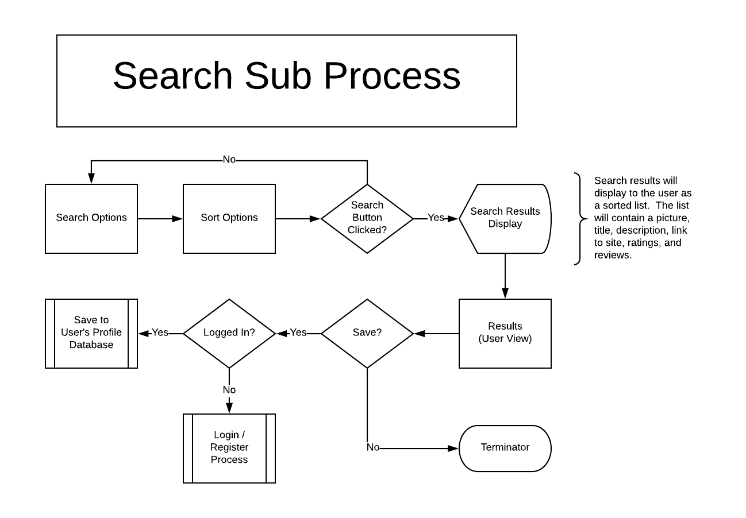

I will exhibit my knowledge of databases by creating a database structure to hold customer information in JSON format. The data will include user login names and passwords and the user profile or preference data. Then, I will parse and transform the JSON data for use in my Android application. The user will be able to create an account and be able to login. After they create an account they then can login to their existing account to set and access their travel preferences. For this project, I will create some test accounts to show its functionality. I will use this data to set search options for when the user decides to do a search using their account. I will have to update the JSON data when the user changes their user preferences. I will include the ability for a user to set destination options as favorites using an icon and then store their selection as part of their user metadata. I will provide a process where the user can show their favorite destinations a sorted list. This will show my knowledge in both database and algorithm/data structure.

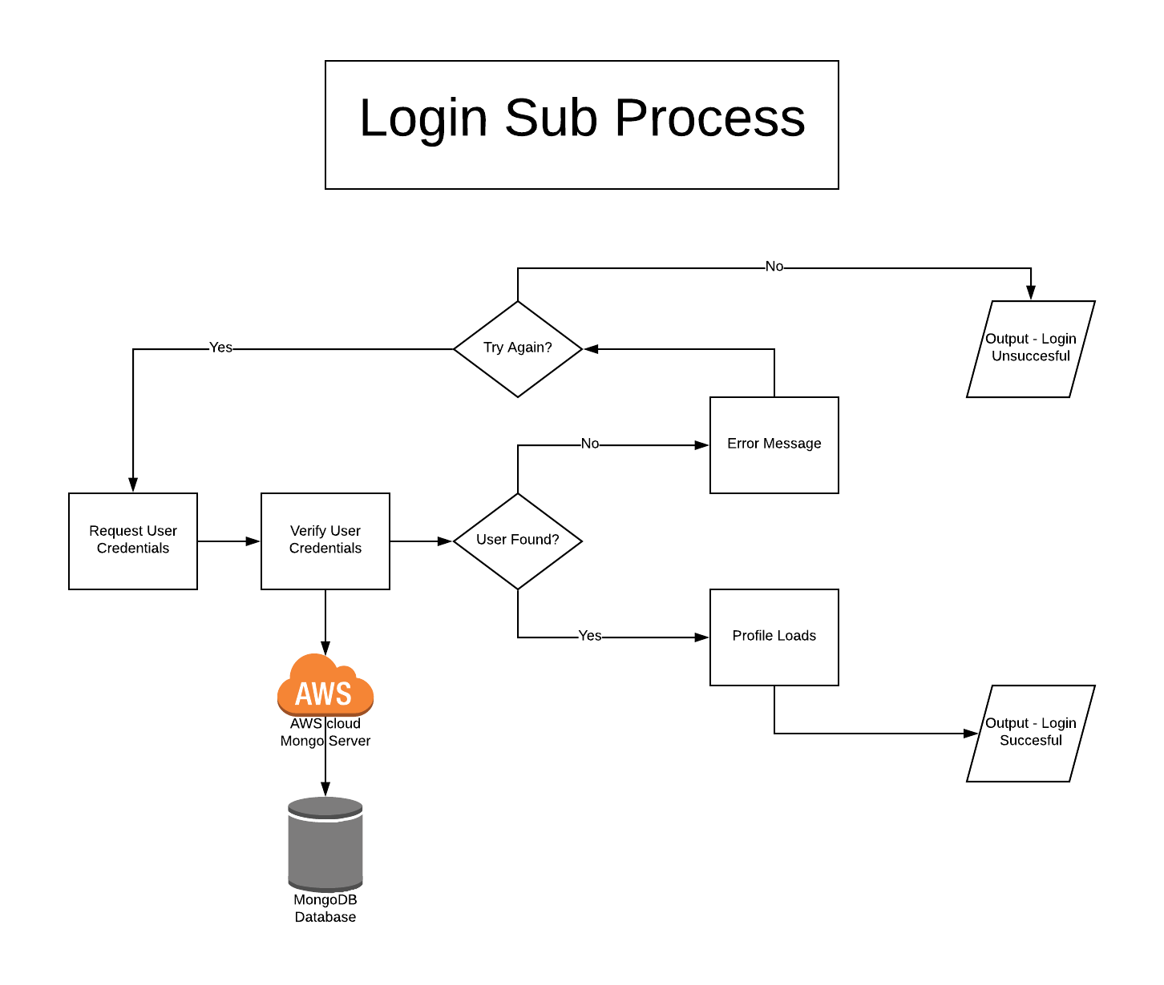

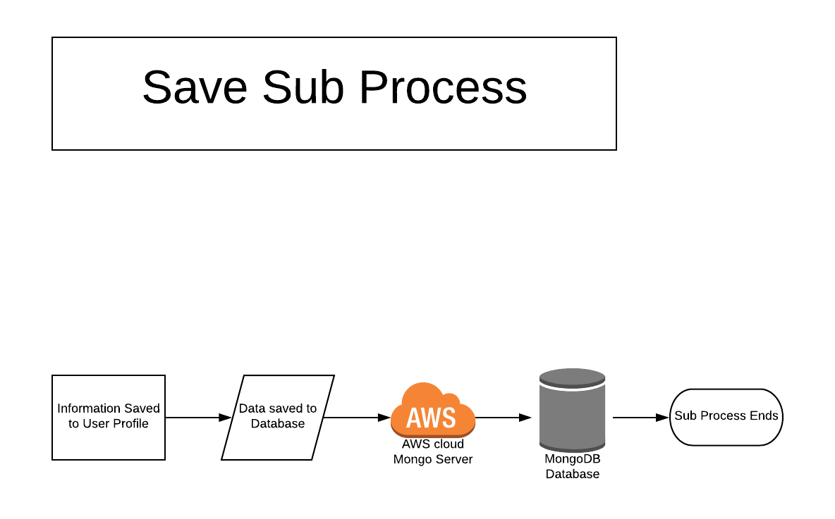

I chose this particular artifact, the Travel Slideshow Application, because the user focus group for this application requested similar modifications. However, their request was not required nor incorporated in any stages of the design process of the application. Recreating the application as a mobile app, I will be fulfilling my enhancement plan as outlined. I will be able to bring their requirements to reality while demonstrating my knowledge of all three areas of this capstone. I will demonstrate my ability to design an application, by transferring the original application by redesigning its functionality from start to finish using software development and programming guidelines in which I learned throughout my Computer Science Program. I will show my understanding of data structures and algorithms with the integration of different sorting options and use of vectors/arrays to store user data. Finally, I will exhibit my database skills by adding a MongoDB Database and the database integrations for user login or registration, saving and loading the user’s profile, and saving the user’s preferences or favorites.