# **Problem statement**

* Hand writing of prescriptions waste time and most of the time is unreadable by pharmacist which may lead to the patient being given the wrong medication
* Doctor examine a lot patient every day so it’s very hard for him to remember each patient condition on consultation

# **System Request**

**Project Sponsor: -**

* Dr\Sam, manager of the center.

## Business Needs: -

* This project has been initiated to
* Control medical center
* Facilitate writing prescriptions for doctors
* Save patients data
* Create digital prescription which leads to facilitate reading it which helps in giving the right medicine to our patients

## Business Requirement: -

* Manager have authority to add, remove and edit employee
* Manager have authority to enquire reports
* Doctor able to add, edit and search patient data
* Doctor able to Print prescriptions
* Receptionist able to register patient’s information

## Business values: -

We expect digital writing for prescriptions will save time so the doctor can examine more patient which leads to increase the number of clinic visitors so the sales will increase and we also expect the system will reduce errors in reading prescription so this will increase our patients’ confidence in us because they will be certain that they will take right medicine

Conservative estimates of tangible values to clinic include the following:

25% increasing in clinic visitors so $5000 in clinic sales in week

Intangible values :

22.2% of wrong prescription reading so digital prescription will save our visitors life

# **Feasibility study**

## Technical feasibility

### **Familiarity with Application:**

* Risk will be medium risk as users have low experiment with clinic management system

### **Familiarity with Technology:**

* Risk will be moderately low as users have ability to deal with computer

### **Project size:**

* Risk in project size is considered low as

## Economic feasibility

|  |  |  |  |  |  |
| --- | --- | --- | --- | --- | --- |
|  | Year 0 | Year 1 | Year 2 | Year 3 | Total |
| **Total benefits** |  | 20,000 | 35,000 | 50,000 | 105,000 |
| **Total costs** | 40,000 | 10,000 | 13,000 | 15,000 | 78,000 |
| **Net benefits** | [40,000] | 10,000 | 22,000 | 35,000 | 27,000 |
| **Cumulative net cash flow** | [40,000] | [30,000] | [8,000] | 27,000 |  |

### **Return On Investment (ROI)= $ROI=\frac{total benefit-total cost}{total cost}$**= $\frac{105,000-78,000}{78,000}$ =34.62%

### **Break _Even Point (BEP)=**

**BEP**= $number of negative cash flow+\frac{that year^{'}s Net cash flow-that year^{'}s comulative cash flow}{that year^{'}s Net cash flow}=2+\frac{35,000-27000}{35,000}=2.22 years$

Rate of return=10%

|  |  |  |  |  |  |
| --- | --- | --- | --- | --- | --- |
|  | Year 0 | Year 1 | Year 2 | Year 3 | Total |
| Total benefits |  | 20,000 | 35,000 | 50,000 |  |
| Pv for benefit |  | 18,181.81 | 28,925.62 | 37,565.74 | 84,673.17 |
| Total cost | 40,000 | 10,000 | 13,000 | 15,000 |  |
| Pv for cost | 40,000 | 9,090.91 | 10,743.8 | 11,269.72 | 71,104.43 |

# **Functional requirement**

### Manager function requirement

* System allow center manger to register doctors and receptionists
* System allow center manger to remove doctors and receptionists
* System allow center manger to enquire center reports
* System allow center manger to filter search results

### Receptionists function requirement

* System allow receptionists to register patients
* System allow receptionists to search for patients
* System allow receptionists to remove for patients

### Doctor function requirement

* System allow doctor to add medical information for patients
* System allow doctor to search for patients
* System allow doctor to edit medical information for patients
* System allow doctor to print prescription for patients

# **Nonfunctional requirement**

### Operational

* Can run on desktop

### Performance

* Interaction between the user and system should not exceed 1 sec

### Security

* Only doctor can see patient medical information
* System includes all available safeguards from viruses

**Use cases**

**1-Use case:** **Register**

* + **Actor:** doctor, assistant
  + **Description:** The user registered for the system to use it
  + **Trigger:** User selects the "Register” button
* **type:** internal
* **Pre-condition:** User is not logged in before registration process
* **Normal case:**
  + User type his/her name, phone, SSN, email
  + User types a user name of his or her choice
  + System checks if the user name is not already in use.
  + User types a password
  + User retypes the password
  + System checks if the two passwords are identical.
  + click on submit button
  + System registers the new user with attributes (name, phone, SSN, email, user name, password).
* **Alternative course:**
  + User name is already in use
    - User is requested to select another user name and password.
  + The two passwords are different
    - User is requested to retype (twice) his/her password
* **Post condition:**
* User is successfully registered becomes a registered.

**Use case: Log in**

* **Actor:** doctor, assistant
* **Description:** users enter their log in data to see if they can log in
* **Trigger:** User selects the "log in” button
* **type:** internal
* **Pre-condition:** the user be already registered
* **Normal case:**
* User input user name and password and successfully logged in
* **Post** **Condition:**
* Users can insert data and search for patients and print data
* **Alternative Course:**
* User forgot his/ her username or password
* User enter his/her phone number of email and system send a massage to inform phone or email and he/his can reset password again
* User has not registered
* System will output the user is not registered

**Use case:** **Search**.

* **Actor:** doctor, assistant
* **type:** internal
* **Description:** user can search for some patient data to see data of visit, prescription, diagnoses, etc.
* **Trigger:** User selects the " Search” button
* **Pre-condition:** the user be already logged in
* **Normal case:**
* Doctor or assistant can search for any patient
* **Post** **Condition:**
* Users can see data they need to know and print it if they want
* **Alternative Course:**
* Patient data they are looking for is not found in system

**Use case: doctor page**

* **priority:** high
* **actor:** doctor
* **description:** the user fill the data required and search about data wanted and print the description
* **trigger:** user select doctor form
* **type:** internal
* **pre-condition:** user login to doctor form
* **normal case:**

1. user select patient data
2. user types prescription
3. user types diagnoses
4. user types history
5. user types symptoms
6. user save data

* **post condition:** user print description

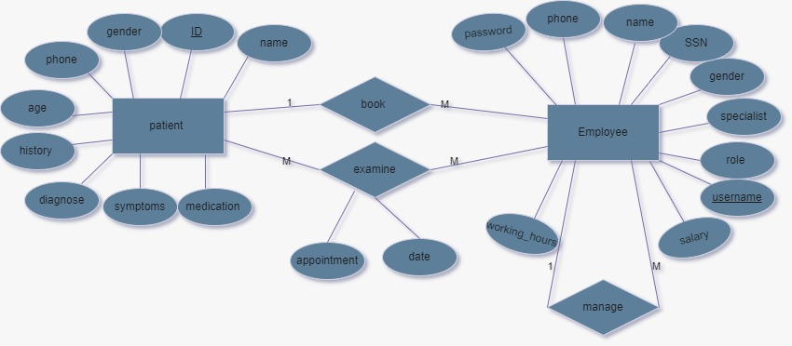

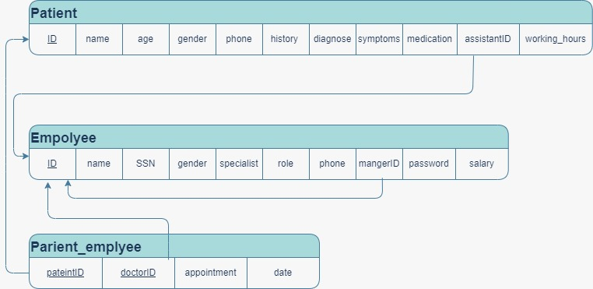

|  |  |
| --- | --- |
| UC -id | UC-1 |
| UC-Name | Search for a patient |
| Description | This case describes How the system searches for a patient |
| Primary Actor | The Doctor |
| Pre condition | The doctor is logged into the system  Search for a patient page is viewed |
| Main success scenario | 1. The doctor clicks on the search button 2. The system displays the search form 3. The doctor types the patient id 4. The system checks the validity of the id 5. The patent name appears 6. The patient information and clinical history appears |
| Post condition | A patient information and clinical appears |
| exception | 1. Patient id is unavailable   -if the id is incorrect an error message appears |

|  |  |
| --- | --- |
| UC id | UC-2 |
| UC name | Add new doctor |
| description | This case describes how the system adds a new doctor |
| Primary actor | the system manager |
| Pre condition | The manager is logged into the control panel |
| Main success scenario | 1. The manager clicks on the “ add new doctor “ button 2. The system displays the add Doctor form 3. The manager fills the adding form 4. The manager clicks on the “add” button 5. The system checks the validity of the data 6. a success message is displayed by the system |
| Post condition | A new doctor is successfully added |
| exception | 1. the doctor already exists   if the doctor information already exists a error message will display “ the doctor already exists on the system   1. the doctor data is invalid   an error message will display “ the email or username is invalid |

|  |  |
| --- | --- |
| UC id | UC-3 |
| UC name | Add new patient |
| description | This case describes how the system adds a new patient |
| Primary actor | the assistant |
| Pre condition | The assistant is logged into the system |
| Main success scenario | The assistant clicks on the “ add new patient “ button  1.The system displays the add patient form  2.The assistant fills the adding form  3.The assistant clicks on the “add” button  4.The system checks the validity of the data  5.a success message is displayed by the system |
| Post condition | A new patient is successfully added |
| exception | 1.the patient already exists  if the patient information already exists a error message will display “ the patient already exists on the system  2. patient data is invalid  an error message will display “ the email or username is invalid |

|  |  |
| --- | --- |
| UC -id | UC-4 |
| UC-Name | Add new info to an exiting patient |
| Description | This case describes How the system adds new details to an already existing patient |
| Primary Actor | The Doctor |
| Pre condition | The doctor is logged into the system |
| Main success scenario | 1. The doctor clicks on the search button 2. The system displays the search form 3. The doctor types the patient id 4. The system checks the validity of the id 5. The patent name appears 6. The patient information and clinical history appears 7. The doctors clicks on the “edit” button 8. The doctor edits the wanted details 9. The doctor clicks the “save “button 10. The system saves the changes |
| Post condition | A patient information and clinical is adjusted and saves successfully |
| exception | 1. Patient id is unavailable    1. -if the id is incorrect an error message appears |

|  |  |
| --- | --- |
| UC id | UC-5 |
| UC name | Add new assistant |
| description | This case describes how the system adds a new assistant |
| Primary actor | the system manager |
| Pre condition | The manager is logged into the control panel |
| Main success scenario | 1. The manager clicks on the “ add new assistant “ button 2. The system displays the add assistant form 3. The manager fills the adding form 4. The manager clicks on the “add” button 5. The system checks the validity of the data 6. a success message is displayed by the system |
| Post condition | A new assistant is successfully added |
| exception | 1. the assistant already exists   if the assistant information already exists a error message will display “ the assistant already exists on the system   1. the assistant data is invalid   an error message will display “ the email or username is invalid |



