{eMath}{sMatematicas}{dMathe}

{eby}{spor}{ddurch}: Ruud  
{eborn}{snacido}{dgeburen}: 21-04-1982  
{eaddress}{sdireccion}{dAdresse}: Haubachstrasse 35, Hamburg{so, Alemania}{e, Germany}  
{ee-mail address}{sdireccion electronica}{dE-mailadresse}: [noreply@10minutemail.com](mailto:noreply@10minutemail.com)

{eIt is well known that}{sTodos sabemos que}{dAlle wissen dass}

1 + 1 = 2, {eas well as}{stanto como}{dso wie auch}

1 + 2 + 3 + 4 + … + 10 = 55.

{eBut almost noone knows that}{sPero casi nadie sabe que}{dAber fast keiner weiss dass}

1 + 2 + 3 + 4 + … = -1/12 🡪 <https://www.youtube.com/watch?v=w-I6XTVZXww>

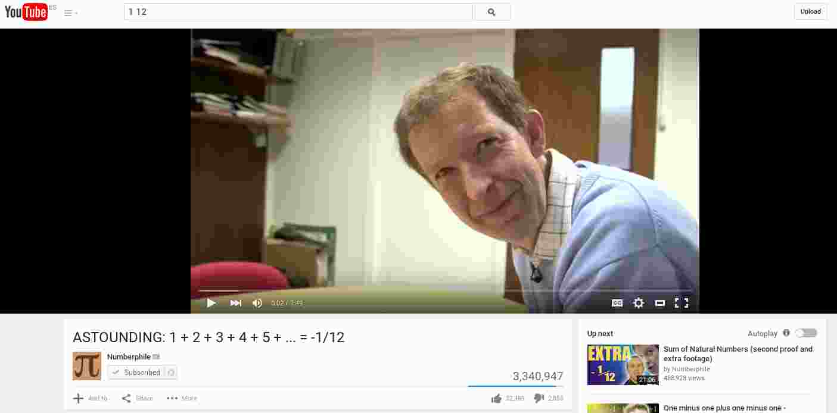

{eAll right, I'm off to have some {1pizza}{2pasta}, see you next {1week}{2month}{3time}!}  
{sHasta la proxima!}  
{dAlso, ich gehe dann mal {1Wurst essen}{2Bier trinken}, bis zum naechsten Mal!}