Docker

# Notes

* It solves compatibility/dependency issues , reduce long setup time.
* Containers are a completely isolated environment . It has separate processes , network .
* Docker containers justa shares a common kernel .
* The main purpose of docker is create and deliver containers , which can run apps without configuration.
* Vm takes more resources . Docker boots up faster . Docker has less isolation as most resources are shared among various docker images.
* Docker run mongodb , docker run nodejs.
* An image is a package or templates. Containers are copies of instances ,You can create your own container and push to docker hub for others to use.
* Docker has a community and enterprise edition .
* To remove older versions of docker sudo apt-get remove docker docker-engine docker.io containerd runc
* Docker installation :

curl -fsSL https://get.docker.com -o get-docker.sh

$ sudo sh get-docker.sh

* To check installation docker version .
* Hub.docker.com contains common docker images
* Whalesay is the hello world package

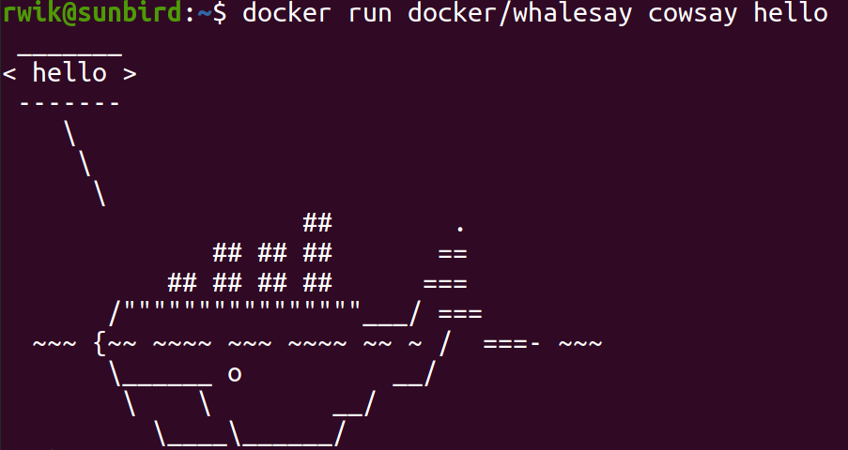

* Docker run downloads a container if not found locally and runs it
* With docker ps, all running containers are listed.
* Image is the movable package, when image is pulled into local and run, it is called container.
* Since docker downloads in layers, in case of version upgrade it downloads only delta parts.
* Docker ps . lists out all running containers .
* Docker ps -a lists out all running containers and stopped containers.
* Docker stop package_name
* Docker rm package_name
* Docker images // lists out all docker images
* Docker pull image name
* docker images . lists all images
* Docker rmi imagename // to delete image .
* Alway delete containers before deleting image.
* Docker run radis:4.0 // this specified version is called tag. If you dont mention, it will be set as latest.
* Docker run -it containername // will take input from stdin
* Docker port mapping can be done using -p . here docker image port and docker host ports are mapped.
* Docker run -p 8306:3306 mysql // host port 8306 is mapped to docker port 3306
* You cant map same host port to multiple docker container.
* Volume mapping is used to keep data outside the container . This way data wont get deleted even if container is stopped.
* Docker run -v /opt/ur_dir:/var/lib/mysql mysql
* Docker inspect container name // will give container details in json
* Docker logs containername // will print logs from that container
* Create your own docker image :
  + From ubuntu // first line specifies os or another docker file
  + Run apt-get .... // then install all dependencies
  + Copy . /opt/source-code // copy application from current folder to a path inside docker image
  + Entrypoint //command to execute when image is run
* Once docker file is ready run “Docker build .”
* Each line in docker file is built as separate layer .
* You can run docker history to see layer details and size of each layer.
* All layers are cached so rebuild is faster.
* To pass environment variable
  + Docker inspect container name // you can see list of environment var in “config”section.
  + You can set it using “-e” option
  + Docker -e VAR_NAME=value image_name
* With docker compose we can create docker configuration file in yml, then use docker up command to start it.
* Docker compose to be installed separately .
* It is simply a script , use curl, change permission and use it.
* In a compose file list out all services as root properties. Then add image specifications under every services.
* Docker-compose up will start all services.
* Docker engine consists off Docker cli , rest api , docker daemon.
* Orchestration is required for handling load . This can be done using docker swarm / kubernetes / mesos .