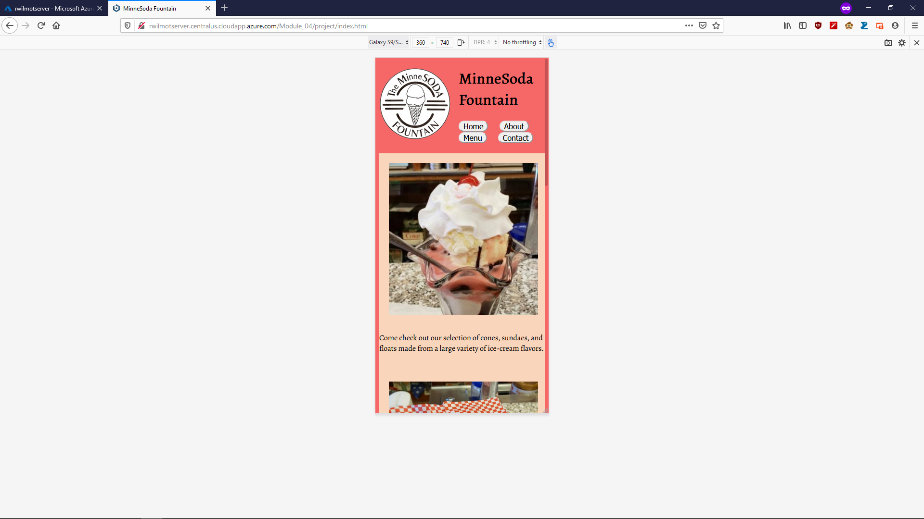

For this one, it would probably be a good idea to increase the margin between rows of the buttons. Otherwise users might accidentally hit the wrong button in a column.

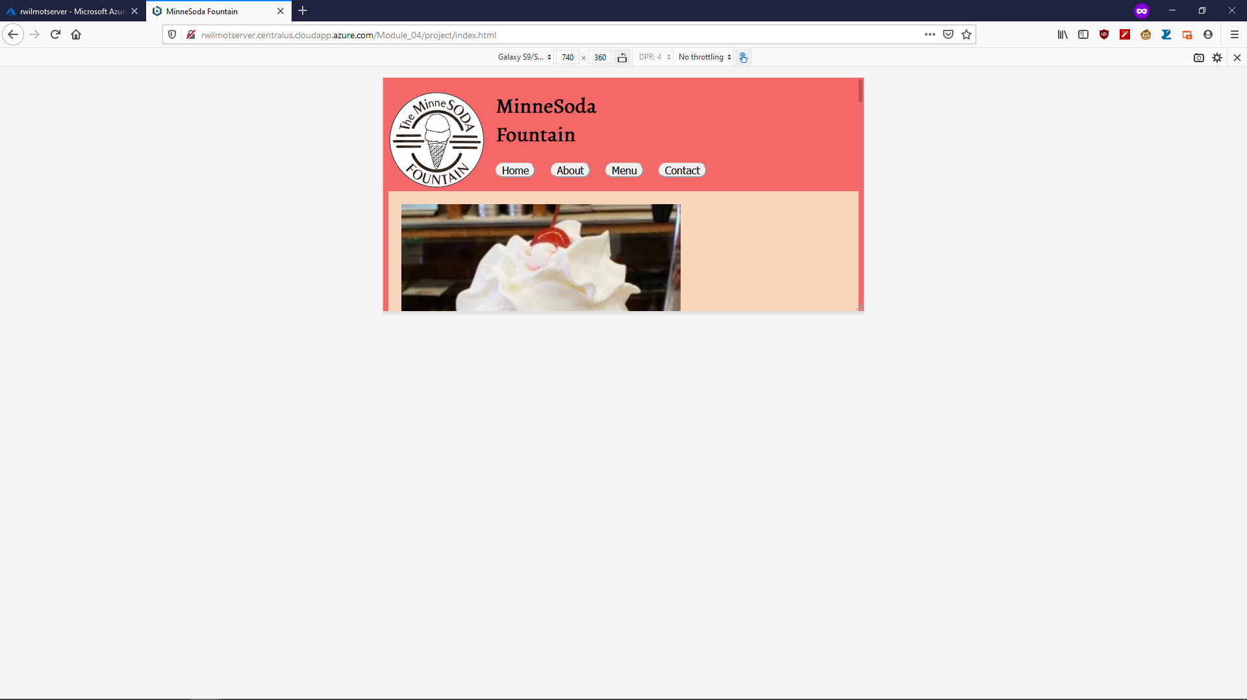

I could try center aligning the pictures here, might look a bit nicer.

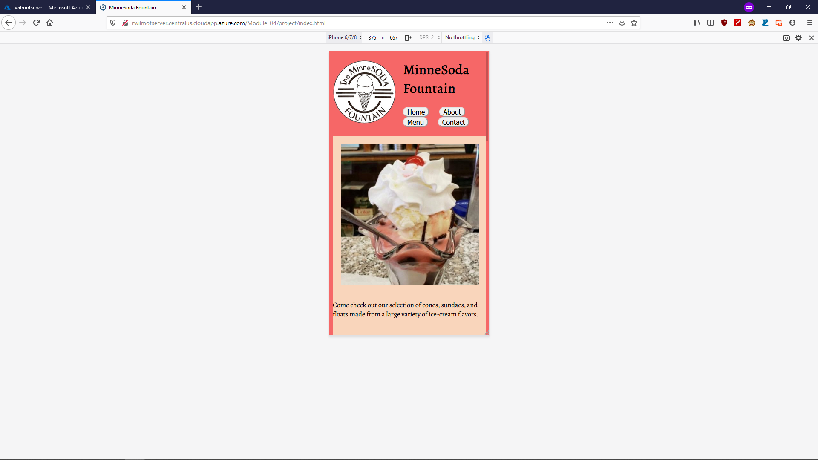

Again, add margin between the button rows. Also should try adding some to the left of the text, it looks a little odd jammed up against the edge of its bounding box.

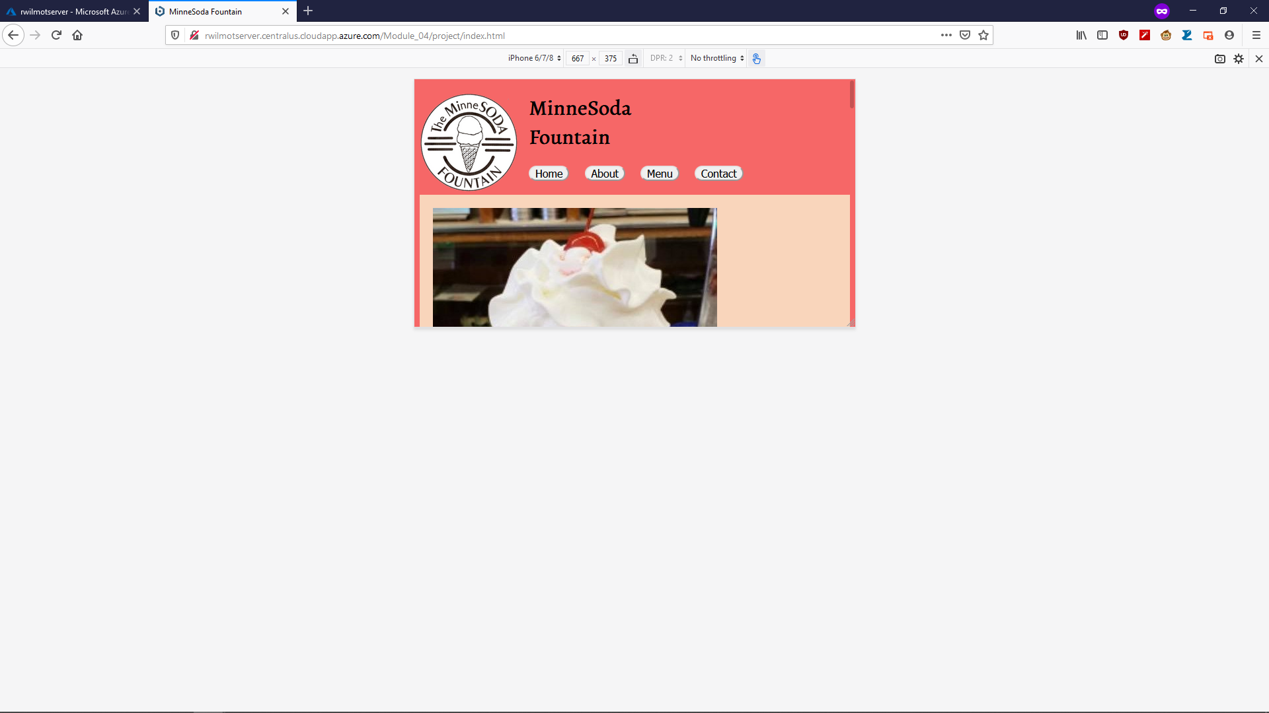

Center align the pictures again, otherwise looking alright.

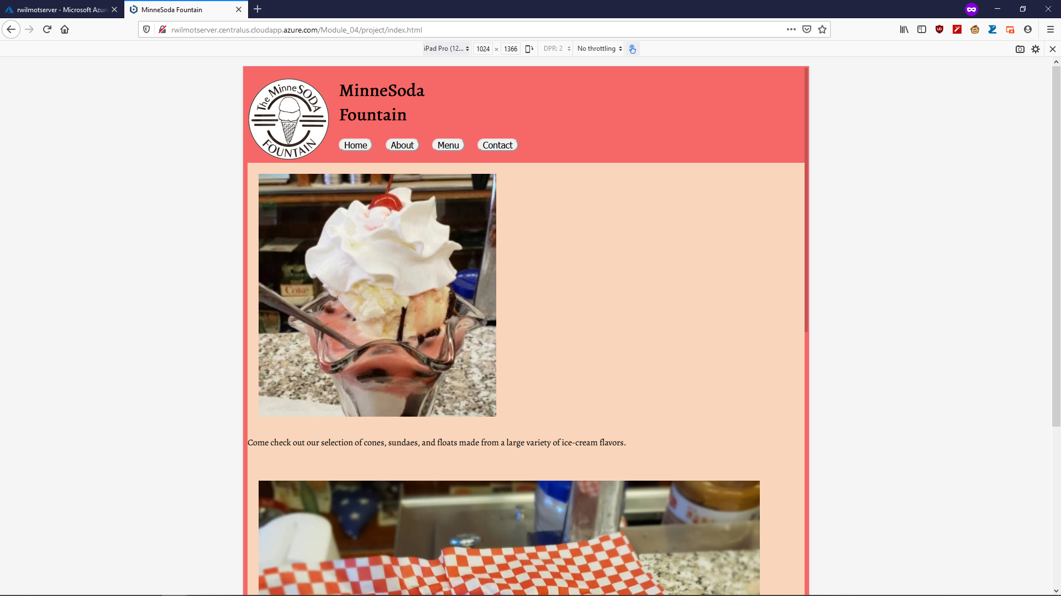

The text needs margin or padding again for this one.

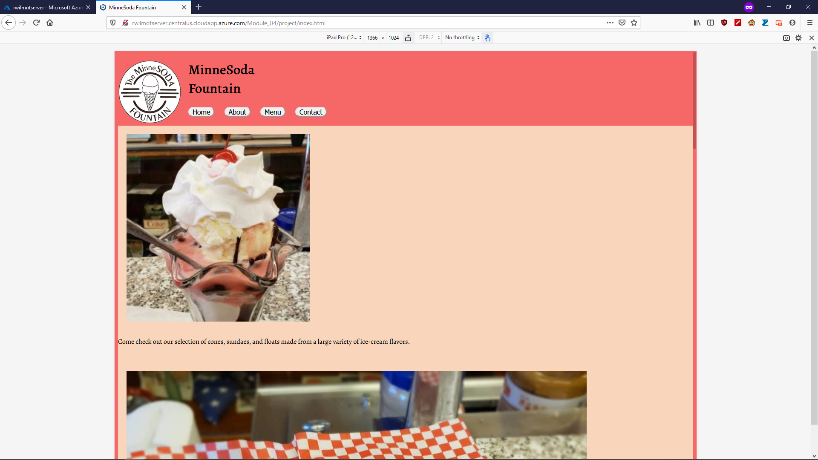

Same text issue.