
CLEAR RIVER PUBLIC SCHOOLS
School Leadership Focus Reporting
System Overview
Version 1.0 | April 2026

1. Purpose of This Document
This document provides a plain-language overview of the School Leadership Focus Reporting system intended for all members of the School Leadership Team and any staff member who uses or manages the system. No technical background is required to understand this document.
If you are looking for technical details including data model details, measure definitions, and maintenance procedures, please refer to the companion document: School Leadership Focus Reporting - Technical Reference.

2. What the System Does
The School Leadership Focus Reporting system helps the district’s School Leadership Team record and report how the team’s working hours are being allocated across the team’s major priorities. Each week, team members record their working hours across five categories:
- Instructional Leadership - time spent directly supporting teaching and learning
- Operations - administrative, facilities, and logistical work
- Professional Development - learning, training, and growth activities
- Community Engagement - family and community-facing work
- Other - any time that does not fit the categories above
Time is reported as weekly totals (not daily totals). The system uses this data, together with leave records from the district's time and attendance system, to calculate two key performance indicators (KPI) for each team member:
Indicator | What It Measures
ILRP | Instructional Leadership Relative Percentage. The share of a team member's total submitted hours that was spent on Instructional Leadership. Target range: 50–60% annually.
ILFT | Instructional Leadership Fixed Target. The share of a team member's minimum required hours (40 hours minus any leave taken) that was spent on Instructional Leadership. This accounts for leave and provides a consistent baseline for comparison. Target range: 50–60% annually.
Both indicators are tracked weekly, accumulated year-to-date, and compared across school years. The target range for both indicators is an overall annual percentage between 50–60%. Values below 50% suggest insufficient Instructional Leadership focus; values above 60% may indicate that other important responsibilities are being underserved.

3. Who Uses the System
The system serves two groups of users, each with a different level of access:
Role | What They Can Do
Team Member | Submit weekly time logs. View their own KPI reports and compliance status. Receive automated reminder emails when submissions are overdue.
Manager and Executive Assistants | View all team members' data. Use the Team Member selector to examine individual performance. Monitor team-wide compliance and KPI trends.
Access is controlled automatically by security group membership in the district's Microsoft 365 environment. The security groups are maintained by the team’s executive assistants. Team members only ever see their own data — they cannot see each other's submissions or KPIs.

4. How the System Works
The system is made up of four connected components, each handling a different part of the process:
- Front-end application (Microsoft Power App)
- Front-end reports (Microsoft Power BI)
- Automated reminders (Microsoft Power Automate)
- Back-end data storage (Microsoft SharePoint)

4.1 Front-end Application (Microsoft Power App)
Team members access the system through a mobile- and desktop-friendly app. The app has two screens, one for submitting hours, and another that displays the reports described in section 4.2 Front-end Reports (Microsoft Power BI).
Each week, team members open the app, select the week they are reporting on, enter their hours across the five categories, and submit. The app prevents duplicate submissions and only shows weeks that are still missing an entry. It also automatically retrieves the leave data for that week from the time and attendance system to display to the team members while they’re building their submission.

4.2 Front-end Reports (Microsoft Power BI)
Reports are embedded directly in the front-end application. There are four report pages:
- Dashboard - a quick-glance summary showing current week KPIs, year-to-date KPIs, and submission compliance status
- Hours - a weekly bar chart showing how hours were distributed across all categories, including leave
- YTD (Year to Date) - line chart showing cumulative ILRP and ILFT trends across the current school year
- YoY (Year over Year) - line chart comparing cumulative ILRP or ILFT across multiple school years
Each report page has a “Management View” mode which enables managers and executive assistants to view any team member's data individually, or all team members combined.

4.3 Automated Reminders (Microsoft Power Automate)
The system automatically sends email reminders to any team member who has outstanding submissions. Reminders are sent from the shared mailbox school_leadership@crps.co.us on the following schedule:
- Mondays at 12:00 PM — first reminder of the week, giving team members Monday morning to submit before being nudged
- Tuesdays through Fridays at 8:00 AM — daily reminders until all submissions are up to date
Each reminder email lists the specific missing weeks and includes a direct link to the app. The team manager and administrative assistant are copied on all reminder emails for visibility.

4.4 Back-end Data Storage (Microsoft SharePoint)
Submitted hours are stored in a SharePoint list that only the system can read and write to. Leave data - holidays, PTO, and sick time - is pulled automatically from the district's time and attendance system and does not require any action from team members.
The reporting system reads both data sources together, combining weekly hours with leave records to calculate the KPI indicators described in section 2.

5. System Architecture
The diagram below shows how the four components connect and how data flows through the system.
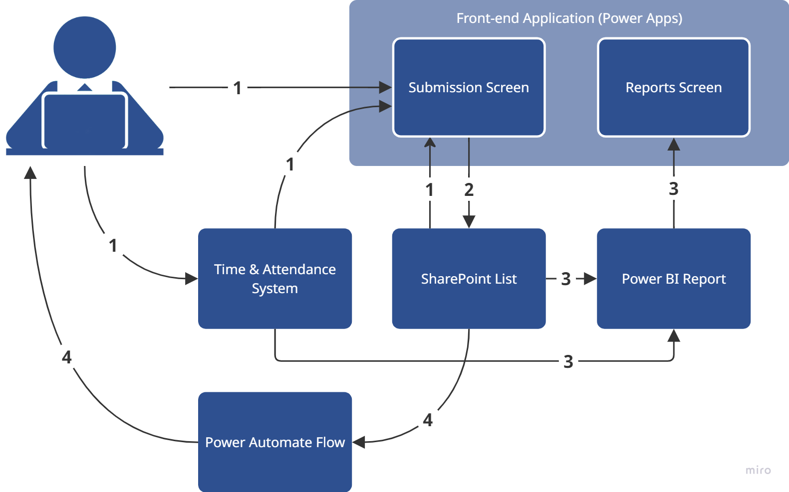

Data flow summary:
- The Submissions screen of the app pulls data from the SharePoint list where all submission data is stored and displays a list of weeks that don’t yet have submission data. The team member selects a week to submit data for. The app pulls leave data from the time and attendance system for the selected week and displays it to the team member for informational purposes (team members maintain leave data in the attendance system as a separate process). The team member logs hours for the week in the relevant categories and submits the data.
- The app writes the data to the SharePoint list.
- The Power BI report automatically refreshes its data from the time and attendance system and the SharePoint list each day. The report is embedded in the Reports screen of the app.
- Power Automate reads the submission data from the SharePoint list once a day (weekdays) and sends reminder emails to team members for missing submissions.

6. Reporting Calendar
The reporting cycle follows the school year, which runs from the first Saturday in September through the last Saturday in August. All KPIs and compliance measures reset at the start of each school year.
When | What Happens
Each week (Saturday) | A new reporting week becomes available in the submission app at 12:00 AM each Saturday.
Monday, 12:00 PM MT | First reminder email sent to any team member with missing submissions.
Tuesday - Friday, 8:00 AM MT | Daily reminder emails continue until all submissions are current.
Daily | The report data (in Power BI) is refreshed once a day. This includes both submissions and leave data.

7. Contacts and Support
For questions or issues related to the system, please contact the appropriate person below:
Topic | Contact | Notes
How to submit hours / using the app | Team manager or executive assistant
Report access or login issues | IT Department | Ensure you are signed in with your Clear River Microsoft 365 account
Technical issues / system errors | IT Department | Please include a screenshot and description of the issue
Reminder email questions | Executive assistant | Reminder emails are sent from school_leadership@crps.co.us
This document is maintained by the implementing contractor and should be reviewed at the start of each school year or whenever significant changes are made to the system.

