**The accelerometer**

Smart phones and tablets contain accelerometers that monitor the device’s orientation, one use is to match the screen and device rotation.

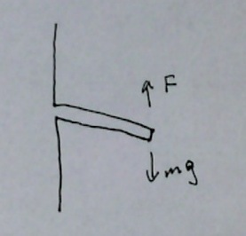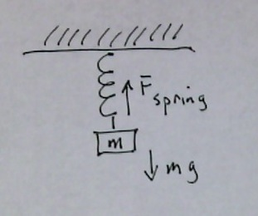A smart phone/tablet accelerometer actually measures force, not acceleration. If you imagine a mass on a spring, the mass pulls down with a force equal to mass times the acceleration of gravity (left). More force makes the spring stretch more. The accelerometer uses a microscopic cantilever to measure force in a particular direction instead of a mass on a spring (at right). In this case the more force, the more the cantilever bends. There are three of these cantilevers, oriented relative to the screen: y, top to bottom; x, left to right; z, through the screen.

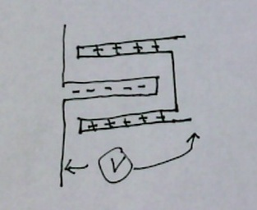

One way to measure the amount of bending of a tiny cantilever is by turning the cantilever into one side of a capacitor. A non-moving conductor is positioned on either side of the movable cantilever and the two are given opposite charges. If the tablet moves, the distance between the cantilever and the conductor change due to the inertia of the cantilever. This relative motion causes the capacitance to change and a small current flows to rebalance the charge distribution. This small current change is interpreted as an acceleration.

The following explains the axis orientation for a phone or tablet laying flat on a table, screen up, you at the bottom of the phone:

* The x and y readings will be zero and z will read 1 = 9.81 m/s2.
* If you push the device on the left side (so it accelerates to the right), the x acceleration value is positive.
* If you push the device on the bottom (so it slides away from you), the y acceleration value is positive.
* If you lift the device toward the sky with an acceleration of A, the z acceleration value is equal to A + 1 $g$, which corresponds to the acceleration of the device (+A ) and the acceleration of gravity.

The following exercise explores the properties of the device’s accelerometer.

Procedure:

1. Start the *Physics Toolbox Accelerometer\**. The app shows x, y and z accelerations in units of = 9.8 m/s2.

 Total and other app options can be changed in the settings.

andstart and stop data collection.

 clears and restarts data collection.

*Record* button captures the data as a text file.

One quirk inherent in the Toolbox app is that it stops taking data if the device is not moving.

1. Find the x, y, z accelerations for the following orientations:
   1. Tablet flat, screen up.
   2. Flat, screen down.
   3. Top of device up, bottom down so the screen is in the horizontal direction.
   4. Screen at an angle of approximately 45 degrees.
2. Using the z value of your last measurement, determine the actual angle to see how close it was to 45 degrees. (Hint: The force component in the –z direction is $gsinθ$.)
3. Find something soft for the device to land on, such as a coat. Hold the device flat with screen up approximately 50 centimeters above the landing zone, start the data collectionand drop the device. When it lands, stop data collectionand examine the data. What occurs to acceleration during free fall?
4. Repeat the last step but release the device from a vertical orientation instead of horizontal. What are the results?
5. With the device horizontal, very gently and carefully toss the device up and catch it. Do this so that the phone stays horizontal. Your data should look something like the picture below. Discuss and interpret with your lab partners what was measured by the accelerometers.

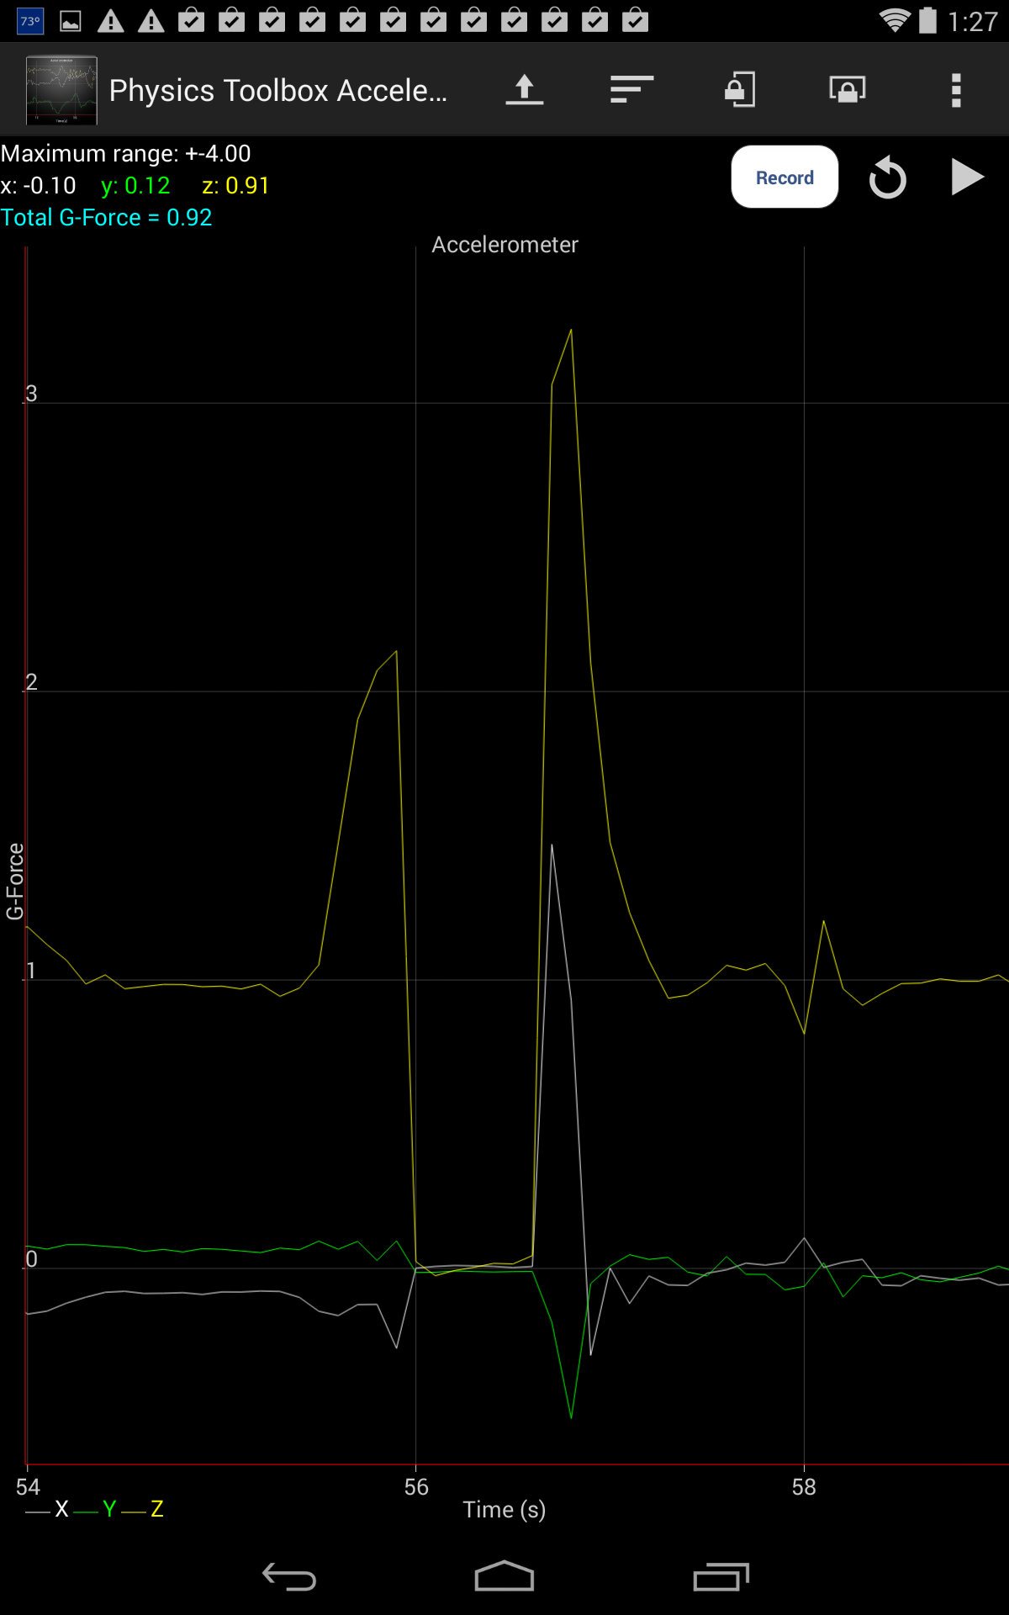

*Physics Toolbox app: <https://play.google.com/store/apps/details?id=com.chrystianvieyra.android.physicstoolboxaccelerometer>