**Coefficient of restitution**

The coefficient of restitution (COR) for an object made of some material is the ratio of the speed of the object before and after collision with a hard surface; $COR={v_{after}}/{v_{before}}$. If the collision is perfectly elastic, COR=1. If the object sticks to the surface after collision, COR=0. The COR is determined by bouncing the object off of a hard surface. Typical golf balls COR=0.78, basketballs COR=0.81 to 0.85, tennis balls COR=0.89 to 0.91. The COR of other objects such as tennis rackets and golf clubs can be determined by bouncing a hard sphere off of them. Typical tennis rackets COR=0.85 and golf clubs COR=0.83.

In practice, the COR is usually determined by dropping an object from some height *H* and measuring the bounce height, *h*. The coefficient of restitution is then given by $COR=\sqrt{h/H}$. Inaccuracy in measuring COR is due to the difficulty in measuring the bounce height, *h*. Below is a procedure for measuring the COR of an object bouncing on a hard surface using time measurements.

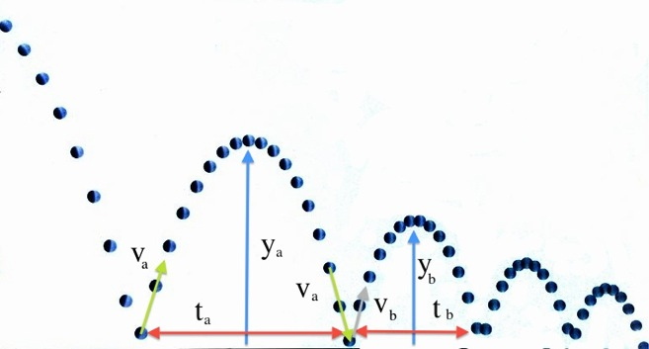

In the diagram, $v_{a}$ is the velocity after the first bounce and $v_{b}$ is the velocity after the second bounce, $y_{a}$ is the height of the first bounce and $y_{b}$ is the height of the second bounce. Notice that, if air resistance can be ignored, $v_{a}$ is also the speed of the ball just before the second bounce. The first bounce takes time $t_{a}$ and the second bounce takes time $t_{b}$.

The equation $y=v_{a}t+\frac{1}{2}at^{2}$ gives the height, y, of the ball at any time *t* during the first bounce where *a* = 9.8 m/s2. When the ball returns to the surface after $t_{a}$ it is at height $y=0$ so we have $0=v_{a}t_{a}+\frac{1}{2}a{t_{a}}^{2}$ or $v_{a}=\frac{1}{2}at_{a}$.

During the period of the second bounce, using the same equation we get $v_{b}=\frac{1}{2}at_{b}$. The coefficient of restitution is ${COR=v}_{b}/v_{a}=\frac{1}{2}at_{b}/\frac{1}{2}at_{a} =t_{b}/t_{a}$. To measure COR only requires an accurate measurement of the times of two consecutive bounces.

Procedure:

1. Start the AudioTime+ app.*
2. Press + button to record; pressing  stops the recording.
3. Start recording, drop the ball and let it bounce at least twice. Then stop the recording.
4. Press the  button to place a line at the first bounce, the highest (loudest) part of the signal.
5. Use pinch and squeeze to enlarge the graph until only the second bounce is on the screen.
6. Press the  button again to place a second line at the second bounce. The time between the two bounces is shown as *Interval* in the lower right. This is $t_{a}$.
7. Press  to show all the graph data. Your graph should look like the one below.
8. Double tap the screen to remove the two lines.
9. Repeat steps 5 and 6 to find the time between the second and third bounce. This new interval is $t_{b}$.
10. You can now find the coefficient from $COR=t_{b}/t_{a}$.
11. To check if the coefficient is correct, drop the ball from a known height, *H* and measure how high it bounces, *h*. The coefficient is $COR=\sqrt{h/H}$. Notice that, due to the uncertainty of *h*, this measurement is not as accurate.

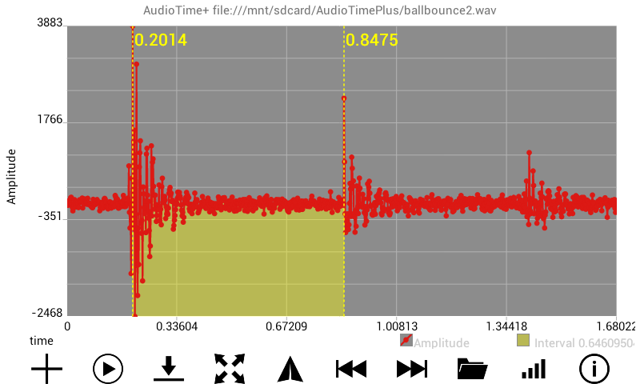

Screen shot of AudioTime+ showing the interval between the first and second bounce.

*Mobile Science AudioTime+ app:

<https://play.google.com/store/apps/details?id=edu.ius.audiotimeplus>