**Doppler Measurement of Speed**

The Doppler frequency sound shift corresponding to an object’s speed is easily heard but difficult to directly determine without special equipment. However, today’s mobile devices record sound and have the computational power for the requisite Fast Fourier Transform (FFT) analysis to generate the frequency spectrum. Many apps exist that can perform this task.1

The Doppler shift is given by $f=\left(\frac{c±v_{r}}{c±v_{s}}\right)f_{o}$ where $f_{o}$ is the frequency of the source when stationary, *c* is the speed of sound, $v_{r}$ is the velocity of the receiver, $v_{s}$ the velocity of the source and *f* is the frequency recorded at the receiver. In the equation the + sign on top is the case of the receiver moving towards the source and becomes negative if the receiver is moving away from the source. On the bottom the + sign is used if the source is moving away from the receiver and negative if moving towards the receiver. Rearranging this equation for a stationary sound source ($v_{s}=0$) gives $v_{r}=c\left(\frac{f}{f_{o}}-1\right)$ for the speed of a receiver moving towards the source and $v_{r}=c\left(1-\frac{f}{f_{o}}\right)$ if the receiver is moving away.

There are some limitations of using the Doppler shift to measure speed. For low speeds and/or low source frequencies the shift is relatively small (only a few Hertz). More accurate results are obtained for fast moving objects and higher frequencies that produce a proportionally greater shift. A single frequency source is preferable as it allows the shift to more easily be determined. Many sources, such as car horns, are challenging because they contain many frequencies and identifying which frequency shifted is sometimes difficult. A final problem is acceleration. The shift can be easily determined if the movement is at constant velocity. Where there is acceleration, other techniques in applying the Doppler shift method can be used.2

Proceedure:

1. Start the AudioTime+ app3.
2. Set up a stationary sound source with a constant frequency. Higher frequencies and louder volumes are best.
3. Press the + button to record; press  to stop. Record several seconds of data while stationary and close to the source.
4. Use the Fourier Transform button  to find the frequency of the stationary source.
5. The Doppler shift for an object moving below 5 m/s is small; the faster the object moves the more accurate the measurement. Also, holding the phone in your hands while moving produces an additional Doppler shift due to the arms swinging back and forth. Place the phone in a front pocket for best results.
6. Start recording, put the phone in your pocket, run past the sound source at a constant speed, then stop the recording. Mounting the phone on a bicycle, skater or other moving object is also possible.
7. Locate the time in the graph when the runner passed the sound source (this should be when the sound is loudest).
8. Use pinch and squeeze to enlarge the graph until the one second of data right before the runner passed the source is shown in the window.
9. Click on the Fourier Transform button  to find the shifted frequency. The graph should look something like the graph shown below.
10. The equation $v_{r}=c\left(\frac{f}{f_{o}}-1\right)$ where *c* = 343 m/s is the speed of sound, gives the speed of the runner.
11. The second of data after the runner passes can also be analyzed and the runner’s speed determined by $v_{r}=c\left(1-\frac{f}{f_{o}}\right)$.
12. The Doppler shift of a sound source moving past a stationary cell phone can also be measured. Again, a faster moving source with a single higher frequency works best. The source should be moving at a constant speed and be loud enough to be detected by the phone.
13. For a moving source the equation is $v_{s}=c\left(1-\frac{f_{o}}{f}\right)$ gives the speed of the source as it moves towards the receiver.

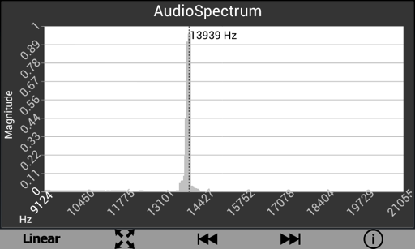

Frequency shift recorded by the AudioTime+ phone app on a bicycle passing a stationary sound source of 13784 Hz. The calculated speed for the bicycle was 3.5 m/s.

1. Examples of FFT apps we have examined include: Spectral Audio Analyzer (<https://play.google.com/store/apps/details?id=radonsoft.net.spectralview&hl=en>) for Android; Signal Scope (<http://www.faberacoustical.com/ios_apps/signalscope_pro/>); AudioScope (<http://www.hensleyindustriesllc.com/iphone/audioscope/audioscope.html>); and oScope (<https://itunes.apple.com/us/app/oscope/id344345859?mt=8>) for iOS.
2. P. Vogt, J. Kuhn, and S. Muller, "Experiments Using Cell Phones in Physics Classroom Education: The Computer-Aided g Determination", *The Physics Teacher*, Vol. 49, No. 9 (2011) p383.
3. AudioTime+ app: https://play.google.com/store/apps/details?id=edu.ius.audiotimeplus