**Acceleration of gravity: Introduction to photo-gate timing.**

We can measure the acceleration of a falling object if we know the speed of the object at two locations during the fall. Additionally, we need either the elapsed time or the distance between the two measurements. If $v_{o}$ is the first speed and $v$ the speed at some time, *t* later, then acceleration can be calculated from $v=v_{o}+gt$. If the distance, *x*, between the two speed measurements is known then acceleration can be calculated from equation $v^{2}-v_{o}^{2}=2gx$.

This lab introduces the use of a photo-gate made from a photo-resistor connected to a smart phone.1 A phone app (AudioTime+)2 outputs a 4000 Hz frequency signal through the headset port to the circuit shown below and records the return signal from the microphone input. Two photo-resistors are in series between the headset output and input to decrease the signal amplitude if light is blocked to either photo-resistor.

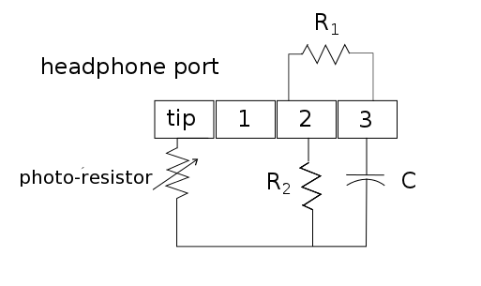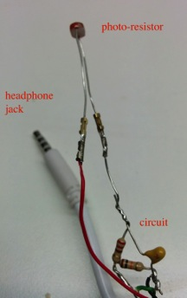

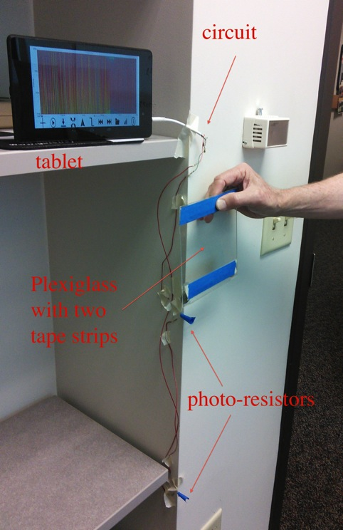The circuit and circuit diagram for using a photo-resistor with a cell phone to make speed measurements is shown on the left. R1 = 10 kΩ, R2 = 220 Ω, C = 0.1 μF. The headset jack is a standard four-pole jack. A single photo-resistor is shown but two or more can be placed in series to make multiple measurements. The photo-resistors used here have a resistance of about 120 kΩ in the dark and 5 kΩ under lamp light. The picture at right shows a tablet, the circuit, two photo-resistors, and a piece of Plexiglas ready to be dropped.

The signal does not drop instantly when the resistor is blocked but rather tapers off to a minimum while blocked. Also, due to hysteresis effects, the dip (high-to-low transition) in the graph when the photo-resistor is blocked is slightly asymmetric. To avoid these problems we used a double flag method where the time at the beginning of two separate dips is used for timing purposes.3 In this method, a Plexiglas card has two strips of tape placed a few centimeters apart so that two dips are produced at each photo-resistor when it passes and blocks the light to each resistor. The photo gate is marked as blocked at the time when the amplitude of the gradual signal drop is 80% of the peak, unblocked signal. The time marked at the first dip to the second dip is the length of time the object takes to pass the resistor.

Average velocity at each resistor is calculated from $v_{ave}=\frac{d}{∆t}$ where *d* is the distance from the leading edge of the first tape strip to the leading edge of the second strip. The time, $∆t$, can be measured with the app. The figure below gives the time at two photo-resistors, entering the first photo-gate at 1.6098s and the second at 1.8168s.

Procedure:

1. Connect the two photo-resistors in series and attach them to a support using tape as shown in the picture above.
2. Start the AudioTime+ app.
3. Press + button to record; pressing  stops the recording.
4. Start recording, drop the Plexiglas so that it passes smoothly in front of both photo-resistors. Then stop the recording by pressing . You may want to practice a few times until the data is smooth as shown in the figure below. If the ambient light is not bright, use a flashlight or lamp in front of the photo-resistors. Using a small piece of tape or drinking straw as a collimator for the resistors will also improve results.
5. Use pinch and squeeze to enlarge the graph until only the first dip is on the screen.
6. Pressing the  icon places a line at the time when the signal drops to 80%.
7. Use pinch and squeeze to enlarge the graph until only the second dip is on the screen.
8. Pressing the  icon places a line at the time when the signal drops to 80% at the second dip. $∆t$, is the time interval between the first and second tape blocking the gate. The velocity at the first photo-resistor is $v_{o}=\frac{d}{∆t}$ where *d* is the distance from the leading edge of the first tape to the leading edge of the second tape.
9. Repeat for the next two dips corresponding to the second photo-resistor for the velocity, *v*, at that resistor.
10. To find the time, *t*, between the two speeds use the  button to find the time when the first resistor was blocked and again to find the interval between the first and third dip (0.20702004 s in the example). Do this again to find the time from the second dip to the fourth dip and average these two time intervals to find *t*, the average time it takes the Plexiglas to get from the first resistor to the second.
11. Acceleration is given by $a=(v-v_{o})/t$.

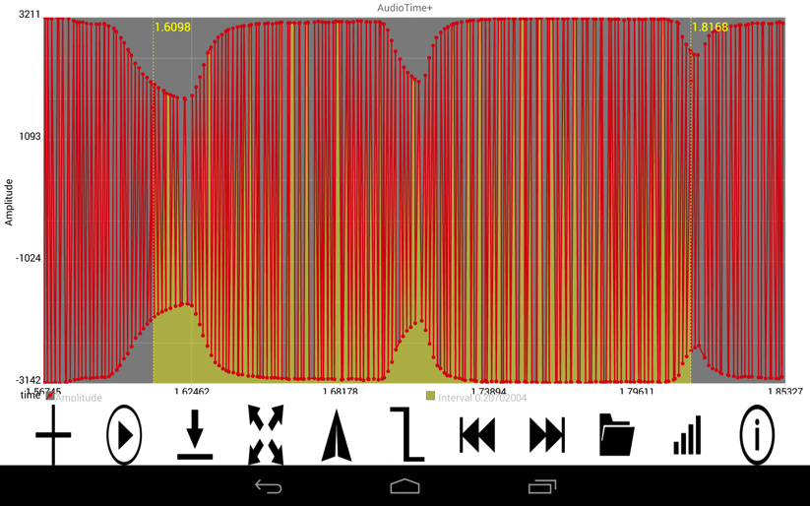

1. K. Forinash and R. Wisman, ‘Smartphones- Experiments with an External Thermistor Circuit’, *The Physics Teacher*, Vol. 50 No. 9 (2012) p566.
2. R. Wisman and K. Forinash, 'Mobile Science – AudioTime+'. November 2013. Google play @ <https://play.google.com/store/apps/details?id=edu.ius.audiotimeplus>
3. Unpublished manuscript by Michael D. Edmiston at Bluffton University, <http://www.bluffton.edu/~edmistonm/double.flag.timing.pdf>