**Direct measurement of g from a falling mass.**

If air resistance can be ignored, the time it takes an object to fall a distance $y$ is given by $t=\sqrt{\frac{2y}{g}}$. Inverting this equation gives a way to measure the acceleration of gravity, $g=\frac{2y}{t^{2}}$ but only if the time of fall can be measured accurately. In this exercise the fall time is measured using sound.

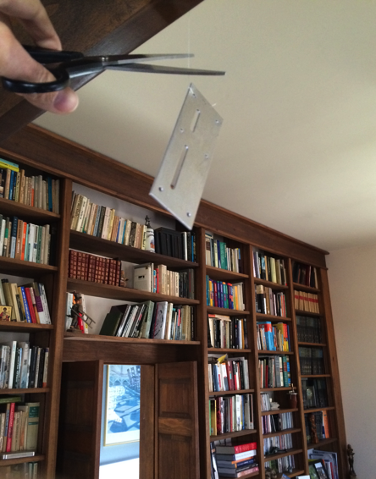

Procedure:

1. Suspend a mass from a thread about two meters from the floor.
2. Accurately measure the distance from the floor to the bottom of the mass, *y*.
3. Start the AudioTime+ app.* The + on the lower left is the record button; press again to stop recording.
4. Hold the phone one meter above the floor and to the side where the mass will fall. Start recording.
5. With scissors, cut the thread, so that the scissors make an audible sound.
6. Stop recording after the mass hits the floor.
7. Pinch and squeeze the screen until the thread cut is the highest (loudest) sound.
8. Press the  button to mark the highest (loudest) sound.
9. Use pinch and squeeze to enlarge the graph until only the sound of the mass hitting the floor is on the screen.
10. Press the  button to put a second line when the mass hit. The fall time, *t*, between the two sounds is the *Interval* at lower right.
11. Press  to see all the graph data (sounds). Your graph should look like the one below.
12. Calculate the acceleration of gravity using $g=\frac{2y}{t^{2}}$.

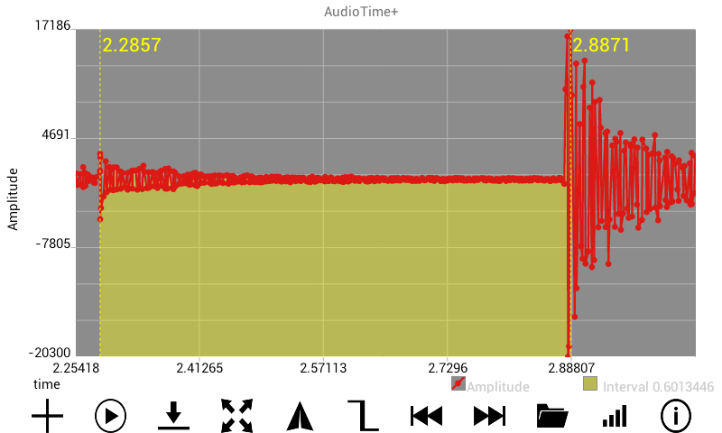

*Mobile Science AudioTime+ app: <https://play.google.com/store/apps/details?id=edu.ius.audiotimeplus>