**Frequency of sound**

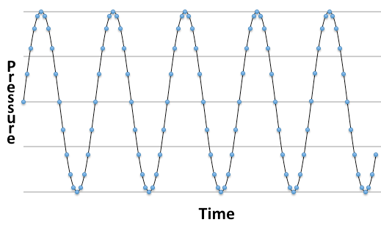Sound waves result when an object, such as vocal chords or a guitar string, vibrate the air causing pressure changes. An object vibrating 500 times per second or 500 Hz would create 500 oscillations in air pressure per second, a 500 Hz sound wave.

Audio recording devices measure those air pressure changes over time; digital recorders sample the changes at fixed time intervals with digital audio commonly sampled at 44100 Hz.

The frequencies present in the air pressure oscillations of a complex sound wave can be accurately determined by Fourier analysis of the digital recording. A discrete Fourier time to frequency transformation samples a complex wave form at discrete time intervals (the points in above figure) to approximate the continuous sound wave. The correlation of these samples with multiple pure sine waves determines the amount of each sine wave frequency present in the original sound. A frequency spectrum plots the amount of each sine wave frequency present.

A smart phone/tablet hardware digitally records audio which can then be transformed by software to component frequencies. The AudioTime* app can be used to record and select audio segments for frequency analysis; the AudioSpectrum+ app can analyze a WAV file audio recording and display a frequency spectrum.

Procedure:

1. Start the *AudioTime* app.
2. The + sign at the lower left is the record button; pressing  stops the recording.
3. Record a short sound, have two people whistle at the same time.
4. Pinch and squeeze the recording to select the segment to analyze.
5. Press the Fourier Transform button  to find the component frequencies and display the frequency spectrum.

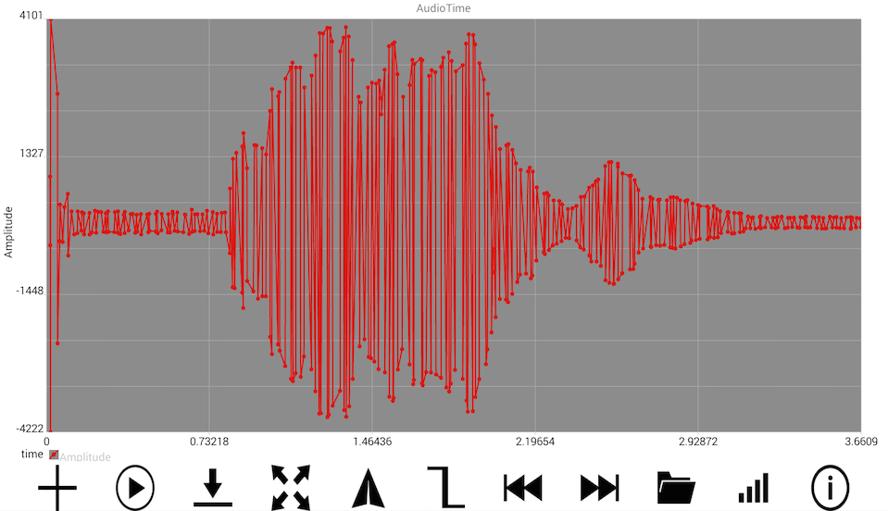 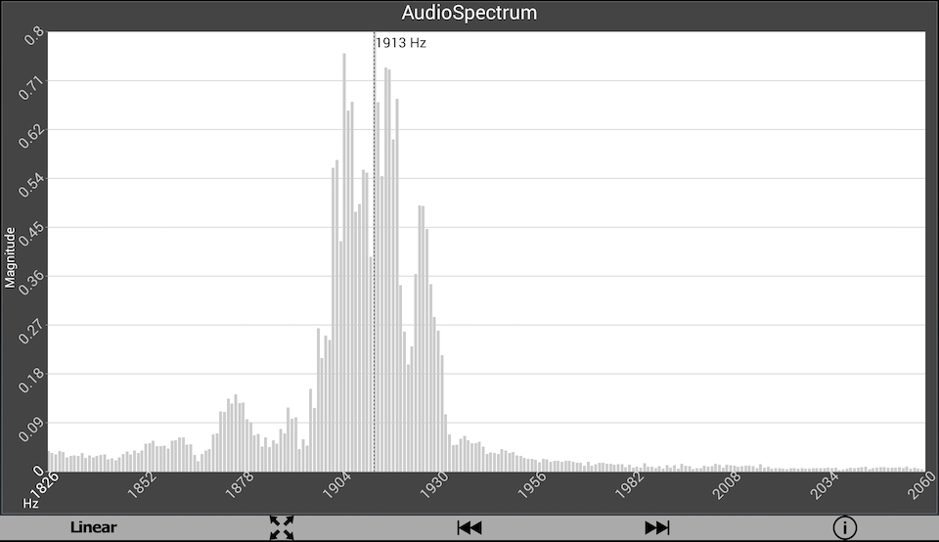

*AudioTime app: <https://play.google.com/store/apps/details?id=edu.ius.audiotime>

+AudioSpectrum <https://play.google.com/store/apps/details?id=edu.ius.audiospectrum>