**Acceleration on an inclined plane using photo gates.**

The acceleration of an object sliding down a frictionless incline is given by $a=g\sin\left(θ\right)$ where $g$ is the acceleration of gravity and $θ$ is the angle of the incline. A toy car with small wheels is not entirely frictionless and the wheels will have some rotational inertia but if friction and the wheels are small, the car will roll down an incline at an acceleration close to that of a frictionless object.

We can measure acceleration if we know the speed of the car at two locations on the incline. Additionally we need either the time elapsed between the two measurements or the distance between the two measurements. If $v_{o}$ is the first speed and $v$ the speed at some time *t* later then acceleration can be calculated from $v=v_{o}+at$. If the distance, *x*, between the two speed measurements is known the acceleration can be calculated from equation $v^{2}-v_{o}^{2}=2ax$.

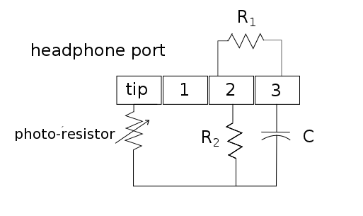  
The following method is used to measure the resistance change in a photo-resistor when light shining on it is blocked.1 A smart phone app (AudioTime+)2 outputs a 4009 Hz frequency signal through the headset port into the circuit shown below and records the return signal from the microphone input. Two photo-resistors are in series between the headset output and input to decrease the signal amplitude when light is blocked to either photo-resistor.

Circuit with a photo-resistor to make speed measurements using a smart phone. R1 = 10kΩ, R2 = 220Ω, C = 0.1μF. The headphone jack is a standard four-pole jack. A single photo-resistor is shown but two or more can be placed in series to make multiple measurements. The photo-resistors used here have a resistance of about 120 kΩ in the dark and 5 kΩ under lamp light.

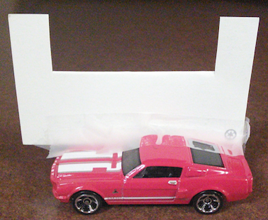

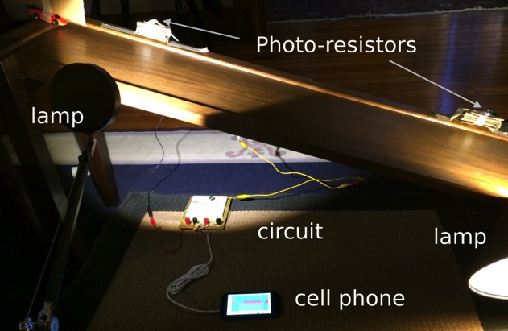The picture at right shows a setup using a homemade inclined plane, two photo-resistors, two lamps, the circuit above and a smart phone. The toy car with a card attached can be seen in the upper left.

The signal does not drop instantly when the resistor is blocked but rather tapers off to a minimum while blocked. Also, due to hysteresis effects, the dip in the graph when the photo-resistor is blocked is slightly asymmetric. To avoid these problems we used a double flag method where the time from the beginning of two separate dips is used for timing purposes.3 In this method a card with a notch cut out is placed on the moving object so that two dips are produced at each photo-resistor when the object passes and blocks the light to each resistor. The photo gate is marked as blocked at the time when the amplitude of the gradual signal drop is 80% of the peak, unblocked signal. The time marked at the first dip to the second dip is the length of time the object takes to pass the photo-resistor.

Average velocity at each resistor is calculated from $v_{ave}=\frac{d}{∆t}$ where *d* is the distance from the leading edge of the card to the leading edge of the second flag (the trailing edge of the notch). The time, $∆t$, from when the card enters the gate until the notch has passed is measured from the app. The figure below shows the amplitude of the recorded return signal from a notched card passing a single photo-resistor. Time is marked when the signal drops by 80% as the first flag passes the resistor at 1.1318s and again at 1.2352 s as the trailing flag passes. The total time the object was at the resistor is given at the bottom of the screen as 0.1035 s.

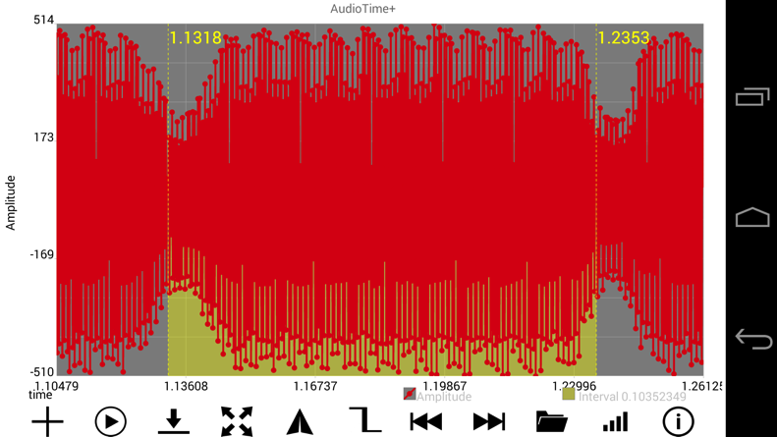

Procedure:

1. Cut a cardboard card with a notch, measure the distance from the leading edge to the edge of the second flag (the end of the notch) and attach it to the toy car.
2. Start the AudioTime+ app.
3. Press the + sign on the lower left to record; press  to stop.
4. Start recording, let the car roll down the incline, making sure the attached card passes between the lamps and both photo-resistors. Then stop the recording by pressing .
5. Use pinch and squeeze to enlarge the graph until only the first dip is on the screen.
6. Pressing the  icon places a line at the time when the signal drops to 80%.
7. Use pinch and squeeze to enlarge the graph until only the second dip is on the screen.
8. Pressing the  icon places a line at the time when the signal drops to 80% at the second dip. The time duration of when the gate is blocked, $∆t$, is given in the lower right (0.10352349 s in the example). The speed at the first photo-resistor is $v_{o}=\frac{d}{∆t}$ where *d* is the distance from the leading edge of the card to the leading edge of the second flag (the trailing edge of the notch).
9. Repeat for the two dips corresponding to the second photo-resistor to get the speed, *v*, at that resistor.
10. To find the time, *t*, between the two speeds use the  button to find the time when the first resistor was blocked and again to find the interval between the first and third dip. Do this again to find the time from the second dip to the fourth dip and average these two time intervals to find *t*, the average time it takes the car to get from the first resistor to the second.
11. Acceleration down the incline is given by $a=(v-v_{o})/t$.

References

1. K. Forinash and R. Wisman, ‘Smartphones- Experiments with an External Thermistor Circuit’, *The Physics Teacher*, Vol. 50 No. 9 (2012) p566.
2. R. Wisman and K. Forinash, 'Mobile Science – AudioTime+'. November 2013. Google play @ <https://play.google.com/store/apps/details?id=edu.ius.audiotimeplus>
3. Unpublished manuscript by Michael D. Edmiston at Bluffton University, <http://www.bluffton.edu/~edmistonm/double.flag.timing.pdf>