**Magnetic field**

In this exercise you will measure the magnetic field of a bar magnet. Measurements are analyzed in a spreadsheet.

The magnetic field, measured in *Tesla*, of a bar magnet at a distance *x* from the center along the direction of one of its poles is given by $M=A/x^{B}$ where *A* and *B* are constants. The field of a point source decreases as $1/r^{2}$ but a dipole field decreases as $1/r^{3}$ along the axis of the dipole (as can be verified by adding two point sources of opposite magnitude separated by a small distance) so the constant *B* should be approximately equal to 3.

Procedure:

1. Find the approximate location of the magnetic field sensor in your device using the Physics Toolbox Magnetometer app and moving a magnet over the device.* The measure will be a maximum when the magnet is near the field sensor on the device. Mark the location with a small piece of tape.
2. Place the magnet flat, with the pole that gives a positive reading in the app close to the device as shown in the picture. If the Magnetometer app gives a zero measure, move the magnet further from the marked sensor (a zero measure indicates field strength exceeds the sensor range). Measure the distance from the sensor location to the center of the magnet (*d* in the figure below).

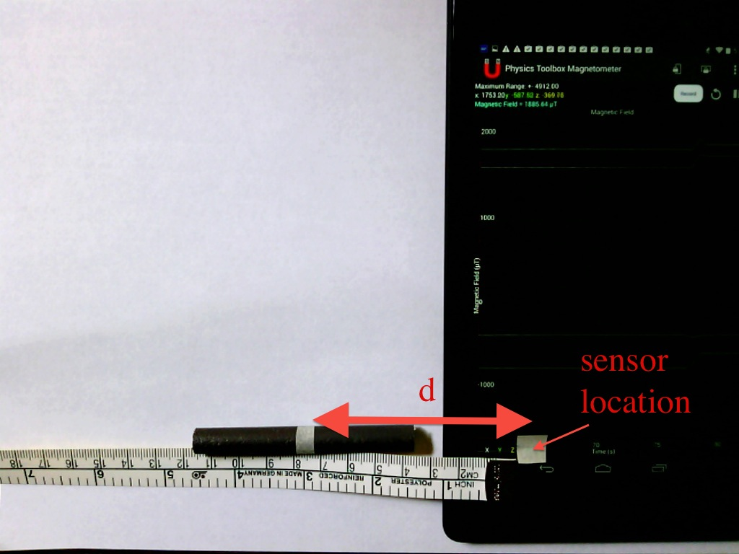

1. Start the Mobile Science Magnetic Field app.# Enter the number of measurements to take (which can be changed later); the initial distance from the sensor location to the center of the magnet (*d* in the figure above); and the device axis for measuring the field (*x* axis in the figure above).
2. Press *Collect Data* and the Physics Toolbox app will open.
3. Press *Record* button and move the magnet 1 cm more from the tablet. Pause for 4 seconds and move another 1 cm. Repeat until the center of the magnet is 20 cm from the sensor. *Stop* recording.
4. Press the back button  to return to the Magnetic Field app and choose *Analyze*. The app loads the data into a spreadsheet using the file ‘input.xls’ as a template and ‘copy.xls’ as the output with the data. Your graph should appear like the picture below.
5. Taking a natural logarithm of $M=A/x^{B}$ gives $lnM=lnA-Blnx$. A plot of $lnM$ versus $lnx$ should be a straight line with slope $–B$. The app calculates and plots as a separate graph in the spreadsheet as shown below. In this example, $B=$ 3.278 and $A=exp14.007=1.2×{10}^{6} Tesla$.
6. Press the back button  to return to the Magnetic Field app. Change the number of points to be used in the analysis and reanalyze the data. Do this for several different numbers of data points. Notice the R2 value for each analysis. What can you conclude about the accuracy of the results as a function of the number of data points used in the analysis?
7. You can download the spreadsheet to a computer (the file ‘copy.xls’ has the current data) for further analysis. You can also download and modify the ‘input.xls’ spreadsheet and upload the new template to the phone or tablet if you want to change the format of the graph or add a different analysis or graph to the template.



*Physics Toolbox Magnetometer app: <https://play.google.com/store/apps/details?id=com.chrystianvieyra.android.physicstoolboxmagnetometer>

#Mobile Science Magnetic Field app: <https://play.google.com/store/apps/details?id=edu.ius.magneticfield>