Three different approaches have been used to forecast USD/INR Exchange Rate. Each of them have been coded on RStudio. These are:
Prophet Model
The Prophet model is an open-source time series forecasting tool developed by Meta (formerly Facebook) that decomposes time series data into trend, seasonality, and holiday effects to predict future values. It uses a decomposable additive model to handle non-linear trends with yearly, weekly, and daily seasonality, as well as irregular holiday effects. Prophet is robust to missing data and outliers and is designed to be user-friendly for business users, making it suitable for forecasting various business-related time series.

Key Components of the Prophet Model
Prophet's additive model breaks down the forecast into several components:
Trend (g_{t}):
Models the non-periodic changes in the time series, often using a piecewise linear or logistic growth curve with automatically selected changepoints.
Seasonality (s_{t}):
Captures recurring patterns like yearly, weekly, or daily cycles, typically modelled using Fourier series.
Holidays (h_{t}):
Incorporates the effects of holidays and other irregular events, often modelled as dummy variables.
Error Term (ε_{t}):
Represents the random noise or unexplained variation in the data.

Code in R
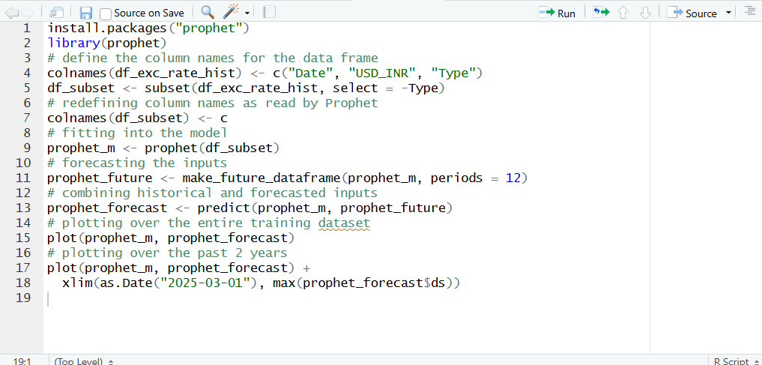

SARIMA Model
A SARIMA model (Seasonal Autoregressive Integrated Moving Average) is a statistical forecasting method used for time series data that exhibits both trend and seasonal patterns. It extends the standard ARIMA model by incorporating additional seasonal components for autoregression (SAR), differencing (SI), and moving averages (SMA), allowing it to capture complex cyclical fluctuations and provide more accurate predictions for seasonal data like monthly sales or weather patterns.
The SARIMA model is defined by its orders, which are represented as (p, d, q) for the non-seasonal part and (P, D, Q) m for the seasonal part, where 'm' denotes the number of periods in the seasonal cycle.
Non-Seasonal Components (p, d, q):
- p (Autoregressive - AR): Models the relationship between an observation and a number of preceding observations.
- d (Integrated - I): Handles the trend in the data by differencing the time series to make it stationary (constant mean and variance).
- q (Moving Average - MA): Models the relationship between an observation and a residual error from a moving average model applied to previous observations.
Seasonal Components (P, D, Q) m:
- P (Seasonal Autoregressive - SAR): Captures the relationship between an observation and past observations from previous seasons.
- D (Seasonal Integrated - SI): Performs seasonal differencing to remove the seasonal component from the data, similar to non-seasonal differencing.
- Q (Seasonal Moving Average - SMA): Incorporates the influence of past seasonal forecast errors into the current prediction.
- m (Seasonal Period): Specifies the length of the seasonal cycle
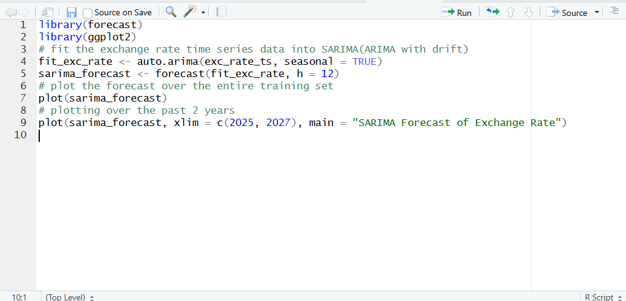
Linear Regression Model
This model as explained in the solution decomposes the Exchange Rate into various macro-economic factors to capture the change in each parameter and regresses them to provide an LM Model to execute forecasts on the exchange rate.

Creating the Linear Regression Model
For this purpose, the following parameters of the exchange rate have been considered:
- Crude Oil Prices (USD per Barrel) – To capture the impact of crude oil prices in exchange rate fluctuations
- Relative CPI (CPI_{India} / CPI_{USA}) - To capture relative inflation in the 2 countries
- Comprehensive Leading Indicator (CLI_{India} / CLI_{USA}) - To capture relative performance of Labour Market, Money Market, Financial Market, Housing Market and Manufacturing and Trade components of the two economies.
- Geopolitical Risk Index (GPR_{India} / GPR_{USA}) – To capture the expected Geopolitical Risk/Threats that the country faces
- Forex Reserves (in billions USD) for India – To capture flow of USD between India and the Rest of the World
- Interest Rate Differential (10y Indian G-Bond Yield – 10y US T-BOND Yield) – To capture the relative investment environment of each economy
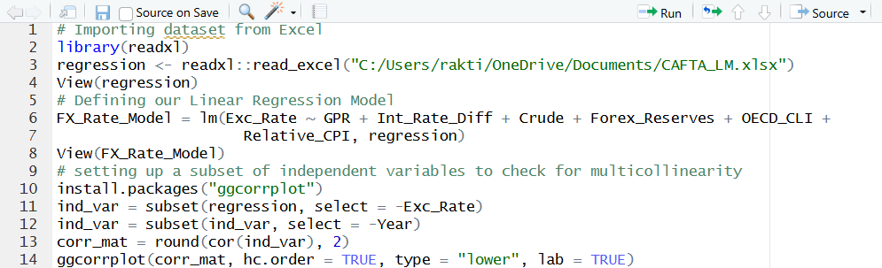

Multi-Collinearity Test
After regressing, we perform multicollinearity test to check for correlation between the parameters. The correlation matrix with the original set of parameters is:
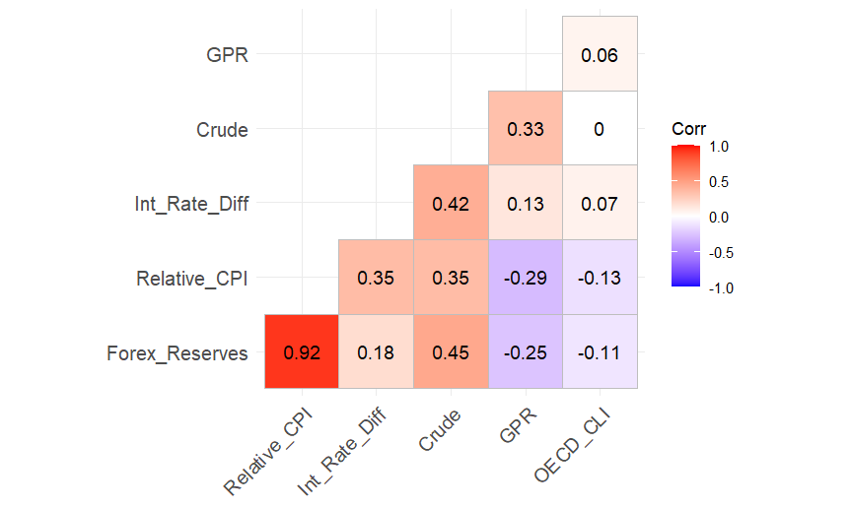
After checking we can see that Relative CPI and Forex Reserves show high correlation with other parameters and after testing the model by removing each parameter, we end up dropping the CPI parameter as its removal does not affect our original R-Squared Value of 0.933.
Thus, we regress the inputs again with our new set of parameters:
- Crude Oil Prices (USD per Barrel)
- Comprehensive Leading Indicator (CLI_{India} / CLI_{USA})
- Geopolitical Risk Index (GPR_{India} / GPR_{USA})
- Forex Reserves (in billions USD) for India
- Interest Rate Differential (10y Indian G-Bond Yield – 10y US T-BOND Yield)

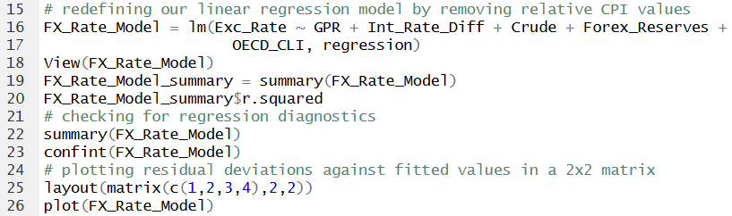

Regression Diagnostics
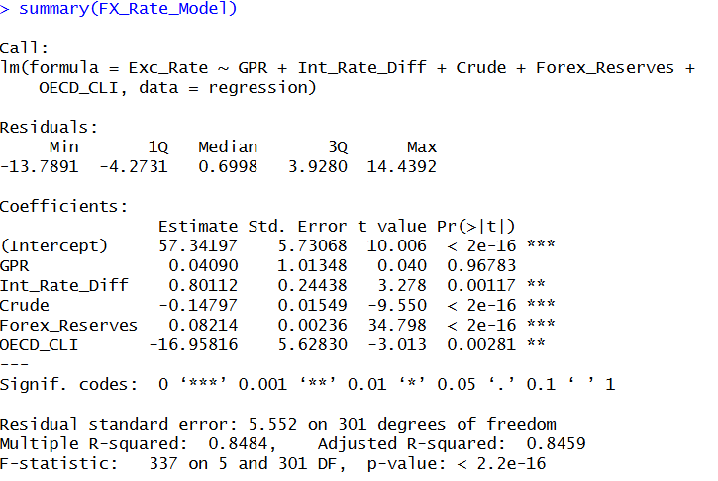
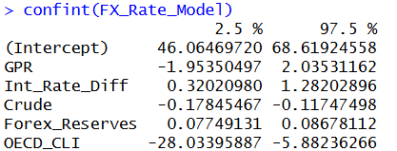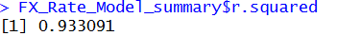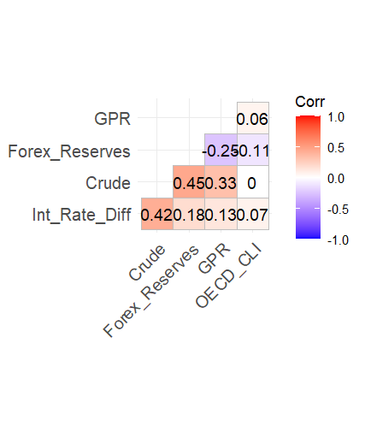

Residual Plots
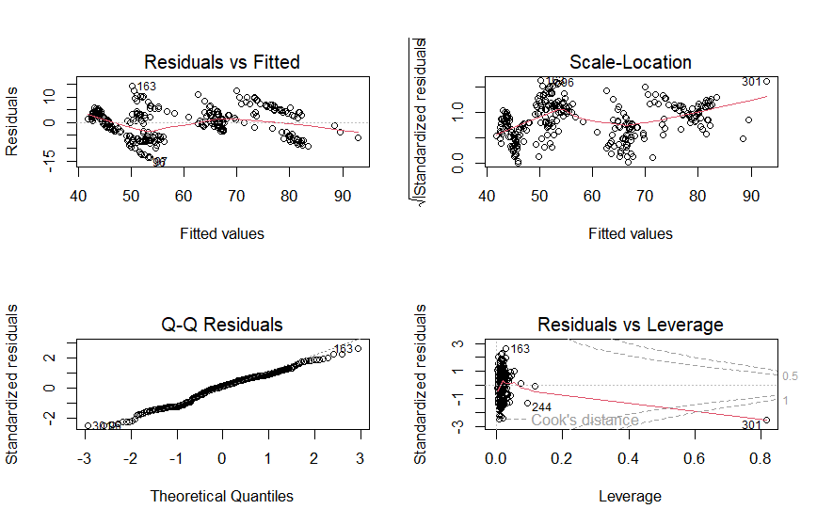

Parameter Forecasting
To decompose the future exchange rate, we have to forecast each of the 5 parameters separately. The following table highlights the forecasting models used for each parameter:
Interest Rate Differential | ARIMA with drift | Drift incorporates the risk-free rate component and ARIMA captures mean-reversion and credit cycle phases.
Geopolitical Risk Index | ARIMA | Helps in short-term forecasting by smoothing the noise.
Comprehensive Leading Indicator | ARIMA with seasonality | Incorporates seasonality in the forward-looking indicator of economic activity
Crude Oil Prices | ARIMA-GARCH | To handle heteroskedastic nature of Crude Oil Price movements while maintaining auto-regression and trend components.
Forex Reserves | ARIMA with drift | To capture a steady upward trend with occasional-drawdowns.

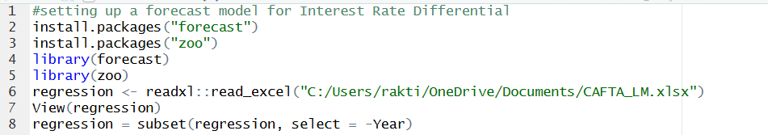
Forecasting Interest Rate Differential
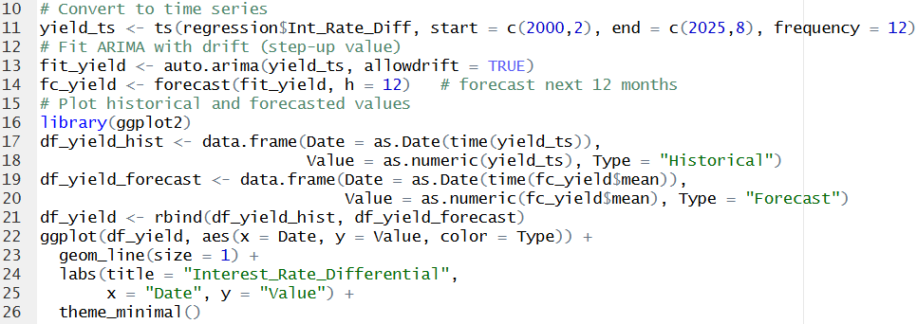
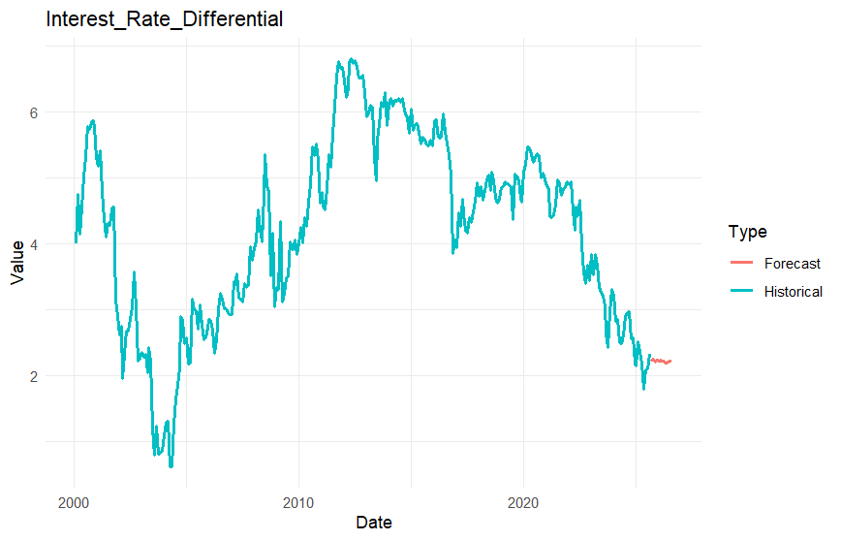

Forecasting Geopolitical Risk Index
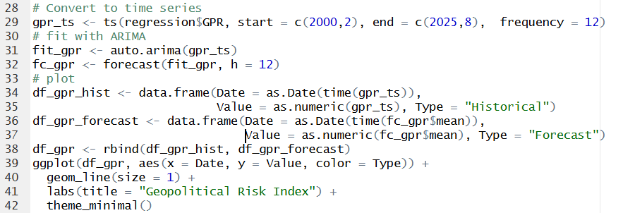
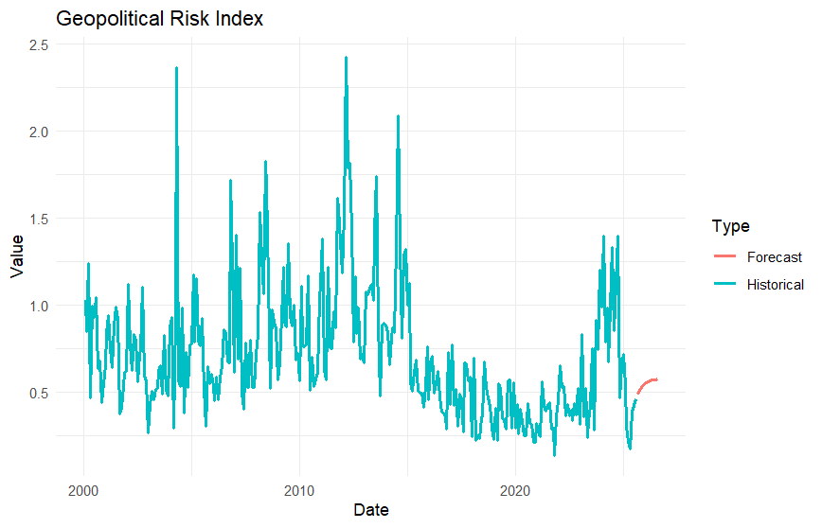
Forecasting Comprehensive Leading Indicator
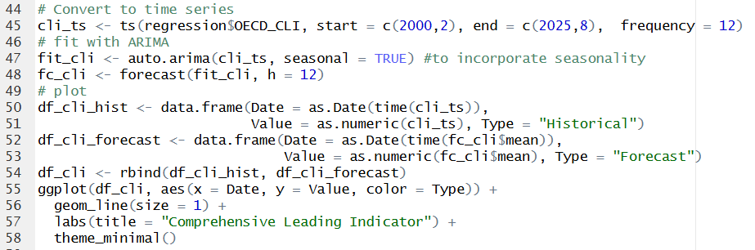
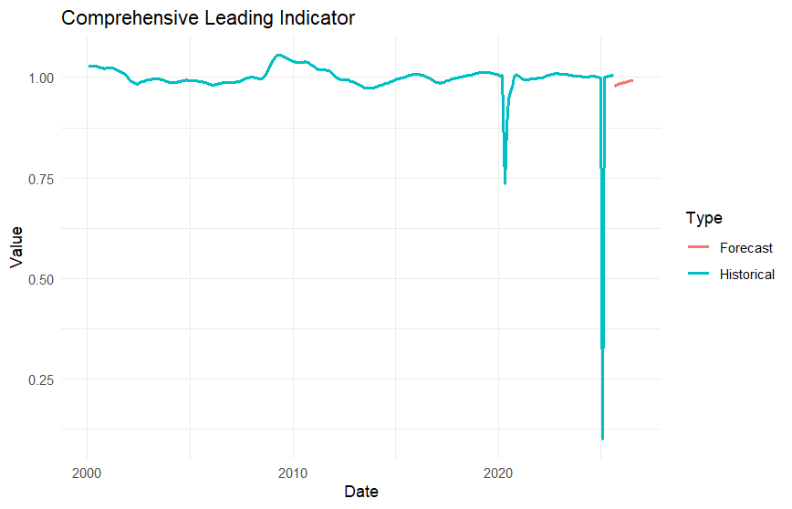
Forecasting Crude Oil Prices
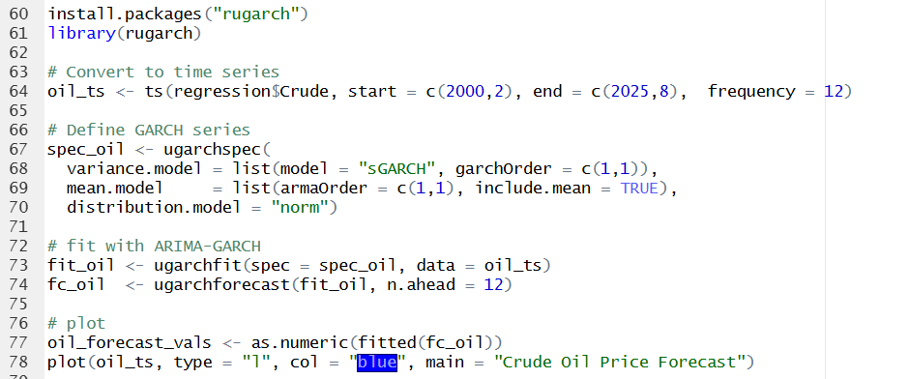
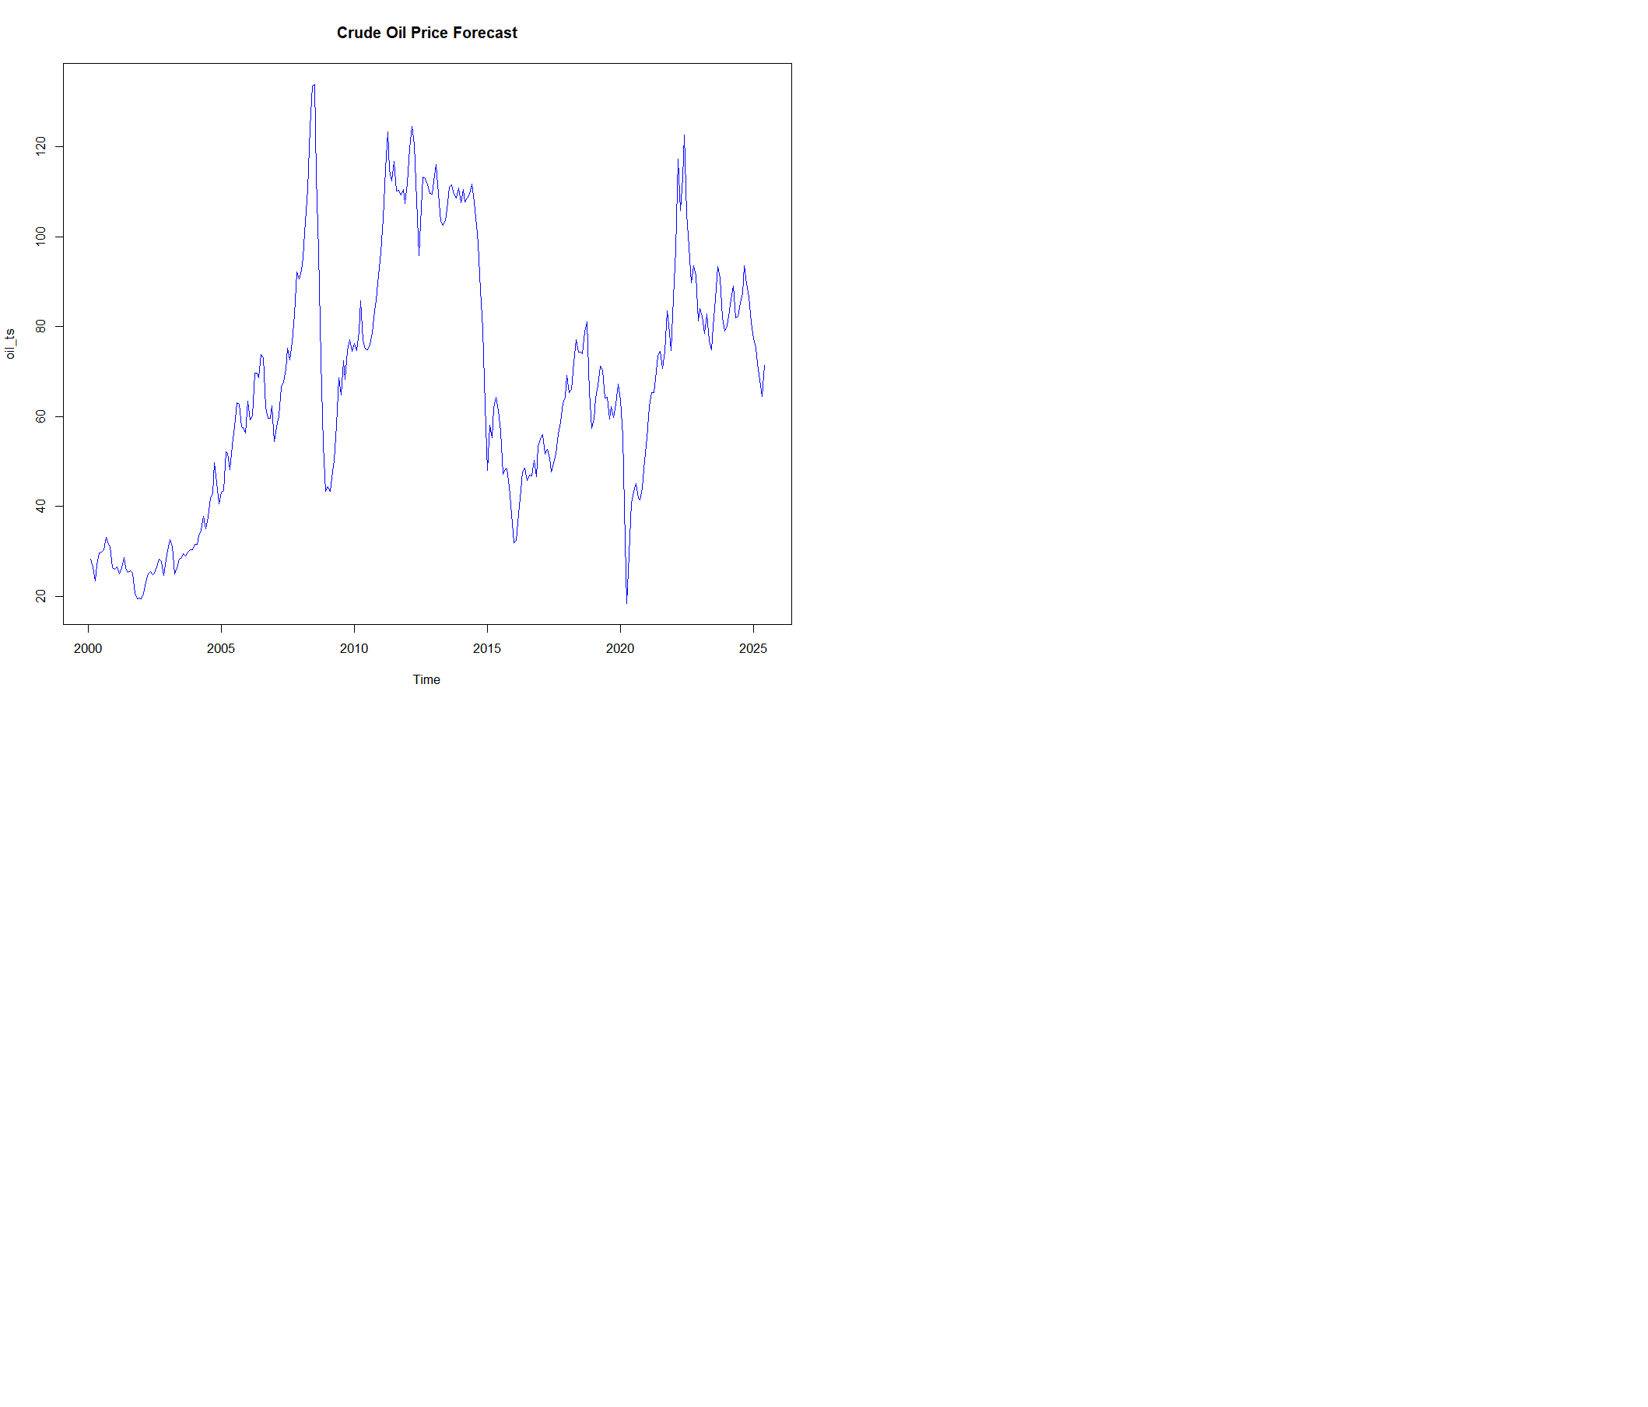
Combining each forecast into a single dataframe
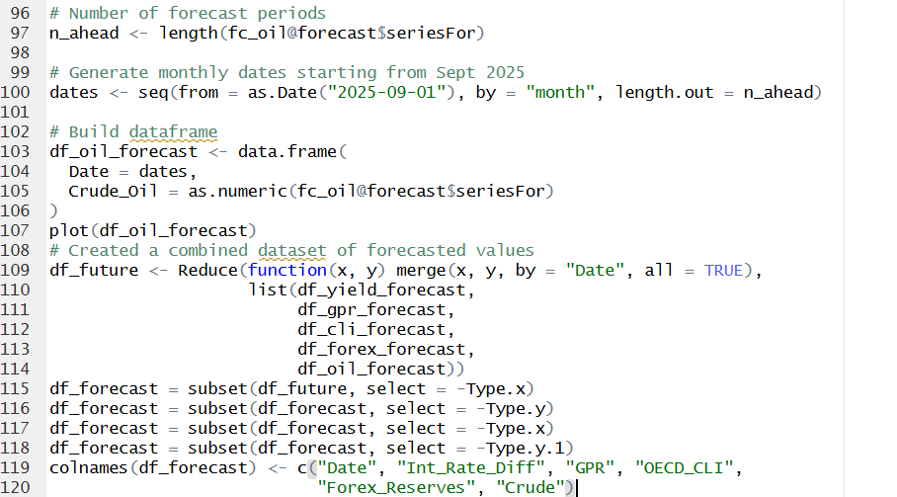

Date | Int Rate Diff | GPR | OECD_CLI | Forex Reserves | Crude
2025-11-01 | 2.210069 | 0.5271839 | 0.9824074 | 706.3661 | 69.79152
2025-12-01 | 2.240960 | 0.5394813 | 0.9840981 | 710.0105 | 69.52537
2026-01-01 | 2.214409 | 0.5488499 | 0.9855994 | 713.1470 | 69.26096
2026-02-01 | 2.235535 | 0.5559870 | 0.9869326 | 715.9524 | 68.99827
2026-03-01 | 2.216685 | 0.5614243 | 0.9881165 | 718.5419 | 68.73729
2026-04-01 | 2.212834 | 0.5655666 | 0.9891678 | 720.9907 | 68.47802
2026-05-01 | 2.191352 | 0.5687223 | 0.9901014 | 723.3479 | 68.22043
2026-06-01 | 2.210436 | 0.5711264 | 0.9909305 | 725.6452 | 67.96452
2026-07-01 | 2.212960 | 0.5729579 | 0.9916667 | 727.9036 | 67.71029
2026-08-01 | 2.225014 | 0.5743532 | 0.9923205 | 730.1365 | 67.45771
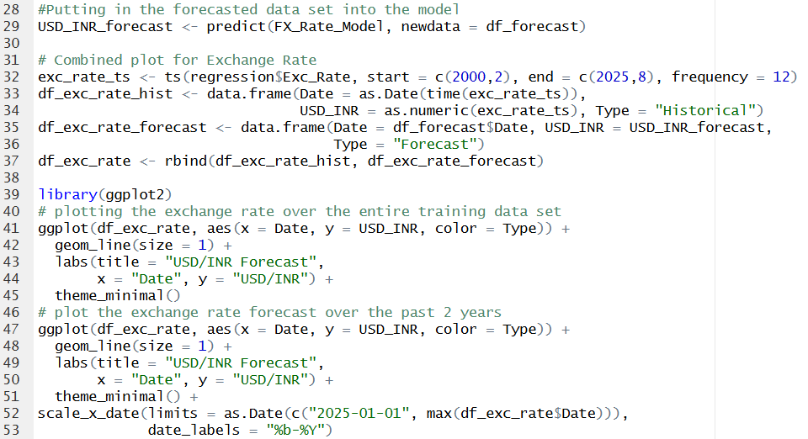

Date | Exc Rate
2025-11-01 | 90.16579
2025-12-01 | 90.50109
2026-01-01 | 90.75149
2026-02-01 | 91.01538
2026-03-01 | 91.23174
2026-04-01 | 91.45050
2026-05-01 | 91.64930
2026-06-01 | 91.87719
2026-07-01 | 92.08991
2026-08-01 | 92.30932

