Title
Did the Paris Agreement Reprice Corporate Environmental Responsibility in Credit Markets? A Meta-Analysis of the Cost of Debt

Running title
Paris Agreement and the Cost of Debt

Abstract
Whether the Paris Agreement repriced corporate environmental responsibility (CER) in credit markets is a central expectation of sustainable finance that no synthesis has tested. We meta-analyze the CER–cost of debt relationship, pooling 2,713 effect sizes from 115 studies forming 113 independent author clusters, with three-level cluster-robust models and pre-specified equivalence tests. The pooled association is statistically detectable but economically negligible — r = −0.059 (95% CI [−0.086; −0.031]), 0.84 times the conventional small-effect benchmark for partial correlations — and explicitly not a null effect. Centrally, the post-minus-pre Paris contrast is statistically equivalent to zero within the pre-specified smallest-effect-size-of-interest band: no detectable Paris-Agreement moderation. No coded measurement, instrument, industry, regulatory, or country context detectably shifts the association, and publication-selection corrections mark the pooled magnitude as an upper bound. We convert a scattered literature into a calibrated quantity and give the Paris-repricing thesis its first meta-analytic test in credit-market pricing.

Keywords
corporate environmental responsibility; cost of debt; Paris Agreement; meta-analysis; equivalence testing; publication bias

1 Introduction
Whether corporate environmental responsibility pays is, for creditors, a question about downside risk. Corporate environmental responsibility (CER) — a firm’s environmental performance and its disclosure — is meant to manage precisely the exposures that determine whether debt is repaid: regulatory penalties, transition costs, stranded assets, litigation. Because lenders’ and bondholders’ payoffs are capped at repayment yet fully exposed to these downside states, credit markets are the natural place to look for the pricing of environmental risk; and because the terms of credit — loan spreads, bond yields, ratings, and the cost of default protection — feed directly into firms’ financing costs, whether creditors price CER matters for corporate investment and for climate policy alike.
The Paris Agreement turned this question into an expectation. Article 2.1(c) commits its parties to making finance flows consistent with low-emission, climate-resilient development (UNFCCC, 2015), and the institutional architecture that followed — the disclosure recommendations of the TCFD (2017) and the central-bank consensus that climate risk is financial risk (NGFS, 2019) — was built on the premise that capital providers would begin to price environmental exposure. Market practice moved in step: rating agencies began publishing entity-level assessments of how ESG factors bear on credit (Fitch Ratings, 2019), and the loan market codified margin adjustments tied to borrowers’ sustainability performance (LMA, APLMA & LSTA, 2019). Institutional investors, for their part, report treating climate risks — regulatory risks above all — as financially material (Krueger et al., 2020). Across public debt (bonds, credit default swaps, ratings) and private debt (bank loans), the expectation since 2015 has been the same: environmental performance should be reflected in the price of credit. Whether the Paris Agreement actually repriced corporate environmental responsibility in credit markets is the question this study answers.
The primary evidence, however, is far less settled than the expectation. A substantial empirical literature links CER to the cost of debt (COD), but its findings diverge: several studies report significant negative associations (e.g., Drago et al., 2018; Fonseka et al., 2019), while others find weak, null, or even positive ones (e.g., Azmi et al., 2021; Ofogbe et al., 2021), across widely varying measures, instruments, regions, and periods. The Paris-specific evidence is equally two-sided. Studies with an explicit post-2015 design report repricing in private debt, that is, in bank lending and firms’ borrowing costs (Delis et al., 2024; Degryse et al., 2023; Owolabi et al., 2024), and in public debt, from corporate bonds and credit ratings to credit default swaps (Seltzer et al., 2022; Okimoto & Takaoka, 2024). Yet other work finds no positive carbon premium in corporate bond returns (Duan et al., 2025), no pricing of carbon exposure in lending in the Middle East and North Africa (Ibrahim et al., 2026), and even supportive studies confine the effect to subsets of sectors or firms (Palea & Drogo, 2020). Whether credit markets have repriced environmental performance is, on the primary evidence alone, an open question.
As it stands, however, the literature leaves that question unanswered, for two reasons. First, almost no primary study tests the Paris break directly: in the body of evidence assembled for this study, 73 studies straddle the 2016 break, of which 72 pool across it without reporting period-specific estimates; only one primary study reports both pre- and post-Paris effect sizes within its own design (Li et al., 2022: 12 pre / 5 post effect sizes; within-study difference +0.036 in z, descriptive display only). Second, no synthesis of this evidence exists: a recent systematic review of the environmental-performance–COD literature concludes that a comprehensive synthesis of the field is lacking, and itself provides no quantitative integration (Bauer et al., 2025), while our companion meta-analysis of CER and the cost of equity (Witte et al., 2026) establishes the equity side of the capital structure — leaving the debt side, where creditor payoffs make downside environmental risk most directly material, without a meta-analytic estimate. No prior meta-analysis isolates CER against the cost of debt, and no synthesis in debt pricing tests the Paris Agreement.
This study provides that synthesis. We assemble the CER–COD literature into a single meta-analytic dataset and subject both the level of the association and its post-Paris shift to a pre-specified testing framework built to be informative in either direction — able to detect a shift if one occurred, and to bound it tightly if none did.
Four research questions structure the analysis.
RQ1. Is CER negatively associated with firms’ cost of debt? — Establishing whether the association exists, and how large it is, fixes the central quantity of this literature and the baseline against which any Paris effect must be read.
RQ2. Has the Paris Agreement moderated the CER–COD relationship? — This is the study’s central question: the repricing expectation documented above is, at its core, a claim about a post-2015 shift.
RQ3. How does the CER–COD association vary across measurement, instrument, industry, regulatory, and country contexts — and does the Paris-period contrast itself vary across these dimensions? — The heterogeneity of the primary evidence makes context the natural suspect, for the level of the association and for its temporal shift alike.
RQ4. Is the pooled CER–COD association robust to publication selection? — Every conclusion a synthesis can draw inherits the selection process of the literature it aggregates; testing that process is therefore part of answering the first three questions, not an afterthought.
To answer these questions, we conduct a first-order meta-analysis of the CER–COD literature. The corpus comprises 120 empirical studies published between 2010 and 2026, identified through a systematic search and hand-coded at the effect-size level; the estimation set comprises 2,713 effect sizes from 115 studies forming 113 independent author clusters, whose primary samples span 1988–2024 and cover firms worldwide across all four debt-market channels — bank loans, bonds, credit default swaps, and credit ratings. Estimation proceeds in four steps. The baseline model is a correlated-and-hierarchical-effects specification with cluster-robust variance estimation (CHE–RVE), which respects the dependence of multiple effect sizes per study. The pooled association (RQ1) is then substantiated by an extensive robustness battery: alternative model specifications and weighting schemes, influence and outlier diagnostics, and equivalence and Bayesian re-assessment. The Paris contrast (RQ2) receives its own pre-specified testing framework, combining the moderation contrast with equivalence testing, Bayesian model averaging, an identification battery, and permutation and multiverse analyses. The contextual variation of the association (RQ3) is examined through pre-specified moderator analyses across measurement, instrument, industry, regulatory, and country contexts. A four-method publication-selection battery, finally, tests whether the evidence base itself is distorted by selective reporting (RQ4).
The meta-analytic design is exceptionally well suited to these questions — its strengths map onto them directly. A pooled estimate built on the full body of evidence provides a benchmark no single study can (Borenstein et al., 2009): each primary estimate is one draw from a literature whose results range widely, and only aggregation with an explicit dependence model yields a calibrated central quantity (RQ1). The Paris question is population-level by construction: primary studies are bound to particular samples, instruments, and windows — and, as shown above, almost all of them pool across the 2016 break — whereas a synthesis whose underlying samples span 1988–2024 can construct the pre/post contrast across the entire evidence base, and can exploit variation in design features, such as the CER measure or the COD instrument, that no single study varies within itself (RQ2, RQ3). Publication selection, finally, is a property of a literature rather than of any study in it, and is testable only at the level of a synthesis (RQ4).
The answers, in brief, are these. First (RQ1), CER is negatively associated with the cost of debt: the pooled partial correlation is r = −0.059 (95% CI [−0.086; −0.031]) — statistically detectable but economically negligible, at 0.84 times the conventional small-effect benchmark for partial correlations (Doucouliagos, 2011), and explicitly not a null effect. In economic terms, this corresponds to approximately −11.8 basis points of loan cost, −8.8 bp of bond yield, and −9.9 bp of CDS spread per one-standard-deviation improvement in CER, on corpus-benchmarked instrument scales (Section 4.1.1). The mean, however, is not the dominant feature of this evidence base: reported effects disperse widely around it, and most of that dispersion reflects genuine differences across studies rather than sampling noise — individual settings can and do depart substantially from the pooled value. Second (RQ2) — and this is the study’s central finding — the predicted post-Paris strengthening does not materialize in any of the pre-specified analyses: the post-minus-pre contrast is statistically equivalent to zero within the pre-specified smallest-effect-size-of-interest band of ±0.05 on the Fisher-z scale — no detectable Paris-Agreement moderation, within power limits the design itself quantifies. Third (RQ3), the pre-specified moderator analysis detects no systematic variation in the association — or in its Paris contrast — across measurement, instrument, industry, regulatory, or country contexts: the aggregate result is not an average over offsetting contextual effects that this design can resolve. Fourth (RQ4), publication selection does not overturn this reading but marks the pooled magnitude as an upper bound: where selection is detectable, it operates against nonsignificant results, and every corrected estimate remains within the small-effect benchmark.
The study makes three contributions. First, it provides the first meta-analytic calibration of the CER–cost-of-debt relationship — isolating the environmental construct, with instrument-level granularity, from the broad CSR and ESG composites of prior syntheses — and maps its (in)variance: the pre-specified moderator analysis documents no detectable systematic variation across measurement, instrument, industry, regulatory, and country contexts, converting a scattered literature into a calibrated quantity with explicit boundaries. Second, it offers the first meta-analytic test of the Paris-repricing thesis in credit-market pricing. Where primary studies can at most examine single settings — and where the one adjacent synthesis tests a Paris moderator for banking financial performance rather than debt pricing (Zarea et al., 2026) — this study confronts the repricing expectation with the full body of evidence, using a design capable of affirming negligibility rather than merely failing to reject: equivalence testing against a pre-specified band, Bayesian model averaging, an identification battery, and permutation and multiverse analyses. Third, it delivers the first systematic publication-selection assessment for this literature. This is not an auxiliary check: because every statement a synthesis makes inherits the selection process of the literature it aggregates, the selection battery is what licenses the first two contributions — establishing that the calibrated association is, if anything, an upper bound, and that the Paris conclusion does not rest on selectively reported evidence. For practice, the findings speak to managers weighing CER investments against financing-cost expectations, to lenders and bond investors calibrating how much environmental information their pricing actually reflects, and to policymakers assessing how far the finance-flow alignment of Article 2.1(c) can be carried by voluntary market repricing alone; Section 5 weighs candidate explanations for this pattern and develops these implications.
The remainder of the paper proceeds as follows. Section 2 develops the theoretical framework and the two hypotheses on the level of the CER–COD association and its post-Paris shift, together with the contextual expectations that structure RQ3. Section 3 describes the data and the meta-analytic methodology, including the pre-specified testing framework. Section 4 reports the results along the four research questions. Section 5 discusses the findings, their boundaries, and their implications, and concludes.

2 Theory & hypotheses

2.1 CER and the cost of debt: mechanisms and baseline hypothesis
The mechanisms that could link CER to the pricing of debt follow from the position creditors occupy in a firm’s capital structure. Debt claims are concave: lenders do not participate in upside outcomes beyond the promised payment, but they absorb losses when the borrower defaults. Creditors therefore price downside risk — the probability of default and the loss given default (Merton, 1974) — rather than growth prospects, and they invest in screening and monitoring to assess it (Diamond, 1991). This payoff asymmetry makes the cost of debt a distinct testing ground from the cost of equity: where equity investors price systematic risk and may hold preferences over firm characteristics, lenders ask two narrower questions — whether an activity changes the borrower’s downside risk, and what it reveals about the borrower that is otherwise costly to observe. The three channels that follow map onto these two questions.
The first channel operates through information. CER-related information is heterogeneous, often opaque, and costly to verify, creating information asymmetries between borrowers and capital providers; credible environmental practices and disclosures can therefore serve as signals from which creditors update their beliefs about a firm’s risk-management quality and future downside exposure (Kölbel et al., 2020; Palea & Drogo, 2020). Credibly disclosed environmental engagement conveys information about compliance culture and strategic orientation (Ge & Liu, 2015), and in market segments with limited observability of firm-level environmental risk it helps lenders differentiate firms that actively manage such exposures from those that do not. Consistent with this reading, carbon disclosure itself — beyond the underlying emission level — has been linked to lower debt costs (Kleimeier & Viehs, 2018). By reducing screening and monitoring costs, credible CER lowers the information premium embedded in debt prices.
The second channel operates through the risk itself: environmental risk management is, at its core, a form of downside-risk management (Sharfman & Fernando, 2008). CER reduces a firm’s exposure to environmental liabilities, regulatory sanctions, litigation, and operational disruption, lowering both the probability of default and the expected loss in default (Bauer & Hann, 2010; Chava, 2014; Jung et al., 2018). The transmission is distinctly creditor-shaped: environmental incidents can trigger lender liability and litigation exposure, and environmental risk erodes the value of the collateral and asset base on which recovery in default rests — channels that matter little for equity pricing but enter credit assessment directly. Firms that manage environmental exposures effectively also tend to exhibit more predictable cash flows and greater long-run resilience, two further inputs that credit evaluation rewards across all four debt-market channels.
The third channel is relational. Stakeholder and legitimacy theory views CER as part of a firm’s alignment with the expectations of communities, employees, regulators, and civil society (Freeman, 1984; Jones, 1995; Ioannou & Serafeim, 2012; Miska et al., 2018): conformity secures the social license to operate that creditors increasingly weigh in risk assessment, and accumulated moral capital can act as insurance-like protection that dampens the sanctions stakeholders impose after adverse events (Godfrey, 2005). For a claimholder whose losses concentrate in bad states, such downside insurance is directly valuable.
None of these channels operates without friction, and each has a counterpart that predicts a weaker — or opposite — association. First, the agency view treats discretionary environmental spending as over-investment: managers may consume private reputational benefits at shareholder and creditor expense, and the resulting cash-flow drag and wealth-transfer risk raise rather than lower credit risk (Friedman, 1970; Jensen & Meckling, 1976; Barnea & Rubin, 2010). Lending evidence is consistent with parts of this reading: banks appear to treat responsibility engagement as a second-order determinant of loan spreads and do not reward discretionary engagement by otherwise sound borrowers (Goss & Roberts, 2011), and bond investors have been found to price such engagement, if anything, at a small premium (Menz, 2010). Second, the information channel is only as strong as the signal is credible: symbolic or superficial engagement — greenwashing — corrupts the signal value of CER and can raise financing costs when detected (Attig et al., 2025). Third, the channels presuppose that lenders attend to environmental information at all; in practice, many banks have long managed sustainability risks separately from core credit assessment (Weber et al., 2010), muting transmission even where the risk logic holds. Nor need the relationship be linear: beyond some level, additional environmental investment may add costs faster than it removes risk.
These contrasting perspectives render the net association an empirical question. On balance, however, the risk-mitigation and information mechanisms bear directly on the two quantities lenders price — default probability and recovery — whereas the counterweights operate through frictions that attenuate rather than reverse them; the baseline expectation is therefore a negative association, of a magnitude the frictions leave open. How much of it survives, and where, should depend on the information environment, the debt instrument, and the institutional setting in which lending occurs — and, over time, on the policy regime that determines how much environmental risk becomes financially material. The first of these contingencies structures the contextual expectations of Section 2.3; the second motivates the hypothesis developed in Section 2.2. We pre-specify the baseline as:
H1. CER is negatively associated with firms’ cost of debt.

2.2 The Paris Agreement and the repricing question
Whether the channels of Section 2.1 operate with constant strength is itself a theoretical question: each of them runs through expectations about future environmental regulation, and such expectations are set by the policy regime. The Paris Agreement of December 2015 is the canonical candidate for a shift in that regime — and, accordingly, the natural candidate moderator of the CER–COD association. Yet theory does not speak with one voice about its pricing consequences. This section develops two opposing readings of the Agreement — as an amplifier of the mechanisms established above, and as an event those mechanisms had largely absorbed in advance or that reshaped the environment around them — and states the directional hypothesis the pre-specified design then adjudicates.
The institutional facts are common ground. Adopted in December 2015 and in force since November 2016, the Agreement is the first universal climate framework: all signatories commit to nationally determined contributions and to holding warming well below 2°C, and Article 2.1(c) extends the commitment to making finance flows consistent with low-emission development (UNFCCC, 2015). A dense disclosure and supervisory infrastructure followed: the Task Force on Climate-related Financial Disclosures (TCFD, 2017), the Network for Greening the Financial System (NGFS, 2019), and the integration of environmental considerations into credit-rating methodologies and sustainability-linked lending practice (Fitch Ratings, 2019). None of these facts is contested. What they imply for the pricing of corporate environmental conduct is.
One family of mechanisms predicts amplification, channel by channel. Through the risk channel, a credible long-run trajectory toward stricter emissions regulation raises the expected costs of non-compliance for environmental laggards — regulatory penalties, stranded assets, eroding collateral values — and thereby widens the default-risk differential between environmental leaders and laggards that creditors price (Seltzer et al., 2022); higher emissions have correspondingly been linked to greater cash-flow uncertainty and weaker credit ratings (Safiullah et al., 2021). Through the information channel, the post-Paris disclosure infrastructure raised the comparability and credibility of environmental information, increasing the signal value of credible CER precisely where Section 2.1 located it: firms with strong environmental profiles can more credibly demonstrate low transition exposure, compressing the information premium (Palea & Drogo, 2020), and credible carbon transparency has been found to improve credit assessments (Lee, 2022). Through the stakeholder channel, the Agreement heightened the expectations of regulators, investors, and civil society and — by shifting lender preferences and the composition of the creditor base — extends to debt the exclusion logic first modeled for equity: if part of the capital-provider base withdraws from environmental laggards, their financing costs rise irrespective of cash-flow news (Heinkel et al., 2001; Bolton & Kacperczyk, 2021) — a shift visible in credit supply itself: European banks reduced lending to U.S. polluting firms when the announced U.S. withdrawal raised the Agreement’s salience (Altavilla et al., 2024). Initial primary evidence is consistent with this family: the sensitivity of debt costs to carbon risk appears to have strengthened after the Agreement in several settings (Owolabi et al., 2024).
Each element of this account, however, has a counterpart that predicts attenuation — or no detectable shift at all. First, anticipation: the policy trajectory did not begin in December 2015. Carbon pricing, disclosure regimes, and the diplomatic path toward a universal agreement were observable years earlier, and credit markets demonstrably priced environmental conduct before Paris (Chava, 2014; Okimoto & Takaoka, 2024); to the extent the Agreement ratified expectations rather than created them, its incremental pricing content is small. Second, diffusion: nationally determined contributions bind governments procedurally rather than firms directly, and policy-induced shifts in asset pricing operate through time-lagged mechanisms — credit models, ratings, and covenants adjust gradually (Seltzer et al., 2022) — so any repricing may be too diffuse to register as a period contrast. Third, dilution: the post-Paris proliferation of green bonds, sustainability-linked instruments, and ESG disclosure lets issuers across the environmental spectrum claim sustainability credentials, crowding the signal and diluting price differentiation by actual environmental performance (Attig et al., 2025). Fourth, substitution: as explicit carbon prices and regulatory exposure metrics become available, creditors can price transition risk directly and rely less on CER as a proxy, reducing its marginal informational value exactly when its salience peaks (Ni et al., 2022). On this reading, the Agreement changed the environment around the CER signal more than the pricing of the signal itself.
Theory does not rank these two families, and the primary literature — largely written within single settings and single instruments — cannot: whether amplification or absorption dominates is a population-level question. Following the direction advanced by the amplification family, and by most of the primary evidence, we pre-specify:
H2. The negative association between CER and COD is stronger in the post-Paris period than in the pre-Paris period.
By design, H2 enters the analysis as an adjudicand rather than a foregone conclusion. Support would indicate that the Agreement shifted how credit markets price environmental conduct; a post-minus-pre contrast that remains within the pre-specified equivalence bounds would be no less informative, marking the limits of voluntary repricing over the horizon this evidence base covers. Which reading prevails is the empirical question the pre-specified testing framework of Section 3 is built to answer; Section 2.3 turns to the contextual conditions under which either reading may vary.

2.3 Moderating contexts: consolidated expectations
The two formal hypotheses concern the level of the CER–COD association and its post-Paris shift. The contextual dimensions along which the association may vary are pre-specified as structured expectations rather than as a hypothesis family — they discipline RQ3 without inflating the formal apparatus.
The cost of debt is not a uniform construct. Primary studies operationalize it through four instrument categories — bank loans, bonds, credit default swaps, and credit ratings — and these differ in exactly the features the channels of Section 2.1 run through. Relationship lenders are delegated monitors: repeated interaction and private information give banks both the incentive and the means to use soft, verification-intensive information such as the credibility of a firm’s environmental engagement when setting loan terms (Diamond, 1991; Du et al., 2017; Fonseka et al., 2019), and environmental disclosure has been shown to shape bank lending conditions directly (Hui et al., 2024). Arm’s-length bond and CDS pricing, by contrast, rests on standardized public information, tying the association more tightly to disclosure quality; credit ratings, finally, are produced by infomediaries whose methodologies incorporate environmental considerations deliberately and gradually. We therefore expect the association to be strongest in relationship (bank) lending, where the informational incentive and the private channels for CER-type information coincide.
How CER itself is measured carries an information-channel argument of its own. Performance-based operationalizations — emissions, resource use, environmental ratings — capture the underlying exposure creditors ultimately bear; disclosure-based operationalizations capture the signal firms choose to send, whose value hinges on credibility (Section 2.1). The two can diverge for the same firm (Kleimeier & Viehs, 2018). We expect the association to be more pronounced for performance-based measures, whose risk content creditors can verify, than for disclosure-based measures.
Regulatory context conditions the stakes. Where carbon taxes or emissions trading systems operate, compliance and non-compliance carry direct financial consequences, making environmental conduct more immediately material to credit risk: carbon-trading pilots have been found to raise the cost of debt (Ni et al., 2022), and stricter regulation amplifies the pricing of environmental performance (Wang et al., 2022). On balance we expect a stronger association under carbon-pricing regimes — while noting that the substitution logic of Section 2.2 cuts the other way: an explicit price signal can crowd out the informational role of CER, so this expectation is held with less confidence than the instrument expectation.
Country and institutional context shape both lender incentives and information environments: institutional pressure conditions how lending institutions use environmental information (Eliwa et al., 2021), and country-level sustainability can be priced even where firm-level conduct is not (Hoepner et al., 2016). We expect systematic regional variation without committing to a direction — noting that the regional composition of the evidence base also shifts over time, a compositional feature the identification analysis of Section 3 addresses.
The remaining pre-specified dimensions complete the inventory. Industry exposure is the sharpest of them: in environmentally sensitive sectors, poor environmental management generates large, quantifiable contingent liabilities that creditors can link directly to solvency, and we expect the association to be stronger there than in less exposed industries (Schneider, 2011; Safiullah et al., 2021). Economic development, cultural cluster, and legal origin are carried as screening dimensions without strong directional priors: each shapes disclosure regimes, enforcement, and lending practice, but theory offers no unambiguous ranking. Figure 1 summarizes the resulting framework — the baseline association (H1), the Paris contrast with its two competing mechanism families (H2), the contextual dimensions structuring RQ3, and the publication-selection assessment (RQ4) underpinning all three as a validity layer. These expectations structure RQ3; the pre-specified analysis examines both whether the association varies across these dimensions and whether the Paris-period contrast does.
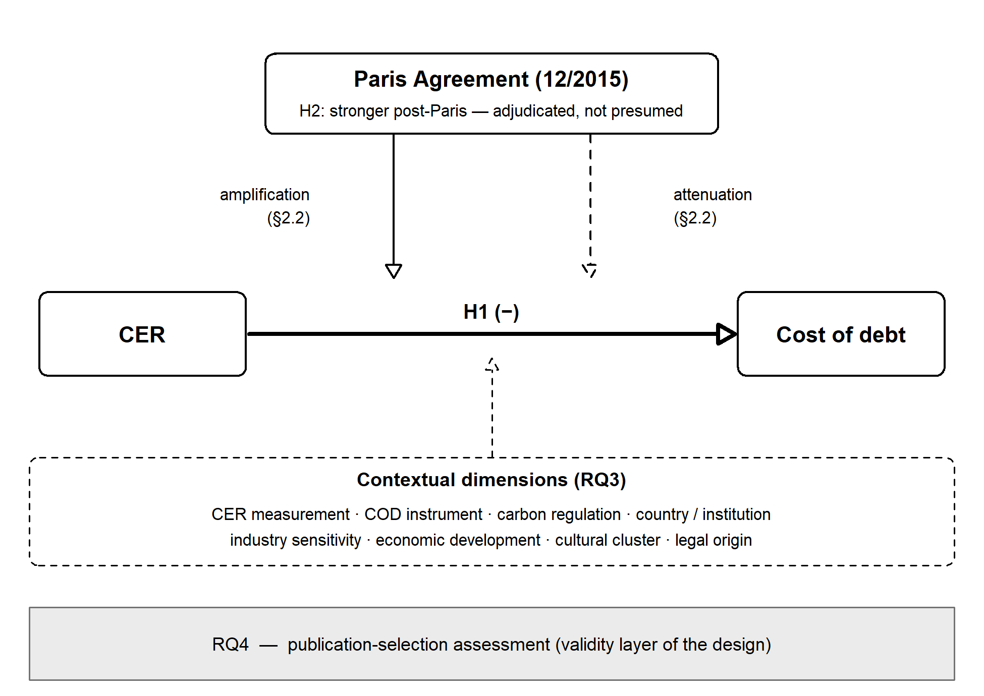
Figure 1. Conceptual framework: the baseline CER–COD association (H1), the Paris contrast with its two competing mechanism families (H2), the pre-specified contextual dimensions structuring RQ3, and the publication-selection assessment (RQ4) as the validity layer of the design.

3 Methods

3.1 Data Collection
The corpus was assembled in two search waves. The first wave (2021/22) followed a five-step protocol: (i) screening of prior reviews of the CER–cost-of-capital literature (Appendix Table A.5); (ii) keyword searches in academic databases (search strings not reported); (iii) title-and-abstract screening; (iv) forward and backward citation tracking; and (v) full-text assessment against pre-specified eligibility criteria. Screening was performed independently by two trained coders, with disagreements resolved by comparison and discussion. Stage-level record counts and execution dates of this wave were not retained at PRISMA-2020 granularity; we disclose this rather than reconstruct counts ex post. The second wave (June–July 2026) was AI-assisted: retrieval across Scopus, Web of Science, and EBSCO, followed by a documented rule-based screening layer (COD- and CER-term and document-type rules; rule outcomes are recorded per record in the deduplicated hit list), an AI-assisted supplementary search, and Google-Scholar snowballing, each reported as separate identification lines (Fig. 2). Because AI-mediated retrieval has no fixed query strings, reproducibility is provided at the record level: the complete deduplicated hit list (2,006 records) and the identified-not-extracted catalogue (593 records) ship with the replication package. An ex-post benchmark shows 43 of the 60 studies in the search protocol’s retrievability benchmark retrievable in the three executed databases (Scopus 38, WoS 40, EBSCO 24); the remaining 17 entered the corpus via the protocol’s complementary channels (citation tracking, review mining, additional sources). Metadata of the 2021/22 search round (per-database counts and execution dates) were not retained; per the pre-specified decision rule, the first wave is therefore reported qualitatively, with full quantitative documentation provided for the 2026 wave.
Studies were included based on four criteria: they had to (i) examine the CER–COD linkage quantitatively and report at least one estimate that is, or can be converted into, a correlation coefficient (Borenstein et al., 2009; Hunter & Schmidt, 2004; Lipsey & Wilson, 2001); (ii) measure CER through environmental constructs — studies reporting social or governance outcomes that could not be separated from the environmental dimension were excluded; (iii) measure COD via bank-based, market-based, derivative-based, or agency-based instruments; and (iv) provide sufficient design information for coding the moderators (Section 3.2).
Wave 1: screening and eligibility assessment were performed independently by two trained coders in parallel; disagreements were resolved by comparison and discussion. No formal inter-rater statistic was computed at the time; we report the process rather than reconstruct one. Wave 2: identification and record-level screening were AI-assisted and rule-based (term filters in the Appendix); author verification applied at defined checkpoints — the FLAG queue (101 records), all corpus-rematch decisions, and every download/eligibility action of the supplementary channel, each documented per record.
The selection process is documented in the PRISMA flow diagram (Figure 2; Page et al., 2021). [PENDING #23: PRISMA deviation note (Capelle-Blancard) and drop-one sensitivity note] The final corpus comprises 120 studies, published between 2010 and 2026, whose primary samples span 1988–2024 and cover firms worldwide.
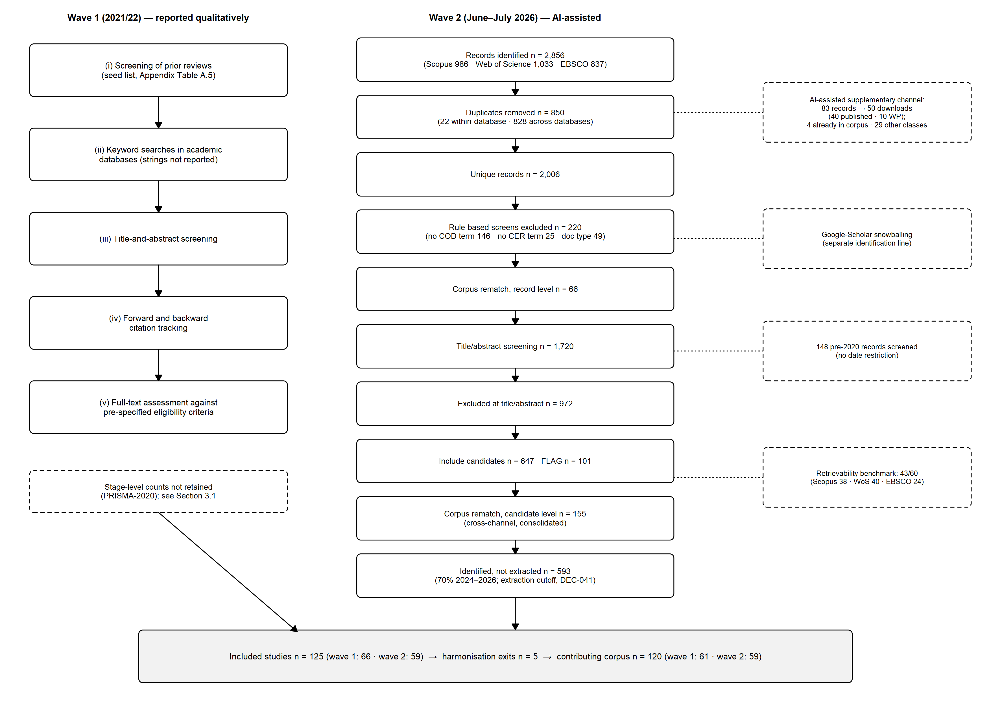

3.2 Data Preparation
Effect sizes and extraction. The effect size is the correlation coefficient between a CER measure and a COD measure; negative values indicate that stronger environmental responsibility is associated with lower borrowing costs. We include both bivariate and partial correlation coefficients: statistically, the two can be meaningfully combined because they exhibit the same sampling-error variance (Hunter & Schmidt, 2004); methodologically, pooling them widens the breadth, depth, and heterogeneity of the evidence base (Hang et al., 2019), and the practice is well established in prior meta-analytical reviews (Chaikumbung et al., 2016). Bivariate coefficients are taken directly from the primary studies; partial correlations are back-calculated from the reported regression statistics — slope coefficients, standard errors, t statistics, and p values. We collect every eligible estimate from each study, an approach considered advantageous (Cheung & Chan, 2004; Bijmolt & Pieters, 2001) and current standard practice (Feld et al., 2013; Fidrmuc & Lind, 2020); the resulting dependence is accounted for in the applied meta-analytical model (Section 3.3.1). The sampling-variance basis is the reported number of observations; where studies report firm counts and window length only, we approximate observations as firms × window years.
Coding protocol. All studies were coded with the assistance of a large language model: Anthropic’s Claude Fable 5, operated through the Claude Cowork agent environment, extracted the full coding set for every included paper — effect sizes, sample characteristics, sample periods, and all moderator variables (June–July 2026). The authors designed, supervised, and audited this process, including prompt design and systematic checks of the extraction code and its outputs, assisted by the same model in a chat interface. Every paper then passed a second, independent coding round: for one half of the corpus, both authors ran parallel model-assisted codings; for the other half, one author coded the paper fully manually and the results were compared against the model-assisted coding. All discrepancies between coding rounds were analyzed and resolved against the source documents. The authors take full responsibility for the accuracy of all extracted data.
Estimation set. The corpus (Section 3.1) comprises 120 studies. Three of them do not report statistics that allow recovering an effect size; the remaining studies yield 2,730 usable effect-size estimates. From these we remove 16 estimates from two studies lacking any sample-size information and one instance of an estimate reported in both papers of a same-sample study pair, which we treat as a single author cluster throughout. A second same-sample pair, identified during the data audit and confirmed by a descriptive-fingerprint screen, is likewise treated as a single author cluster; no duplicate estimate arises there. The estimation set comprises 2,713 effect sizes from 115 studies forming 113 independent author clusters. Robustness, moderation, publication-selection, and identification batteries (Sections 4.1.2–4.4) were estimated on the pre-erratum structure of 114 author clusters; the erratum merges a single cluster boundary, leaves the headline estimate and confidence interval unchanged at reporting precision, and its influence is bounded from above by the extended drop-set sensitivity in Section 4.1.2.
Paris Agreement exposure. Codings of Paris-Agreement exposure differ across the literature: event-window studies anchor on calendar cutoffs around the Agreement (e.g., Palea & Drogo, 2020; Seltzer et al., 2022), and meta-analytic work has used the sample midpoint (Zarea et al., 2026). We code exposure by the majority of each estimate’s sample window (post if the post-2015 share is at least one half, ties assigned to post). This majority rule ties the period label to the data behind each estimate: a coefficient summarizes its entire sample window, so it counts as post-Paris evidence only when post-Agreement years dominate that window.
Moderators and study descriptors. Beyond exposure, each estimate carries eight substantive moderators. Two capture how the construct pair is measured — the CER measure and the COD instrument. Two capture the economic environment of the sampled firms — the environmental sensitivity of their industry and the presence of carbon-price regulation in the sampled market. The remaining four characterize the country context along distinct dimensions: geographic region, economic development, cultural cluster, and legal origin. In addition, we code methodological descriptors such as the effect-size type and publication characteristics. Table 1 defines all variables, category inventories, and coding rules. [Table 1 about here]

3.3 Meta-Analytical Procedures
The remainder of this section describes the estimation and inference apparatus for the pooled association (see Section 3.3.1, addressing RQ1/H1) and the Paris contrast (see Section 3.3.1, addressing RQ2/H2), the moderator analyses (see Section 3.3.2, addressing RQ3), and the publication-bias analyses (see Section 3.3.3, addressing RQ4). All analyses were conducted in R (version 4.6.1) using, in particular, the metafor, clubSandwich, RoBMA (version 3.6.1), and puniform packages; exact package versions are pinned in an renv lockfile shared with the replication materials, and all stochastic procedures use fixed seeds recorded in the code.

3.3.1 Estimation and Inference
Pooled association. All analyses build on one analytical model, chosen to account for the dependence that arises from extracting multiple estimates per study and per author cluster; it yields the pooled-association estimate addressing RQ1/H1 and underlies every further test. We apply a correlated-and-hierarchical three-level random-effects model (Van den Noortgate et al., 2013, 2015): effect sizes are nested in author clusters, with random effects at the cluster, study, and estimate level, a constant assumed sampling correlation of ρ = 0.6 within clusters, and cluster-robust variance estimation with CR2 small-sample correction and Satterthwaite degrees of freedom at the cluster level (Hedges et al., 2010; Tipton & Pustejovsky, 2015; Pustejovsky & Tipton, 2022). Throughout, we refer to this specification as the CHE–RVE model. All estimation is carried out on the Fisher-z scale with sampling variance 1/(n − 3) following van Aert (2023); estimates are back-transformed to r for reporting. Alongside each estimate we report the 95% confidence interval, which quantifies the uncertainty of the mean effect, and the 95% prediction interval, which conveys the range of true effects to be expected across comparable settings (Borenstein et al., 2017).
For economic interpretation, the pooled correlation is translated into basis points of cost of debt per one-standard-deviation improvement in CER, Δ = tanh(z) × SD(COD), where z is the pooled Fisher-z estimate and SD(COD) is the instrument-level benchmark: the two-stage median (within study, then across studies) of printed sample descriptives per instrument class, with the number of contributing studies and the benchmark’s sensitivity ladder reported alongside (Section 4.1.1).
Robustness tests of the pooled association. We verify that the pooled estimate does not hinge on any single analytic choice or data point. A pre-specified battery of twenty-three specification variants re-estimates the headline model under alternative analytic choices: sample restrictions (excluding star-bound estimates or proxy-based sample sizes), estimators and aggregation schemes (one estimate per cluster with ρ-based or median aggregation, unrestricted weighted least squares [UWLS+3; Stanley et al., 2025], the Hunter–Schmidt bare-bones estimator [Hunter & Schmidt, 2004], and the weighted average of adequately powered estimates [WAAP; Stanley et al., 2017]), sampling-variance, dependence (ρ), and degrees-of-freedom conventions, effect-size-type, outlet-quality, and research-field subgroups, and outlier treatments. Following best-practice recommendations for outlier handling (Aguinis et al., 2013), outliers are identified by studentized deleted residuals (|t| > 3) and a median-absolute-deviation rule on the Fisher-z scale (Leys et al., 2013), each followed by a drop-and-refit sensitivity; we additionally winsorize and trim at the empirical 1st/99th percentiles — the primary estimate itself remains unwinsorized — and re-estimate the model deleting each of the 114 author clusters in turn, with cluster-level influence diagnostics. Each variant is reported against the headline estimate in the register (Section 4.1.2 and Appendix).
Testing the Paris contrast. We address RQ2/H2 in two steps. The headline test estimates the contrast directly: the Paris exposure indicator (headline coding, Section 3.2) enters the CHE–RVE model as a moderator, and the post-minus-pre difference is tested with cluster-robust inference. Because a single non-significant difference would be weak evidence on its own, we then stack complementary analyses so that a genuine Paris effect would have several independent chances to reveal itself: (i) equivalence testing, (ii) robust Bayesian model averaging, (iii) a power calibration of what the design could detect, (iv) identification checks, and (v) permutation and multiverse analyses. First, to separate evidence of a negligible effect from mere non-significance, we pre-specify smallest effect sizes of interest (SESOI) before estimation, |r| = 0.070 as the primary band for the pooled association — the small-effect benchmark for partial correlations in economics (Doucouliagos, 2011) — with ±0.05 as a stricter secondary band, and ±0.05 on the Fisher-z scale for the Paris contrast; equivalence is assessed with the two one-sided tests procedure (TOST; Lakens, 2017). An equivalence conclusion for the Paris contrast requires the E2 TOST pass in combination with the Bayes-factor ladder of the robust Bayesian moderation model (BF01 ≥ 3: full evidence-of-absence register; 1 < BF01 < 3: equivalence-based register only), a decision rule fixed before the Bayesian models were estimated. Second, null-hypothesis tests cannot distinguish absence of evidence from evidence of absence; Bayes factors quantify the latter directly. As a Bayesian complement, we estimate robust Bayesian model averaging (RoBMA; Bartoš et al., 2022), which averages across model specifications with and without an effect, with and without heterogeneity, and with and without publication selection. The level analysis uses one estimate per cluster (k = 114); the moderation analysis tests the Paris contrast with a pre-specified contrast prior of Normal(0, 0.025). Prior sets comprise the package defaults (primary) and a companion-informed prior Normal(−0.041, 0.021) derived from our cost-of-equity meta-analysis (Witte et al., 2026), plus doubled-width variants of both informed priors as pre-specified sensitivity. Third, a null result is informative only if the design could have detected a relevant effect in the first place; a simulation-based power calibration therefore establishes the minimum Paris contrast detectable by this design under the estimated variance components, with its grid-ceiling validation reported in the Appendix.
Fourth, the Paris contrast is an observational comparison: pre- and post-Agreement estimates may differ not only in period but also in literature composition, underlying trends, and the choice of cut year. We probe the identification of the Paris contrast with a pre-specified battery of design checks: a composition-adjusted contrast that re-weights the pre- and post-Paris cells to a common moderator mix, placebo cut years around the Agreement, a search for the strongest structural break across all candidate years, a within-study contrast restricted to studies whose windows span the Agreement, exclusion-based variants, pre-trend and trend-versus-break specifications, a dose–response analysis in the post-2015 exposure share, and sensitivity bounds quantifying how strong an unobserved trend or confounder would need to be to overturn the contrast (Oster, 2019; VanderWeele & Ding, 2017). Fifth, permutation inference and a multiverse analysis across all pre-specified exposure codings (shifted majority cuts, lagged and end-anchored variants, and a clean-window restriction; Steegen et al., 2016; Simonsohn et al., 2020) complete the battery, complemented by descriptive time-course displays — a cumulative meta-analysis in study chronology and rolling-window estimates; all are reported with the results.

3.3.2 Moderator Analyses
The moderator analyses answer RQ3 and are pre-specified heterogeneity analyses rather than hypothesis tests: we formulate no directional hypotheses for individual moderators, and their purpose is to map where in the literature the CER–COD association — and the Paris contrast itself — is stronger or weaker. All eight moderators, their category inventories, and the analysis design — a two-tier structure of level inventories and period-interaction tests — were fixed before any moderator estimate existed.
For each of the eight substantive moderators we fit a cell-means main-effects model and a level-by-period cell-means model on the classified period domain, using the CHE–RVE specification (Section 3.3.1). Observations unclassifiable on the respective dimension (not elsewhere classified, NEC; Table 1) are excluded from all moderator analyses and disclosed per panel; period cells with fewer than three clusters, and any contrast with Satterthwaite degrees of freedom below five, are reported descriptively without p-values. The moderation test per panel is a small-sample-corrected Wald test on the difference-in-differences block (HTZ; Tipton & Pustejovsky, 2015); the eight p-values are reported unadjusted together with a single Holm line (Holm, 1979). In addition, two pre-specified unified models enter the moderators jointly — a lean and a full variant, composed ex ante along a-priori collinearity families. Structurally empty cells and coefficients without support on a complete-case domain appear as not-estimable rows with the triggering condition documented, so that no pre-specified quantity is silently omitted.

3.3.3 Publication-Bias Analyses
The publication-bias analyses address RQ4. If statistically significant negative estimates are more likely to be reported and published — a pervasive pattern in empirical economics (Ioannidis et al., 2017) — the pooled association would be overstated and the Paris contrast potentially distorted. We therefore probe publication and small-study bias with a pre-specified battery of complementary methods: funnel-asymmetry regression with precision-effect corrections, formal selection models, a direct grey-literature comparison, and a p-curve analysis.
First, on the full estimation set (2,713 effect sizes; 115 studies; 114 clusters) we estimate FAT-PET-PEESE on the CHE–RVE model (Section 3.3.1; CR2 with Satterthwaite degrees of freedom), with the standard error (PET) and its square (PEESE) as precision regressors (Stanley, 2008); following Stanley and Doucouliagos (2013), PEESE supplies the corrected estimate when the PET intercept is significant (two-sided α = .05), with both estimates reported throughout. These models are additionally re-estimated within the pre- and post-Paris subsamples to examine whether selection pressure differs between the two literatures. Intuitively, the funnel-asymmetry test (FAT; Egger et al., 1997) asks whether smaller, noisier studies report systematically stronger effects — the classic footprint of selective reporting — while PET-PEESE extrapolates to a hypothetical maximally precise study to obtain a selection-corrected estimate. Because the Fisher-z sampling variance depends on sample size alone, the FAT regressor is not mechanically correlated with the effect size, avoiding the artifact known for standardized mean differences (Pustejovsky & Rodgers, 2019).
Second, selection models — a three-parameter selection model (one cutpoint at one-sided p = .025, selection favoring significant negative effects; Vevea & Hedges, 1995) and p-uniform* (van Aert & van Assen, 2026) — are fitted to one-effect-per-cluster aggregates (compound-symmetry aggregation, ρ = .6; k = 114), likewise for the full set and separately for the pre- and post-Paris subsamples. Rather than inferring selection from funnel asymmetry, these models specify the publication process itself — the probability that an estimate is published as a function of its significance — and recover the mean effect corrected for that process.
Third, a direct grey-literature check compares published and unpublished studies in the CHE–RVE framework. This comparison makes selection directly observable, because a publication filter should drive published and unpublished results apart.
Fourth, a conditional p-curve analysis of the significant post-Paris estimates, pre-specified to run only if at least five significant studies are available, examines their evidential value (Simonsohn et al., 2014): if those findings reflect a true effect rather than selective reporting, their p-values should cluster at very small values. Robust Bayesian model averaging (RoBMA) complements these estimators in the Bayesian analyses (Section 3.3.1).

Data Availability
All specification choices were fixed in a time-stamped analysis plan before the respective estimates existed; the plan and decision log are part of the replication materials. The dataset of coded effect sizes, all analysis and verification scripts underlying the reported analyses, the run outputs, and the versioned computational environment (renv lockfile) are available in the study’s public repository; an archived, DOI-referenced release accompanies publication.
Table 1. Variables, category inventories, and coding rules.
Variable | Categories | Coding rule | Source
A — Paris Agreement exposure
Paris exposure (headline) | pre · post | Majority of the estimate’s sample window: post if post-2015 share ≥ 0.5, ties → post | own coding (Sec. 3.2)
B — Substantive moderators
CER measure | performance-based · disclosure-based | Classification of the primary study’s CER measure | own coding
COD instrument | loan (interest rate) · bond (yield) · credit rating · derivative (CDS spread) | Classification of the primary study’s COD instrument | own coding
Industry sensitivity | sensitive · non-sensitive · NEC | Sensitive if > 50% of firm-years in listed sectors; borderline/mixed → NEC (note a) | [PENDING RQ-7a: coding-scheme source — codebook, author/Volker]
Carbon-price regulation | with ETS/carbon tax · without · NEC | Regulation status of the sample country at the sample end year; rule-fills note b | [PENDING RQ-7b: coding-scheme source — codebook, author/Volker]
Country: region | US · Europe · Asia-Pacific · NEC | Sample-country region; multi-country rule note c | own coding
Country: economic development | developed · developing · NEC | As above (note c) | [PENDING RQ-7c: coding-scheme source — codebook, author/Volker]
Country: cultural cluster | western · non-western · NEC | As above (note c) | [PENDING RQ-7d: coding-scheme source — codebook, author/Volker]
Country: legal origin | common law · civil law · NEC | As above (note c) | [PENDING RQ-7e: coding-scheme source — codebook, author/Volker]
C — Methodological descriptors
Effect-size type | partial · bivariate | Type of correlation coefficient (Sec. 3.2) | —
Conversion route | computed from regression statistics · directly reported · star-bound | Extraction route of the estimate (note d) | —
Publication status | published · not published | Outlet status at coding date | —
Outlet quality | high · low · NEC | VHB-JOURQUAL rating [PENDING RQ-7f: VHB-JOURQUAL version — codebook, author/Volker] | VHB-JOURQUAL
Research field | finance/accounting/economics · sustainability · management | Outlet field | —
Notes. (a) Environmentally sensitive sectors: Oil & Gas, Energy, Utilities, Basic Materials/Chemicals, Mining/Metals, Paper/Forestry, Cement/Construction Materials; classification requires more than 50% of sampled firm-years in these sectors; borderline or mixed samples are coded NEC. (b) Regulation coding fills follow documented rules (mixed jurisdictions and worldwide samples → NEC); the recode log is part of the replication materials. (c) Multi-country samples are classified on a dimension only if all sampled countries share the category; otherwise NEC [PENDING RQ-7g: verify shared-category rule — codebook, author/Volker]. (d) NEC (not elsewhere classified) collects estimates that cannot be classified on the respective dimension; the technical dataset label is 99_NCE, and internal provenance labels remain in the replication materials.

Footnotes

4 Results
This chapter reports the results along the four research questions. Section 4.1 presents the pooled CER–COD association, its heterogeneity, and the pre-specified robustness register (RQ1/H1). Section 4.2 addresses the Paris contrast (RQ2/H2), combining the headline moderation test with equivalence, Bayesian, identification, and multiverse evidence. Section 4.3 reports the moderator analyses (RQ3), and Section 4.4 the publication-bias analyses (RQ4), closing with the triangulation of bias-corrected estimates.

4.1 The Pooled CER–COD Association (RQ1)

4.1.1 Headline Estimate and Heterogeneity
Across 2,713 effect sizes from 115 studies, the pooled partial correlation between corporate environmental responsibility and the cost of debt is r = −0.059 (95% CI [−0.086; −0.031], df = 110.7, p < 0.001). At |r| = 0.059, the pooled association falls below the ‘small’ partial-correlation benchmark of 0.07 (Doucouliagos, 2011), at 0.84 times that threshold. In economic terms, the pooled association translates into a first-order scale anchor of approximately −11.8 basis points of loan cost, −8.8 bp of bond yield, and −9.9 bp of CDS spread per one-standard-deviation improvement in CER — obtained by converting the pooled Fisher-z estimate back to the correlation scale and multiplying by the instrument-level SD(COD), benchmarked from the corpus itself as the two-stage median of printed sample descriptives: 200.0 bp for loans (k = 49 contributing studies), 150.0 bp for bonds (k = 21), and 168.6 bp for CDS (k = 7), at a coverage of 80 of 109 eligible study–instrument cells. The loan benchmark pools two operationalizations — 39 studies measure the cost of debt as an accounting ratio (median SD 310.0 bp) and 10 as a loan spread (111.7 bp) — so the spread-only benchmark implies a proportionally smaller translation of approximately −6.6 bp per SD; we report the pooled figure as primary and state the composition. The benchmark’s sensitivity ladder — high-confidence rows only (157.0 / 153.7 / 159.7 bp, k = 37/12/6) and a lognormal lower-bound back-transformation for log-scale sources (loan 186.5 bp, k = 7; CDS 163.0 bp, k = 3) — keeps every cut within roughly 110–200 bp of the primary anchors. These are scale conversions of the point estimate, not estimates with sampling error of their own.
Heterogeneity, not the mean, is the dominant feature of the evidence base: the 95% prediction interval spans [−0.392; 0.288], so a single new study can plausibly report either sign. The dispersion is visible in the cluster-level caterpillar plot (Figure 3); the full study-level forest plot is provided in the Appendix (Figure A1). Of total variance, 62.6% lies between author clusters and 37.2% within studies; sampling error accounts for less than 1%. The study-within-cluster component is empirically indistinguishable from zero, as only two clusters contain more than one study. Because studies and author clusters coincide in all but two cases — the 115 studies form 113 clusters, and each of two clusters comprises two studies — the study level carries almost no independent information, and heterogeneity is effectively partitioned between author clusters and effect sizes within them.
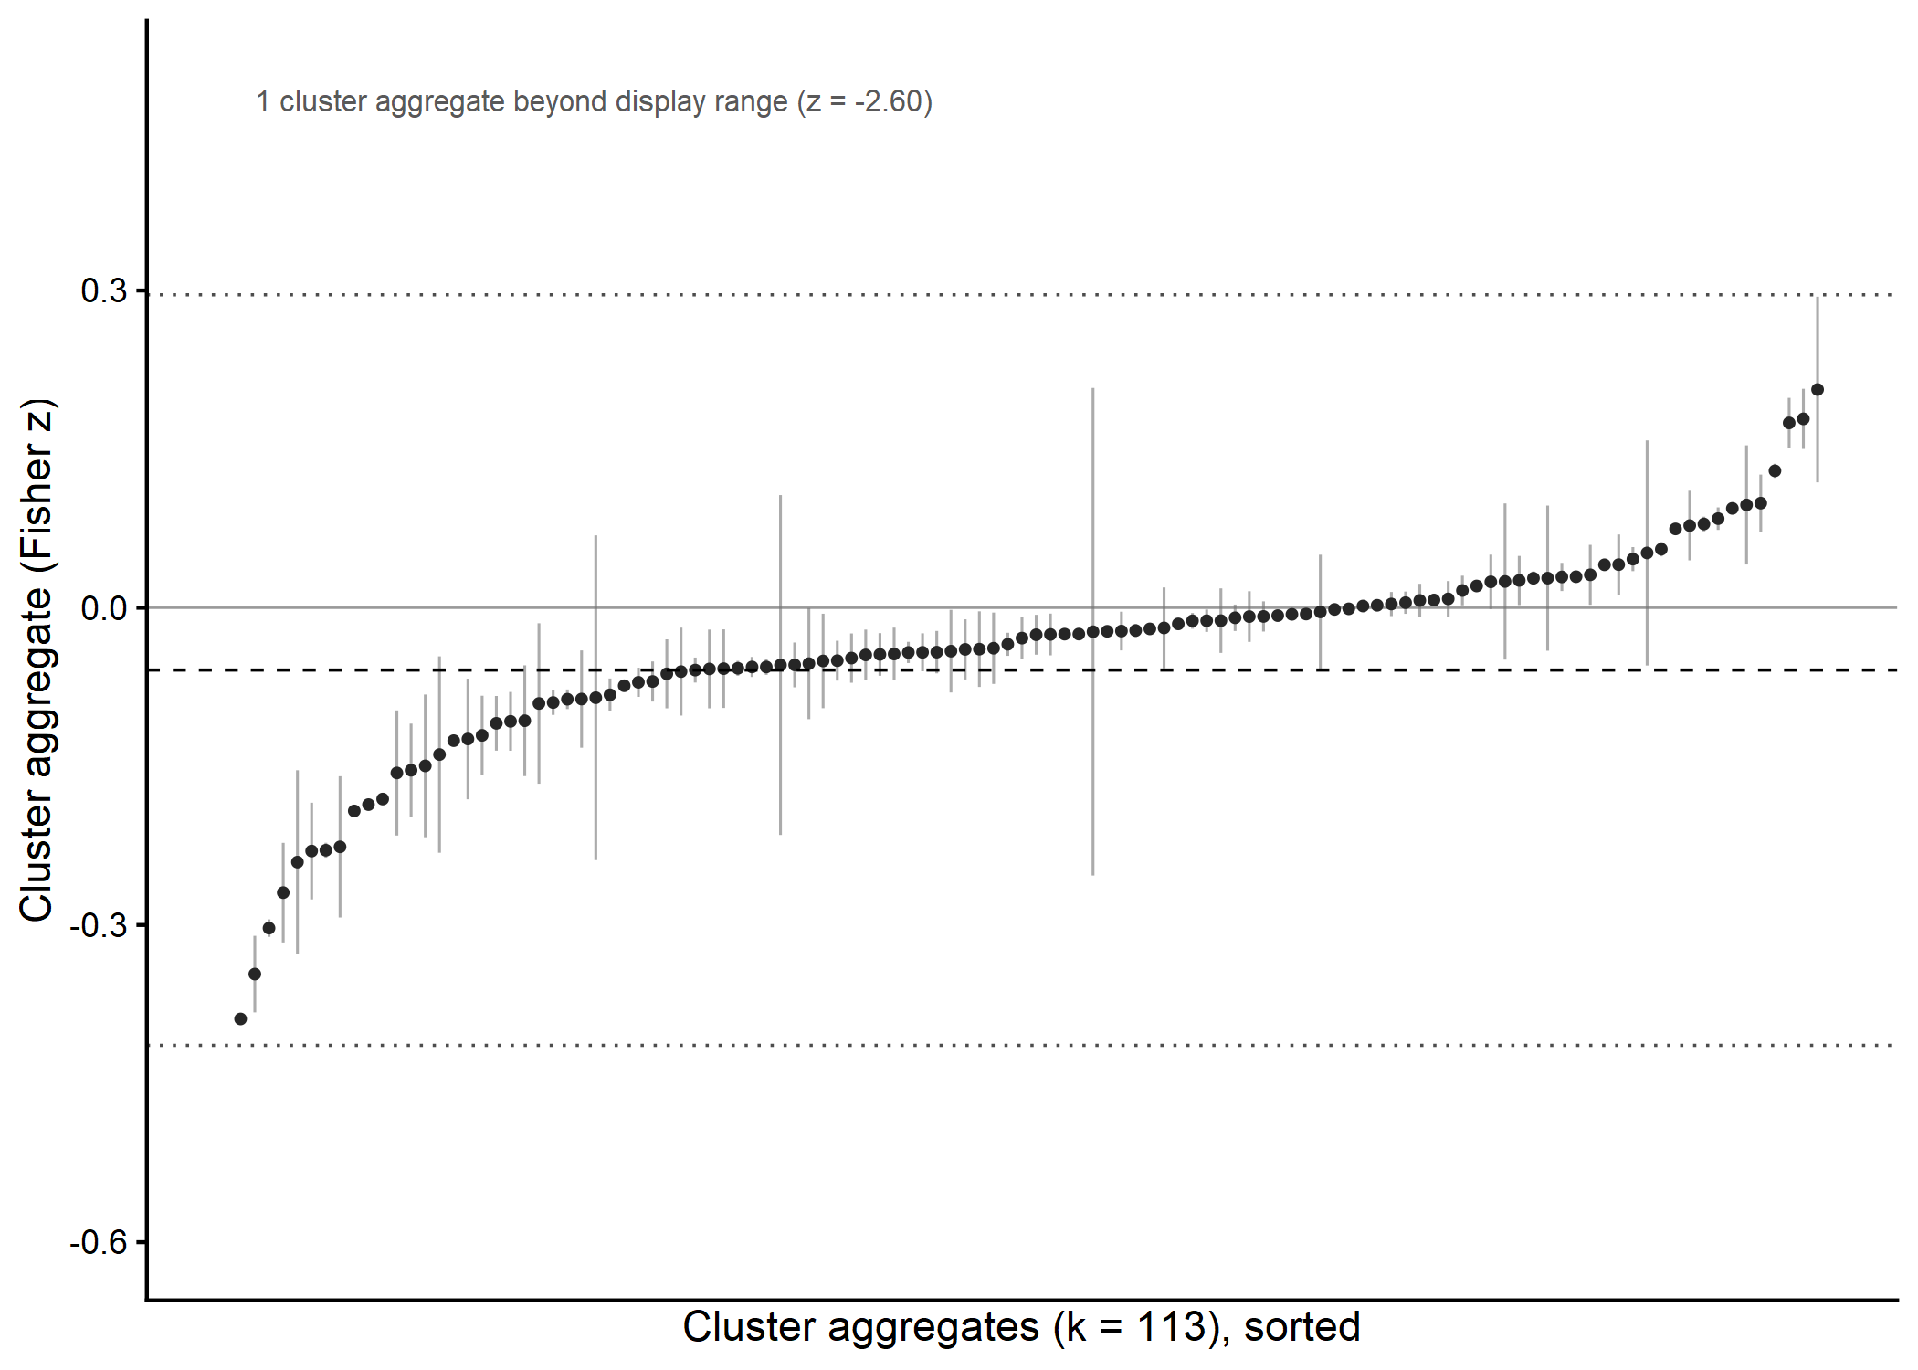 Figure 3. Cluster-level caterpillar plot of the 113 author-cluster estimates (Fisher z) with 95% confidence intervals, ordered by magnitude. The dashed line marks the pooled CHE–RVE estimate. The dotted lines mark the bounds of the 95% prediction interval.

4.1.2 Robustness of the Pooled Association
The pre-specified robustness register comprises twenty-three specifications of the headline model — five anchor specifications, eleven design variants, and seven outlier and influence rows, reported in this order below and followed by the v12.1 anchor and the result-blind extended drop-set (Table 2; the full register is provided as a machine-readable file in the online appendix). Every populated specification retains the negative sign and stays inside the pre-specified primary SESOI band of |r| = 0.070 (Section 3.3.1), at |r| = .031 to .062 against the headline .059.
Table 2. Robustness register for the pooled CER–COD association (23 pre-specified specifications plus the v12.1 anchor and one result-blind extended drop-set; Δ on the Fisher-z scale against the headline; full register machine-readable in the online appendix).
Specification | k (ES) | r | 95% CI | Δz vs. headline
Anchor specifications
Headline model (CHE–RVE) | 2,713 | −0.059 | [−0.086; −0.031] | (reference)
One effect per cluster (Knapp–Hartung) | 114 | −0.062 | [−0.109; −0.013] | −0.003
UWLS+3 | 2,713 | −0.031 | [−0.087; 0.025] | +0.028
Working correlation ρ = 0.4 | 2,713 | −0.059 | [−0.087; −0.032] | −0.001
Working correlation ρ = 0.8 | 2,713 | −0.058 | [−0.085; −0.031] | +0.001
Design variants
Excluding star-bound effect sizes | 2,614 | −0.058 | [−0.087; −0.029] | +0.001
Excluding proxy-filled sample sizes | 2,417 | −0.038 | [−0.048; −0.029] | +0.020
Sampling variance on firm counts | 2,713 | −0.051 | [−0.071; −0.032] | +0.007
Directly reported correlations only | 104 | −0.038 | [−0.086; 0.011] | +0.021
Partial-correlation df, k = 10 | 2,713 | −0.058 | [−0.086; −0.031] | 0.000
Partial-correlation df, k = 20 | 2,712 | −0.058 | [−0.085; −0.030] | +0.001
Cluster-median aggregation | 114 | −0.062 | [−0.094; −0.030] | −0.003
Panel: journal quality | — | — | reported in text | —
Panel: research field | — | — | reported in text | —
Panel: effect-size type | — | — | reported in text | —
Panel: conversion route | — | — | reported in text | —
Outlier and influence
Excluding studentized-residual outliers (13 ES) | 2,700 | −0.038 | [−0.046; −0.029] | +0.021
Excluding MAD outliers (275 ES) | 2,438 | −0.032 | [−0.038; −0.026] | +0.027
Winsorized (P1/P99) | 2,713 | −0.041 | [−0.050; −0.031] | +0.018
Trimmed (P1/P99) | 2,657 | −0.041 | [−0.050; −0.032] | +0.018
Leave-one-out (114 cluster refits) | — | — | summary in text; Appendix | —
Influence diagnostics | — | — | Appendix | —
Post-Paris leave-one-study-out | — | — | Section 4.2.1 | —
v12.1 anchor and extended drop-set (Section 3.2 erratum; Section 4.1.2)
Headline model, v12.1 anchor (cluster-merge erratum) | 2,713 | −0.059 | [−0.086; −0.031] | 0.000
Extended combined drop-set (erratum constellation) | 2,636 | −0.062 | [−0.091; −0.033] | −0.003
The five anchor specifications vary the dependence and weighting assumptions of the headline model. The pooled estimate is insensitive to the working-correlation assumption (rho = 0.4/0.8: r = −0.060/−0.058) and to aggregation to one effect per cluster (r = −0.063, 95% CI [−0.112; −0.015], Knapp-Hartung, k = 113). Precision-weighted estimators are smaller (UWLS+3: −0.031; WAAP: −0.031; Hunter-Schmidt: −0.022), reflecting the dominance of two very large samples in the precision weights (top cluster: 37.9% of total UWLS+3 weight; top two: 52.6%); we therefore retain the hierarchical model as the headline and report the precision-weighted family in the Appendix.
Seven of the eleven design variants re-estimate the pooled association under alternative sample and estimator choices; the remaining four are the technical level panels reported below. All seven re-estimations leave the headline reading intact. Excluding the 99 star-bound effect sizes (r = −.058), rebuilding the sampling variance on firm counts instead of firm-years (r = −.051), shifting the partial-correlation df convention to k = 10 or k = 20 (r = −.058 in both cases), and replacing the rho-based cluster aggregation with an assumption-free cluster-median analysis (r = −.062) all reproduce the headline estimate of r = −.059 to within .008 on the r scale. Two specifications attenuate the association: dropping the 296 proxy-filled sample-size rows (r = −.038, 95% CI [−.048, −.029]) and restricting to directly reported correlations (r = −.038, 95% CI [−.086, .011], 52 studies) — both retain the negative sign and, like every other row, lie inside the SESOI band.
The four remaining design variants are technical level panels — effect-size type, journal quality, research field, and conversion route — each contrasting the pooled association across one methodological coding; all are reported descriptively. First, the effect-size-type panel (van Aert, 2023) contrasts partial correlations (r = −.062) with the small bivariate cell (r = −.026; 106 effect sizes, 53 author clusters; HTZ F = 1.57, df = 36.9, p = .218). Because the bivariate cell coincides with the direct-correlations specification up to 2 effect sizes and 1 study, the two rows are cross-referenced rather than read as independent checks. Second, the journal-quality panel shows cell means of r = −.060 for higher-ranked and r = −.056 for lower-ranked outlets (HTZ p = .988); the not-classified cell (r = −.056) is carried descriptively, and publication-status inference is reported with the selection models (Section 4.4). Third, the research-field panel shows r = −.046 for finance, accounting, and economics outlets, r = −.090 for sustainability outlets, and r = −.052 for management outlets (HTZ p = .617). Fourth, the conversion-route panel — cells defined by how effect sizes were recovered from the reported statistics (Section 3.2) — spans r = −.022 to −.095 across its four cells (HTZ p = .565).
The remaining seven rows address outliers and influence. Outlier handling leaves the pooled association small, negative, and distinguishable from zero in every variant. Studentized deleted residuals from the three-level model flag 13 of 2,713 effect sizes (|t| > 3); a Leys MAD rule (k = 3, b = 1.4826) flags 275, fully containing the rstudent set. Dropping either flag set, winsorizing at the empirical 1st/99th percentiles, or trimming symmetrically yields r between −.032 and −.041 (headline −.059); all four CIs exclude zero and all estimates lie inside the SESOI band. Of the two extreme values documented in the screening decisions, Drago et al. (2018; z = −3.39) is flagged and carried by the drop-and-refit variants, while the Devalle et al. (2017) extreme was superseded by a documented data revision before analysis.
Leave-one-out over the 114 clusters retains sign and significance in 114/114 refits (est_z −.060 to −.041; range 0.019). The largest single-cluster shift comes from Drago et al. (2018) — Cook’s distance 1.64, 70 times the runner-up — whose single extreme effect size is also the top studentized-residual flag; excluding it attenuates the pooled estimate to r = −.041 without changing its reading.
An extended combined drop-set removes the entire flagged constellation at once — the two merged multi-study clusters, the amount-scaled outcomes (Du et al., 2022; the Sandra/Ofogbe cluster), and the three studies with arithmetically defective descriptive tables (Zhou et al., 2018; Azmi et al., 2021; Cicchini et al., 2026): 77 effect sizes from 8 studies (6 clusters). The pooled association is unchanged within the equivalence band and marginally stronger without them (r = −0.062, 95% CI [−0.091; −0.033]; 2,636 effect sizes, 107 clusters), bounding the influence of the erratum constellation from above.
Taken together, these results answer RQ1 in the affirmative and support H1: corporate environmental responsibility is negatively associated with the cost of debt, and the association survives every pre-specified robustness variant. Its magnitude, however, remains inside the SESOI band of |r| = 0.070 throughout, and the wide prediction interval marks pronounced heterogeneity across the literature. Whether the Paris Agreement has altered this association is examined in Section 4.2.

4.2 The Paris Contrast (RQ2)

4.2.1 Headline Contrast and Equivalence
Descriptively, the association is marginally weaker in study windows lying predominantly after the Paris Agreement (r = −0.049, 95% CI [−0.066; −0.031], 711 effect sizes from 31 studies) than before (r = −0.061, 95% CI [−0.099; −0.022], 1,994 effect sizes from 83 studies); the corresponding prediction intervals are [−0.208; 0.113] and [−0.442; 0.339].
The formal test of the Paris Agreement moderator yields a precise null: the post-minus-pre contrast on the Fisher-z scale is 0.010 (95% CI [−0.028; 0.049], t(15.0) = 0.56, p = 0.582), based on 2,705 effect sizes with defined sample windows. The confidence interval excludes any shift larger than roughly 80% of the pooled effect itself in either direction.
The null survives every pre-specified coding of Paris exposure: shifting the majority-of-window cut to 2017, 2018, or 2019 leaves the contrast between +0.003 and +0.008 (all p > 0.66); the tie-break variant is indistinguishable (+0.010); and the clean-window comparison — studies whose samples lie entirely before or entirely after the Agreement — yields −0.013 (95% CI [−0.049; 0.023], full inference on 929 effect sizes). Only the any-exposure end-coding family shows sign instability, and Section 3.2 documents why: 66% of the effect sizes it classifies as post-Paris draw the majority of their data from pre-Agreement years. Under Zarea et al.’s Paris operationalization (study-midpoint rule with tie exclusion), applied within the CHE–RVE model, the post-minus-pre contrast is +0.011 (t(11.6) = 0.58, p = 0.574; 2,626 effect sizes from 108 studies; 79 tied effect sizes from 5 studies at sample_mid = 2015.5 excluded, post cell 31 → 26 studies). No single post-Paris study drives the result: refitting the moderation model 31 times, each time dropping one post-cell study entirely, moves the contrast within [0.002; 0.014] — a spread of 0.011, less than a third of the interval half-width — and no refit approaches significance.
Equivalence testing separates this non-significance from evidence of a negligible contrast. For the pooled CER–COD association, the two one-sided tests procedure (TOST; Lakens, 2017) against the pre-specified primary SESOI band of |r| = 0.070 yields p_TOST = 0.205, with the 90% confidence interval [−0.082; −0.036] extending beyond the lower band edge; against the secondary ±0.05 band, p_TOST = 0.732. The pooled estimate (z = −0.059, 95% CI [−0.086; −0.031]) is thus statistically distinguishable from zero and not statistically equivalent to zero at either band. The pooled association is therefore reported as statistically detectable but economically negligible — explicitly not as a null effect; the equivalence vocabulary is reserved for the Paris contrast. For the Paris-Agreement contrast (post- minus pre-majority exposure windows, headline coding), diff_z = +0.010 (t(15.0) = 0.56, p = 0.582). The TOST procedure against the ±0.05 z band yields p_TOST = 0.022; the 90% confidence interval [−0.022; +0.042] lies entirely within the band. The post-minus-pre contrast is therefore statistically equivalent to zero within the secondary SESOI band (±0.05 on Fisher-z): no detectable Paris-Agreement moderation.
A design-based power calibration qualifies what this equivalence can and cannot show: with the variance components fixed at their observed magnitudes, the minimum detectable Paris contrast at 80% power exceeds the pre-specified calibration ceiling of 0.08 on the Fisher-z scale under the observed and doubled heterogeneity scenarios (power at δ = 0.08: 0.730 and 0.448); under the half-heterogeneity scenario, MDE80 = 0.063. Only under a lower-bound scenario that substitutes the equity companion’s study-level heterogeneity does MDE80 fall to 0.010–0.018 — the observed between-cluster heterogeneity, not the number of studies, is the binding constraint.

4.2.2 Bayesian Model Averaging
Model averaging leaves the pooled-effect component with limited support: BF01 = 7.03 under package defaults and 2.38 and 1.69 under the companion-informed and wide priors, with model-averaged estimates between −0.009 and +0.008 whose 95% intervals carry an exact-zero bound from the point-null spike. Heterogeneity support is saturated (BF01 = 0 at double precision in all sets), and the publication-selection block is strongly included throughout (BF10 = 94.7, 11.1, and 16.8).
For the Paris-period moderator, the pre-specified contrast prior yields BF01 = 1.03 with a model-averaged post-minus-pre contrast of +0.003 (95% CI −0.031 to +0.045), and the doubled-width prior yields BF01 = 1.17; the package-default factor prior yields BF01 = 8.49, which we report with disclosed convergence caveats concentrated in that fit.
As a descriptive cross-channel comparison, the debt-side pooled estimate (r = −0.059) is larger in magnitude than the equity-side companion’s study-level estimate (r = −0.039, 95% CI [−0.046; −0.032]; Witte et al., 2026). The companion contains no Paris moderator, and its main model is a conventional inverse-variance effect-size-level analysis without cluster-robust inference; no formal test is therefore attached. Corpus overlap is minimal (6/115 estimation-set studies; 0 shared effect sizes; Section 3.1).

4.2.3 Identification of the Paris Contrast
Because the Paris contrast is an observational comparison, we probe its identification with the pre-specified battery of design checks (Section 3.3.1); the pre-specified within-study contrast is not estimable, as only one study reports effect sizes on both sides of the Agreement. Neither component wins the trend-versus-break race: the secular trend is −0.002 Fisher-z per year (95% CI [−0.006; +0.001]; p = .113) and the 2016 break is +0.026 [−0.026; +0.079] (p = .306) once the trend is allowed; the unadjusted break replicates the headline moderation at +0.010 [−0.028; +0.049] (p = .582). A segmented meta-regression at the 2015.5 threshold finds no level shift (+0.028; p = .260), no slope change (−0.001; p = .871), and no pre-2016 trend (−0.002 per year; p = .160); the joint break test yields F = 0.67 (p = .525).
The treaty year is not where the data break: 2016 ranks 7th of 9 cutoffs by absolute break magnitude, with placebo cuts at 2009–2011 producing breaks of |0.033–0.040| against |0.010| at 2016; no placebo is individually significant (smallest p = .076). Across the twelve admissible candidate break years (2008–2019; Satterthwaite df ≥ 5 on the break coefficient), the largest absolute break statistic is |t| = 2.12, attained at 2009; its permutation assessment follows in Section 4.2.4.
Continuous post-Paris exposure shows no dose–response gradient: +0.052 Fisher-z per unit exposure share (95% CI [−0.043; +0.146]; p = .271); the pinned 0→0.6 contrast is +0.031 [−0.026; +0.088], and the quadratic and joint dose tests are likewise null (p = .332 / .207). Model-implied associations remain negative across the dose range (−0.087 at zero to −0.035 at full exposure, at calendar 2015.5). Adjusting the Paris contrast for the three disclosed composition drifts (region, debt instrument, CER measure) moves it by +0.002 Fisher-z: the adjusted contrast is +0.012 [−0.025; +0.050] and, with the trend held, +0.014 [−0.024; +0.052]; the composition covariates are jointly insignificant in both models (p ≈ .3). Both adjusted intervals exclude a material Paris effect at the primary SESOI (|r| = 0.070). Under proportional selection on unobservables (δ = 1; Rmax = 1.3 R²_controlled; Oster, 2019) the Paris contrast moves to +0.012 Fisher-z; the selection strength required to drive it to zero is 9.3, though with a near-null coefficient this figure is mechanically unstable and is read jointly with the masking E-values (VanderWeele & Ding, 2017): confounding of RR = 1.42 (1.53) would suffice to hide a true contrast at the secondary (primary) SESOI.
Across all identification moves the Paris moderation is a consistent null: no race winner, no placebo localization, no threshold break, no dose gradient, a composition delta of +0.002, and bounding that keeps the contrast within the SESOI band under δ = 1.

4.2.4 Permutation and Multiverse Analyses
Permutation inference and a multiverse across all pre-specified exposure codings complete the battery. Across all 1,260 specification cells (10 Paris codings × 3 outlier treatments × 2 effect-size sets × 3 df bases × 7 estimator/rho variants), exactly one contrast is significant at α = .05 (end-anchored lag-2 coding, winsorized, full set, effect-size-level df, CHE–RVE ρ = 0.4: diff_z = +0.018, p = .049) — against roughly 63 cells expected under a global null at this alpha. None of the 10 pre-specified core cells is significant (observed share 0/10); the joint cluster-time-translation permutation yields p_perm(share) = 1.000 and p_perm(median |t|) = 0.854 (B_eff = 500). Within the pre-specified core family, contrasts range from −0.019 (end_any_exposure) to +0.040 (end_lag2), with the smallest p-value at 0.142 (end_lag2); the clean-window cell rests on 929 effect sizes from 40 clusters by design.
The permutation reference distribution for the supremum break statistic (cluster time translation, identical permutation list as the race test, admissible years fixed at the observed design) yields p_perm = 0.341 (B_eff = 500). The pre-specified permutation test of the trend-vs-break race statistic yields p_perm = 0.401 (B_eff = 500; observed |t_race| = 1.052, whose point estimate and CR2 p-value are reported once in the identification battery).
In the chronological cumulative meta-analysis (Figure 4; studies ordered by median sample-window midpoint, ties alphabetical; 113 steps), the pooled estimate moves within [−0.095; −0.015] once the 10-cluster confidence floor is reached (step 10) and ends at −0.059 (95% CI [−0.087; −0.031]), reproducing the period-domain pooled value. Steps 1–9 are displayed point-only; step 1 is not estimable by rule (single cluster). Rolling six-year windows (Figure 5; step one year, anchor 1998; 21 windows, of which 20 estimable — the 2002–2007 window falls below the 5-cluster floor) yield window means between −0.087 and −0.015. Windows with at least 10 clusters carry full cluster-robust inference; 5–9-cluster windows are displayed descriptively.
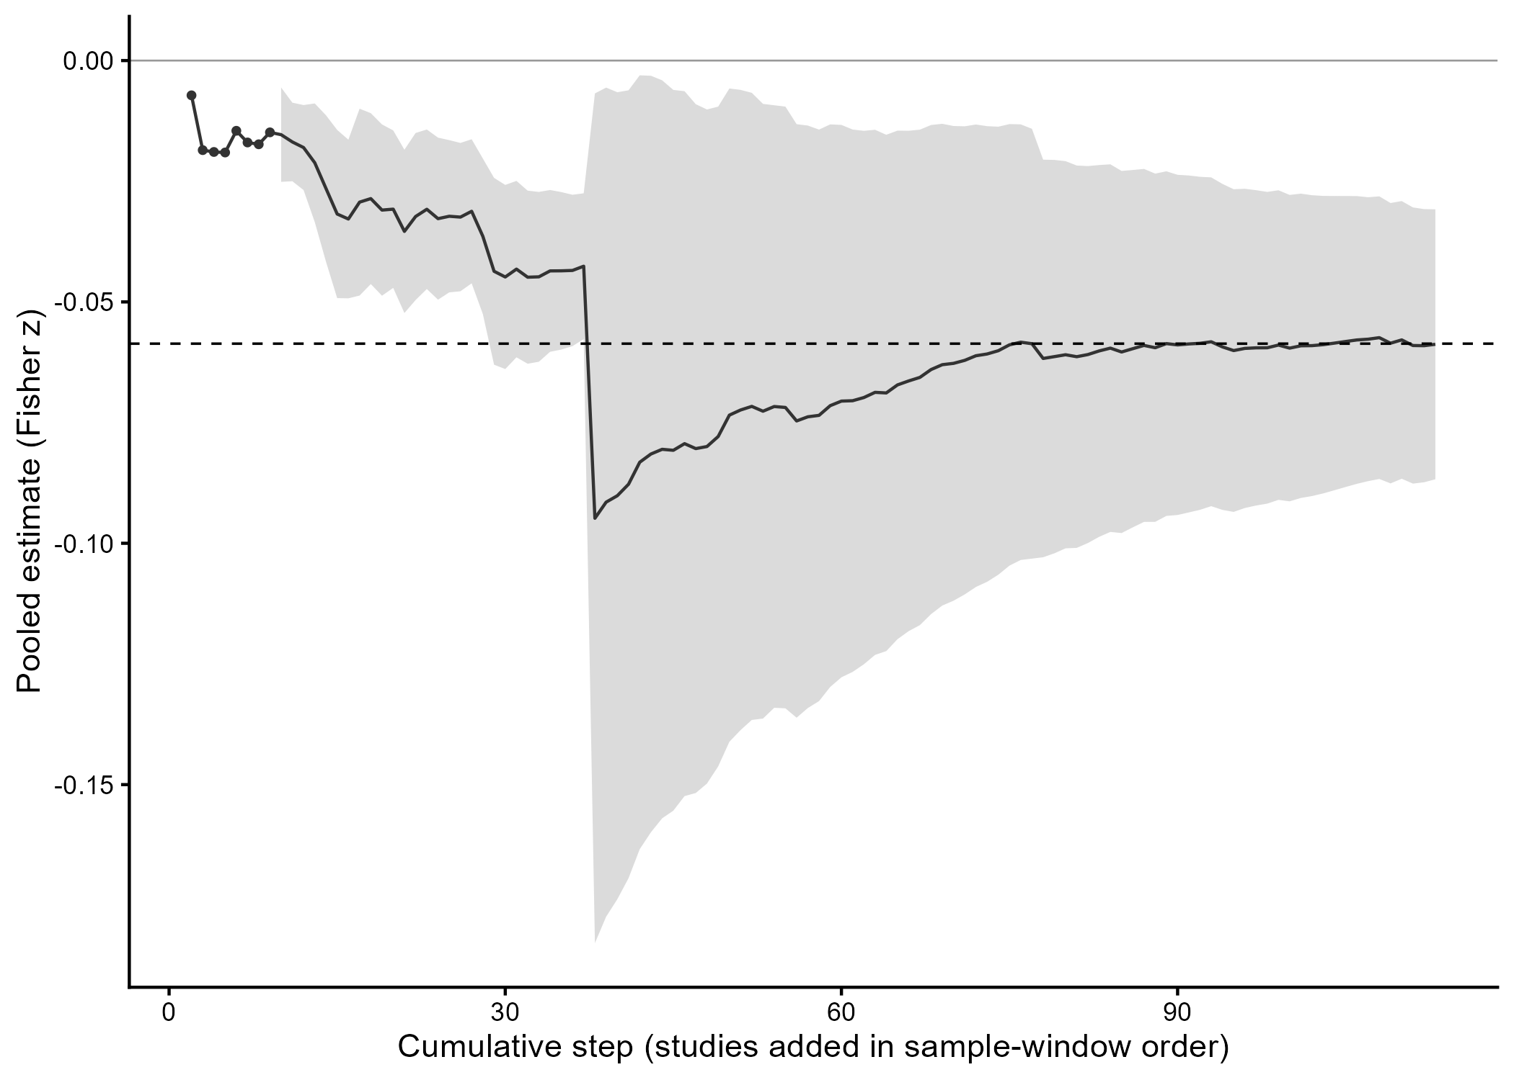 Figure 4. Chronological cumulative meta-analysis (113 steps; studies added by median sample-window midpoint, ties alphabetical). The line traces the cumulative pooled estimate; the shaded band shows 95% confidence intervals from the 10-cluster floor onward (step 10). Steps 1–9 are displayed point-only; step 1 is not estimable (single cluster). The dashed line marks the pooled CHE–RVE estimate.
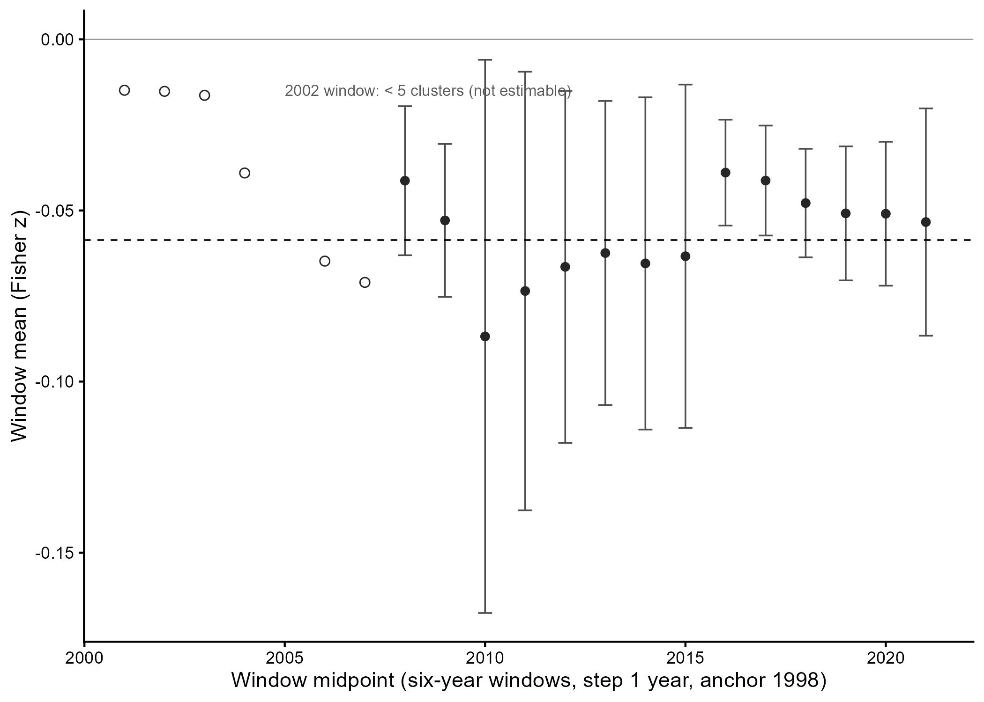 Figure 5. Rolling six-year windows (step one year, anchor 1998; 21 windows, 20 estimable). Filled points with 95% confidence intervals: windows with at least 10 clusters (full cluster-robust inference); open points: 5–9 clusters (descriptive, intervals suppressed by rule); the 2002–2007 window falls below the 5-cluster floor. The dashed line marks the pooled CHE–RVE estimate.
Taken together, these results answer RQ2 in the negative and do not support H2: the predicted post-Paris strengthening of the CER–COD association does not materialize in any of the pre-specified analyses. The headline contrast, its coding and leave-one-out variants, the Bayesian model averaging, the identification battery, and the permutation and multiverse analyses all point to the same conclusion — no detectable Paris-Agreement moderation, with the headline contrast statistically equivalent to zero (Section 4.2.1). Within the power limits documented above, the Paris Agreement has left no measurable imprint on the pooled CER–COD association. Whether this aggregate stability conceals contextual variation — across measures, instruments, industries, regulation, and country contexts — is examined in Section 4.3. The wording tier adopted for this conclusion — the equivalence register — is motivated in Section 5.

4.3 Moderator Analyses (RQ3)
The moderator analysis comprises two pre-specified tiers, addressing both prongs of RQ3: level tests ask whether the CER–COD association itself differs across the eight moderator dimensions; period-interaction tests ask whether the Paris-period contrast does. Table 3 reports both tiers for all eight panels.
Table 3. Moderator analysis, all eight panels: level tests (M_A) and period-interaction tests (M_B).
Panel / level | k (ES / cl) | r | 95% CI | Paris shift Δz | p (shift)
CER measurement — level test p = 0.428; interaction test p = 0.077
Performance-based | 2,212 / 97 | −0.056 | [−0.085; −0.027] | +0.022 | 0.248
Disclosure-based | 501 / 34 | −0.068 | [−0.103; −0.034] | −0.036 | 0.205
Debt instrument — level test p = 0.113; interaction test p = 0.707
Loan (interest rate) | 1,352 / 67 | −0.038 | [−0.057; −0.019] | +0.016 | 0.530
Bond (yield) | 654 / 25 | −0.091 | [−0.122; −0.061] | −0.051 | 0.472
Rating | 398 / 24 | −0.058 | [−0.092; −0.024] | +0.053 | —
CDS spread | 309 / 11 | −0.122 | [−0.304; 0.069] | — | —
Industry sensitivity — level test p = 0.446; interaction test p = 0.700
Non-sensitive | 1,961 / 77 | −0.062 | [−0.099; −0.024] | +0.019 | 0.495
Sensitive | 299 / 17 | −0.046 | [−0.081; −0.011] | +0.039 | —
Carbon regulation — level test p = 0.867; interaction test p = 0.383
Without ETS/CT | 1,273 / 56 | −0.063 | [−0.093; −0.033] | −0.014 | 0.645
With ETS/CT | 531 / 30 | −0.068 | [−0.143; 0.007] | +0.047 | 0.500
Country region — level test p = 0.541; interaction test p = 0.666
United States | 932 / 32 | −0.052 | [−0.101; −0.002] | +0.037 | —
Europe | 333 / 23 | −0.072 | [−0.155; 0.012] | +0.089 | 0.260
Asia-Pacific | 662 / 39 | −0.074 | [−0.118; −0.029] | +0.001 | —
Economic development — level test p = 0.085; interaction test p = 0.191
Developed | 1,131 / 47 | −0.029 | [−0.043; −0.015] | −0.040 | —
Developing | 491 / 34 | −0.051 | [−0.071; −0.031] | 0.000 | 0.979
Cultural cluster — level test p = 0.880; interaction test p = 0.799
Western | 1,330 / 57 | −0.061 | [−0.117; −0.004] | +0.012 | 0.747
Non-western | 626 / 39 | −0.066 | [−0.104; −0.028] | +0.023 | —
Legal origin — level test p = 0.929; interaction test p = 0.610
Common law | 1,047 / 46 | −0.064 | [−0.133; 0.006] | −0.022 | —
Civil law | 616 / 37 | −0.067 | [−0.109; −0.026] | +0.022 | —
Note. Level tests = panel omnibus HTZ; interaction tests = period-interaction HTZ; Holm-adjusted minimum across the eight interaction tests = .616. Shifts without p are reported descriptively under the pre-specified small-cell rule (Section 3.3.2); — = no estimable post-Paris cell (Section 4.3 text). Pairwise level contrasts: Appendix Table A.1. NEC categories excluded per Section 3.3.2.
The level tests detect no systematic differences: none of the eight panel-level omnibus tests is significant, with HTZ p-values from 0.085 (economic development) to 0.929 (legal origin), and of the fifteen pre-specified pairwise contrasts only loan versus bond instruments is nominally significant (Δz = 0.053, p = 0.009) — read descriptively within the fifteen-pair family, and marking a difference in the overall association across instruments, not in the Paris-period response. Where the literature reports CER–COD estimates, it thus reports them at broadly similar magnitudes: no measurement, instrument, industry, regulation, or country classification partitions the association into significantly different segments.
The period-interaction tests reach the same verdict for the Paris contrast: none of the eight pre-specified moderation tests is significant, with interaction HTZ p-values from 0.077 (CER measurement) to 0.799 (cultural cluster) and a Holm-adjusted minimum of 0.616. The Paris-period contrast does not differ detectably across CER measurement type, debt instrument, industry sensitivity, carbon-regulation exposure, or any of the four country classifications. The post-Paris evidence base is, however, compositionally thin in specific segments: no CDS study is majority-post (0 of 11 clusters), the United States contributes a single majority-post cluster, and common-law settings two. Under the maximally inclusive end-anchored coding these cells fill exclusively with majority-pre windows (CDS: 299 of 299 effect sizes), so the absences are coding-robust rather than coding-dependent; the fully cross-classifiable post-Paris literature comprises nine clusters, all Asia-Pacific, developing-economy, non-western and civil-law. The interaction nulls thus hold wherever the post-Paris evidence permits a comparison; where it does not, the absence is a property of the literature’s composition rather than of the coding.
Across all nineteen substantive moderator levels the pooled association remains within a narrow negative band (r = −0.029 to −0.122). Four cells reach or exceed the SESOI benchmark of |r| = 0.070 in magnitude — CDS spreads (r = −.122), bond yields (−.091), Asia-Pacific (−.074), and Europe (−.072) — of which only bond yields (95% CI [−.122; −.061]) and Asia-Pacific ([−.118; −.029]) carry intervals excluding zero; the CDS interval spans zero ([−.304; +.069], 11 clusters), as does the European one ([−.155; +.012]).
The unified models corroborate the interaction tier under joint adjustment: the conditional Paris coefficient is +0.008 (SE 0.025, df 5.1, p = 0.769) in the lean specification and +0.013 (SE 0.016, df 12.0, p = 0.426) with all eight moderator mains; the mechanical design-df rule admitted only the CER and region interaction blocks in the lean model and none in the full model. Because the complete-case post-Paris cell contains no US clusters, the design matrix satisfies pp = pp × Europe + pp × AsiaPac exactly; the conditional contrast is therefore identified on Asia-Pacific and European post-period evidence.
Pre-trend guards show no differential trends across exposure levels (industry p = 0.311; carbon regulation p = 0.272). The single sensitivity approaching a conventional threshold is the ever-treated regulation coding (interaction HTZ p = 0.058, against 0.383 under the pre-specified end-anchored coding); the divergence is driven by 366 effect sizes in 17 clusters whose regulation status changed within the sampling window, and this sensitivity is carried descriptively in the Appendix.
Taken together, these results answer RQ3: neither tier of the pre-specified moderator analysis detects systematic variation. The level tests leave the association within a narrow negative band across all nineteen substantive levels, and the period-interaction tests show no detectable differences in the Paris-period contrast across any of the eight dimensions — the aggregate null of Section 4.2 is not an average over offsetting contextual effects that this design can resolve. The compositional thinness of specific post-Paris segments bounds these conclusions and is taken up in Section 5. Section 4.4 turns to the final research question: whether publication selection distorts the pooled estimate.

4.4 Publication-Bias Analyses (RQ4)
Section 4.4 turns to RQ4 and asks whether the pooled CER–COD association is robust to publication selection. The pre-specified battery (Section 3.3.3) combines the FAT-PET-PEESE family of regression-based corrections, formal selection models, a direct published–unpublished comparison, and a conditional p-curve; Table 4 triangulates the corrected estimates across methods.
Table 4. Triangulation of the pooled association across publication-bias methods (Fisher-z scale).
Method | est (z) | 95% CI | Note
Unadjusted CHE–RVE headline | −0.059 | [−0.086; −0.031] | reference (2,713 ES / 114 clusters)
Unadjusted RE/ML on aggregates | −0.062 | [−0.109; −0.014] | aggregate base model (k = 114)
PET (regression-corrected) | −0.043 | [−0.076; −0.010] | not claim-carrying (PEESE selected per rule)
PEESE (regression-corrected) | −0.055 | [−0.084; −0.027] | claim-carrying per pre-specified rule
3PSM (selection-adjusted) | 0.012 | [−0.071; 0.094] | δ = 0.49; LRT p = .025
p-uniform* (selection-adjusted) | 0.012 | [−0.069; 0.098] | concordant with 3PSM
Grey-literature contrast (unpub. − pub.) | 0.002 | [−0.054; 0.059] | direct check: precise null
RoBMA (Bayesian model averaging) | — | model-averaged mean between −0.009 and +0.008 | cross-cited from Section 4.2.2; strong selection-component inclusion
The FAT-PET-PEESE corrections indicate mild small-study asymmetry and a modestly attenuated, still-negative corrected mean. Smaller studies report somewhat more negative effects — the funnel-asymmetry test sits exactly at the conventional threshold (slope −0.642, p = .0500; funnel plot: Appendix, Figure A2) — and correcting for this pattern leaves the association negative: per the pre-specified rule, PEESE carries the corrected estimate at r = −0.055 (z scale −0.055 [−0.084; −0.027]; PET intercept −0.043 [−0.076; −0.010], p = .011), somewhat attenuated relative to the unadjusted pooled mean but retaining its sign. Read descriptively, the correction changes little: the small-study pattern accounts for only a fraction of the already small pooled association. Within periods the alignment rule again selects PEESE, with corrected means of −0.058 pre- and −0.045 post-Paris; funnel asymmetry is not significant pre-Paris but pronounced post-Paris (the full period panel is reported in the Appendix, without a pre-versus-post inferential test).
The formal selection models tell a sharper story. Both estimate what the mean effect would be absent selective publication, and both move it to approximately zero: the three-parameter selection model yields an adjusted mean of +0.012 [−0.071; +0.094], and p-uniform* is nearly identical at +0.012 [−0.069; +0.098]. The fitted selection weight implies that nonsignificant results reach publication at roughly half the rate of significant ones (δ = 0.49; likelihood-ratio test against no selection, p = .025) — selection is detectable, and correcting for it shifts the mean to zero with wide uncertainty, while between-aggregate heterogeneity is essentially unchanged (τ² ≈ 0.069). Read descriptively, these corrections do not turn the association positive; they say its small negative mean is compatible with a literature that under-reports null results.
A direct comparison of published and unpublished studies under the headline model shows virtually identical cell means (−0.059 vs −0.057, z scale); the contrast is +0.002 [−0.054; +0.059] (p = .928; Satterthwaite df = 17.1) — a precise null on the direct selection check within the retrieved corpus.
A conditional p-curve on the post-Paris cell (first-reported effect size per study; 28 of 31 studies significant) indicates evidential value: the right-skew tests are strongly significant (binomial p = 1.5e-06; Stouffer p = 2.1e-119), and the flatness test against 33% power does not indicate inadequate evidential value (pp = 1.000; Simonsohn et al., 2014).
Mechanically, the corrected estimates split by estimator family — a divergence consistent with simulation evidence that no single correction method dominates across heterogeneity and selection conditions (Carter et al., 2019): the FAT-PET-PEESE corrections retain a small negative mean (−0.04 to −0.06 z), selection-model corrections move to approximately zero with intervals spanning zero, the direct grey-literature check is a precise null, and the likelihood-ratio test indicates selection against nonsignificant results. All corrected point estimates lie inside the primary SESOI band (|r| = 0.070); the Bayesian model averaging of Section 4.2.2 complements this picture with strong selection-component inclusion — a prior-sensitivity bracket, not a separate verdict.
Taken together, these results answer RQ4: publication selection does not overturn the pooled association’s reading, but it does mark its magnitude as an upper bound. The FAT-PET-PEESE corrections retain a small negative mean, selection models move toward zero, and the direct published–unpublished check shows no difference — while every corrected point estimate stays inside the primary SESOI band. Where selection is detected, it operates against nonsignificant results, so the unadjusted mean is, if anything, inflated rather than understated. The significant post-Paris estimates, finally, carry evidential value rather than reflecting selective reporting. The joint reading of these corrections is developed in Section 5.

5 Discussion & conclusion
This chapter interprets the evidence of Section 4 and develops its implications. Section 5.1 summarizes the principal findings and motivates the wording adopted for the Paris conclusion, Section 5.2 weighs candidate explanations for the observed pattern, and Section 5.3 draws the theoretical implications. Sections 5.4 to 5.6 address the boundaries of the evidence base, the practical implications, and the limitations; Section 5.7 outlines directions for future research; Section 5.8 concludes.

5.1 Principal Findings
The answer to RQ1 is a calibration. CER is negatively associated with the cost of debt: the pooled partial correlation is r = −0.059 (95% CI [−0.086; −0.031]; Section 4.1), at 0.84 times the small-effect benchmark for partial correlations (Doucouliagos, 2011) — statistically detectable, economically negligible, and explicitly not null, a characterization that survives the pre-specified robustness register unchanged in sign and band (Section 4.1.2). In economic terms, this is a first-order scale anchor of approximately −11.8 basis points (loans), −8.8 bp (bonds), and −9.9 bp (CDS) per one-standard-deviation improvement in CER (Section 4.1.1). The pooled value, however, is a benchmark rather than a prediction: reported effects disperse widely around it, most of that dispersion reflects genuine differences between study settings rather than sampling noise (Section 4.1.1), and it is dispersion that the pre-specified context dimensions do not detectably resolve (Section 4.3). Any single setting may sit far from the calibrated mean.
The study’s central question is RQ2 (Section 4.2). For the Paris-moderation claim we adopt the equivalence register: there is no detectable Paris-Agreement moderation, and the post-minus-pre contrast is statistically equivalent to zero within the secondary SESOI band (±0.05 on Fisher-z) — carried by the equivalence test (diff_z = +0.010, p = .582; p_TOST = .022; 90% CI [−0.022; +0.042]) and coherent with the model-averaged contrast (+0.003, 95% CI [−0.031; +0.045]). Under the pre-specified priors the Bayes factors remain anecdotal (BF01 = 1.03 / 1.17), with no support for moderation in any set (BF10 < 1 throughout); the diffuse package default yields BF01 = 8.49 and is shown as a sensitivity bracket with disclosed caveats.
This register is not a stylistic preference but the output of a rule fixed in advance: Section 3.3.1 ties the wording tier to the pre-specified Bayes-factor ladder, and with BF01 in the 1–3 band, the equivalence-based register — and no stronger one — is licensed. It also sits deliberately between two inadequate alternatives. A bare non-rejection would leave the size of any moderation unbounded; the equivalence test converts that absence of significance into a bounded statement. A stronger affirmative reading of the null, conversely, is precisely what the pre-specified Bayes factors decline to support. The register thus claims exactly what the strongest pre-specified test establishes: whatever the true shift, it lies within a band defined in advance as too small to be of interest.
How much weight can a bounded null bear? That depends on sensitivity, and here the synthesis and its primary literature part ways. Only 704 of 2,713 effect sizes (26%, from 49 clusters) are adequately powered against the pooled effect (Stanley, Doucouliagos, & Ioannidis, 2017), echoing the low statistical power documented for empirical economics more broadly (Ioannidis, Stanley, & Doucouliagos, 2017). A mixed single-study record is therefore the expected signature of an effect of this size, not evidence of contextual instability — and no individual study could have adjudicated the Paris question with useful precision. The synthesis can: it operates on the accumulated sample, and what it could and could not have detected is quantified rather than assumed, through the pre-specified power calibration (Section 3.3.1) and the permutation and multiverse analyses (Section 4.2.4).
Both tiers must finally survive the selection process of the literature they aggregate — the reason the publication-selection battery licenses, rather than merely accompanies, these answers (Section 4.4, Table 4). The bias battery triangulates rather than converging on a single corrected value, and the divergence is itself informative. Regression-based corrections retain a small negative mean (PET −0.043 [−0.076; −0.010]; PEESE, selected by the pre-specified alignment rule, −0.055 [−0.084; −0.027]), whereas selection-model corrections move to approximately zero with intervals spanning it (3PSM +0.012 [−0.071; +0.094]; p-uniform* +0.012 [−0.069; +0.098]), the likelihood-ratio test registering selection against nonsignificant results (p = .025); the direct grey-literature contrast is a precise null (+0.002 [−0.054; +0.059], p = .928). Robust Bayesian model averaging, which weights these mechanisms rather than choosing among them, brackets the model-averaged mean between −0.009 and +0.008 (spike-bounded 95% credible intervals), with strong inclusion support for the selection component (bias-block BF10 = 94.7 / 11.1 / 16.8) and level Bayes factors that remain prior-dependent (BF01 = 7.03 / 2.38 / 1.69), shown as a prior-sensitivity complement with the mixture mechanics disclosed rather than as a null verdict. Divergence of exactly this pattern between regression- and selection-based estimators is a documented property of the estimator families rather than a defect of the corpus (Carter et al., 2019). The substantive consequence is one-directional: every corrected point estimate lies inside the primary SESOI band (|r| = 0.070), so bias correction — under any mechanism — leaves the headline characterization of the pooled association as statistically detectable but economically negligible intact, and none of the corrections produces a conventionally meaningful effect. Two consequences carry to the tiers. Where selection is detectable it operates against nonsignificant results, so the calibrated association is, if anything, an upper bound; and because the significant post-Paris estimates carry evidential value rather than reflecting selective reporting (Section 4.4), the equivalence conclusion does not rest on a selectively reported post-Paris record.
Taken together, the battery yields one internally consistent and notably asymmetric picture: the same pre-specified machinery that bounds the Paris contrast within its equivalence band declines to grant the pooled association the same equivalence — it remains small, negative, and sign-stable across specifications (Section 4.1.2) and across time (Section 4.2.4), detectable but never material. The design does not default to null conclusions; it distinguishes. What could produce exactly this pattern — a real but economically negligible pricing relation that the Paris Agreement left measurably unchanged — is the question to which the next section turns.

5.2 Candidate Explanations
Three features of the record call for explanation: an association that is real but negligible on average, a Paris contrast bounded at zero, and dispersion that dominates the mean yet is resolved by none of the coded contexts. For each we weigh candidate explanations — candidates drawn from the mechanisms of Section 2, not adjudicated causes.
Why is the average so small? A first reading follows from the payoff structure that opens Section 2.1: creditors price downside risk (Merton, 1974), so environmental conduct enters spreads where it moves default probability or recovery — and the further a borrower sits from default, the smaller that increment. A small average concealing materially larger pricing in high-risk segments is exactly what a concave claim would produce; our study-level design cannot resolve the borrower-level risk variation this reading turns on. A second reading notes that spreads are only one margin of the lending relationship: lenders can respond through allocation, covenants, and collateral — terms that adjust gradually (Seltzer et al., 2022) — and the sharpest credit-market response documented around the Paris episode ran through lending volumes rather than prices (Altavilla et al., 2024). A price-based synthesis is blind to these margins by construction. A third reading is the net-of-frictions account of Section 2.1: agency costs, greenwashing skepticism, and lender inattention subtract from the gross channels — lending evidence treats responsibility engagement as second-order (Goss & Roberts, 2011) — so a small net effect need not indicate inert mechanisms. This last family is not debt-specific: assessment divergence and processing limits blunt the same signal on the equity side (Berg et al., 2022; Hirshleifer & Teoh, 2003), and, consistent with a shared origin, the companion meta-analysis finds the equity-side association of the same negligible order (Witte et al., 2026).
Why no Paris shift? The contrast is identified — the composition-adjusted contrast and the identification battery point to the same conclusion (Section 4.2.3) — so the explanation must be substantive rather than compositional. The equivalence band then cuts symmetrically. A strengthening beyond the band is excluded: the amplification family of Section 2.2, whose observable implication was precisely a post-Paris strengthening, finds no support at any tested margin. A weakening of that size is excluded as well, which disciplines the attenuation side: the strong forms of dilution and substitution — signal crowding, and direct carbon pricing displacing CER’s informational role — predict exactly such a weakening and find no more support than the amplification they oppose. What remains consistent with a bounded contrast is the anticipation reading — credit markets priced environmental conduct well before 2015 (Chava, 2014; Okimoto & Takaoka, 2024), leaving the Agreement little incremental pricing content — together with any mechanism operating below the band. Within this residual family the design cannot rank: the period contrast is the identified quantity, and mechanism-level discrimination requires designs of the kind Section 5.7 outlines. None of this is a claim about the Agreement’s effectiveness; the object here is a pricing relation, not the Agreement’s regulatory or real-economy effects.
Why does dispersion dominate while every coded context stays silent? The variance geometry points below the coding grid: a substantial share of the dispersion arises within studies (Section 4.1.1) — the same sample, specified differently — and the constructs themselves can diverge at the firm level, where performance and disclosure measure different things for the same borrower (Kleimeier & Viehs, 2021; Section 2.3). Add the soft-information character of relationship lending (Diamond, 1991), which varies borrower by borrower within any instrument class, and a parsimonious reading emerges: the association’s variation is generated at the firm, deal, and specification level — below the resolution of study-level moderators, where meta-analytic coding necessarily operates. That is a statement about where the heterogeneity lives, not a residual excuse; it fixes the design requirements for resolving it (Section 5.7).
These candidates share one structural property: each caps the aggregate pricing channel without denying its existence. What that property implies for the theory of Section 2 is the subject of the next section.

5.3 Theoretical Implications
For the theory of Section 2, these results discipline rather than refute. The creditor channels behind H1 — information, downside risk, stakeholder alignment — survive in sign: the association is negative and stable. What the evidence adds is a ceiling: in the aggregate, the net pricing consequence is bounded below economic materiality — a constraint every account must carry, whether by capping the gross channels or by netting them against the frictions of Section 2.1. The object to be explained is a small net effect, not a large one. The scope conditions relocate as well: the coded contexts of RQ3 yield no detectable variation (Section 4.3), while Section 5.2 locates the plausible sources at borrower, deal, and specification level — theorizing about where the channels bind should follow them there.
For H2, Section 2.2 framed the Agreement as an adjudicand between amplification and absorption; the adjudication has now been made within the design’s bounds. Over this horizon the record is consistent with accounts in which the Agreement’s pricing content was anticipated, diffuse, or below the band — and inconsistent with any account that ties a shift of material size, in either direction, to the Agreement itself. Policy regimes, on this evidence, enter credit pricing as anticipated, gradually diffusing expectations rather than as discrete repricing moments. Section 2.2 anticipated that a bounded contrast would mark the limits of voluntary repricing over the horizon this evidence base covers; those limits are now marked. Revising this reading would take evidence from margins this synthesis cannot see — within-firm designs, non-price terms, high-risk borrower segments (Section 5.7) — and how far it travels is bounded, in turn, by the composition of the evidence, to which we turn next.

5.4 Boundary Conditions and Evidence Composition
The equivalence conclusion is identified on the available post-Paris evidence, and the shape of that evidence sets the boundaries within which the conclusion travels. The post-Paris record is compositionally thin in specific segments (Section 4.3): no majority-post CDS evidence exists, majority-post United States and common-law representation is minimal, and the fully cross-classifiable post-Paris literature is concentrated in Asia-Pacific, developing-economy, civil-law settings. These absences are features of the literature rather than artifacts of our coding — they persist under the most inclusive period coding — and they realize, in sharper form, the compositional drift anticipated in Section 2.3. The near-absence of majority-post United States evidence coincides with the 2017–2020 U.S. withdrawal episode; we note this as a plausible supply-side account of the composition of the post-Paris literature, without attaching causal weight to it.
The consequence for inference is asymmetric and worth stating precisely. Identification is not at issue: the composition-adjusted analysis already carries the contrast (Section 4.2.3), so the thin cells do not manufacture the aggregate conclusion. Generalization is at issue: where the post-Paris record is empty or near-empty — CDS pricing, the post-2020 United States, common-law lending environments — the equivalence conclusion is open, neither established nor refuted. Within the observed composition the conclusion stands with the full battery behind it; beyond that composition, any extension is a projection rather than a finding. Practical readings of the results inherit the same boundaries, and we turn to them next.

5.5 Practical Implications
The practical readings follow from both tiers and inherit the boundaries of Section 5.4. For managers weighing CER investments against financing-cost expectations, the calibration is direct: the average debt-cost dividend is too small to carry a business case, so environmental investment needs its justification in operations and risk substance rather than in expected spread relief. The dispersion qualifies rather than reverses this: individual settings can sit far from the average — on the readings of Section 5.2, most plausibly where downside risk is material — a possibility the evidence leaves open, not a premium it promises.
For lenders and bond investors, the results calibrate how much environmental information debt pricing actually reflects: little, on average, and not detectably more in any coded market context. Whether that footprint is adequate to the underlying exposure is a question this design does not answer. What it does indicate is where differentiation, if it operates, must live: below instrument, regulation, and region — at the borrower and deal level where credit assessment itself works.
For policymakers, the assessed object is precise: how far the finance-flow alignment of Article 2.1(c) can be carried by voluntary repricing in debt markets. Over the horizon and composition this evidence covers, the answer is: not measurably — debt markets show no detectable repricing anchored to the Agreement, and the average premium available for amplification is negligible to begin with. This is a bound on one transmission channel, not a verdict on the Agreement (Section 5.2). Policy designs that treat debt-market repricing as load-bearing should not assume the load is being carried; this record identifies no coded context — regulatory or otherwise — in which it demonstrably is.

5.6 Limitations
Six limits qualify these conclusions. First, the synthesis inherits the identification limits of its primary designs: the evidence base consists predominantly of partial correlations from observational specifications, so the pooled quantity is an association — bounded, calibrated, and selection-checked, but not a causal effect — and primary-level endogeneity concerns carry to the aggregate. Second, the heterogeneity bounds that qualify every average reported here are themselves estimates: they depend on the variance-component structure of the dependence model, and their width should be read as modeled rather than observed.
Third, the identification battery carries one acknowledged trade-off. The race specification buys identification at a precision cost: with corr(sample mid-year, exposure share) = 0.81, the trend-adjusted break interval widens to [−0.026; +0.079] and cannot exclude effects up to the primary SESOI; the equivalence claim therefore rests on the unadjusted and composition-adjusted forms, per the pre-specified effect-size read-out. That trade-off was accepted at design time, not discovered after it.
Fourth, on the Bayesian side: Bayes-factor magnitudes for both model components — level and moderation — scale with prior width in the expected direction, which is why the pre-specified informed priors anchor the reported values and the package-default factors appear only as sensitivity brackets.
Fifth, the basis-point translation rests on corpus-printed descriptives: benchmark coverage is 80 of 109 eligible study–instrument cells, the loan benchmark pools accounting-ratio and spread operationalizations (Section 4.1.1), and log-scale sources enter only through a lower-bound back-transformation — the translation is a first-order scale anchor, not an estimate with sampling error.
Sixth, search-process metrics of the first wave were not retained at PRISMA granularity, and query-level reproducibility is not available for AI-mediated retrieval; compensating transparency is provided through record-level disclosure (complete hit list and identified-not-extracted catalogue in the replication package), the documented rule layer, the retrievability benchmark, and complete enumeration of the corpus.
These limits bound what the conclusions mean, not whether the design could have detected what it tested — that sensitivity was quantified in advance (Section 3.3.1). Each limit also marks a design requirement for the research that follows.

5.7 Future Research
The agenda follows from the study’s own boundaries: each candidate explanation and each thin cell names the design that would test it. The first requirement is within-study contrast estimation. Only one primary study to date estimates the Paris contrast within its own design (Li et al., 2022); designs of this kind hold sample, measurement, and instrument fixed and can therefore discriminate what a between-study contrast cannot — the residual attenuation family of Section 5.2 and the borrower- and deal-level variation located there. Stratification by borrower default risk would test the concavity reading directly. The second requirement is post-2020 United States evidence: the emptiest cell of Section 5.4 is also the setting where the supply-side account of the literature’s composition can be confronted with data. The third is instrument-level work: majority-post CDS evidence is absent, and the non-price margins on which lenders may respond — allocation, covenants, collateral — are invisible to any price-based synthesis; deal-level designs would show whether differentiation operates there. Each item converts a boundary of this study into a testable question.

5.8 Conclusion
Did the Paris Agreement reprice corporate environmental responsibility in credit markets? On the full body of evidence, the answer is: not detectably — and not merely for want of significance, but within bounds fixed in advance. What the Agreement left unchanged is itself now precisely measured: a CER–COD association that is real but economically negligible — statistically detectable, never material — and dominated by dispersion that no coded context resolves. In establishing this, the study converts a scattered literature into a calibrated quantity, gives the Paris-repricing thesis its first meta-analytic test in credit-market pricing, and shows that both conclusions survive the selection process of the literature they rest on. The result is a gain in precision, not a loss of information: the limits of voluntary repricing over this horizon are marked, and marked limits are where the next designs can begin.

Consolidated Reference List — FOMA CER–COD–Paris (references_consolidated.md)
Aguinis, H., Gottfredson, R. K., & Joo, H. (2013). Best-practice recommendations for defining, identifying, and handling outliers. Organizational Research Methods, 16(2), 270–301. https://doi.org/10.1177/1094428112470848
Albertini, E. (2013). Does environmental management improve financial performance? A meta-analytical review. Organization & Environment, 26(4), 431–457.
*Altavilla, C., Boucinha, M., Pagano, M., & Polo, A. (2024). Climate risk, bank lending and monetary policy (ECB Working Paper No. 2969). European Central Bank.
*Attig, N., Rahaman, M., & Trabelsi, S. (2025). Creditors at the gate: Effects of selective environmental disclosure on the cost of debt. Corporate Governance, 33(2), 202–230. https://doi.org/10.1111/corg.12599
*Azmi, W., Hassan, M. K., Houston, R., & Karim, M. S. (2021). ESG activities and banking performance: International evidence from emerging economies. Journal of International Financial Markets, Institutions and Money, 70, 101277. https://doi.org/10.1016/j.intfin.2020.101277
Barnea, A., & Rubin, A. (2010). Corporate social responsibility as a conflict between shareholders. Journal of Business Ethics, 97(1), 71–86.
Bartoš, F., Maier, M., Wagenmakers, E.-J., Doucouliagos, H., & Stanley, T. D. (2023). Robust Bayesian meta-analysis: Model-averaging across complementary publication bias adjustment methods. Research Synthesis Methods, 14(1), 99–116. https://doi.org/10.1002/jrsm.1594 [online 2022; in-text: Bartoš et al. (2022) — version family]
Bauer, L., Follert, F., & Stöckl, S. (2025). The impact of environmental performance and disclosure on the cost of debt: A systematic literature review and a conceptual model. Management Review Quarterly. https://doi.org/10.1007/s11301-025-00541-5
*Bauer, R., & Hann, D. (2010). Corporate environmental management and credit risk. SSRN Working Paper. https://doi.org/10.2139/ssrn.1660470
Benlemlih, M. (2017). Corporate social responsibility and firm financing decisions: A literature review. Journal of Multinational Financial Management, 42, 1–10.
Berg, F., Kölbel, J. F., & Rigobon, R. (2022). Aggregate confusion: The divergence of ESG ratings. Review of Finance, 26(6), 1315–1344. https://doi.org/10.1093/rof/rfac033
*Bhattacharya, S., & Sharma, D. (2019). Do environment, social and governance performance impact credit ratings: A study from India. International Journal of Ethics and Systems, 35(3), 466–484.
Bijmolt, T. H. A., & Pieters, R. G. M. (2001). Meta-analysis in marketing when studies contain multiple measurements. Marketing Letters, 12(2), 157–169. https://doi.org/10.1023/A:1011117103381
Bolton, P., & Kacperczyk, M. (2021). Do investors care about carbon risk? Journal of Financial Economics, 142(2), 517–549.
Borenstein, M., Hedges, L. V., Higgins, J. P. T., & Rothstein, H. R. (2009). Introduction to meta-analysis. Wiley.
Borenstein, M., Higgins, J. P. T., Hedges, L. V., & Rothstein, H. R. (2017). Basics of meta-analysis: I² is not an absolute measure of heterogeneity. Research Synthesis Methods, 8(1), 5–18. https://doi.org/10.1002/jrsm.1230
Busch, T., & Lewandowski, S. (2018). Corporate carbon and financial performance: A meta-analysis. Journal of Industrial Ecology, 22(4), 745–759.
Carnevale, C., & Drago, D. (2024). Do banks price ESG risks? A critical review of the empirical research. Journal of Risk and Financial Management, 17(7), 289. https://doi.org/10.3390/jrfm17070289
Carter, E. C., Schönbrodt, F. D., Gervais, W. M., & Hilgard, J. (2019). Correcting for bias in psychology: A comparison of meta-analytic methods. Advances in Methods and Practices in Psychological Science, 2(2), 115–144. https://doi.org/10.1177/2515245919847196
Chaikumbung, M., Doucouliagos, H., & Scarborough, H. (2016). The economic value of wetlands in developing countries: A meta-regression analysis. Ecological Economics, 124, 164–174. https://doi.org/10.1016/j.ecolecon.2016.01.022
*Chava, S. (2010). Do environmental concerns affect the cost of bank loans (Working paper). Mays Business School, Texas A&M University.
*Chava, S. (2014). Environmental externalities and cost of capital. Management Science, 60(9), 2223–2247. https://doi.org/10.1287/mnsc.2013.1863
*Chen, L. H., & Silva Gao, L. (2012). The pricing of climate risk. Journal of Financial and Economic Practice, 12(2), 115–131. [companion cites the 2011 WP version — version family; fn 6]
Cheung, S. F., & Chan, D. K.-S. (2004). Dependent effect sizes in meta-analysis: Incorporating the degree of interdependence. Journal of Applied Psychology, 89(5), 780–791. https://doi.org/10.1037/0021-9010.89.5.780
Degryse, H., Goncharenko, R., Theunisz, C., & Vadasz, T. (2023). When green meets green. Journal of Corporate Finance, 78, 102355. https://doi.org/10.1016/j.jcorpfin.2023.102355
*Delis, M. D., de Greiff, K., Iosifidi, M., & Ongena, S. (2024). Being stranded with fossil fuel reserves? Climate policy risk and the pricing of bank loans. Financial Markets, Institutions & Instruments, 33(3), 239–265. https://doi.org/10.1111/fmii.12189 [corpus key: Delis et al (2021), SFI WP vintage — version family]
*Devalle, A., Fiandrino, S., & Cantino, V. (2017). The linkage between ESG performance and credit ratings: A firm-level perspective analysis. International Journal of Business and Management, 12(9), 53–65. https://doi.org/10.5539/ijbm.v12n9p53
Diamond, D. W. (1991). Monitoring and reputation: The choice between bank loans and directly placed debt. Journal of Political Economy, 99(4), 689–721.
Dixon-Fowler, H. R., Slater, D. J., Johnson, J. L., Ellstrand, A. E., & Romi, A. M. (2013). Beyond “Does it pay to be green?” A meta-analysis of moderators of the CEP–CFP relationship. Journal of Business Ethics, 112(2), 353–366.
Doucouliagos, C. (2011). How large is large? Preliminary and relative guidelines for interpreting partial correlations in economics (Working Paper No. SWP 2011/5). Deakin University, Department of Economics.
*Drago, D., Carnevale, C., & Gallo, R. (2019). Do corporate social responsibility ratings affect credit default swap spreads? Corporate Social Responsibility and Environmental Management, 26(3), 644–652. https://doi.org/10.1002/csr.1709 [corpus key/in-text: Drago et al. (2018), online-first — version family]
*Du, X., Weng, J., Zeng, Q., Chang, Y., & Pei, H. (2017). Do lenders applaud corporate environmental performance? Evidence from Chinese private-owned firms. Journal of Business Ethics, 143(1), 179–207. https://doi.org/10.1007/s10551-015-2758-2 [corpus key: Du et al (2015) — version family]
Duan, T., Li, F. W., & Wen, Q. (2025). Is carbon risk priced in the cross-section of corporate bond returns? Journal of Financial and Quantitative Analysis, 60(1), 1–35.
Egger, M., Davey Smith, G., Schneider, M., & Minder, C. (1997). Bias in meta-analysis detected by a simple, graphical test. BMJ, 315(7109), 629–634. https://doi.org/10.1136/bmj.315.7109.629
*Eliwa, Y., Aboud, A., & Saleh, A. (2021). ESG practices and the cost of debt: Evidence from EU countries. Critical Perspectives on Accounting, 79, 102097. https://doi.org/10.1016/j.cpa.2019.102097
Endrikat, J., Guenther, E., & Hoppe, H. (2014). Making sense of conflicting empirical findings: A meta-analytic review of the relationship between corporate environmental and financial performance. European Management Journal, 32(5), 735–751.
Endrikat, J., Guenther, T. W., & Titus, R. (2020). Consequences of strategic performance measurement systems: A meta-analytic review. Journal of Management Accounting Research, 32(1), 103–136.
Feld, L. P., Heckemeyer, J. H., & Overesch, M. (2013). Capital structure choice and company taxation: A meta-study. Journal of Banking & Finance, 37(8), 2850–2866. https://doi.org/10.1016/j.jbankfin.2013.03.017
Fidrmuc, J., & Lind, R. (2020). Macroeconomic impact of Basel III: Evidence from a meta-analysis. Journal of Banking & Finance, 112, 105359. https://doi.org/10.1016/j.jbankfin.2018.05.017
Fitch Ratings. (2019, January 7). Fitch Ratings launches ESG Relevance Scores [press release]. [grey literature — house format at style pass]
*Fonseka, M., Rajapakse, T., & Richardson, G. (2019). The effect of environmental information disclosure and energy product type on the cost of debt: Evidence from energy firms in China. Pacific-Basin Finance Journal, 54, 159–182. https://doi.org/10.1016/j.pacfin.2018.05.001 [corpus key: Fonseka et al (2019a); the 2019b cluster (Fonseka, Tian, & Al Farooque, published 2020) is corpus-only, not text-cited]
Freeman, R. E. (1984). Strategic management: A stakeholder approach. Pitman.
Friede, G., Busch, T., & Bassen, A. (2015). ESG and financial performance: Aggregated evidence from more than 2000 empirical studies. Journal of Sustainable Finance & Investment, 5(4), 210–233.
Friedman, M. (1970, September 13). The social responsibility of business is to increase its profits. The New York Times Magazine, 122–124. [page display at style pass]
*Ge, W., & Liu, M. (2015). Corporate social responsibility and the cost of corporate bonds. Journal of Accounting and Public Policy, 34(6), 597–624. https://doi.org/10.1016/j.jaccpubpol.2015.05.008
Gillan, S. L., Koch, A., & Starks, L. T. (2021). Firms and social responsibility: A review of ESG and CSR research in corporate finance. Journal of Corporate Finance, 66, 101889.
Godfrey, P. C. (2005). The relationship between corporate philanthropy and shareholder wealth: A risk management perspective. Academy of Management Review, 30(4), 777–798.
Goss, A., & Roberts, G. S. (2011). The impact of corporate social responsibility on the cost of bank loans. Journal of Banking & Finance, 35(7), 1794–1810.
Hang, M., Geyer-Klingeberg, J., & Rathgeber, A. W. (2019). It is merely a matter of time: A meta-analysis of the causality between environmental performance and financial performance. Business Strategy and the Environment, 28(2), 257–273. https://doi.org/10.1002/bse.2215
Hedges, L. V., Tipton, E., & Johnson, M. C. (2010). Robust variance estimation in meta-regression with dependent effect size estimates. Research Synthesis Methods, 1(1), 39–65. https://doi.org/10.1002/jrsm.5 [Erratum: Research Synthesis Methods, 1(2), 164–165]
Heinkel, R., Kraus, A., & Zechner, J. (2001). The effect of green investment on corporate behavior. Journal of Financial and Quantitative Analysis, 36(4), 431–449.
Hirshleifer, D., & Teoh, S. H. (2003). Limited attention, information disclosure, and financial reporting. Journal of Accounting and Economics, 36(1–3), 337–386.
*Hoepner, A., Oikonomou, I., Scholtens, B., & Schröder, M. (2016). The effects of corporate and country sustainability characteristics on the cost of debt: An international investigation. Journal of Business Finance & Accounting, 43(1–2), 158–190. https://doi.org/10.1111/jbfa.12183
Holm, S. (1979). A simple sequentially rejective multiple test procedure. Scandinavian Journal of Statistics, 6(2), 65–70.
*Hui, Z., Li, H., & Elamer, A. A. (2024). Financing sustainability: How environmental disclosures shape bank lending decisions in emerging markets. Corporate Social Responsibility and Environmental Management, 31(5), 3940–3967. https://doi.org/10.1002/csr.2789
Hunter, J. E., & Schmidt, F. L. (2004). Methods of meta-analysis: Correcting error and bias in research findings (2nd ed.). Sage.
Ibrahim, [full author list PENDING-external]. (2026). Do banks in the Middle East and North Africa region price carbon exposure? Business Strategy and the Environment. https://doi.org/10.1002/bse.71303 [Early View; vol/issue/pages at final publication]
Ioannidis, J. P. A., Stanley, T. D., & Doucouliagos, H. (2017). The power of bias in economics research. The Economic Journal, 127(605), F236–F265.
Ioannou, I., & Serafeim, G. (2012). What drives corporate social performance? The role of nation-level institutions. Journal of International Business Studies, 43(9), 834–864. https://doi.org/10.1057/jibs.2012.26
Jensen, M. C., & Meckling, W. H. (1976). Theory of the firm: Managerial behavior, agency costs and ownership structure. Journal of Financial Economics, 3(4), 305–360.
Jones, T. M. (1995). Instrumental stakeholder theory: A synthesis of ethics and economics. Academy of Management Review, 20(2), 404–437.
*Jung, J., Herbohn, K., & Clarkson, P. (2018). Carbon risk, carbon risk awareness and the cost of debt financing. Journal of Business Ethics, 150(4), 1151–1171. https://doi.org/10.1007/s10551-016-3207-6 [corpus key: Jung et al (2016) — version family]
Khlif, H., & Hussainey, K. (2016). The association between risk disclosure and firm characteristics: A meta-analysis. Journal of Risk Research, 19(2), 181–211.
*Kleimeier, S., & Viehs, M. (2018). Carbon disclosure, emission levels, and the cost of debt (SSRN Working Paper No. 2719665, version 7 January 2018; earlier: GSBE Research Memorandum No. 003/2016, Maastricht University). https://doi.org/10.2139/ssrn.2719665 [corpus key: Kleimeier, Viehs (2021); M7a supersession of the M4 FRL attribution — see ledger and ERROR #50; data-side source disambiguation vs. the Economics Letters twin pending]
Knapp, G., & Hartung, J. (2003). Improved tests for a random effects meta-regression with a single covariate. Statistics in Medicine, 22(17), 2693–2710. https://doi.org/10.1002/sim.1482
*Kölbel, J. F., Leippold, M., Rillaerts, J., & Wang, Q. (2024). Ask BERT: How regulatory disclosure of transition and physical climate risks affects the CDS term structure. Journal of Financial Econometrics, 22(1), 30–69. https://doi.org/10.1093/jjfinec/nbac027 [corpus key/in-text: Kölbel et al. (2020), SSRN WP vintage — version family]
Krueger, P., Sautner, Z., & Starks, L. T. (2020). The importance of climate risks for institutional investors. The Review of Financial Studies, 33(3), 1067–1111. https://doi.org/10.1093/rfs/hhz137
Lakens, D. (2017). Equivalence tests: A practical primer for t tests, correlations, and meta-analyses. Social Psychological and Personality Science, 8(4), 355–362. https://doi.org/10.1177/1948550617697177
*Lee, J. (2022). Voluntary disclosure of carbon emissions information, managerial ability, and credit ratings. Sustainability, 14(12), 7504. https://doi.org/10.3390/su14127504
*Lemma, T., Feeman, M., Mlilo, M., & Park, J. D. (2017). Corporate carbon risk, voluntary disclosure, and cost of capital: South African evidence. Business Strategy and the Environment, 28(1), 111–126. https://doi.org/10.1002/bse.2242 [co-author spelling flag (Feeman/Feedman/Freedman) and 2017/2019-issue split — style pass]
*Li, Y., Chen, R., & Xiang, E. (2022). Corporate social responsibility, green financial system guidelines, and cost of debt financing: Evidence from pollution-intensive industries in China. Corporate Social Responsibility and Environmental Management, 29(3), 593–608. https://doi.org/10.1002/csr.2222
*Li, Y., Eddie, I., & Liu, J. (2014). Carbon emissions and the cost of capital: Australian evidence. Review of Accounting and Finance, 13(4), 400–420. https://doi.org/10.1108/RAF-08-2012-0074 [second-author spelling per COE list; draft has “Eddi” — style pass]
Lipsey, M. W., & Wilson, D. B. (2001). Practical meta-analysis. Sage.
LMA, APLMA, & LSTA. (2019, March 20). Sustainability Linked Loan Principles (joint publication). [grey literature — house format at style pass]
Menz, K.-M. (2010). Corporate social responsibility: Is it rewarded by the corporate bond market? A critical note. Journal of Business Ethics, 96(1), 117–134.
Merton, R. C. (1974). On the pricing of corporate debt: The risk structure of interest rates. Journal of Finance, 29(2), 449–470.
Miska, C., Szőcs, I., & Schiffinger, M. (2018). Culture’s effects on corporate sustainability practices: A multi-domain and multi-level view. Journal of World Business, 53(2), 263–279. https://doi.org/10.1016/j.jwb.2017.12.001
*Ng, A. C., & Rezaee, Z. (2012). Sustainability disclosures and cost of capital (SSRN Working Paper No. 2038654).
NGFS. (2019, April 17). A call for action: Climate change as a source of financial risk (First comprehensive report). Network for Greening the Financial System. [grey literature — house format at style pass]
Ni, X., Jin, Q., & Huang, K. (2022). Environmental regulation and the cost of debt: Evidence from the carbon emission trading system pilot in China. Finance Research Letters, 49, 103134. https://doi.org/10.1016/j.frl.2022.103134
*Ofogbe, N. S., Nnamani, C., Anisiuba, C. A., & Ezuwore-Obodoekwe, C. N. (2021). The relationship between the corporate social responsibility and the cost of the capital of the companies listed on the Nigerian Stock Exchange. Economic Horizons, 23(3), 277–292. https://doi.org/10.5937/ekonhor2103289O
*Okimoto, T., & Takaoka, S. (2024). Credit default swaps and corporate carbon emissions in Japan. Energy Economics, 133, 107504. https://doi.org/10.1016/j.eneco.2024.107504 [the IRFA twin (91, 103052) is the published version of the Okimoto & Takaoka (2022) cluster, corpus-only, not text-cited]
Oster, E. (2019). Unobservable selection and coefficient stability: Theory and evidence. Journal of Business & Economic Statistics, 37(2), 187–204. https://doi.org/10.1080/07350015.2016.1227711
*Ould Daoud Ellili, N. (2020). Environmental, social, and governance disclosure, ownership structure and cost of capital: Evidence from the UAE. Sustainability, 12(18), 7706.
*Owolabi, A., Mousavi, M. M., Gozgor, G., & Li, J. (2024). The impact of carbon risk on the cost of debt in the listed firms in G7 economies: The role of the Paris agreement. Energy Economics, 139, 107925. https://doi.org/10.1016/j.eneco.2024.107925
Page, M. J., McKenzie, J. E., Bossuyt, P. M., Boutron, I., Hoffmann, T. C., Mulrow, C. D., … Moher, D. (2021). The PRISMA 2020 statement: An updated guideline for reporting systematic reviews. BMJ, 372, n71.
*Palea, V., & Drogo, F. (2020). Carbon emissions and the cost of debt in the eurozone: The role of public policies, climate-related disclosure and corporate governance. Business Strategy and the Environment, 29(8), 2953–2972. https://doi.org/10.1002/bse.2550
*Panjwani, A., Melin, L., & Mercereau, B. (2023). Do Scope 3 carbon emissions impact firms’ cost of debt? The Journal of Portfolio Management, 50(2), 175–198.
Pustejovsky, J. E., & Rodgers, M. A. (2019). Testing for funnel plot asymmetry of standardized mean differences. Research Synthesis Methods, 10(1), 57–71. https://doi.org/10.1002/jrsm.1332
Pustejovsky, J. E., & Tipton, E. (2022). Meta-analysis with robust variance estimation: Expanding the range of working models. Prevention Science, 23(3), 425–438. https://doi.org/10.1007/s11121-021-01246-3 [pages DOI-anchored — final check at style pass]
*Safiullah, M., Kabir, M. N., & Miah, M. D. (2021). Carbon emissions and credit ratings. Energy Economics, 100, 105330. https://doi.org/10.1016/j.eneco.2021.105330
*Schneider, T. E. (2011). Is environmental performance a determinant of bond pricing? Evidence from the U.S. pulp and paper and chemical industries. Contemporary Accounting Research, 28(5), 1537–1561. https://doi.org/10.1111/j.1911-3846.2010.01064.x [corpus key: Schneider (2010) — version family]
Schreder, M. (2018). Idiosyncratic information and the cost of equity capital: A meta-analytic review of the literature. Journal of Accounting Literature, 41(5), 142–172.
*Seltzer, L., Starks, L. T., & Zhu, Q. (2022). Climate regulatory risks and corporate bonds (FRBNY Staff Report No. 1014, April 2022, revised March 2025). SSRN. https://doi.org/10.2139/ssrn.3563271 [working paper; journal status re-checked 2026-08-05 — unpublished]
*Shad, M. K., Lai, F.-W., Shamim, A., & McShane, M. (2020). The efficacy of sustainability reporting towards cost of debt and equity reduction. Environmental Science and Pollution Research, 27(19), 22511–22522. https://doi.org/10.1007/s11356-020-08398-9 [corpus key: Shad et al (2022) — version family]
Sharfman, M. P., & Fernando, C. S. (2008). Environmental risk management and the cost of capital. Strategic Management Journal, 29(6), 569–592.
Simonsohn, U., Nelson, L. D., & Simmons, J. P. (2014). p-Curve and effect size: Correcting for publication bias using only significant results. Perspectives on Psychological Science, 9(6), 666–681. https://doi.org/10.1177/1745691614553988
Simonsohn, U., Simmons, J. P., & Nelson, L. D. (2020). Specification curve analysis. Nature Human Behaviour, 4(11), 1208–1214. https://doi.org/10.1038/s41562-020-0912-z
Singhania, M., & Gupta, D. (2025). Impact of ESG sustainability on cost of equity: Meta-analytic review investigating the moderating role of country characteristics. Corporate Social Responsibility and Environmental Management. https://doi.org/10.1002/csr.70478 [Early View; vol/issue PENDING-external]
Souissi, M., & Khlif, H. (2012). Meta-analytic review of disclosure level and cost of equity capital. International Journal of Accounting & Information Management, 20(1), 49–62.
Stanley, T. D. (2008). Meta-regression methods for detecting and estimating empirical effects in the presence of publication selection. Oxford Bulletin of Economics and Statistics, 70(1), 103–127. https://doi.org/10.1111/j.1468-0084.2007.00487.x
Stanley, T. D., & Doucouliagos, H. (2014). Meta-regression approximations to reduce publication selection bias. Research Synthesis Methods, 5(1), 60–78. https://doi.org/10.1002/jrsm.1095
Stanley, T. D., Doucouliagos, H., & Ioannidis, J. P. A. (2017). Finding the power to reduce publication bias. Statistics in Medicine, 36, 1580–1598.
Stanley, T. D., Doucouliagos, H., & Havranek, T. (2025). Reducing the biases of the conventional meta-analysis of correlations. Research Synthesis Methods, 16(1), 42–59. https://doi.org/10.1017/rsm.2024.5
Steegen, S., Tuerlinckx, F., Gelman, A., & Vanpaemel, W. (2016). Increasing transparency through a multiverse analysis. Perspectives on Psychological Science, 11(5), 702–712. https://doi.org/10.1177/1745691616658637
TCFD. (2017, June 29). Recommendations of the Task Force on Climate-related Financial Disclosures: Final report. Financial Stability Board. [grey literature — house format at style pass]
Tipton, E., & Pustejovsky, J. E. (2015). Small-sample adjustments for tests of moderators and model fit using robust variance estimation in meta-regression. Journal of Educational and Behavioral Statistics, 40(6), 604–634. https://doi.org/10.3102/1076998615606099
UNFCCC. (2015). Paris Agreement (FCCC/CP/2015/10/Add.1). United Nations Framework Convention on Climate Change. [treaty house format at style pass]
van Aert, R. C. M. (2023). Meta-analyzing partial correlation coefficients using Fisher’s z transformation. Research Synthesis Methods, 14(5), 768–773. https://doi.org/10.1002/jrsm.1654
van Aert, R. C. M., & van Assen, M. A. L. M. (2026). Correcting for publication bias in a meta-analysis with the p-uniform* method. Psychonomic Bulletin & Review. https://doi.org/10.3758/s13423-025-02812-4 [advance online 27 February 2026; vol/pages PENDING-external]
Van den Noortgate, W., López-López, J. A., Marín-Martínez, F., & Sánchez-Meca, J. (2013). Three-level meta-analysis of dependent effect sizes. Behavior Research Methods, 45(2), 576–594. https://doi.org/10.3758/s13428-012-0261-6
Van den Noortgate, W., López-López, J. A., Marín-Martínez, F., & Sánchez-Meca, J. (2015). Meta-analysis of multiple outcomes: A multilevel approach. Behavior Research Methods, 47(4), 1274–1294. https://doi.org/10.3758/s13428-014-0527-2 [pages DOI-anchored — final check at style pass]
VanderWeele, T. J., & Ding, P. (2017). Sensitivity analysis in observational research: Introducing the E-value. Annals of Internal Medicine, 167(4), 268–274. https://doi.org/10.7326/M16-2607
Vevea, J. L., & Hedges, L. V. (1995). A general linear model for estimating effect size in the presence of publication bias. Psychometrika, 60(3), 419–435.
*Wang, A., Zhang, M., & Zhou, S. (2022). Air pollution, environmental violation risk, and the cost of debt: Evidence from China. International Journal of Environmental Research and Public Health, 19(6), 3584. https://doi.org/10.3390/ijerph19063584 [corpus key: Wang et al (2022a)]
Wang, K., Bai, Y., Dong, Z., & Zhu, J. (2025). Heterogeneous impact of ESG disclosure: A meta-analysis. Journal of Cleaner Production, 516, 145804. [citation per PDF header — see ERROR #42]
Weber, O., Scholz, R. W., & Michalik, G. (2010). Incorporating sustainability criteria into credit risk management. Business Strategy and the Environment, 19(1), 39–50. https://doi.org/10.1002/bse.636
Witte, R., Aschauer, E., & Pernsteiner, H. (2026). Corporate environmental responsibility and cost of equity capital: A meta-analytical review. Business Strategy and the Environment. https://doi.org/10.1002/bse.70853
Zarea, M., Prior, D., & Hegazy, M. (2026). ESG and banking financial performance: A multi-level meta-analysis review. The Journal of Economic Asymmetries, 33, e00467. https://doi.org/10.1016/j.jeca.2026.e00467
Zeng, H., Li, R. Y. M., & Zeng, L. (2025). Impact of corporate social responsibility on financial costs in different economic development levels: A meta-analysis approach. The Engineering Economist, 70(4), 219–235. https://doi.org/10.1080/0013791X.2025.2576477

Online Appendix

Literature search documentation
Search strings. Query-level strings are not reported: the 2021/22 wave’s execution metadata were not retained, and the 2026 wave’s AI-mediated retrieval has no fixed query strings (Section 3.1). Reproducibility is provided at the record level — the complete deduplicated hit list (2,006 records) and the identified-not-extracted catalogue (593 records) ship with the replication package.
PRISMA flow diagram. Reported as Figure 2 (Section 3.1): two-wave flow, with the first wave shown qualitatively per the pre-specified decision rule and the 2026 wave fully quantified.

Supplementary tables
Appendix Table A.1. Pairwise level contrasts across the eight moderator panels (Fisher-z scale; nominal p-values, reported descriptively; the inferential home for moderation is the eight-test interaction family, Table 3).
Panel | Contrast | Δz | p (nominal)
CER measurement | Performance-based − Disclosure-based | +0.013 | 0.428
Debt instrument | Loan − Bond | +0.053 | 0.009
Debt instrument | Loan − Rating | +0.020 | 0.254
Debt instrument | Loan − CDS spread | +0.084 | 0.309
Debt instrument | Bond − Rating | −0.033 | —
Debt instrument | Bond − CDS spread | +0.031 | 0.687
Debt instrument | Rating − CDS spread | +0.064 | —
Industry sensitivity | Non-sensitive − Sensitive | −0.016 | 0.446
Carbon regulation | Without ETS/CT − With ETS/CT | +0.005 | —
Country region | United States − Europe | +0.020 | —
Country region | United States − Asia-Pacific | +0.022 | 0.531
Country region | Europe − Asia-Pacific | +0.002 | 0.969
Economic development | Developed − Developing | +0.022 | 0.085
Cultural cluster | Western − Non-western | +0.005 | 0.880
Legal origin | Common law − Civil law | +0.004 | 0.929
Under the alternative any-with (ever-treated) carbon-regulation coding, the regulation-by-period interaction is HTZ p = .058, against p = .383 under the pre-specified end-anchored coding; the coding families and their reading are given in Section 4.3.
Appendix Table A.2. Alternative pooled estimators (PCC-r scale; the three-level CHE–RVE headline shown for reference).
Estimator | k (ES) | Clusters | Estimate (r) | 95% CI | df
Three-level CHE–RVE (headline) | 2,713 | 113 | −0.059 | [−0.086; −0.031] | 110.7
One effect per cluster — RE (REML, Knapp–Hartung) | 113 | 113 | −0.063 | [−0.112; −0.015] | 112
UWLS+3 | 2,713 | 113 | −0.031 | — | 2.3
Hunter–Schmidt (bare-bones) | 2,713 | 113 | −0.022 | — | —
WAAP | 704 | 48 | −0.031 | — | 2.2
CR2 Satterthwaite degrees of freedom for the UWLS+3 and WAAP estimators are 2.3 and 2.2, respectively – below the df >= 4 threshold at which the t-approximation is reliable (Tipton & Pustejovsky, 2015); their confidence intervals should therefore not be used for inference. The small degrees of freedom reflect weight concentration rather than an estimation defect.
Influence diagnostics are reported descriptively: cluster-level Cook’s distances derived from the leave-one-out refits and observation-level hat values from the full-set fit. Apart from the Drago et al. (2018) cluster (D = 1.64), all cluster distances are ≤ 0.024 and hat values are ≤ 0.0061 (mean 0.00037 ≈ 1/k); no threshold-based adjudication is applied.
Appendix Table A.3. Cluster-level leave-one-out refits and influence diagnostics (Fisher-z scale; 114 clusters, pre-erratum structure; see the erratum note in Section 3.2).
Cluster (study) | est_z (−cluster) | 95% CI | Cook’s D
Drago et al (2018) | −0.041 | [−0.051; −0.031] | 1.639
Ben Slimane et al (2019) | −0.057 | [−0.086; −0.027] | 0.024
Fonseka et al (2019b) | −0.057 | [−0.085; −0.030] | 0.011
Okimoto & Takaoka (2024) | −0.060 | [−0.088; −0.033] | 0.011
Jang et al (2020) | −0.060 | [−0.088; −0.033] | 0.010
Shad et al (2022) | −0.057 | [−0.085; −0.030] | 0.009
Wang et al (2025b) | −0.058 | [−0.085; −0.030] | 0.007
Brinette et al (2026) | −0.058 | [−0.085; −0.030] | 0.006
Zhou et al (2018) | −0.060 | [−0.087; −0.032] | 0.005
Srivisal et al (2021) | −0.059 | [−0.087; −0.032] | 0.004
Nasih et al (2024) | −0.058 | [−0.085; −0.030] | 0.004
Ehlers et al (2021) | −0.059 | [−0.087; −0.032] | 0.004
Azmi et al (2021) | −0.059 | [−0.087; −0.032] | 0.003
Attig et al (2025) | −0.059 | [−0.087; −0.032] | 0.003
Yilmaz (2022) | −0.059 | [−0.087; −0.032] | 0.003
Fonseka et al (2019a) | −0.058 | [−0.086; −0.030] | 0.003
Hu et al (2024) | −0.059 | [−0.087; −0.032] | 0.003
D’Arcangelo et al (2025) | −0.059 | [−0.087; −0.032] | 0.003
Ferriani (2022) | −0.059 | [−0.087; −0.032] | 0.002
Du et al (2022) | −0.059 | [−0.087; −0.032] | 0.002
Ratajczak & Mikolajewicz (2021) | −0.058 | [−0.086; −0.030] | 0.002
Salvi et al (2021) | −0.059 | [−0.087; −0.032] | 0.002
Ali et al (2023) | −0.058 | [−0.086; −0.030] | 0.002
Kordschia (2020) | −0.058 | [−0.086; −0.030] | 0.002
Schneider (2010) | −0.059 | [−0.087; −0.031] | 0.002
Mahmoudian et al (2023) | −0.058 | [−0.086; −0.030] | 0.002
Kölbel et al (2020) | −0.059 | [−0.087; −0.032] | 0.002
Drago, Carnevale (2020) | −0.058 | [−0.086; −0.030] | 0.002
Borsuk & Shrimali (2026) | −0.059 | [−0.087; −0.031] | 0.002
Tang et al (2023) | −0.058 | [−0.086; −0.030] | 0.002
Bannier et al (2022) | −0.059 | [−0.087; −0.031] | 0.001
Kim & Pouget (2026) | −0.059 | [−0.087; −0.031] | 0.001
Luo et al (2019) | −0.059 | [−0.087; −0.031] | 0.001
Ririmasse et al (2026) | −0.059 | [−0.087; −0.031] | 0.001
Owolabi et al (2024) | −0.059 | [−0.087; −0.031] | 0.001
CLUSTER Sandra/Ofogbe | −0.059 | [−0.087; −0.031] | 0.001
Panjwani et al (2023) | −0.059 | [−0.087; −0.032] | 0.001
Wang et al (2020) | −0.058 | [−0.086; −0.030] | 0.001
Nandy, Lodh (2012) | −0.059 | [−0.087; −0.031] | 0.001
Boermans et al (2023) | −0.059 | [−0.087; −0.031] | 0.001
Sze et al (2021) | −0.059 | [−0.087; −0.031] | 0.001
Safiullah et al (2025) | −0.059 | [−0.087; −0.031] | 0.001
Ho & Wong (2023) | −0.059 | [−0.087; −0.031] | 0.001
Li & Qiu (2026) | −0.059 | [−0.087; −0.031] | 0.001
Chen et al (2020) | −0.059 | [−0.087; −0.031] | 0.001
Caragnano et al (2020) | −0.059 | [−0.087; −0.031] | 0.001
Xiang & Gong (2026) | −0.058 | [−0.086; −0.031] | 0.001
Zhu, Zhao (2022) | −0.059 | [−0.087; −0.031] | 0.001
Zhou et al (2024) | −0.059 | [−0.087; −0.031] | 0.001
Tan et al (2026) | −0.059 | [−0.087; −0.031] | 0.001
Delis et al (2021) | −0.059 | [−0.087; −0.031] | 0.001
Hui et al (2024) | −0.059 | [−0.087; −0.031] | 0.001
Chava (2010) | −0.059 | [−0.087; −0.031] | 0.001
Chava (2014) | −0.059 | [−0.087; −0.031] | 0.001
CLUSTER Kleimeier-Viehs | −0.059 | [−0.087; −0.031] | 0.001
Oikonomou et al (2014) | −0.059 | [−0.087; −0.031] | 0.001
Okimoto, Takaoka (2022) | −0.059 | [−0.087; −0.031] | 0.001
Palea, Drogo (2020) | −0.059 | [−0.087; −0.031] | 0.001
Wang & Wijethilake (2026) | −0.059 | [−0.087; −0.031] | 0.001
Altavilla et al (2024) | −0.059 | [−0.087; −0.031] | 0.000
Ali et al (2026) | −0.059 | [−0.087; −0.031] | 0.000
Lee (2022) | −0.059 | [−0.087; −0.031] | 0.000
Kim, Kim (2022) | −0.058 | [−0.086; −0.031] | 0.000
Shi et al (2025) | −0.059 | [−0.087; −0.031] | 0.000
Zhang et al (2023) | −0.059 | [−0.086; −0.031] | 0.000
Cicchini et al (2026) | −0.059 | [−0.087; −0.031] | 0.000
Duong et al (2025) | −0.059 | [−0.087; −0.031] | 0.000
Ding et al (2022) | −0.059 | [−0.087; −0.031] | 0.000
Wu et al (2020) | −0.058 | [−0.086; −0.031] | 0.000
Liu et al (2023) | −0.059 | [−0.087; −0.031] | 0.000
Cubas, Martinez (2018) | −0.059 | [−0.087; −0.031] | 0.000
Maaloul, Wegener (2021) | −0.059 | [−0.087; −0.031] | 0.000
Lemma et al (2017) | −0.059 | [−0.087; −0.031] | 0.000
Ma et al (2022) | −0.059 | [−0.087; −0.031] | 0.000
Hoepner et al (2016) | −0.058 | [−0.086; −0.031] | 0.000
Jung et al (2016) | −0.058 | [−0.086; −0.031] | 0.000
Tan et al (2021) | −0.058 | [−0.086; −0.031] | 0.000
Devalle et al (2017) | −0.059 | [−0.086; −0.031] | 0.000
Trinh et al (2024) | −0.059 | [−0.086; −0.031] | 0.000
Chodnicka-Jaworska (2022) | −0.058 | [−0.086; −0.031] | 0.000
Du et al (2015) | −0.059 | [−0.087; −0.031] | 0.000
Bauer, Hann (2010) | −0.059 | [−0.086; −0.031] | 0.000
Safiullah et al (2021) | −0.058 | [−0.086; −0.031] | 0.000
Li et al (2022) | −0.059 | [−0.087; −0.031] | 0.000
Truong, Kim (2019) | −0.059 | [−0.087; −0.031] | 0.000
Gonzales Sanches et al (2026) | −0.059 | [−0.087; −0.031] | 0.000
Apergis et al (2022) | −0.058 | [−0.086; −0.031] | 0.000
Eichholtz et al (2019) | −0.059 | [−0.087; −0.031] | 0.000
Pizzutilo et al (2020) | −0.058 | [−0.086; −0.031] | 0.000
Kozak (2021) | −0.059 | [−0.087; −0.031] | 0.000
Wang et al (2022a) | −0.059 | [−0.086; −0.031] | 0.000
Chen, Gao (2011) | −0.059 | [−0.086; −0.031] | 0.000
Eliwa et al (2021) | −0.059 | [−0.086; −0.031] | 0.000
Jiraporn et al (2014) | −0.059 | [−0.086; −0.031] | 0.000
Hansen & Marcet (2025) | −0.059 | [−0.086; −0.031] | 0.000
Ge, Liu (2015) | −0.059 | [−0.087; −0.031] | 0.000
Yang et al (2024) | −0.059 | [−0.086; −0.031] | 0.000
Atif, Ali (2021) | −0.059 | [−0.086; −0.031] | 0.000
Christ et al (2022) | −0.059 | [−0.086; −0.031] | 0.000
Lin et al (2025) | −0.059 | [−0.086; −0.031] | 0.000
Temiz (2022) | −0.059 | [−0.086; −0.031] | 0.000
Li et al (2014) | −0.059 | [−0.086; −0.031] | 0.000
Höck et al (2020) | −0.059 | [−0.086; −0.031] | 0.000
Ng & Rezaee (2012) | −0.059 | [−0.086; −0.031] | 0.000
Dumrose & Höck (2023) | −0.059 | [−0.086; −0.031] | 0.000
Bhattacharya & Sharma (2019) | −0.059 | [−0.086; −0.031] | 0.000
Almutairi (2026) | −0.059 | [−0.086; −0.031] | 0.000
Boubaker et al (2026) | −0.059 | [−0.086; −0.031] | 0.000
Seltzer et al (2022) | −0.059 | [−0.086; −0.031] | 0.000
Zheng (2021) | −0.059 | [−0.086; −0.031] | 0.000
Al-Fakir Al Rabab’a et al (2023) | −0.059 | [−0.086; −0.031] | 0.000
Hamrouni et al (2019a) | −0.059 | [−0.086; −0.031] | 0.000
Wang et al (2025a) | −0.059 | [−0.086; −0.031] | 0.000
Erragragui (2018) | −0.059 | [−0.086; −0.031] | 0.000
Note. Ordered by Cook’s distance. Cluster labels are the corpus keys of the estimation set; ‘CLUSTER Sandra/Ofogbe’ and ‘CLUSTER Kleimeier-Viehs’ denote merged multi-study clusters.
The post-Paris cell is moderately concentrated – its largest contributor (Panjwani et al., 2023) accounts for 23.9% of post-cell effect sizes and 22.8% of the information weight, with the top three studies near 44% – but the leave-one-out analysis shows this concentration is immaterial to the conclusion.
Within periods, the alignment rule again selects PEESE (pre: −0.058 [−0.098; −0.018], PET p = .0497; post: −0.045 [−0.061; −0.028], PET p = .0098). Funnel asymmetry is not significant pre-Paris (p = .162) but pronounced post-Paris (slope −1.24, p = .0047). Selection models attenuate toward zero in both periods (3PSM: −0.022 pre, −0.006 post; LRT p = .309 and .080).
Appendix Table A.4. FAT–PET–PEESE by Paris period (Fisher-z scale).
Period | k (ES / studies) | FAT slope (p) | PET intercept [95% CI] (p) | PEESE intercept [95% CI] | Selected
Pre-Paris | 1,994 / 83 | −0.590 (.162) | −0.046 [−0.091; −0.000] (.0497) | −0.058 [−0.098; −0.018] | PEESE
Post-Paris | 711 / 31 | −1.238 (.0047) | −0.025 [−0.042; −0.007] (.0098) | −0.045 [−0.061; −0.028] | PEESE
Appendix Table A.5. Prior reviews of the CER–cost-of-capital literature screened in the first search wave (seed list; Section 3.1).
Seed review
Alshehhi et al. (2018)
Benlemlih (2017)
Clark & Viehs (2014)
Friede et al. (2015)
Gianfrate et al. (2015)
Gillan et al. (2021)
Velte et al. (2020)
Velte (2021)
Appendix Table A.6. Rule-based screening layer of the 2026 search wave: rule outcomes, record-level census (Section 3.1).
Rule | Records excluded
No cost-of-debt term | 146
No CER term | 25
Document type | 49
Total rule-based screens | 220
Rule outcomes are recorded per record in the deduplicated hit list (replication package; SUBMISSION_READINESS Item 20). [PENDING Item 20: tier-class census of the deduplicated master; verbatim rule definitions are superseded by the record-level outcome disclosure — a later recovery may retrofit via logged exception]

Design calibration and additional notes
A 200-replicate full-REML calibration of the analytic power stream at the grid ceiling (delta = 0.08, primary scenario) yields a rejection rate of 0.765 against the 0.80 target (optimism +0.035; fits/fallback/fail = 200/2/0), supporting the y-free precompute as mildly conservative-to-accurate.

Supplementary figures
Figure A1. Study-level forest plot of the 115 studies (Fisher z) with 95% confidence intervals. 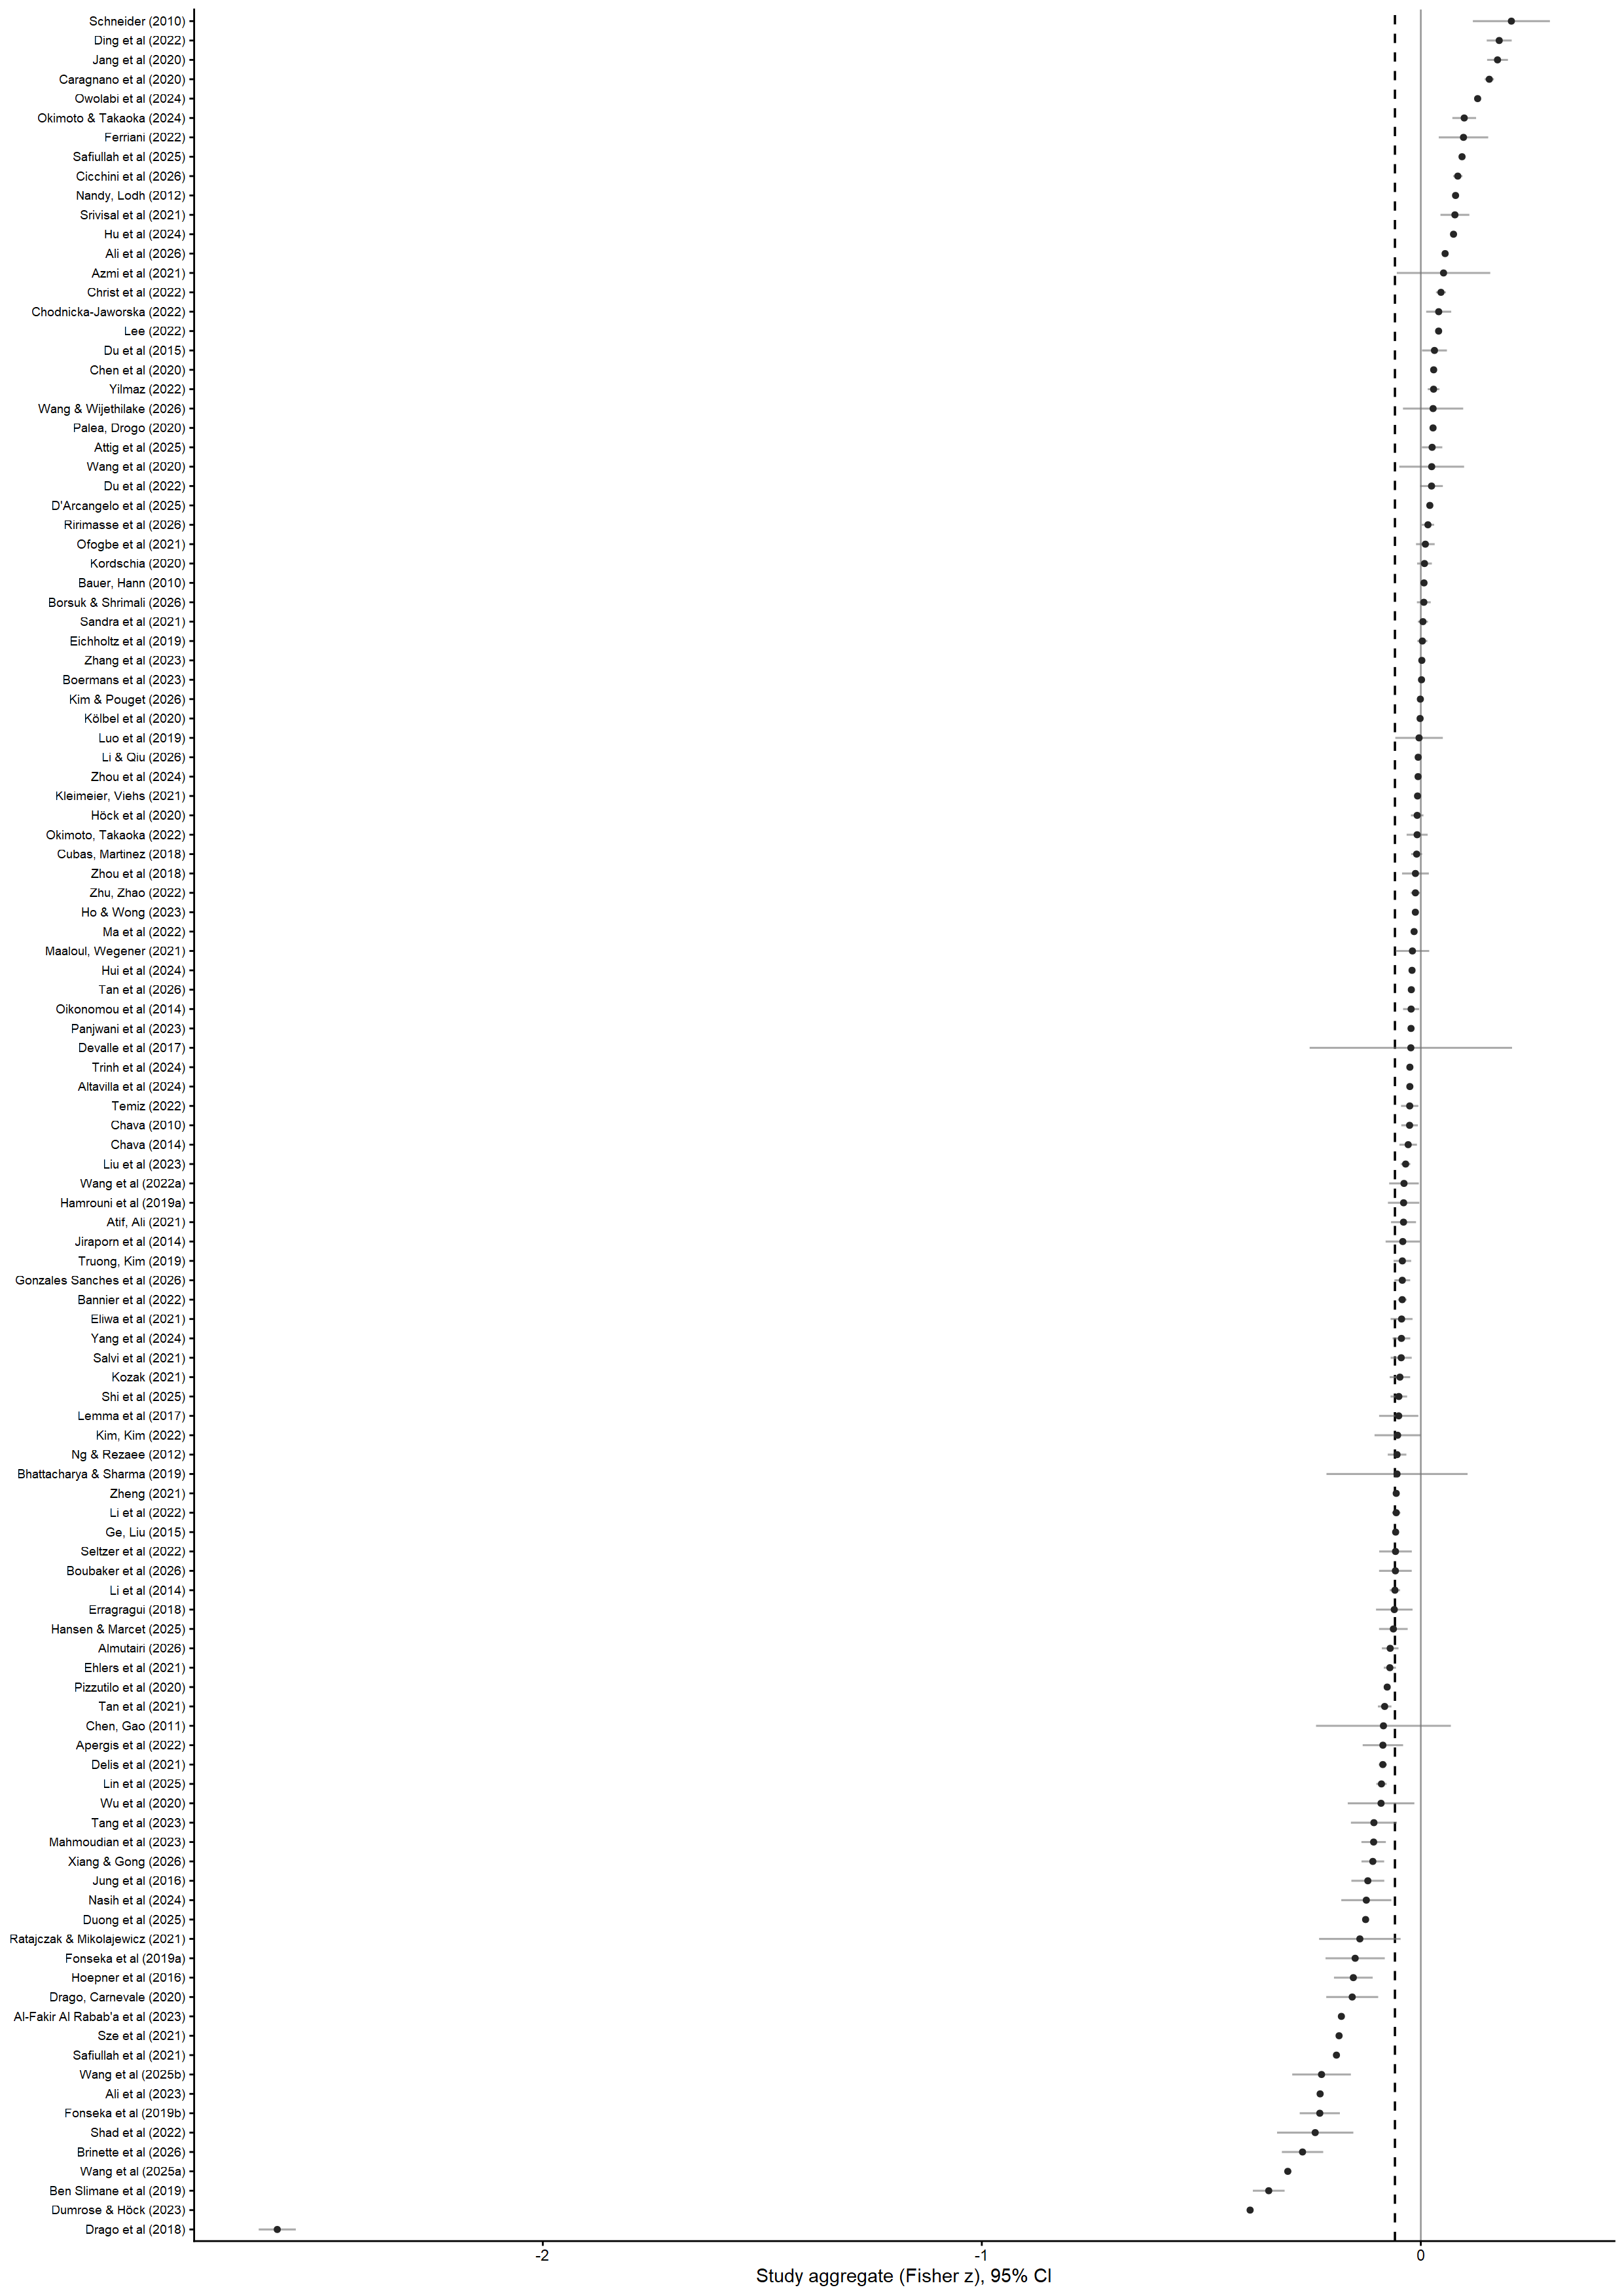
Figure A2. Contour-enhanced funnel plot of the 2,713 effect sizes (Fisher z against standard error). Shaded regions mark |z/SE| significance at the 10%, 5%, and 1% levels (light to dark); the dashed line marks the pooled CHE–RVE estimate. Five effect sizes lie beyond the display range of |z| ≤ 1 (largest |z| = 3.39; Drago et al., 2018; Section 4.1.2). 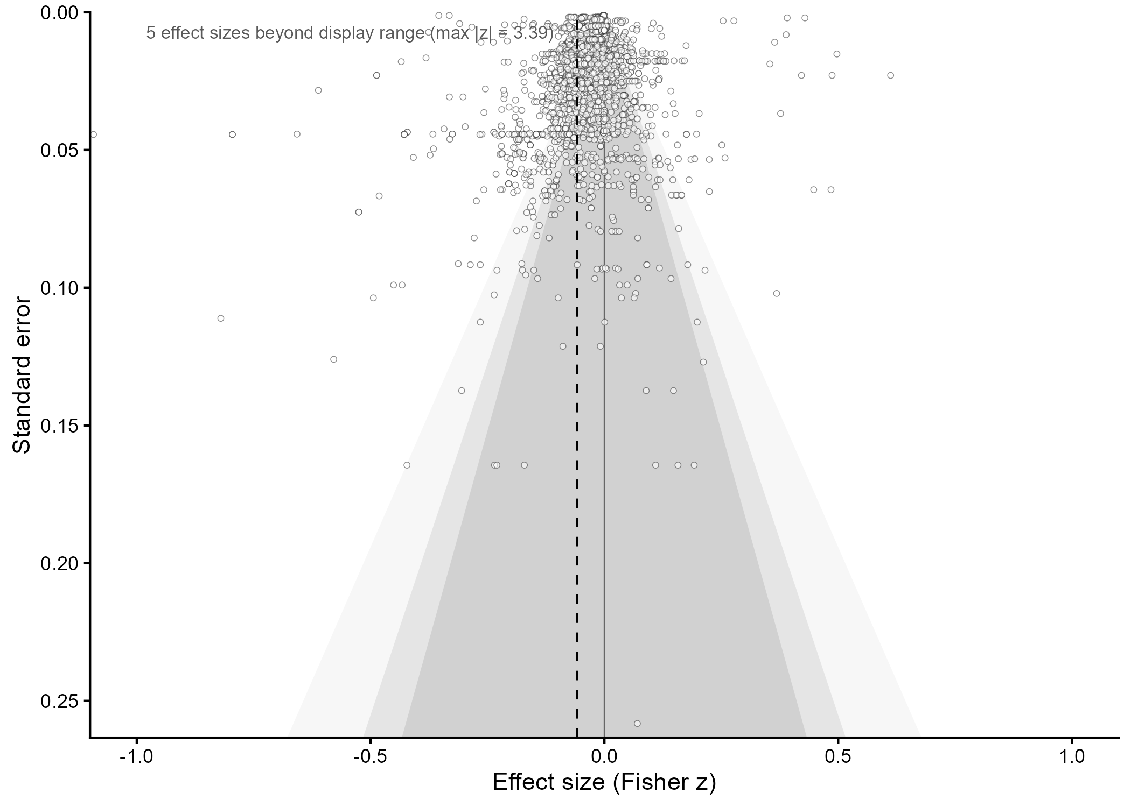

Prior syntheses either pool broad CSR or ESG constructs, with debt-financing costs at most one of several outcomes (e.g., Zeng et al., 2025; Wang et al., 2025; Friede et al., 2015; Gillan et al., 2021); provide narrative or systematic accounts without quantitative integration (e.g., Bauer et al., 2025; Carnevale & Drago, 2024; Benlemlih, 2017); target the equity side of the capital structure (e.g., Witte et al., 2026; Singhania & Gupta, 2025; Schreder, 2018; Souissi & Khlif, 2012); or synthesize broad financial-performance outcomes without debt pricing (e.g., Albertini, 2013; Busch & Lewandowski, 2018; Endrikat et al., 2014; Hang et al., 2019). The only synthesis testing a Paris-period moderator examines banking financial performance rather than debt pricing (Zarea et al., 2026).
If a study examined broader constructs (e.g., ESG or CSR) but reported a sub-analysis that isolated the environmental dimension and linked it to COD using one of our four COD instruments, we extracted only this environment-specific evidence.
If a study examined a broader outcome (e.g., cost of capital) but reported a sub-analysis that explicitly separated cost of debt from cost of equity and linked it to CER, we included the study and extracted only the cost-of-debt results.
The included studies are part of the reference list and marked with an asterisk (*).
E.g., Dixon-Fowler et al. (2013); Endrikat et al. (2020); García-Meca and Sánchez-Ballesta (2006, 2010); Khlif and Hussainey (2016); Schreder (2018).
Where a study reports a coefficient with significance stars only, the estimate enters at the bound implied by the reported significance threshold — the most conservative value consistent with the reporting (99 effect sizes from 11 studies).
One of the authors is also an author of a companion meta-analysis of the CER–cost-of-equity relationship (Witte et al., 2026), which reappears below as an external prior source and comparison channel. Seven of the 120 corpus studies also appear in the companion’s included-study list (Chava 2014; Chen and Silva-Gao 2011; Li et al. 2014; Shad et al. 2022, published 2020 in the companion’s citation; Lemma et al. 2017, cited there as 2019; Ng and Rezaee 2012; Ould Daoud Ellili 2020). Six enter the estimation set (6/115) and five the Paris-period domain (5/113), contributing 60 of 2,713 estimates (2.2 %). No effect size is shared between the two papers: the companion analyzes cost-of-equity estimands, this study cost-of-debt estimands, and both extraction protocols enforce disjoint outcome sets. The corpus additionally contains Chava (2010), an earlier unpublished sample coded as a separate cluster; the companion includes only the published 2014 study.
Eight effect sizes from two studies (Bhattacharya & Sharma, 2019; Ng & Rezaee, 2012) do not report recoverable sample windows; they remain in the estimation set but are excluded listwise from all period-based cells.
An any-exposure end-of-window coding is reported as an upper-recall bound but is unsuitable as the headline: 66.0% of the effect sizes it labels post-Paris (1,383 of 2,094, from 56 studies) draw the majority of their observations from pre-Agreement years. The majority cut is not threshold-fragile: only 2.9% of effect sizes (79, from 5 studies) lie within 0.05 of the 0.5 boundary, and all tie-break disagreements between the two rounding conventions occur exactly at the boundary. Because panels are unbalanced, later years contribute modestly more observations than their calendar share (effect-size-level mean post-2015 exposure 0.358 versus 0.343 at the study level); we disclose this drift and address time-composition formally in the identification analyses (Section 3.3.1).

