Rich Knoll
CS-360
Project 1 Milestone
1/25/2026

Project – Option 1: Inventory App

1. Application Goals
The purpose of this application is to allow the user to keep track of the quantities and locations of a specific list of items that they have in their inventory. The user should have the ability to create and remove different items. Once the item has been created, it should then be given a specific inventory location, and finally, the user should be able to increase and decrease the quantity of each item as needed. As an additional feature, the app should notify the user when any item’s quantity has reached zero, or stock-out level.
In terms of screens, the app should have a login screen for both returning users as well as new users who want to set up an account. There should also be a screen that visually represents the layout of the inventory items in a grid format.

2. Competition
There are other mobile applications of this kind on the market today. Two such apps are Sortly and Odoo Inventory. Both allow the user to add inventory items and adjust their on-hand quantities (OHQs) and locations. These apps also have some additional features that might be worth considering for future versions of our application. Both allow the user to add pictures to inventory items, making the UI even more intuitive. Sortly allows for the use of barcodes and QR codes for item entry and edits, making data entry even more streamlined, while Odoo allows for multiple warehouse locations, expanding on the scope that app can cover. Overall, these two apps have very similar features to the one we are creating and can be great resources for comparison and idea generation.

3. User Definition
There are several typical users for our application. The most common would be the small business owner looking to keep track of their inventory and don’t want to do it on a spreadsheet. Our application would be perfect for this user because the barrier to entry and learning curve will be low. However, if the small business expands, this user may begin to look for other options with more features.
The second user would be the serious hobbyist. Someone who is a step above your average person with a hobby, this user really takes their craft seriously and wants to keep track of such things as materials and tools. While a heavier-weight inventory management app might be cumbersome and intimidating for this type of user, our lightweight application will be perfect for catering directly to their needs, without all the extras.
Finally, our application can also be used by families who just want to keep track of such things as groceries, diapers, garage supplies, or any other home inventory-type items. Like the hobbyist, this user will find the streamlined and lightweight interface of our application perfect for their needs without having to wade through all the extras that exist in other apps within this space.

4. Screens and Features
This application will have two primary screens – a login screen, and an inventory screen. The following wireframe diagrams will show the basic layout and features of each screen respectively.

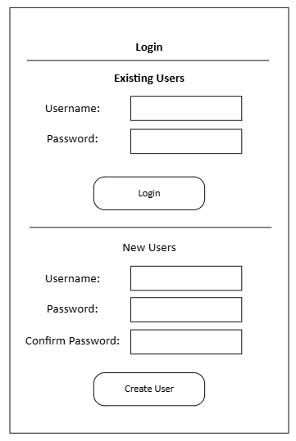
Figure 1 - Login Screen
The landing screen for the application will be the login screen. On this screen, the user will have two choices:
- Existing users can use previously created username and password to login to their account. These criteria will be stored in a User table in the database to validate the login credentials. Then, assuming the credentials are valid, the user will be brought to their specific inventory page.
- New users will have the option to create an account by entering a username and password. The password must be entered twice to verify that it is the same. Once this has been done, the user can hit the “Create User” button to create their account. Once this is done, the user will be taken to their empty inventory page.
The My Inventory screen will be where the major functionality of the application will reside.
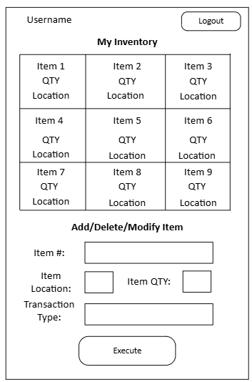
Figure 2 - My Inventory Screen
The user’s name will be displayed in the upper right corner. The main part of the screen will be the inventory grid, which will be a 3x3 grid that will display the inventory item name and on-hand quantity in each cell. If there is no item in each location, the location will be blank. If the item quantity for a given item is zero, the application will highlight the text red.
Underneath the grid will be where the user can interact with their inventory. They will have the ability to add a new item, delete an item, or adjust an item. Depending on the transaction type, which will be chosen by the user from a drop-down menu, certain criteria will need to be met, which will be defined in the next section.
The user can also log out of their account by pressing the logout button in the upper righthand corner of the screen.

5. UI Elements and Code Design
Referring to Figure 1, we will walk through all its UI elements and provide explanations.
- Existing Users:
  - Username Input – Text field that will accept alphanumeric input from the user
  - Password Input – Text field that will accept alphanumeric input from the user
  - Login Button – When pressed, this button will take the input from the username and password text fields as parameters. Then, using these parameters, we will check if the username and password combination exists in the User table. If yes, then we will log the user into their account and bring them to the My Inventory page. If no, we will notify the user that the username/password combination does not exist.
- New Users:
  - Username Input – Text field that will accept alphanumeric input from the user
  - Password Input – Text field that will accept alphanumeric input from the user
  - Confirm Password Input - Text field that will accept alphanumeric input from the user
  - Create User Button – When pressed, this button will first look to make sure the username does not already exist in the User table. If it does, we will notify the user that the username already exists and prompt them to login using the existing users’ portion of the page. If the username does not already exist then we will perform our second validation check, which will be to make sure that the input from the Password and Confirm Password fields match. If they do not match, we will notify the user. If they do match, we will create a new account, add it to the User table, and bring the user to an empty My Inventory screen where they can start building out their inventory.
Referring to Figure 2, we will walk through all its UI components and provide explanations.
- Header:
  - Username Text Field – Will display the username of the currently logged in user
  - Logout Button – When pressed, will log the current user out of the application and bring the user back to the Login page
- My Inventory Grid:
  - Item X Text Field – Will display the Item # for the respective Inventory Location
  - QTY Text Field – Will display the on-hand quantity for the inventory item in that location
  - Location Text Field – Will display the inventory location. These will be static values, 1-9.
- Add/Delete/Modify Item
  - Item # Text Input – Will accept alphanumeric input from the user
  - Item Location Input – Will accept integer value from the user. Must be a value from 1-9, as these are the static inventory locations the app defines.
  - Item QTY Input – Will accept an integer value from the user
  - Transaction Type Dropdown – Will list the three transaction types:
    - Add
    - Delete
    - Modify
  - Execute Button – When pressed, the button will execute inventory transaction based on the option selected in the Transaction Type Dropdown:
    - Add – If this option is selected, the button will be looking for an Item #, Item Location, and Item QTY. If any of these are blank, the user will receive an error message. Additionally, the item location cannot already be in use, or the user will also receive an error message. If all these criteria are met, the item will be added to the Item table in the database and displayed, with its pertinent information, in the My Inventory grid view.
    - Delete – If this option is selected, the button will be looking for an Item# and Item Location. If the Item # does not exist in the Item table, the user will be notified with an error message. If it does, and the Item Location input is associated with the item, the item will be deleted from the Item table, and the location will be shown as empty in the My Inventory grid view. If the Item Location entered is not associated with the Item # entered, the user will be notified with an error message.
    - Modify – If this option is selected, the button will be looking for Item #, Item Location, and Item QTY. If the Item # does not exist in the Item table, the user will be notified with an error message. If the Item Location is not associated with the Item #, the user will also be notified with an error message. If the item exists in the Item table and the Item Location is associated with the Item #, the Item QTY in the Item table will be updated to reflect the input from the Item QTY user input. This updated quantity will then be shown in the My Inventory grid view.

