**Convert google maps routes to GPX tracks**

[**https://gis.stackexchange.com/questions/152571/export-google-maps-route-to-kml-gpx**](https://gis.stackexchange.com/questions/152571/export-google-maps-route-to-kml-gpx)

**Goto -** [**http://google.com/mymaps**](http://google.com/mymaps)

**Create a route by selecting two locations, then generate directions.**

**At top of layer, click with left-hand mouse button on the three dots**

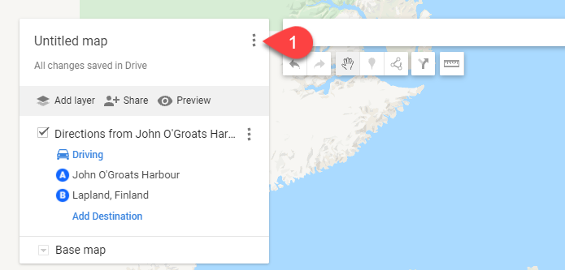

From the menu, select “Export to KML/KMZ.’

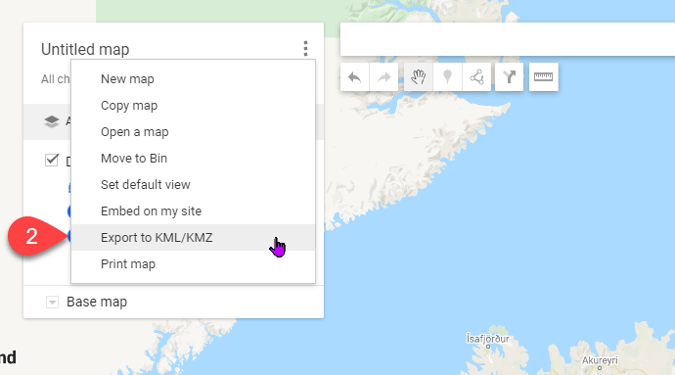

**When prompted to download the file, click on “Entire map.”**

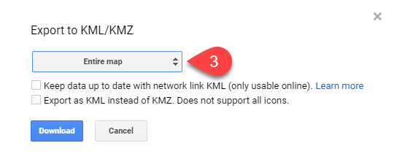

Select the direction which has been created.

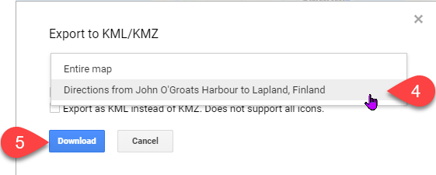

Goto - <https://www.alltrails.com/converter>

The first step is to import the file that is going to convert.

1. Upload the file that wants to convert
2. Select ‘Track / Route.’
3. Select the file type to download as ‘SQL Inserts Track’
4. Confirm that no route simplification
5. Convert the file

This will produce a ‘SQL script’ like this one

#CREATE TABLE tracks (

# fileId VARCHAR(16) NOT NULL,

# idx INT NOT NULL,

# lat DOUBLE NOT NULL,

# lon DOUBLE NOT NULL,

# ele DOUBLE NULL,

# PRIMARY KEY (fileId, idx)

#);

INSERT INTO tracks (fileId, idx, lat, lon, ele) VALUES ('null', '1', '42.33876000', '-83.0525900', '190.0');

INSERT INTO tracks (fileId, idx, lat, lon, ele) VALUES ('null', '2', '42.33762000', '-83.0552800', '184.0');

INSERT INTO tracks (fileId, idx, lat, lon, ele) VALUES ('null', '3', '42.33822000', '-83.0557500', '180.0');

INSERT INTO tracks (fileId, idx, lat, lon, ele) VALUES ('null', '4', '42.33833000', '-83.0558200', '180.0');

INSERT INTO tracks (fileId, idx, lat, lon, ele) VALUES ('null', '5', '42.33839000', '-83.0558500', '180.0');

INSERT INTO tracks (fileId, idx, lat, lon, ele) VALUES ('null', '6', '42.33855000', '-83.0559600', '182.0');

INSERT INTO tracks (fileId, idx, lat, lon, ele) VALUES ('null', '7', '42.33875000', '-83.0561600', '183.0');

Some modifications can then be made to the SQL script to allow the generation of a suitable table.

<https://products.aspose.app/gis/conversion/kmz-to-geojson>

SELECT u.name AS UserName, u.type_desc AS UserType, r.name AS RoleName

FROM sys.database_principals AS you

LEFT JOIN sys.database_role_members AS rm ON rm.member_principal_id = u.principal_id

LEFT JOIN sys.database_principals AS r ON r.principal_id = rm.role_principal_id

WHERE

u.type NOT IN('R', 'G')

ORDER BY

UserName

, RoleName;

sp_droprolemember 'role' ,

'security_account'

--GRANT INSERT ON SCHEMA :: [Staging] TO aQuorumJourney;

GRANT SELECT ON SCHEMA :: [Staging] TO aQuorumJourney;

GRANT DELETE ON SCHEMA :: [Staging] TO aQuorumJourney;

GRANT ALTER ON SCHEMA :: [Staging] TO aQuorumJourney;

GRANT EXECUTE ON SCHEMA ::[dbo] TO aQuorumJourney;

SELECT DISTINCT pr.principal_id, pr.name, pr.type_desc,

pr.authentication_type_desc, pe.state_desc, pe.permission_name

FROM sys.database_principals AS pr

JOIN sys.database_permissions AS pe

ON pe.grantee_principal_id = pr.principal_id;